UNITED STATES
SECURITIES AND EXCHANGE COMMISSION
Washington, D.C. 20549

SCHEDULE 14A
Proxy Statement Pursuant to Section 14(a) of the Securities
Exchange Act of 1934 (Amendment No. )

Filed by the Registrant ☒
Filed by a Party other than the Registrant ☐
Check the appropriate box:
☐ | Preliminary Proxy Statement
☐ | Confidential, for Use of the Commission Only (as permitted by Rule 14a-6(e)(2))
☒ | Definitive Proxy Statement
☐ | Definitive Additional Materials
☐ | Soliciting Material Pursuant to §240.14a-12
REPUBLIC SERVICES, INC.
(Name of Registrant as Specified In Its Charter)

(Name of Person(s) Filing Proxy Statement, if other than the Registrant)
Payment of Filing Fee (Check the appropriate box):
☒ | No fee required.
☐ | Fee paid previously with preliminary materials:
☐ | Fee computed on table in exhibit required by Item 25(b) per Exchange Act Rules 14a-6(i)(1) and 0-11



SUSTAINABILITY IN ACTION

Dear Shareholder,

We believe our best days are ahead. We continue to provide the most complete set of products and services in the industry for our customers. Despite increased volatility in the economy, our ability to execute our strategy allowed us to achieve record results in 2022:

- | Revenue growth of 20% vs. 2021, including 10% from acquisitions
- | Earnings per share of $4.69, a 16% year-over-year increase, and adjusted earnings per share of $4.93, an 18% year-over-year increase
- | Cash flow from operations of $3.19 billion, a 14% year-over-year increase, and adjusted free cash flow of $1.74 billion, a 15% year-over-year increase
We are proud of our progress building world-class capabilities in Customer Zeal, Digital and Sustainability. We believe these investments drive customer retention. Our recent advancements across circularity and decarbonization demonstrate our ability to leverage sustainability as a platform for growth:

- | Republic Services Polymer Center, the nation’s first integrated plastics recycling facility
- | Republic Services and bp joint venture, the largest U.S. renewable natural gas (RNG) portfolio build-out
- | Republic Services fleet investment, the industry’s largest commitment to fleet electrification, including the first fully integrated electric recycling and waste collection truck, expected to begin operating this fall

Our values guide how we work: Safe, Committed to Serve, Environmentally Responsible, Driven and Human-Centered. We have a highly engaged, inclusive and diverse culture where every voice counts. Our most recent employee engagement score is 85. None of this would be possible without our frontline employees. To recognize their dedication to our customers, we extended our Committed to Serve appreciation program in 2022.

The importance of our work has never been greater, and our future is bright. Our 2022 accomplishments have put us on track to deliver our ambitious 2030 sustainability goals. We are grateful to our team members for the hard work they do every day and to you, our shareholders, for the trust you put in us and our company.

We invite you to join our virtual Annual Meeting of Shareholders at 10:30 a.m. Pacific Time on Friday, May 12, 2023, via webcast at www.virtualshareholdermeeting.com/RSG2023.

 | 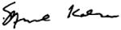  MANUEL KADRE  Chairman of the Board |  |  | 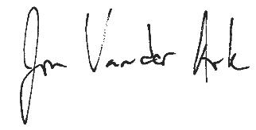  JON VANDER ARK  President and Chief Executive Officer

 | Republic Services, Inc. 2023 Proxy Statement | | | 3



Notice of the 2023 Annual Meeting of Shareholders
Important notice regarding the availability of proxy materials for the 2023 Annual Meeting of Shareholders (the “Annual Meeting”) of Republic Services, Inc., a Delaware corporation (the “company”). This Proxy Statement relating to the Annual Meeting and the Annual Report on Form 10-K for the year ended December 31, 2022 are available at www.proxyvote.com.
Date: | Friday, May 12, 2023
Time: | 10:30 a.m., Pacific Time
Place: | Via webcast at www.virtualshareholdermeeting.com/RSG2023
Items of Business
 | 1. | To elect the 11 director nominees listed in this proxy statement to serve until the 2024 annual meeting of shareholders or until their respective successors are duly elected and qualified;
 | 2. | To hold an advisory vote to approve our named executive officer compensation;
 | 3. | To hold an advisory vote on the frequency of an advisory vote to approve our named executive officer compensation;
 | 4. | To ratify the appointment of our independent registered public accounting firm for 2023; and
 | 5. | To transact such other business as may properly come before the Annual Meeting or any adjournment thereof.
Record Date
Only shareholders of record at the close of business on March 15, 2023 are entitled to notice of and to vote at the Annual Meeting or any adjournment of it. A list of such shareholders will be available commencing March 29, 2023 and may be examined prior to the Annual Meeting at our corporate headquarters during normal business hours.
Availability of Proxy Materials
We are pleased to utilize Securities and Exchange Commission rules that allow us to furnish these proxy materials and our Annual Report on Form 10-K in digital form online. Shareholders of record will be mailed a Notice of Internet Availability of Proxy Materials, which provides instructions on how to access the proxy materials and our Annual Report on Form 10-K online and, if they prefer, how to request paper copies of these materials. We believe providing these materials online enables us to reduce the environmental impact of our Annual Meeting and lower our printing and delivery costs while providing shareholders with the information they need more quickly and efficiently.
Proxy Voting
Your participation at our Annual Meeting is important. To ensure your representation, if you do not expect to participate in the virtual meeting, please vote your shares as instructed in your Notice of Internet Availability of Proxy Materials, proxy card or voting instruction card at your earliest convenience. Your prompt return of proxies will ensure a quorum and save us the expense of further solicitation.
Virtual Meeting
We will hold this year’s Annual Meeting in a virtual meeting format only. Shareholders of record at the close of business on March 15, 2023 may attend the Annual Meeting as well as vote and submit questions during the live webcast of the meeting by visiting www.virtualshareholdermeeting.com/RSG2023 and entering the 16-digit control number included in our Notice of Internet Availability of Proxy Materials, on your proxy card or in the instructions that accompanied your proxy materials. The format of the Annual Meeting will ensure that shareholders are afforded the same rights and opportunities to participate as they would at an in-person meeting.
By Order of the Board of Directors,

CATHARINE D. ELLINGSEN
Executive Vice President, Chief Legal Officer,
Chief Ethics & Compliance Officer, and Corporate Secretary
Phoenix, AZ
March 29, 2023

 | Republic Services, Inc. 2023 Proxy Statement | | | 5



SAFE We protect the livelihoods of our colleagues and communities.

Proxy Statement Table of Contents

Proxy Summary |  |  |  | 10-15 |  | Audit and Related Fees |  | 43
Board of Directors and Corporate Governance |  |  |  | 18-47 |  | Independent Registered Public Accounting Firm Fee Information |  | 43
Republic’s Board of Directors |  |  |  | 18 |  | Pre-Approval Policies and Procedures |  | 43
Director Skills, Experience, and Background |  |  |  | 19
Biographical Information Regarding Director Nominees |  |  |  | 21 |  | Director Compensation |  | 44
Board of Directors and Corporate Governance Matters |  |  |  | 28 |  | Certain Relationships and Related Party Transactions |  | 45
 | Board Leadership Structure |  |  | 28 |  | Security Ownership of the Board of Directors and Management |  | 46
Board Meetings and Committees |  |  |  | 29 |  | Delinquent Section 16(a) Reports |  | 47
 |  | Meeting Participation |  | 29 |  | Security Ownership of Five Percent Shareholders |  | 47
 |  | Committee Composition |  | 29
 |  | Board Refreshment |  | 29 |  | Executive Compensation |  | 50-83
 |  | Director Onboarding Process |  | 29 |  | Compensation Discussion and Analysis
 |  | Continuing Education |  | 29 |  | CD&A Table of Contents |  | 50
 |  | Thoughtful Board Evaluation Process |  | 29 |  | 2022 Summary Compensation Table |  | 71
 |  | Director Succession Planning |  | 29 |  | All Other Compensation for 2022 |  | 72
 |  | Executive Succession Planning and Leadership Development |  | 31 |  | Grants of Plan-Based Awards in 2022 |  | 73
 |  | Stock Ownership Guidelines and Anti-Hedging and Anti-Pledging Policies |  | 31 |  | Outstanding Equity Awards at Fiscal Year-End |  | 74
 |  | Director Nomination Procedures and Diversity Relating to Board Candidacy |  | 32 |  | PSUs and RSUs Vested in 2022 |  | 76
 |  | Director Independence |  | 32 |  | Nonqualified Deferred Compensation in 2022 |  | 76
 |  | Shareholder Engagement |  | 32 |  | Employment Agreements and Post-Employment Compensation |  | 77
 |  | Highlights of 2022 Engagement |  | 33 |  | CEO Pay Ratio |  | 80
Additional Board Policies |  |  |  | 34 |  | Pay versus Performance |  | 81
 |  | Shareholder Director Recommendation Policy |  | 34
 |  | Proxy Access Director Nominations |  | 34 |  | Proposals to be Voted on at the Meeting |  | 86-89
 |  | Director Resignation Policy |  | 34 |  | Proposal 1: Election of Directors |  | 86
 |  | Communications with the Board of Directors |  | 35 |  | Proposal 2: Advisory Vote on Named Executive Officer Compensation |  | 87
 |  | Attendance at Annual Meetings Policy |  | 35 |  | Proposal 3: Advisory Vote on the Frequency of An Advisory Vote on Named Executive Officer Compensation |  | 88
 |  | Additional Information Regarding Corporate Governance |  | 35 |  | Proposal 4: Ratification of Independent Registered Public Accounting Firm |  | 89
Risk Oversight |  |  |  | 35
Board Oversight of Sustainability |  |  |  | 36 |  | Information About the Meeting |  | 92-95
Board Oversight of Talent |  |  |  | 36 |  | Questions and Answers About the Annual Meeting |  | 92
Ethics and Compliance |  |  |  | 37 |  | Expenses of Solicitations |  | 94
Sustainability and Corporate Responsibility |  |  |  | 38 |  | Proxy Statement Mailing Information and Householding |  | 94
 |  | Our Commitment to Safety |  | 38 |  | Submission of Shareholder Proposals for our 2024 Annual Meeting |  | 95
 |  | Sustainability Focus |  | 38 |  | Miscellaneous Matters |  | 95
 |  | Industry Leadership |  | 39
Talent |  |  |  | 40 |  | Annex – CD&A Appendix |  | 98-101
 |  | Employee Engagement |  | 40 |  | Important notice regarding the availability of proxy materials for the Annual Meeting of Shareholders to be held on May 12, 2023: This Proxy Statement relating to the 2023 Annual Meeting of Shareholders and the Annual Report on Form 10-K for the year ended December 31, 2022 are available at www.proxyvote.com.
 |  | Inclusion and Diversity |  | 40
 |  | Committed to Serve |  | 41
Audit Committee Matters |  |  |  | 42
 |  | Audit Committee Report |  | 42

Forward-Looking Statements
This Proxy Statement contains certain forward-looking information about us that is intended to be covered by the safe harbor for "forward-looking statements" provided by the Private Securities Litigation Reform Act of 1995. Forward-looking statements are statements that are not historical facts. Words such as "guidance," "expect," "will," "may," "anticipate," "plan," "estimate," "project," "intend," "should," "can," "likely," "could," "outlook" and similar expressions are intended to identify forward-looking statements. These statements include information about our plans, strategies and prospects. Forward-looking statements are not guarantees of performance. These statements are based upon the current beliefs and expectations of our management and are subject to risk and uncertainties that could cause actual results to differ materially from those expressed in, or implied or projected by, the forward-looking information and statements. Although we believe that the expectations reflected in the forward-looking statements are reasonable, we cannot assure you that the expectations will prove to be correct. Among the factors that could cause actual results to differ materially from the expectations expressed in the forward-looking statements are the impacts of the overall global economy and increasing interest rates, our ability to effectively integrate and manage companies we acquire and to realize the anticipated benefits of any such acquisitions, acts of war, riots or terrorism, and the impact of these acts on economic, financial and social conditions in the United States, as well as our dependence on large, long-term collection, transfer and disposal contracts. More information on factors that could cause actual results or events to differ materially from those anticipated is included from time to time in our reports filed with the Securities and Exchange Commission, including our Annual Report on Form 10-K for the year ended December 31, 2022, particularly under Part I, Item 1A – Risk Factors. Additionally, new risk factors emerge from time to time and it is not possible for us to predict all such risk factors, or to assess the impact such risk factors might have on our business. We undertake no obligation to update publicly any forward-looking statements whether as a result of new information, future events or otherwise, except as required by law.



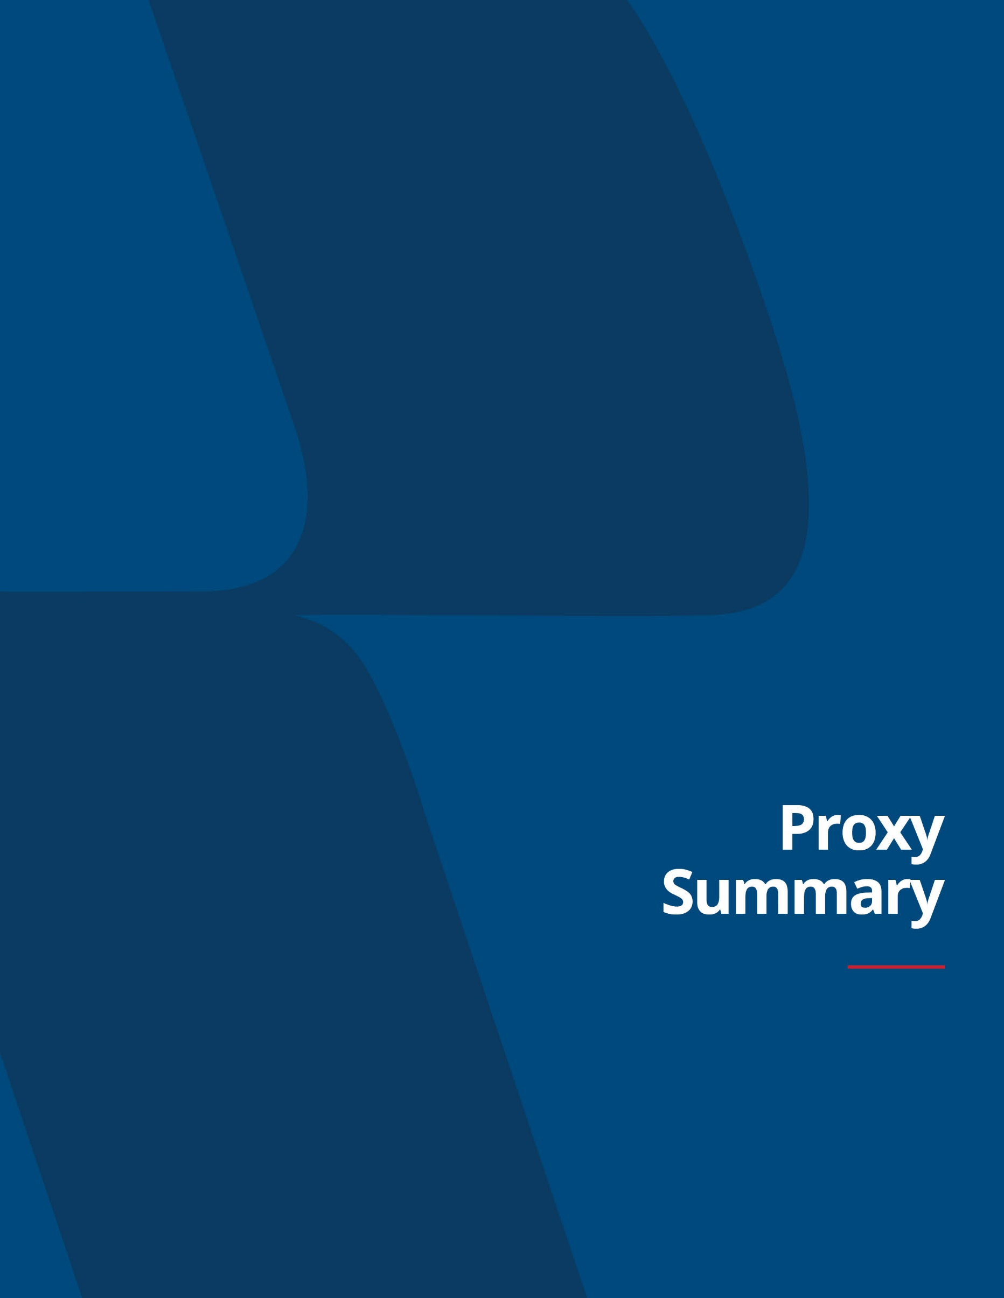

PROXY SUMMARY |  | BOARD AND GOVERNANCE |  | EXECUTIVE COMPENSATION |  | PROPOSALS |  | MEETING INFORMATION |  | ANNEX

Proxy Summary

Proxy Summary
We are providing this proxy statement (“Proxy Statement”) to shareholders in connection with the solicitation by the Board of Directors (the “Board”) of Republic Services, Inc., a Delaware corporation (“Republic,” “Republic Services,” the “Company,” “we,” “us” or “our”), of proxies to be voted at the annual meeting of shareholders to be held virtually on May 12, 2023 (the “Annual Meeting”), and at any adjournment thereof, for the purposes set forth in the accompanying notice. This proxy summary is intended to provide an overview of the items contained in this Proxy Statement. We encourage you to read the entire Proxy Statement prior to voting your shares.
annual meeting of shareholders
Date and time:Friday, May 12, 2023 at 10:30 a.m., Pacific Time
Place:Via webcast at www.virtualshareholdermeeting.com/RSG2023
record date:Shareholders as of March 15, 2023 are entitled to attend and vote

Proposals and Board Recommendations |  | BOARD’S  RECOMMENDATION | PAGE  REFERENCE
Proposal 1 | Election of the 11 Director Nominees in this Proxy Statement | FOR | 86
Proposal 2 | Advisory Vote on Named Executive Officer Compensation | FOR | 87
Proposal 3 | Advisory Vote on the Frequency of an Advisory Vote to approve our Named Executive Officer Compensation | EVERY YEAR | 88
Proposal 4 | Ratification of Independent Registered Public Accounting Firm for 2023 | FOR | 89

2022 Business and Performance Highlights
During 2022, we continued to create value for our shareholders. Our performance reflects our continued progress on our strategic priorities. We remain focused on executing our strategy designed to generate profitable growth by sustainably managing our customers’ needs, managing our cost structure, generating consistent earnings and free cash flow growth, improving return on invested capital, and increasing cash returns to our shareholders. We outperformed our upwardly revised adjusted earnings per share (“EPS”) and adjusted free cash flow (“FCF”) guidance. Highlights of the year include:

10 | | | Republic Services, Inc. 2023 Proxy Statement

PROXY SUMMARY |  | BOARD AND GOVERNANCE |  | EXECUTIVE COMPENSATION |  | PROPOSALS |  | MEETING INFORMATION |  | ANNEX

20% | $1.74B | 18%
TOTAL REVENUE GROWTH OF 20% | Generated $1.74 billion  of adjusted free cash  flow(1) | Grew adjusted EPS(1) 18%
44% | $796M | $2.7B+
adjusted  free cash flow(1)  conversion  OF 44.3% | Returned $796 million to  shareholders through  share repurchases and  dividends | Invested over $2.7  billion in acquisitions
 | (1) | Adjusted free cash flow, adjusted EPS and adjusted free cash flow conversion are non-GAAP financial measures. For a reconciliation of these non-GAAP measures to the comparable measures in accordance with GAAP, see “Reconciliation of GAAP to Non-GAAP Financial Measures” in the Annex on page 98.
Sustainability Leadership
Our sustainability goals and practices are core to our business and are integrated into our business strategy as well as our long-term financial targets. Sustainable business practices are embedded in our day-to-day operations, which we believe improve our profitability and support long-term value creation for our shareholders. The Board is responsible for overseeing our management’s handling of environmental, social and enterprise risks, including physical and transition risks and opportunities associated with climate change. As a result of this ongoing commitment, we have been recognized for our leading performance in several key areas including employee engagement, ethics, innovation and climate change management and resiliency.
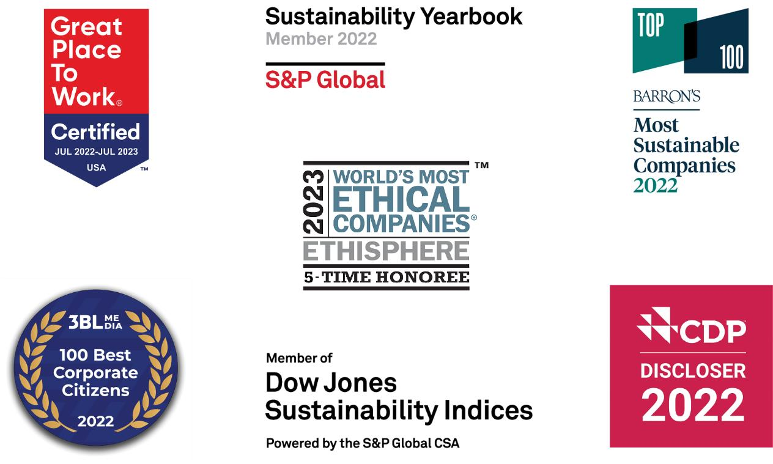

 | Republic Services, Inc. 2023 Proxy Statement | | | 11

PROXY SUMMARY |  | BOARD AND GOVERNANCE |  | EXECUTIVE COMPENSATION |  | PROPOSALS |  | MEETING INFORMATION |  | ANNEX

Sustainability in Action
We are partnering with our customers to create a more sustainable world. We are passionate about our role as responsible stewards of our nation’s waste, and we continue to make progress on our 2030 Sustainability Goals, which reaffirm our commitment to the elements of our sustainability platform: Safety, Talent, Climate Leadership and Communities.
Director Nominees and Corporate Governance Highlights
The table below lists the names of our director nominees and the standing committees on which they serve as of the date of this Proxy Statement.

DIRECTOR  NAME |  | AGE | DIRECTOR  SINCE | COMMITTEES | INDEPENDENT
Manuel Kadre  (Chairman) |  | 57 | 2014 | —
Tomago Collins |  | 51 | 2013 | Sustainability & Corporate  Responsibility Committee (Chair)  and Audit Committee
Michael A. Duffy |  | 53 | 2020 | Audit Committee and  Sustainability & Corporate  Responsibility Committee
Thomas W. Handley |  | 68 | 2016 | Talent & Compensation  Committee (Chair) and  Nominating & Corporate  Governance Committee
Jennifer M. Kirk |  | 48 | 2016 | Audit Committee (Chair) and  Nominating & Corporate  Governance Committee
Michael Larson |  | 63 | 2009 | Nominating & Corporate Governance  Committee (Chair), Finance Committee  and Talent & Compensation Committee
James P. Snee |  | 56 | 2018 | Finance Committee (Chair),  Nominating & Corporate  Governance Committee and  Talent & Compensation Committee
Brian S. Tyler |  | 56 | 2021 | Audit Committee, Finance Committee  and Sustainability & Corporate  Responsibility Committee
Jon Vander Ark |  | 47 | 2021 | —
Sandra M. Volpe |  | 55 | 2016 | Finance Committee, Nominating &  Corporate Governance  Committee and Sustainability & Corporate Responsibility Committee
Katharine B. Weymouth |  | 56 | 2018 | Audit Committee, Finance Committee and Talent & Compensation Committee

12 | | | Republic Services, Inc. 2023 Proxy Statement

PROXY SUMMARY |  | BOARD AND GOVERNANCE |  | EXECUTIVE COMPENSATION |  | PROPOSALS |  | MEETING INFORMATION |  | ANNEX

Board Highlights
Our Board is comprised of highly engaged and skilled directors with varied experiences and backgrounds, who bring diverse perspectives to their oversight of our business, while representing the long-term interests of our shareholders.
Kim Pegula, who has served on our Board since 2017, will not be standing for re-election in 2023. Ms. Pegula has been a valued member of our Board and we thank her for her contributions to the Company.
Board Practices
Our Board has developed a robust set of practices to help ensure appropriate composition and effective functioning. The Board maintains a regular Board evaluation process that is closely linked with ongoing succession planning and is committed to regular board refreshment based on the Company’s current and future needs and strategic priorities. The following charts summarizes the independence, tenure, age and diversity of our director nominees.

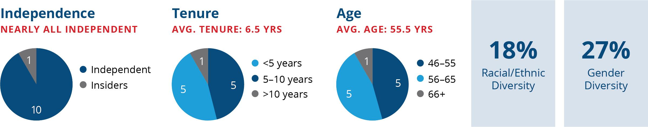

Shareholder Engagement
We have a well-developed shareholder engagement program that emphasizes year-round shareholder engagement and direct communication with our Board. During 2022, we engaged directly with shareholders representing approximately 55% of shares outstanding, as well as one proxy advisor and discussed our business performance, commitment to sustainable business practices and our human-centered talent program.
Corporate Governance Highlights
We continuously monitor developments and best practices in corporate governance and enhance our practices as warranted and based on shareholder feedback. Key features of our corporate governance practices are noted below:

 | Shareholder Engagement Program with select participation of independent directors |  | Robust Clawback Policy (updated in 2022)
 | Proxy Access Right |  | Thoughtful Board Evaluation Process
 | Independent Board Chairman |  | Formal Onboarding Program for New Directors
 | Director and Executive Succession Planning |  | Majority Vote Standard
 | Majority Independent Board (10 of 11 director nominees) |  | Deferral of Compensation for Directors  (restricted stock units or cash)
 | No Supermajority Vote Requirements |  | Code of Business Ethics and Conduct
 | Shareholder Action by Written Consent |  | Political Contributions Policy
 | Independent Board Committees |  | Mandatory Retirement Age for Directors
 | Annual Director Elections |  | Anti-Hedging and Anti-Pledging Policies
 | Human Rights Policy |  | One Share, One Vote Structure

 | Republic Services, Inc. 2023 Proxy Statement | | | 13

PROXY SUMMARY |  | BOARD AND GOVERNANCE |  | EXECUTIVE COMPENSATION |  | PROPOSALS |  | MEETING INFORMATION |  | ANNEX

Executive Compensation Highlights
Components of Our Executive Compensation Program
The Talent & Compensation Committee is committed to a performance-based executive compensation program that enables us to attract, retain and motivate our leadership team to drive financial success and sustained shareholder value creation. The core compensation elements for the executive officers listed in the Summary Compensation Table (referred to as “named executive officers” or “NEOs”) are:
 | • | base salary;
 | • | annual cash incentive based on target; and
 | • | long-term incentive (“LTI”) awards based on targets, which are delivered in performance shares (“PSUs”) and restricted stock units (“RSUs”).
Our annual incentive metrics are designed to encourage profitable growth and are widely accepted by the investment community as important performance metrics, while our LTI metrics are designed to grow our business with an emphasis on cash flow while maximizing investment returns and aligning interests between our executives and shareholders. Together, these metrics provide the appropriate balance in target total direct compensation (“Target TDC”) to drive financial and operational performance that will build long-term value for our shareholders.

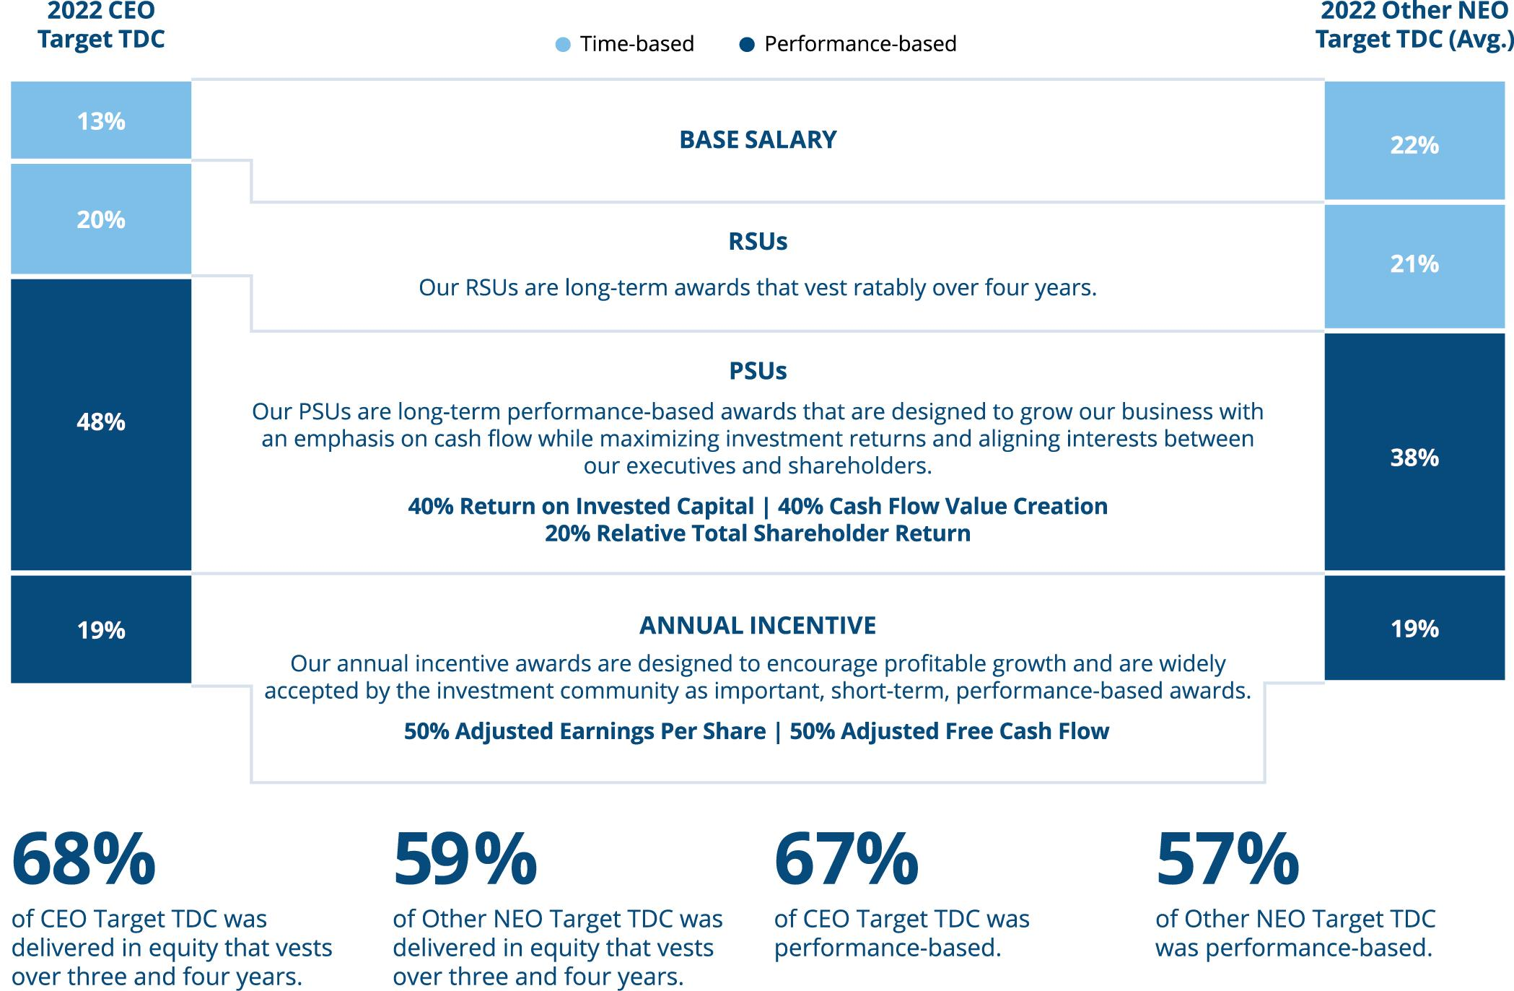

14 | | | Republic Services, Inc. 2023 Proxy Statement

PROXY SUMMARY |  | BOARD AND GOVERNANCE |  | EXECUTIVE COMPENSATION |  | PROPOSALS |  | MEETING INFORMATION |  | ANNEX

Executive Compensation Link to Strategy
Our compensation program is focused on achieving key financial results that support shareholder value creation. We maintain rigorous performance goals on a bottom-up basis, reflecting management initiatives, such as profitable revenue growth, controllable operating expenses, capital investment and M&A, and the impact of anticipated external factors, such as the macroeconomic environment, Consumer Price Index (“CPI”) impact on pricing, commodity pricing and regulatory changes. Progress towards our sustainability goals is included within each of our management initiatives and therefore directly linked to our executive compensation. To align management incentives, our metrics and performance targets focus on factors that management can impact, rather than external factors that are outside of management’s control or ability to mitigate.
In 2022, the Talent & Compensation Committee modified the annual incentive portion of our executive compensation program to further align compensation with our sustainability-related strategic priorities. Under the modified program, the annual incentives for senior executives including our NEOs are subject to adjustment, positively or negatively, of up to 10% based on the Company’s interim performance on safety, talent and climate leadership goals. See the Executive Compensation Section of the Proxy Statement for further information regarding the sustainability modifier of our annual incentive program.
Compensation Governance Highlights
We have established a number of compensation best practices that help ensure our compensation program remains aligned with shareholder interests. Key features of these practices are noted below:

 | Pay-for-Performance Incentive Structures |  | Active Management of Dilution from Equity Plans
 | Stock Ownership Guidelines for Senior Management and Directors |  | No Dividends on Unearned PSUs
 | Sustainability modifier in Annual Incentive Program for Senior Management |  | Limited Perquisites
 | Independent Compensation Consultant |  | No Excise Tax Gross-Ups
 | Robust Clawback Policy (updated in 2022) |  | No Hedging, Pledging or Short Sales
 | Double Trigger Change in Control Provisions |  | Annual Risk Assessment of Compensation Program

We encourage you to read the entire Proxy Statement for additional information prior to voting your shares.

 | Republic Services, Inc. 2023 Proxy Statement | | | 15



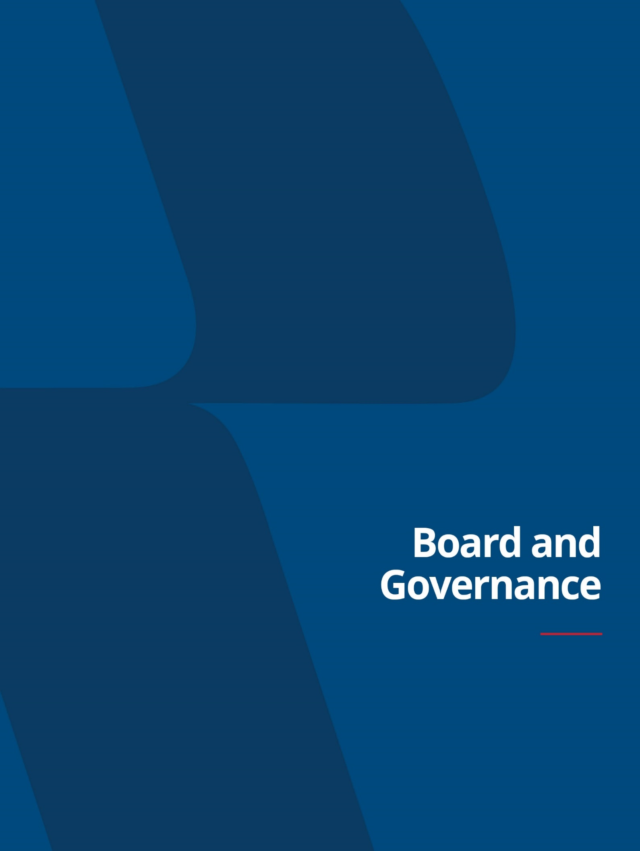

PROXY SUMMARY |  | BOARD AND GOVERNANCE |  | EXECUTIVE COMPENSATION |  | PROPOSALS |  | MEETING INFORMATION |  | ANNEX

Board of Directors and Corporate Governance
Republic’s Board of Directors
Republic’s Board currently consists of 12 directors; however, Kim S. Pegula is not standing for re-election to the Board at the Annual Meeting. Ms. Pegula has been a valuable member of the Company’s Board, and we greatly appreciate her many years of service.
The Board’s Nominating & Corporate Governance Committee (the “Governance Committee”) evaluated our 11 director nominees in accordance with the Governance Committee’s charter and our Corporate Governance Guidelines and submitted the nominees to the full Board for approval. We believe that each of our director nominees is highly qualified and collectively, they represent an ideal mix of experience, wisdom, integrity, and ability to advance Republic’s strategy and serve the interests of all our stakeholders.



18 | | | Republic Services, Inc. 2023 Proxy Statement

PROXY SUMMARY |  | BOARD AND GOVERNANCE |  | EXECUTIVE COMPENSATION |  | PROPOSALS |  | MEETING INFORMATION |  | ANNEX

DIRECTOR SKILLS, EXPERIENCE, AND BACKGROUND
Republic is an environmental services company providing essential services to customers. We operate in a highly technical, regulated, and competitive industry. As such, we require a Board that possesses a wide array of skill sets to help us drive forward our long-term strategy. We seek directors who have a growth mindset, business judgment, integrity, professionalism, and a diverse set of experiences.

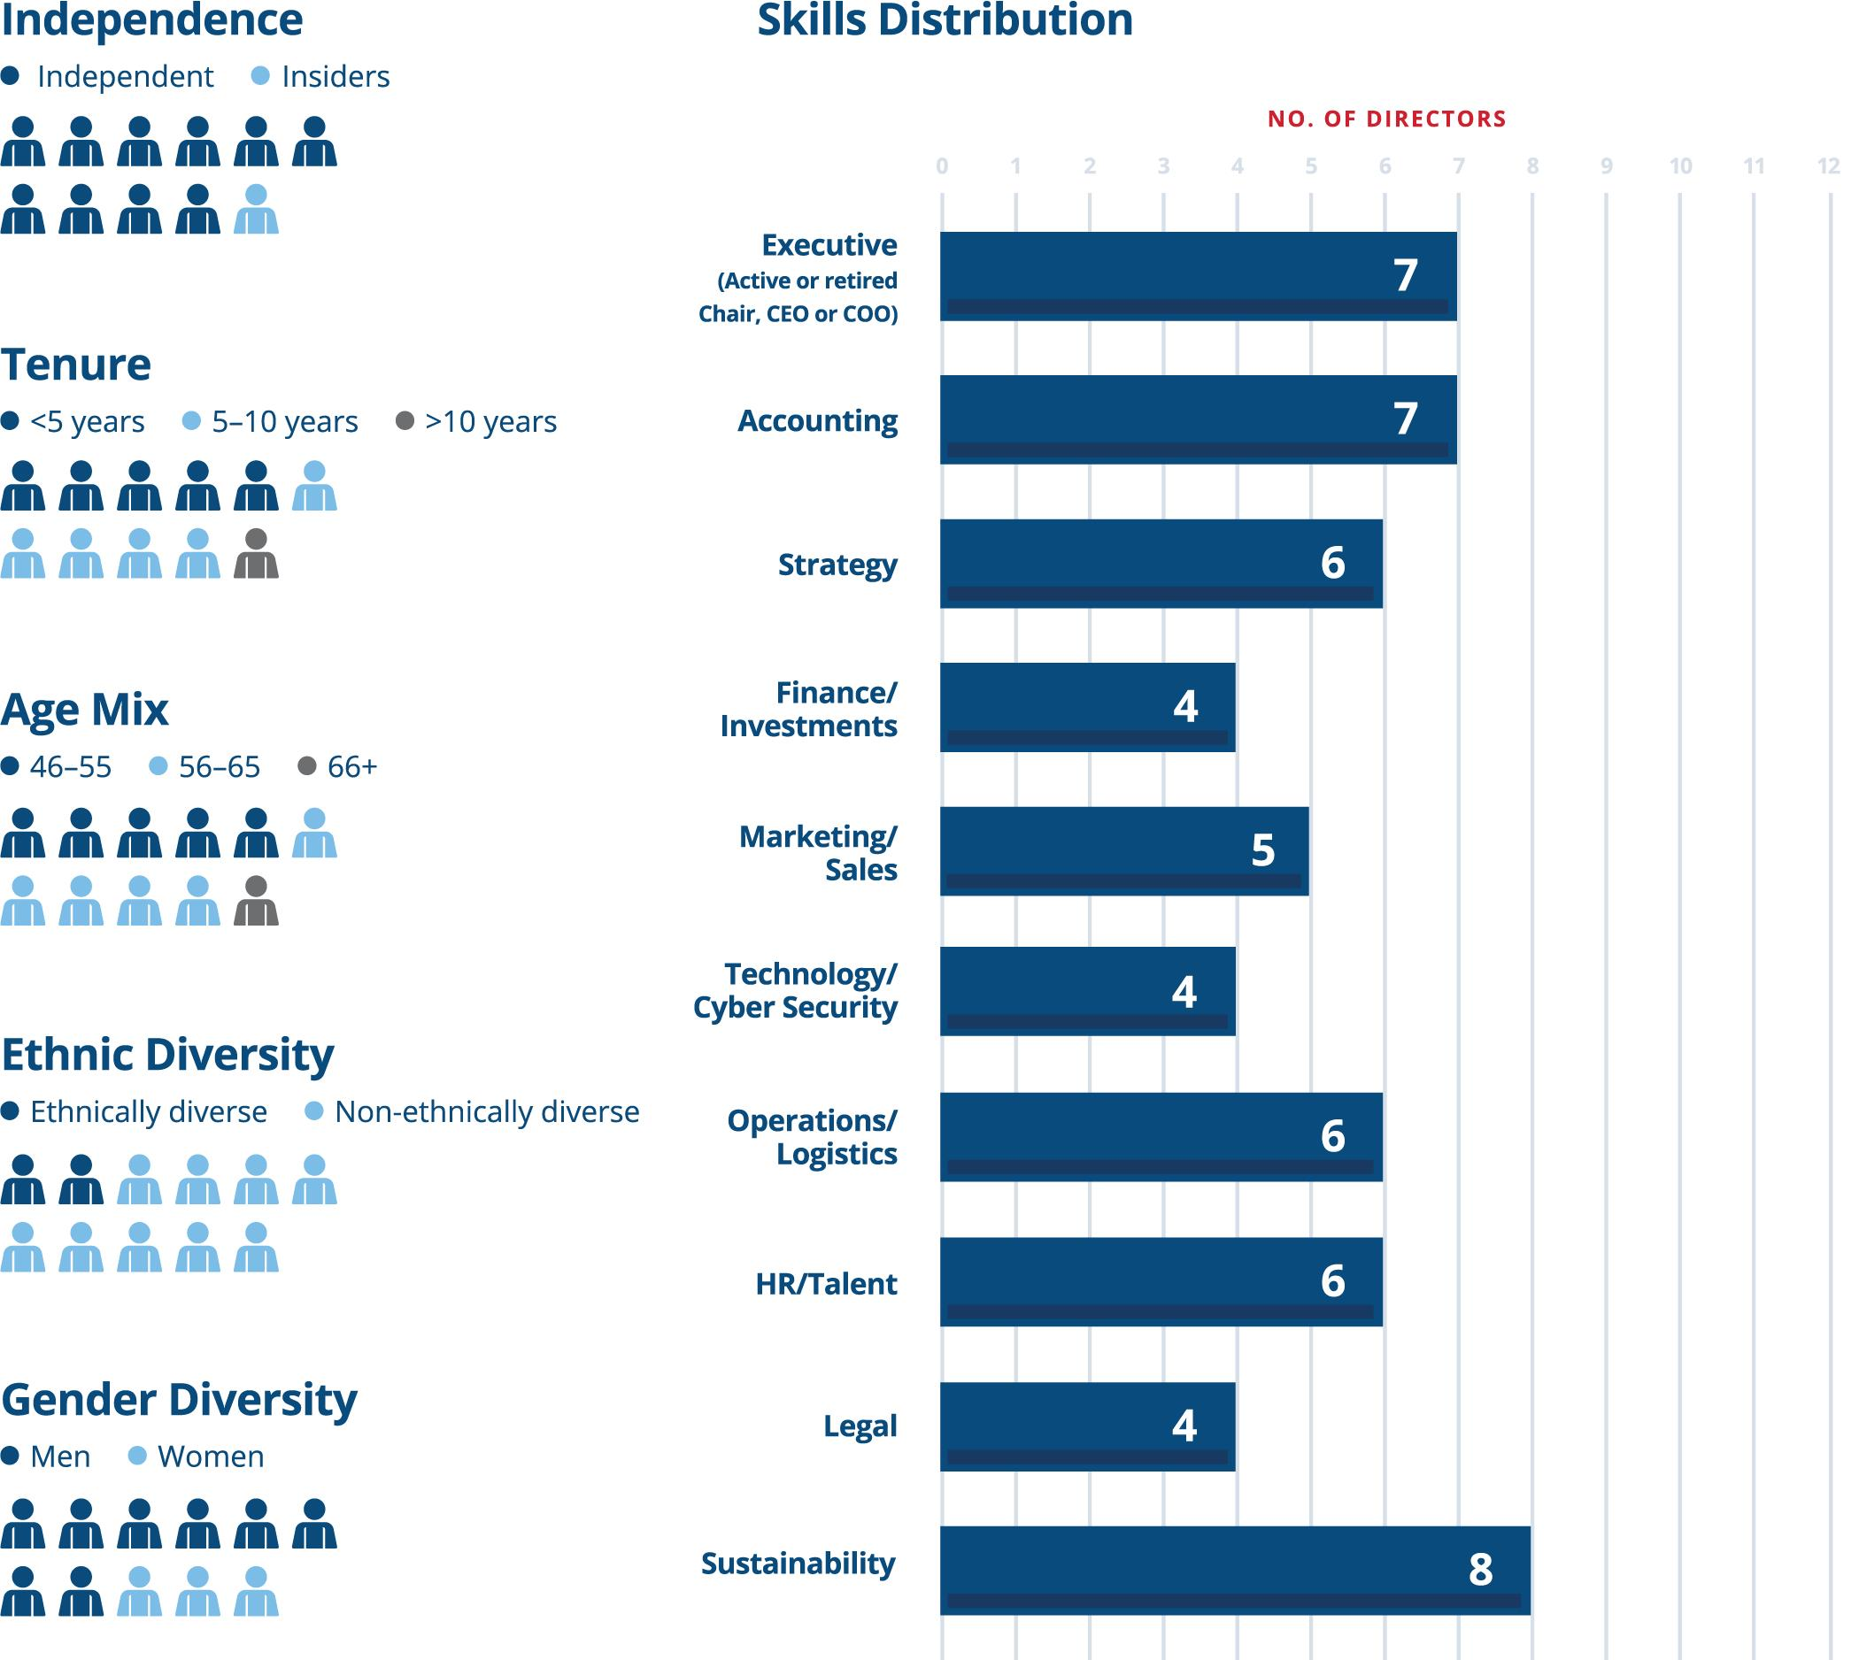
ndependence independent insiders Tenure <4years 5-10years >10years Age Mix 46-55 56-65 66+ Ethnic Diversity Ethnically diverse Non-ethnically diverse Gender Diversity Men Women Skills distribution Executive (Active or retired chair, CEO or COO) Accounting Strategy Finance/Investments Marking sales Technology/Cyber Security Operations/Logistics HR/Talent ESG NO OF DIRECTORS 0 1 2 3 5 6 7 8 9 10 11 12 8 77 4 6 4 78 4 8

Each of our 11 director nominees is a highly engaged and skilled professional who recognizes that strong corporate governance contributes to long-term shareholder value.

 | Republic Services, Inc. 2023 Proxy Statement | | | 19

PROXY SUMMARY |  | BOARD AND GOVERNANCE |  | EXECUTIVE COMPENSATION |  | PROPOSALS |  | MEETING INFORMATION |  | ANNEX

Listed below are the core skills and experiences we consider to be beneficial for our Board to possess.

Skills & Experience | Application to Republic Services
Executive  (Active or retired Chair, CEO or COO) | As a leader in the environmental services industry with vertically integrated operations across the U.S. and Canada, the scale and intricacies of Republic’s business make it necessary to have directors who have experience leading their organizations. These directors provide valuable guidance and perspective when analyzing and overseeing complex financial, operational, and strategic decisions, and leading strong corporate governance practices.
Financial Accounting | As a publicly traded company with a national footprint and diversified exposure to franchise, large urban and small to mid-sized markets, financial accounting experience enables Republic directors to advise on and provide oversight into risk management, financial reporting and internal control items.
Strategy | A focus on customer needs and sustainability is core to how Republic generates profitable growth. Directors with a background in developing and implementing the strategic direction of a company provide useful insight into operating and growing Republic’s business.
Finance/Investments | As a vertically integrated company in an industry where consolidation often presents an opportunity to drive growth and build scale, directors with knowledge of financial markets, financing, funding operations and merger integration bring useful insights to the Board, particularly given the role M&A has in Republic’s strategy. In addition, directors who possess a generic understanding of business cycles, capital markets and the investor perspective provide guidance on Republic’s capital allocation strategy and broader strategic positioning.
Marketing/Sales | As a customer-facing brand focused on growing new business, driving brand awareness and customer loyalty are important to Republic’s growth strategy. Directors with expertise in amplifying and enhancing effective corporate marketing strategies provide useful insight toward developing customer zeal, brand recognition and top-line revenue growth.
Technology/  Cybersecurity | A core aspect of Republic’s long-term strategy is using technology to differentiate our service offerings, improve customer satisfaction and drive operational efficiencies. Directors who are familiar with innovative technological strategies and understand emerging trends bring necessary perspectives to the Board regarding technology’s role in Republic’s strategy. In addition, Republic’s technology and cybersecurity programs are crucial to maintaining secure cybersecurity operations, delivering customer satisfaction and trust, which means directors with knowledge of cybersecurity risks and best practices provide valuable insight into oversight of these risks.
Operations/Logistics | Republic’s business is focused on providing a comprehensive set of integrated environmental services to customers as efficiently and safely as possible in a cost-effective manner. This includes planning vehicle routes, operating and maintaining facilities such as recycling processing centers and regenerative landfills, and managing the company’s resources, such as equipment and personnel. Directors with experience strategizing, controlling and implementing logistics management systems can contribute valuable perspective and management to the Board on this essential element of Republic’s business.
HR/Talent | As a highly technical organization with employees that possess specialized skills in significant demand, directors that are able to provide guidance on attracting and retaining top talent, have experience managing compensation of executives and other employees and have experience in succession planning are of immense value to the Board. Maintaining an engaged workforce and investing in employee development are also core to Republic’s talent strategy, an area where directors with human resources experience provide thoughtful insight.
Legal | As a publicly traded company and a provider of services in a highly regulated industry, directors with in-depth legal knowledge and background are beneficial to assist the Board in its oversight of Republic’s compliance on legal and regulatory matters.
Sustainability | Republic’s strategy is designed to generate profitable growth by partnering with customers to create a more sustainable world. As an environmental services company, directors with expertise in evolving issues around talent, specifically inclusion and diversity, employee safety, climate leadership and community engagement provide valuable guidance and insight to the Board when providing oversight on Republic’s sustainability efforts.

20 | | | Republic Services, Inc. 2023 Proxy Statement

PROXY SUMMARY |  | BOARD AND GOVERNANCE |  | EXECUTIVE COMPENSATION |  | PROPOSALS |  | MEETING INFORMATION |  | ANNEX

Biographical Information Regarding Director Nominees


Experiences and skill sets aligned with Board Contributions and Republic’s Strategy:  Mr. Kadre is currently the Chief Executive Officer of Kollective Auto Group, a premium luxury retail automotive group, and previously was Chief Executive Officer of a number of beverage, automotive, healthcare and real estate companies.  Mr. Kadre has gained significant management and leadership experience from serving as Chief Executive Officer of these companies for over two decades. He brings to the Board valuable perspective on managing the strategic direction of organizations, particularly useful given Republic operates in a highly technical, regulated and competitive industry.  Throughout his career, Mr. Kadre has held leadership roles in acquiring, managing, and running several businesses, gaining valuable financial and strategy experience. These experiences enable him to provide guidance regarding Republic’s M&A opportunities, which is important given the role M&A plays in Republic’s strategy and Republic’s position in an industry where consolidation presents an opportunity to drive growth and build scale.  Mr. Kadre has extensive experience strategically positioning well-known, customer-facing brands to drive customer awareness and loyalty. His focus on using marketing efforts to heighten brand recognition, particularly for businesses in highly regulated industries, augments the Board’s ability to oversee and provide input on marketing and sales topics.  Through Mr. Kadre’s leadership roles at companies in highly regulated industries, including serving as General Counsel of beverage product distributor CC1 Companies, he offers the Board valuable expertise when assessing legal and regulatory matters. In addition, he has extensive public company experience having served on four public company boards; Republic, Bright Health, The Home Depot, and Mednax. | Career Highlights  Kollective Auto Group, 2012 – Present  Chief Executive Officer  Gold Coast Caribbean Importers, 2005 – 2014  Chief Executive Officer  CC1 Companies, 1995 – 2009  President, Vice President, General Counsel and Secretary
Other Public Company Directorships
(within the last 5 years)
Bright Health Group, Inc., 2021 – Present
(Lead Independent Director, Chair of the Nominating and Corporate Governance Committee, Member of the Audit Committee and the Compensation and Human Capital Committee)

The Home Depot, Inc., 2018 – Present
(Member of the Audit Committee and the Finance Committee)

Mednax, Inc., 2007 – 2022
(Lead Independent Director, Member of the Compensation Committee, Strategy Committee, and Chair of the Nominating and Corporate Governance Committee)
Additional Experience & Service
Board of Trustees, University of Miami
Board of Directors, University of Miami Health System


Experiences and skill sets aligned with Board Contributions and Republic’s Strategy:  Mr. Collins currently serves as Executive Vice President of Communications and Business Development at Kroenke Sports & Entertainment. | Career Highlights  Kroenke Sports & Entertainment, 2003 – Present  Executive Vice President, Communications and Business Development  The (Louisville) Courier-Journal and CNN International  Journalist

 | Republic Services, Inc. 2023 Proxy Statement | | | 21

PROXY SUMMARY |  | BOARD AND GOVERNANCE |  | EXECUTIVE COMPENSATION |  | PROPOSALS |  | MEETING INFORMATION |  | ANNEX

Mr. Collins deeply understands successful marketing strategies from leading communications, business development, and public affairs for a diverse multibillion dollar portfolio of sports, entertainment, media, real estate, ranch, and vineyard products.  Through his roles at Kroenke Sports & Entertainment-owned products, Mr. Collins maintains a unique perspective on determining and implementing corporate strategy.  Mr. Collins’ business development and mergers and acquisitions experience gives him a strong understanding of considerations in potential transactions and their integration.  Through his experience at Kroenke Sports & Entertainment, specifically in leading ranch and vineyard conservation efforts and service on multiple company and non-profit boards, Mr. Collins has important sustainability and climate leadership knowledge. | Other Public Company Directorships  (within the last 5 years)  AutoNation, Inc., 2014 – 2019  Clear Secure, Inc., 2021 – Present  (Member of the Audit Committee and the Nominating and Corporate Governance Committee)  Additional Experience & Service  Director, Global Down Syndrome Foundation  Director, Four Seasons Hotels and Resorts


Experiences and skillsets aligned with Board Contributions and Republic’s Strategy:  Mike Duffy is a seasoned distribution, supply chain and retail executive with over 25 years of experience, and currently serves as the Chief Executive Officer of LaserShip/OnTrac, the largest regional e-commerce parcel carrier in the U.S.  Mr. Duffy has extensive leadership and chief executive experience from his roles at LaserShip/OnTrac, FleetPride, and C&S Wholesale Grocers.  In his roles as Chief Executive Officer of FleetPride and C&S Wholesale Grocers, Mr. Duffy developed and implemented strategic initiatives to drive the growth of these organizations.  Mr. Duffy managed complex supply chains for Cardinal Health and The Procter & Gamble Company through his roles as Global President of Supply Chain and Vice President of Supply Chain, respectively.  Through his chief executive experience at LaserShip/On Trac, FleetPride, and C&S Wholesale Grocers, Mr. Duffy has gained important perspective on human resources, talent, and labor topics. | Career Highlights  LaserShip/OnTrac, 2023 – Present  Chief Executive Officer  FleetPride, Inc., 2021 – Present  Chief Executive Officer1  C&S Wholesale Grocers, Inc., 2017 – 2020  Chief Executive Officer  Cardinal Health, Inc., 2006 – 2017  President, Hospital Solutions and Global Supply Chain President, Medical Products  Various executive positions with increasing responsibility  The Procter & Gamble Company, 2005 – 2006  Vice President, Global Supply Chain  Gillette Company, 2001 – 2005 (Acquired by P&G in 2005)  Vice President, North America Value Chain  New York Consulting Partners, 1997 –1999, 2000 – 2001  Partner  Additional Experience & Service  Board Member, LaserShip/OnTrac  Board Member, FleetPride
1 | Mr. Duffy is transitioning to Chairman of the FleetPride Board.

22 | | | Republic Services, Inc. 2023 Proxy Statement

PROXY SUMMARY |  | BOARD AND GOVERNANCE |  | EXECUTIVE COMPENSATION |  | PROPOSALS |  | MEETING INFORMATION |  | ANNEX


Experiences and skill sets aligned with Board Contributions and Republic’s Strategy:  Mr. Handley is the Chief Operating Officer of Cascade Asset Management Company, the investment office for William H. Gates III, and the Bill & Melinda Gates Foundation Trust.  Mr. Handley’s experience as the former President and Chief Operating Officer of Ecolab, a hygiene and infection prevention solutions and services company, benefits the Board and management as they implement strategies for growth while operating in a safe, responsible and cost-effective manner.  Mr. Handley’s understanding of corporate strategic planning, business operations, sales and marketing gained during two decades in senior executive roles at The Procter & Gamble Company helps the Board oversee Republic’s brand and customer experience.  Mr. Handley’s expertise in business operations and information technology provides the Board governance skills with respect to field operations and cybersecurity which assists Republic in maintaining a strong digital capability.  Mr. Handley’s combined experience in corporate operations and investment management also supports the Board as it considers matters relating to corporate governance, investor relations, compensation, operational safety and sustainability. | Career Highlights  William H. Gates III, 2019 – Present  Chief Operating Officer of Cascade Asset Management Company, the investment office for William H. Gates III, and the Bill & Melinda Gates Foundation Trust  Ecolab Inc., 2003 – 2019  Special Advisor to the CEO responsible for the spin-off of Ecolab’s upstream energy business  President and Chief Operating Officer  Various executive positions with increasing responsibility  The Procter & Gamble Company, 1981 – 2003  Vice President, Global Planning, Marketing and Always Global Franchise  Various positions in general and brand management both in the United States and internationally
Other Public Company Directorships
(within the last 5 years)
HB Fuller Company, 2010 – Present
(Member of the Corporate Governance and Nominating Committee and Chair of the Audit Committee)
Additional Experience & Service
Former Director and Member, National Association of Manufacturers Executive Board (organization’s governing board)


Experiences and skill sets aligned with Board Contributions and Republic’s Strategy:  Ms. Kirk currently serves as Senior Vice President, Global Controller and Chief Accounting Officer at Medtronic PLC, a medical device company.  With more than 25 years in finance and accounting roles, including her current role at Medtronic, Ms. Kirk has deep experience in financial accounting.  During her over 20 years at Occidental Petroleum, Ms. Kirk held various positions, including Senior Vice President of Integration and Value Capture, where she led initiatives focused on technological innovation and cybersecurity. | Career Highlights  Medtronic PLC, 2021 – Present  Senior Vice President, Global Controller and Chief Accounting Officer  Occidental Petroleum Corporation, 1999 – 2020  Senior Vice President, Integration and Value Capture  Vice President, Controller and Chief Accounting Officer  Various operational and HQ positions with increasing responsibility  Arthur Andersen LLP, 1996 – 1999  Responsibilities encompassed all areas of financial statement audits including planning, supervision and financial statement reporting at both a staff and senior level

 | Republic Services, Inc. 2023 Proxy Statement | | | 23

PROXY SUMMARY |  | BOARD AND GOVERNANCE |  | EXECUTIVE COMPENSATION |  | PROPOSALS |  | MEETING INFORMATION |  | ANNEX

Ms. Kirk has experience leading companies’ financial departments, particularly their financial support and financial business processes, providing useful perspectives on financial positioning and capital allocation.  Through Ms. Kirk’s role at Medtronic and her time at Occidental Petroleum, she has extensive experience in overseeing compliance for organizations that operate in highly regulated industries. | Other Public Company Directorships  (within the last 5 years)  Western Midstream Partners, LP, 2019 – 2020  Additional Experience & Service  Member, Chief Accounting Officer Network and the American Institute of Certified Public Accountants  Member, Healing with Horseplay


Experiences and skill sets aligned with Board Contributions and Republic’s Strategy:  Mr. Larson is the Chief Investment Officer of both Cascade Asset Management Company, the investment office for William H. Gates III, and the Bill & Melinda Gates Foundation Trust.  Over the course of his successful 40-year career as an investor, Mr. Larson has developed a deep understanding of global capital markets, business cycles and capital allocation. These experiences prove invaluable as the Board and management seek to drive growth and build scale.  Mr. Larson’s commitment to sound corporate governance enhances the Board’s ability to align the interests of Republic’s management, investors, shareholders and stakeholders.  Mr. Larson’s insight into sustainability issues also offers the Board unique perspective concerning matters vital to Republic’s business model including talent management, employee safety and climate leadership.  Mr. Larson brings to the Board a special appreciation of the interests of long-term shareholders, including the perspective of Republic’s largest shareholder, Cascade Investment, L.L.C. | Career Highlights  William H. Gates III, 1994 – present  Chief Investment Officer for William H. Gates III and the Bill & Melinda Gates Foundation Trust
Other Public Company Directorships
(within the last 5 years)
Ecolab Inc., 2012 – Present (Chair of the Finance Committee and Member of the Safety, Health and Environment Committee)
Fomento Económico Mexicano, S.A.B.de C.V., 2011 – Present
AutoNation, Inc., 2010 – 2018
Additional Experience & Service
Member of the Western Asset Funds Board of Directors, Member of the Audit, Governance and Nominating, Executive and Contracts, and Investment and Performance Committees. Formerly served on the Board of Directors of Grupo Televisa, S.A.B., Hamilton Lane and Pan American Silver Corp.
Additional Experience, Prior to 1994
Harris Investment Management
Putnam Management Company
ARCO

24 | | | Republic Services, Inc. 2023 Proxy Statement

PROXY SUMMARY |  | BOARD AND GOVERNANCE |  | EXECUTIVE COMPENSATION |  | PROPOSALS |  | MEETING INFORMATION |  | ANNEX


Experiences and skill sets aligned with Board Contributions and Republic’s Strategy:  Mr. Snee is the Chairman, President and Chief Executive Officer of Hormel Foods Corp, a global manufacturer and marketer of consumer-branded food.  Mr. Snee has extensive executive experience through his multiple leadership roles at Hormel Foods Corp, a publicly traded Fortune 500 company.  While overseeing the expanding global portfolio for Hormel Foods, Mr. Snee gained a depth of marketing experience helping customer-facing brands develop customer loyalty and brand awareness.  Mr. Snee has held multiple senior operational roles at Hormel Foods, a company that derives revenue from over 80 countries. In these roles, he has gained experience with logistics and operating large-scale organizations efficiently.  While leading Hormel Foods, Mr. Snee has developed a keen awareness of numerous sustainability factors, especially talent attraction and retention.  At Hormel Foods, Mr. Snee led the modernization of its technology and e-commerce capabilities. | Career Highlights  Hormel Foods Corporation, 1989 – Present  Chairman, President and Chief Executive Officer  President and Chief Operating Officer  Group Vice President and President, Hormel Foods International Corporation  Vice President and Senior Vice President, Hormel Foods International Corporation  Vice President, Affiliated Business Units
Other Public Company Directorships
(within the last 5 years)
Hormel Foods Corporation, 2015 – Present
(Chairman of the Board)
Additional Experience & Service
Board and Executive Committee Member, Consumer Brands Association
Executive Board Member, North American Meat Institute
Board Member, The Hormel Foundation

Experiences and skill sets aligned with Board Contributions and Republic’s Strategy:  Mr. Tyler is the Chief Executive Officer of McKesson Corporation, a publicly traded $230 billion healthcare distribution and services firm.  Through his experiences at McKesson, Mr. Tyler has gained leadership experience, helping design, analyze, and execute on the company’s strategy.  With more than twenty-five years at McKesson, Mr. Tyler has developed valuable operations and logistics experience. This helps him oversee Republic’s ability to provide integrated environmental services to customers in an efficient and safe manner.  At McKesson, Mr. Tyler has assessed numerous potential transactions, including financing and funding options, and led the integration of acquired assets. | Career Highlights  McKesson Corporation, 1997 – Present  Chief Executive Officer and President, McKesson Corporation  Chairman, McKesson Europe AG  President and Chief Operating Officer, McKesson Europe AG  President, North America Pharmaceutical Distribution & Services  Various executive positions with increasing responsibility  Other Public Company Directorships  (within the last 5 years)  McKesson Corporation, 2019 – Present

 | Republic Services, Inc. 2023 Proxy Statement | | | 25

PROXY SUMMARY |  | BOARD AND GOVERNANCE |  | EXECUTIVE COMPENSATION |  | PROPOSALS |  | MEETING INFORMATION |  | ANNEX

As the Chief Executive Officer of the leading healthcare distribution and services firm, Mr. Tyler understands the importance of making sustainability a core aspect of a company’s strategy.  In Mr. Tyler’s roles at McKesson, he has been focused on improving patient care and customer value. These efforts have provided him with experience in enhancing customer relationships, brand awareness, and customer loyalty. | Additional Experience & Service  Board member, International Federation of Pharmaceutical Wholesalers (IFPW)


relevant Experience:  Mr. Vander Ark is President and Chief Executive Officer of Republic Services, Inc. He is responsible for driving its values-based culture and leading the Company’s strategy. He was instrumental in developing Republic’s strategy to partner with customers to create a more sustainable world. By executing this strategy, Republic now has the most comprehensive environmental services offering in North America.  Mr. Vander Ark has extensive knowledge of the Company’s customer base and growth opportunities that he first developed as the company’s Chief Marketing Officer. He played a critical role in building the company’s capabilities in customer zeal, digital, and sustainability.  Mr. Vander Ark also gained extensive knowledge of the Company’s operating assets through a series of operating roles, culminating in his time as the Company’s Chief Operating Officer. He has spent extensive visiting the Company’s 190 business units. This provides an unrivaled perspective on the company’s talent, local competitive dynamics and the regulatory environment.  More recently, in Mr. Vander Ark’s time as President and CEO, he has helped develop a strategy to compete more broadly in environmental services while building world-class capabilities in customer zeal, digital, and sustainability.  Prior to joining Republic, Mr. Vander Ark’s role in consulting exposed him to a wide range of industries including automotive, logistics, and consumer durables. He developed deep expertise in marketing and sales serving leading global companies. | Career Highlights  Republic Services, Inc., 2013 – Present  President and Chief Executive Officer  Executive Vice President, Chief Operating Officer  Executive Vice President, Operations  Executive Vice President, Chief Marketing Officer  McKinsey & Company, 2000 – 2012  Partner  Associate Principal  Manager
Additional Experience & Service
Board member, Chances for Children

26 | | | Republic Services, Inc. 2023 Proxy Statement

PROXY SUMMARY |  | BOARD AND GOVERNANCE |  | EXECUTIVE COMPENSATION |  | PROPOSALS |  | MEETING INFORMATION |  | ANNEX


Experiences and skill sets aligned with Board Contributions and Republic’s Strategy:  Ms. Volpe is the former Senior Vice President of Strategic Planning, Communications and Business Development Solutions at FedEx Ground.  Ms. Volpe led FedEx Ground in strategic planning, communications, and business development for over two decades. This gives her a unique point of view on operations and logistics, including planning vehicle routes and operating and maintaining facilities.  In her roles at FedEx and Lender’s Service, Ms. Volpe developed an understanding of attracting and retaining talent, training and developing employees, and maintaining an engaged workforce.  Ms. Volpe has more than thirty years in financial and strategic planning roles at large global companies. Her knowledge of financial accounting allows her to support Republic with oversight on risk management, financial reporting, and internal control items.  Ms. Volpe’s career in financial and strategic planning brings important perspective to discussions regarding capital allocation and the strategic direction of Republic. | Career Highlights  FedEx Ground, 2000 – 2022  Senior Vice President, Strategic Planning, Communications and Business Development Solutions  Senior Vice President, Strategic Planning, Communications and Contractor Relations  Vice President, Strategic Planning  Vice President, Finance  Lender’s Service, Inc., 1993 – 2000  Director of Financial Planning and Analysis  Associate Vice President
Additional Experience & Service
Executive Leadership Chair, Go Red for Women
Board Member (former Board Chair), American Heart Association, Eastern States
Vice Chair, National Advisory Board for the Ambassador Crawford College of Business and Entrepreneurship at Kent State University
National Trustee, Kent State University Board of Trustees
FedEx 5 Star Award, FedEx Leadership Award, FedEx Corporation Bravo Zulu Award for Service, and Prudential Principle Player Award
2018 Spirit of Women in Business Award, Kent State University


Experiences and skill sets aligned with Board Contributions and Republic’s Strategy:  Ms. Weymouth is currently the Chief Operating Officer at FamilyCare, a start-up in the mental health space.  Ms. Weymouth has executive leadership and strategy experience through numerous leadership positions at The Washington Post, including Publisher and Chief Executive Officer.  Ms. Weymouth has held roles at two start-ups, including her current work of building a digital community platform. These roles have given her unique insight into building businesses, developing talent, and managing sustainability issues. | Career Highlights  FamilyCare, 2021 – Present  Chief Operating Officer  The Chef Market (formerly dineXpert), 2017 – 2022  Senior Advisor  Chief Operating Officer  Chief Executive Officer  The Washington Post, 1996 – 2014  Chief Executive Officer and Publisher  Director of Advertising Sales  Vice President of Advertising  Assistant General Counsel  Various other legal and advertising positions with increasing responsibility

 | Republic Services, Inc. 2023 Proxy Statement | | | 27

PROXY SUMMARY |  | BOARD AND GOVERNANCE |  | EXECUTIVE COMPENSATION |  | PROPOSALS |  | MEETING INFORMATION |  | ANNEX

In her roles at the Washington Post, Ms. Weymouth led initiatives to modernize the newspaper’s digital platform to improve customer experience. She brings valuable points of view on how Republic can use technology to differentiate its service offering.  Ms. Weymouth’s legal experience from her time as the Assistant General Counsel at The Washington Post gives her a strong understanding of legal and regulatory considerations for high-profile industries. | Other Public Company Directorships  (within the last 5 years)  Xometry, Inc., 2020 – Present  (Chair of the Nominating and Corporate Governance Committee and Member of the Audit Committee)  Sequoia Fund, Inc., 2020 – Present  (Member of the Audit Committee and the Nominating Committee)  Cable One, Inc., 2015 – Present  (Member of the Compensation and Talent Management Committee)  Graham Holdings Company, 2010 – Present  (Member of the Finance Committee and the Compensation Committee)
Additional Experience & Service
Trustee, Philip L. Graham Fund
Trustee, Greater Washington Community Foundation
Board of Directors and Corporate Governance Matters
We operate within a comprehensive corporate governance framework that defines responsibilities, sets high ethical standards of professional and personal conduct, and helps ensure compliance with these responsibilities and standards. The Board’s Corporate Governance Guidelines provide the framework for effective governance and are amended by the Board from time to time in response to changing laws, evolving best practices, and shareholder input.
Board Leadership Structure
We have a non-executive Chairman of the Board. The Board believes that having a non-executive, independent director serving as the Chairman of the Board is in the best interests of Republic and our shareholders because it strengthens the Board’s independence and allows the CEO to focus his talents and attention on managing our business. The Chairman of the Board is also a valuable bridge between the Board and management and provides independent leadership to the Board. Responsibilities of the role include:
 | • | setting the agenda and procedures for Board meetings in collaboration with the CEO;
 | • | presiding over all Board meetings;
 | • | supervising the circulation of information to the directors;
 | • | after consulting with the CEO and other directors, providing input to the Governance Committee regarding revisions to our Corporate Governance Guidelines and the appointment of chairs and members of the Board’s committees;
 | • | coordinating periodic reviews of senior management’s strategic plan;
 | • | shareholder engagement;
 | • | consulting with committee chairs about the retention of advisors and experts; and
 | • | performing such other duties and services as the Board may require.
The Chairman of the Board also has the authority to request access to any of our employees at any time.
Our Board has five standing committees — the Audit Committee, the Talent & Compensation Committee, the Finance Committee, the Governance Committee and the Sustainability & Corporate Responsibility Committee. Each committee consists solely of independent directors and has its own chair who is responsible for directing the committee’s work in fulfilling its responsibilities.

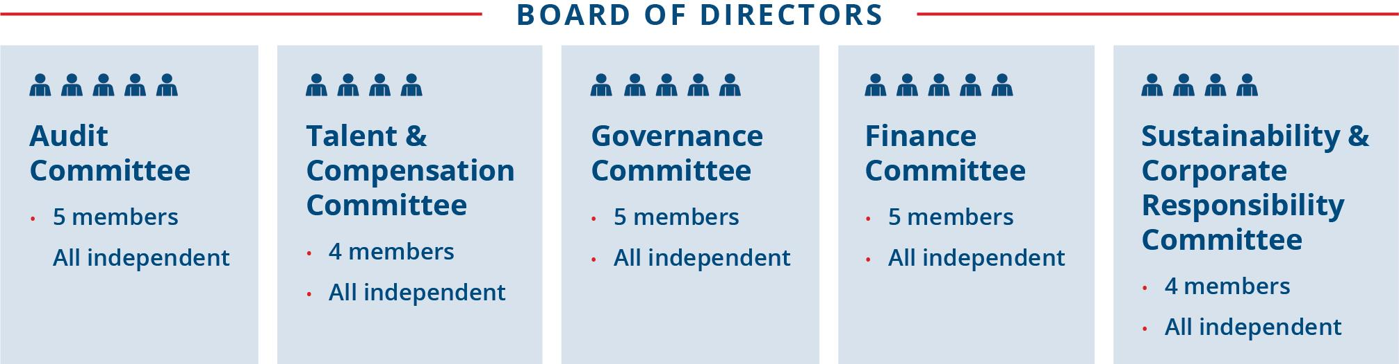

28 | | | Republic Services, Inc. 2023 Proxy Statement

PROXY SUMMARY |  | BOARD AND GOVERNANCE |  | EXECUTIVE COMPENSATION |  | PROPOSALS |  | MEETING INFORMATION |  | ANNEX

Board Meetings and Committees
Meeting Participation
The Board held six meetings during 2022. Each director other than Ms. Pegula attended at least 75% of the total number of Board meetings and the total number of meetings of all Board committees on which he or she served. The non-employee directors met regularly in executive sessions during 2022.
Committee Composition
Each of the five standing committees operates under a written charter adopted by the Board and reviews its charter at least annually. Messrs. Kadre and Vander Ark are not members of any of our standing committees. Information regarding each of the current standing committees as of the mailing date of this Proxy Statement appears in the chart on the following page.
Board Refreshment
We are committed to maintaining a Board that has a balanced mix of skills and attributes, and we accomplish this through our active refreshment and director succession planning process. We evaluate our evolving operating environment to ensure that the skills and attributes we seek in our Board members reflect the needs of our Company. The addition of nine new directors since 2016 highlights our commitment to seek highly qualified candidates who will bring additional skills and perspectives to the Board.
Director Onboarding Process
Upon joining our Board, new directors are provided with a comprehensive orientation and participate in a formal onboarding process to facilitate their transition onto our Board. Our onboarding process familiarizes new directors with the Company’s business, strategic plans, governance program, Board policies, and the director’s responsibilities on assigned committees. New directors hold meetings with Republic’s senior leadership and key management representatives to learn about the Company. They also participate in site visits. Based on feedback received, we believe this onboarding program, coupled with participation in regular Board and committee meetings, provides new directors with a strong foundation in our Company’s business, and accelerates their ability to fully engage in Board discussions and decision-making. Additional training is also encouraged when a director assumes a leadership role as either our Chairman or as a committee chair.
Continuing Education
Our directors attend seminars and continuing education programs relating to corporate governance, audit, compensation and other matters. In addition, site visits and external and in-house presentations are scheduled as part of the directors’ continuing education. Examples of continuing education programs attended by some of our directors in 2022 include G100 Network’s Board Excellence program, Harvard Business School executive education programs focused on governance, Corporate Board Member conferences, and NACD webinars, among others.
Thoughtful Board Evaluation Process
We recognize that Board and committee evaluations play an important role in ensuring the effective functioning of our Board. Therefore, the Board and each of its committees conduct annual self-assessments, which are overseen by the Governance Committee and include written evaluation forms to assess their effectiveness. Periodically, we will employ the services of an external advisor to assist with the evaluation process. Regardless of whether an external advisor is involved in the evaluation process, the results of these assessments are compiled without attribution and sent to the directors for a full Board assessment and to each committee member, for those committees on which they serve, to identify areas for future improvement. This feedback is also considered by the Governance Committee when searching for and evaluating potential future Board nominees to help ensure we are adding new directors with the proper mix of subject matter expertise and perspective consistent with the needs of our growing Company.
Director Succession Planning
The Board, through the Governance Committee, engages in formal Board succession planning/forward planning discussions at regular intervals throughout the year, in which it considers and evaluates director tenure and the skill sets of current directors. These discussions are supported by the formal evaluation process that identifies areas for improvement, including the need to add new members with unique expertise and experience that it believes will benefit our Company. These discussion topics are included as quarterly agenda items for the Governance Committee. The Governance Committee utilizes an executive search firm to identify potential director candidates and conducts interviews on an ongoing basis. The Board also established a mandatory director retirement age of 72 to promote continual refreshment and the addition of diverse perspectives.

 | Republic Services, Inc. 2023 Proxy Statement | | | 29

PROXY SUMMARY |  | BOARD AND GOVERNANCE |  | EXECUTIVE COMPENSATION |  | PROPOSALS |  | MEETING INFORMATION |  | ANNEX

Audit  Committee |  |  |  | Key Responsibilities |  |  |  | The committee held FOUR meetings and met regularly in executive sessions during 2022
 |  |  |  | • |  | Assists the Board in monitoring the integrity of financial statements, our compliance with legal and regulatory requirements, political contributions, our ethics and compliance program and the independence and performance of our internal and external auditors on an annual basis
Jennifer M. Kirk*, Chair  Tomago Collins  Michael A. Duffy  Brian S. Tyler*  Katharine B. Weymouth |  |  |  | • |  | Meets with management and the independent auditor to review the Company’s major financial and cybersecurity risk exposures and the steps management has taken to monitor and control such exposures including a review of information and security policies, data protection strategies and internal controls
 |  |  |  | • |  | Reviews issues regarding accounting principles, financial statement presentations, internal controls and the effect of regulatory and accounting initiatives on the financial statements of the Company
 |  |  |  | • |  | Has the ultimate authority and responsibility to select, evaluate, terminate and replace our independent registered public accounting firm
 |  |  |  | • |  | Approves the Audit Committee Report in this Proxy Statement
 |  |  |  | * Our Board has determined that each of Ms. Kirk and Mr. Tyler qualify as an "audit committee financial expert" within the meaning of Item 407 of Regulation S-K.
Talent & Compensation Committee |  |  |  | Key Responsibilities |  |  |  | The committee held SIX meetings and met regularly in executive sessions during 2022
 |  |  |  | • |  | Establishes and regularly reviews our compensation and benefits philosophy and program consistent with corporate financial goals and objectives, including sustainability metrics
 |  |  |  | • |  | Determines the salaries and incentive compensation payable to executive officers, including annual and long-term incentive compensation under our shareholder-approved pay-for performance program
Thomas W. Handley, Chair  Michael Larson  James P. Snee  Katharine B. Weymouth |  |  |  | • |  | Administers our benefits plans and our stock incentive plan
 |  |  |  | • |  | Evaluates our CEO's performance, sets his compensation and reviews the executive succession plan overseen by the Governance Committee
 |  |  |  | • |  | Reviews and oversees our talent management strategy and execution including talent acquisition and retention, inclusion and diversity, employee engagement and employee wellbeing
 |  |  |  | • |  | Engages with management each quarter on critical elements of our talent program
 |  |  |  | • |  | Oversees the annual risk assessment of our compensation policies and practices
 |  |  |  | • |  | Oversees the scope and engagement of the external compensation consultant's services
 |  |  |  | The Committee retained Pearl Meyer & Partners ("Pearl Meyer") as its compensation consultant, as further discussed on page 69.
Nominating & Corporate Governance Committee |  |  |  | Key Responsibilities |  |  |  | The committee held FOUR meetings and met regularly in executive sessions during 2022
 |  |  |  | • |  | Identifies Director candidates that it recommends to our Board for selection as the director nominees for the next annual meeting or to fill vacancies and candidates that it recommends to our Board for selection as the Chairman of the Board
 |  |  |  | • |  | Develops and recommends our corporate governance principles and reviews and provides oversight of the effectiveness of our governance practices
Michael Larson, Chair  Thomas W. Handley  Jennifer M. Kirk  James P. Snee  Sandra M. Volpe |  |  |  | • |  | Oversees the annual evaluation of the Board and its committees
 |  |  |  | • |  | Makes recommendations to the Board related to the compensation of nonemployee directors, and monitors the talent management and succession planning program for executive management to ensure appropriate focus on maintaining a diverse team of current and future executives
 |  |  |  | • |  | Considers nominations for the Board from shareholders that are entitled to vote for the election of directors, as described under “Shareholder Director Recommendation Policy"
Sustainability & Corporate Responsibility Committee |  |  |  | Key Responsibilities |  |  |  | The committee held FOUR meetings and met regularly in executive sessions during 2022
 |  |  |  | • |  | Reviews the Company’s sustainability performance and progress toward sustainability goals and objectives, including appropriate sustainability scorecards and rankings and the Company’s climate change initiatives
 |  |  |  | • |  | Reviews and provides oversight on sustainability and corporate responsibility topics including community engagement, sustainability performance and innovation, climate change, environmental management and security for the Company’s people and assets
Tomago Collins, Chair
Michael A. Duffy
Brian S. Tyler
Sandra M. Volpe
 |  |  |  | • |  | Reviews the annual sustainability report and charitable giving policies
 |  |  |  | • |  | Engages with shareholders and proxy advisor firms on sustainability, business conduct, environmental, safety and other matters relating to social, political and public policy issues, including the review and evaluation of shareholder proposals on these topics
Finance  Committee |  |  |  | Key Responsibilities |  |  |  | The committee held SEVEN meetings and met regularly in executive sessions during 2022
 |  |  |  | • |  | Reviews the financial condition of the Company including the annual finance plan, long-term financial objectives and financial management principles
James P. Snee, Chair  Michael Larson  Brian S. Tyler  Sandra M. Volpe  Katharine B. Weymouth |  |  |  | • |  | Reviews and makes recommendations on management proposals for financing requirements, dividends, proposed capital budget, certain capital expenditures and the repurchase of Company stock
 |  |  |  | • |  | Evaluates the financial impact of certain acquisitions and divestitures and conducts post-acquisition reviews
 |  |  |  | • |  | Annually reviews the Company’s insurable risk management strategy
 |  |  |  | • |  | Reviews and reports to the Board on the significant financial impact of retirement benefit plans

30 | | | Republic Services, Inc. 2023 Proxy Statement

PROXY SUMMARY |  | BOARD AND GOVERNANCE |  | EXECUTIVE COMPENSATION |  | PROPOSALS |  | MEETING INFORMATION |  | ANNEX

Our Board evaluation and succession planning processes are critical components of the Board’s commitment to and execution of its Board refreshment policy. The following graphic illustrates how these processes support our commitment to help ensure we have the right members on our Board:
ANNUAL BOARD EVALUATION |  | SUCCESSION PLANNING |  | BOARD REFRESHMENT
• Results shared with full Board  • Identifies skills and experiences that could be additive to Board composition  • Identifies board governance efficiencies |    | • Quarterly Governance Committee agenda item  • Committee discusses results of Board evaluation annually  • Informs new director candidate skill sets |  | • Evaluation and succession planning process support refreshment planning  • Board emphasizes key criteria, diversity

Interconnected evaluation and succession planning practices ensure that our Board composition reflects the skills and experiences that best meet both the current and future needs of our business.
Executive Succession Planning AND LEADERSHIP DEVELOPMENT
The Board believes that planning for CEO succession is one of its most important responsibilities. The Governance Committee discusses potential successor candidates and their qualifications, experience and preparedness. The Governance Committee also maintains and reviews annually an emergency CEO succession plan for the timely and efficient transfer of the CEO’s responsibilities in the event of an emergency or his sudden incapacitation or departure, which includes a periodic external market scan of potential candidates to replace the CEO.

The Board, through the Governance Committee, also regularly reviews the Company’s executive management succession plan to help ensure business continuity in the event a key executive departs from the Company. This evaluation includes a thorough discussion on the Company’s senior leadership structure with a focus on key executive positions and maintaining a diverse team of current and future executives. Every year, our CEO and Chief Human Resources Officer review with the Governance Committee succession plans for executive officers and other key positions in the organization. The review includes a discussion of potential successors, an evaluation of their readiness for the role and a discussion of development or other opportunities to prepare them for the role. The Company maintains development plans for potential successors identifying specific skills, training, or other development opportunities to help them prepare for the role. The Board’s committees also frequently discuss the talent pipeline, and individuals identified as potential future leaders are given exposure to Board members through formal presentations and informal meetings or events. More broadly, the Board, through the Talent & Compensation Committee, is regularly updated on key talent indicators for the overall workforce and recruiting and development programs. Republic is also cognizant of the impact our overall compensation program has on our succession planning process and has designed our program accordingly.
Stock Ownership Guidelines and Anti-Hedging and Anti-Pledging Policies
Our Board believes that ownership of our stock by directors, executive officers, and certain other members of management is important to align their interests with our shareholders’ interests and to demonstrate their commitment to the investing public and our employees.
Our Corporate Governance Guidelines reflect the Board’s belief that directors should be shareholders and have a financial stake in Republic. To support that philosophy, we pay our non-employee directors a significant portion of their compensation in the form of RSUs. Our non-employee directors receive RSUs that either (1) do not distribute until the director’s termination of service on the Board or (2) distribute three years after their grant date. To further demonstrate the Board’s commitment to align itself with our shareholders, our Board’s equity ownership guideline requires each independent director to hold Republic stock or vested RSUs, or both, having a total value of $750,000 within five years from the date of the director’s first full annual grant. All of our independent directors who have been on the Board for at least five years meet this guideline.
We also maintain stock ownership guidelines for our executive officers and other members of management. The stock ownership guidelines for executive officers are: (1) CEO — five times salary; (2) President — four times salary; (3) Executive Officer EVP — three times salary; (4) Senior Vice President — two times salary; and (5) Vice President, Area President and Market Vice President – one times salary. Each member of management has a five-year period from the time of promotion or hire into a covered position to meet the applicable guideline, and interim progress is expected. Members of management may meet their requirement by holding Republic stock or vested Republic stock equivalents in the Deferred Compensation

 | Republic Services, Inc. 2023 Proxy Statement | | | 31

PROXY SUMMARY |  | BOARD AND GOVERNANCE |  | EXECUTIVE COMPENSATION |  | PROPOSALS |  | MEETING INFORMATION |  | ANNEX

Plan (“DCP”), or both, having the requisite value, and by holding shares in the 401(k) plan. As discussed further in the CD&A on page 50, all of our executive officers either meet or are on track to meet their stock ownership guidelines.
Our insider trading policy prohibits all directors, officers and employees, and their immediate family members, from engaging in the following transactions relating to Republic securities or derivatives thereof: purchasing or selling puts or calls, short sales, placing standing orders (other than under approved 10b5-1 plans), engaging in short-term or “in-and-out” trading, and holding Republic securities or derivatives thereof in a margin account or pledging them.
Director Nomination Procedures and Diversity Relating to Board Candidacy
The Governance Committee is responsible for soliciting recommendations for candidates for the Board, reviewing background information for such candidates, and making recommendations to the Board with respect to such candidates. In evaluating candidates, the Governance Committee considers, among other things, the following attributes:
 | • | independence (if required);
 | • | personal and professional integrity;
 | • | sound business judgment;
 | • | relevant business and industry experience;
 | • | proper mix of education and skills; and
 | • | potential effectiveness as a director in serving the long-term interests of our shareholders.
With respect to diversity relating to Board candidacy, our Corporate Governance Guidelines state that directors will be selected in the context of assessing the Board’s needs at the time and with the objective of ensuring diversity in the background, experience, and viewpoints of Board members. To assist in promoting such diversity, the Governance Committee shall take reasonable steps to ensure that new Board nominees are properly drawn from a pool that includes diverse candidates. The Board and the Governance Committee will continue to assess the need to expand the breadth of experience, expertise, and viewpoints represented collectively by our directors and continue to seek top-quality candidates to fill any identified gaps.
Please also see “Shareholder Director Recommendation Policy” on page 34 for information regarding our policies for director candidates identified by shareholders.
Director Independence
Our common stock is listed on the New York Stock Exchange (“NYSE”), which requires that a majority of our Board be comprised of “independent directors” according to the NYSE’s independence standards. The Governance Committee considers the “per se” disqualifications from director independence under NYSE rules when assessing the independence of a current director or a nominee for director. In addition, our Board has adopted categorical standards that provide that certain relationships are not material relationships that would prevent a director’s independence. The Board reviews director independence and considers relationships between each of the directors and their immediate family members and Republic and its subsidiaries, both in the aggregate and individually. Mr. Vander Ark is not an “independent director” under the NYSE listing standards because he is an employee of Republic. The Board determined that the other 10 director nominees meet the NYSE standards for independence and the categorical standards adopted by our Board, and have no material relationships with us that impair their independence. In making its determination, the Board considered, in the case of Messrs. Larson and Handley, their status as chief investment officer and chief operating officer, respectively, to William H. Gates III, who is the beneficial owner of Cascade Investment, L.L.C., our largest shareholder. The Board also considered Mr. Collins’ membership on the board of directors of Four Seasons Hotels and Resorts as a representative of Cascade Investment, L.L.C.
Shareholder Engagement
We have a well-developed shareholder engagement program that emphasizes year-round shareholder engagement and direct communication with our Board.
The ways in which we communicate with our investors throughout the year include quarterly earnings releases and earnings conference calls, SEC filings, sustainability reports, investor conferences, press releases, bi-annual or annual investor meetings, and our website.

32 | | | Republic Services, Inc. 2023 Proxy Statement

PROXY SUMMARY |  | BOARD AND GOVERNANCE |  | EXECUTIVE COMPENSATION |  | PROPOSALS |  | MEETING INFORMATION |  | ANNEX

HIGHLIGHTS OF 2022 ENGAGEMENT
During 2022, we reached out to shareholders representing approximately 61% of shares outstanding, and engaged directly with shareholders representing approximately 55% of shares outstanding as well as one proxy advisor.

In the fall of 2022, we conducted extensive shareholder outreach to discuss corporate governance, sustainability, our differentiated operating model, and executive compensation, among other topics. We also reached out to proxy advisors and engaged with one proxy advisor.

INVITED  11 shareholders representing approximately  61% of our outstanding stock |  | MET  8 shareholders representing approximately  55% of our outstanding stock

Our individual engagements with our shareholders allow us insight into their views on our corporate governance practices, our sustainability journey, our differentiated operating model, and our compensation program, among other topics. Overall, shareholders were positive in their feedback, specifically regarding:
 | • | Sustainability – Shareholders are encouraged by the progress we have made in our sustainability strategy, including our joint venture with Archaea Energy (recently acquired by bp) to develop 40 landfill RNG projects and our creation of the Republic Services Polymer Center, the nation’s first integrated plastics recycling facility. Shareholders also continue to recognize our commitment to greenhouse gas reductions as the only environmental services provider with a goal approved by the Science Based Targets initiative (SBTi). Please see our most recent Sustainability Report for more information.
 | • | Inclusion and Diversity – Shareholders were pleased that we committed to undertake a civil rights assessment. Shareholders also expressed appreciation of our programs and publicly disclosed EEO-1 report. Please see our most recent EEO-1 and Sustainability Report found under Sustainability within our Investor section of our website.
 | • | Executive Compensation – Shareholders were pleased that Republic included a sustainability modifier into executive compensation last year. Shareholders expressed interest in understanding how we assess sustainability performance in terms of executive compensation. Please see the Compensation Discussion and Analysis section for more information on this topic.
 | • | Environmental Justice – Many shareholders expressed an appreciation of our latest environmental justice disclosure which included an analysis of both a one kilometer and five kilometer radius around our facilities, including our recent US Ecology acquisition. To further enhance transparency, we also created a map of individual facilities and their socioeconomic data using the EPA’s Environmental Justice Screening and Mapping Tool (EJScreen), which can be accessed through the Sustainability section of our website.

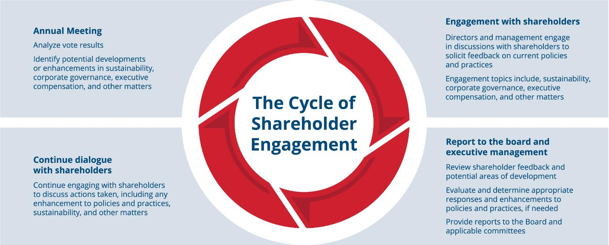

 | Republic Services, Inc. 2023 Proxy Statement | | | 33

PROXY SUMMARY |  | BOARD AND GOVERNANCE |  | EXECUTIVE COMPENSATION |  | PROPOSALS |  | MEETING INFORMATION |  | ANNEX

Additional Board Policies
Shareholder Director Recommendation Policy
The Governance Committee will consider director candidates recommended by our shareholders unrelated to a recommendation under our proxy access bylaw provision, described below. A shareholder may propose a nominee to serve as a director before a meeting of shareholders by giving timely written notice and meeting the other requirements set forth in Section 2.12 of our Amended and Restated Bylaws (“Bylaws”) and complying with applicable SEC regulations.
The Governance Committee determines the eligibility of a proposed nominee to serve as a director, and may require additional information to determine such eligibility. Director candidates proposed by shareholders are evaluated on the same basis as all other director candidates. See “Director Nomination Procedures and Diversity Relating to Board Candidacy” on page 32. The Governance Committee may, in its discretion, interview any director candidate proposed by a shareholder.
Shareholders wishing to recommend director candidates for consideration by the Governance Committee may do so by sending the required information in writing to: Attention: Office of the Corporate Secretary, Republic Services, Inc., 18500 North Allied Way, Phoenix, Arizona 85054. To consider a candidate for nomination at the 2024 annual meeting of shareholders, we must receive the shareholder’s written notice no earlier than January 13, 2024 and no later than February 12, 2024. Refer to our Bylaws for additional information and notice requirements.
In addition to satisfying the requirements of our Bylaws, to comply with the universal proxy rules, shareholders who intend to solicit proxies in support of director nominees other than the Board's nominees must also provide notice that sets forth the information required by Rule 14a-19 under Securities Exchange Act of 1934, as amended (the “Exchange Act”) and comply with the additional requirements of Rule 14a-19 under the Exchange Act.
Proxy Access Director Nominations
In addition to the right to recommend directors to the Governance Committee, qualifying shareholders also have the right to nominate and include director candidates in our proxy materials by giving adequate and timely notice to the Corporate Secretary pursuant to the procedures and requirements contained in our proxy access bylaw. Any shareholder or group of up to 20 shareholders who have maintained continuous qualifying ownership of at least 3% of the shares of our outstanding common stock for at least the previous three years are permitted to include up to 25% of the number of director nominees in our proxy materials for our annual meeting of shareholders, provided that the shareholders and nominees satisfy the requirements specified in our Bylaws. In order for such nominees to be included in our proxy statement and form of proxy, shareholders and nominees must submit a notice of proxy access nomination together with certain related information required by our Bylaws.

Shareholders wishing to recommend director candidates using our proxy access bylaw may do so by sending the required information in writing to: Attention: Office of the Corporate Secretary, Republic Services, Inc., 18500 North Allied Way, Phoenix, Arizona 85054. To provide adequate time to assess shareholder-nominated candidates, requests to include these candidates in our proxy materials for our 2024 annual meeting of shareholders must be delivered or mailed and received at our principal executive offices no earlier than October 31, 2023 and no later than November 30, 2023.
Director Resignation Policy
Republic is a Delaware corporation. The affirmative vote of the majority of votes cast with respect to that director’s election at a stockholder meeting is required for the election of each director. Under Delaware law, if an incumbent director is not elected, that director remains in office until the director’s successor is duly elected and qualified or until the director’s death, resignation or retirement. To address this potential outcome, we have a director resignation policy in our Bylaws. Under this policy, the Board will nominate for further service on the Board only those incumbent candidates who tender, in advance, irrevocable resignations. Each irrevocable resignation is contingent on the failure to receive the required vote at any annual meeting at which the nominee is nominated for re-election and on Board acceptance of the resignation. The Governance Committee will recommend to the Board whether to accept or reject the tendered resignation. The Board will publicly disclose its decision within 90 days after certification of the election results. If the Board does not accept the resignation, the director will continue to serve until the next annual meeting and until his or her successor is duly elected, or until his or her earlier resignation or removal. If the Board accepts the resignation, then the Board, in its sole discretion, may fill any resulting vacancy or reduce the size of the Board.

34 | | | Republic Services, Inc. 2023 Proxy Statement

PROXY SUMMARY |  | BOARD AND GOVERNANCE |  | EXECUTIVE COMPENSATION |  | PROPOSALS |  | MEETING INFORMATION |  | ANNEX

Communications with the Board of Directors
Any shareholder or other interested party who wishes to communicate with the Board, a Board committee, the Chairman of the Board or the non-management directors (as a group or individually) may send correspondence to: Attention: Office of the Corporate Secretary, Republic Services, Inc., 18500 North Allied Way, Phoenix, Arizona 85054. The Corporate Secretary will compile and submit such correspondence on a periodic basis to the entire Board or, if designated in the communication, to the appropriate Board committee, the Chairman of the Board or the non-management directors (as a group or the appropriate individual member(s)). The independent directors have approved this process.
Attendance at Annual Meetings Policy
We do not have a formal policy requiring our directors to attend the Annual Meeting. Mr. Vander Ark attended and chaired our 2022 annual meeting of shareholders.
Additional Information Regarding Corporate Governance
Shareholders may obtain, free of charge, the current charters for the Audit Committee, Finance Committee, Talent & Compensation Committee, Governance Committee, and Sustainability & Corporate Responsibility Committee, as well as our Certificate of Incorporation, Bylaws, Corporate Governance Guidelines, Code of Ethics, Political Contributions Policy and Clawback Policy by written request to: Attention: Office of the Corporate Secretary, Republic Services, Inc., 18500 North Allied Way, Phoenix, Arizona 85054. These documents also are available on the “Investors” section of our website at www.RepublicServices.com.
Risk Oversight
We face a variety of risks, including credit and liquidity, operational, environmental, litigation, compliance, compensation and cyber security risks. Management, the Board and its committees, work together to manage these risks and the opportunities they create. Our management annually reports to the Board the results of its internal survey and analysis of enterprise risk management, and regularly discusses with the Board, and its committees, various operational and compliance risks, including pricing, recycled commodity prices, safety, talent, environmental, fleet and cyber risks. While management is responsible for the day-to-day risk management processes, the role of the Board, either acting as the full Board or through its committees, is to ensure that:
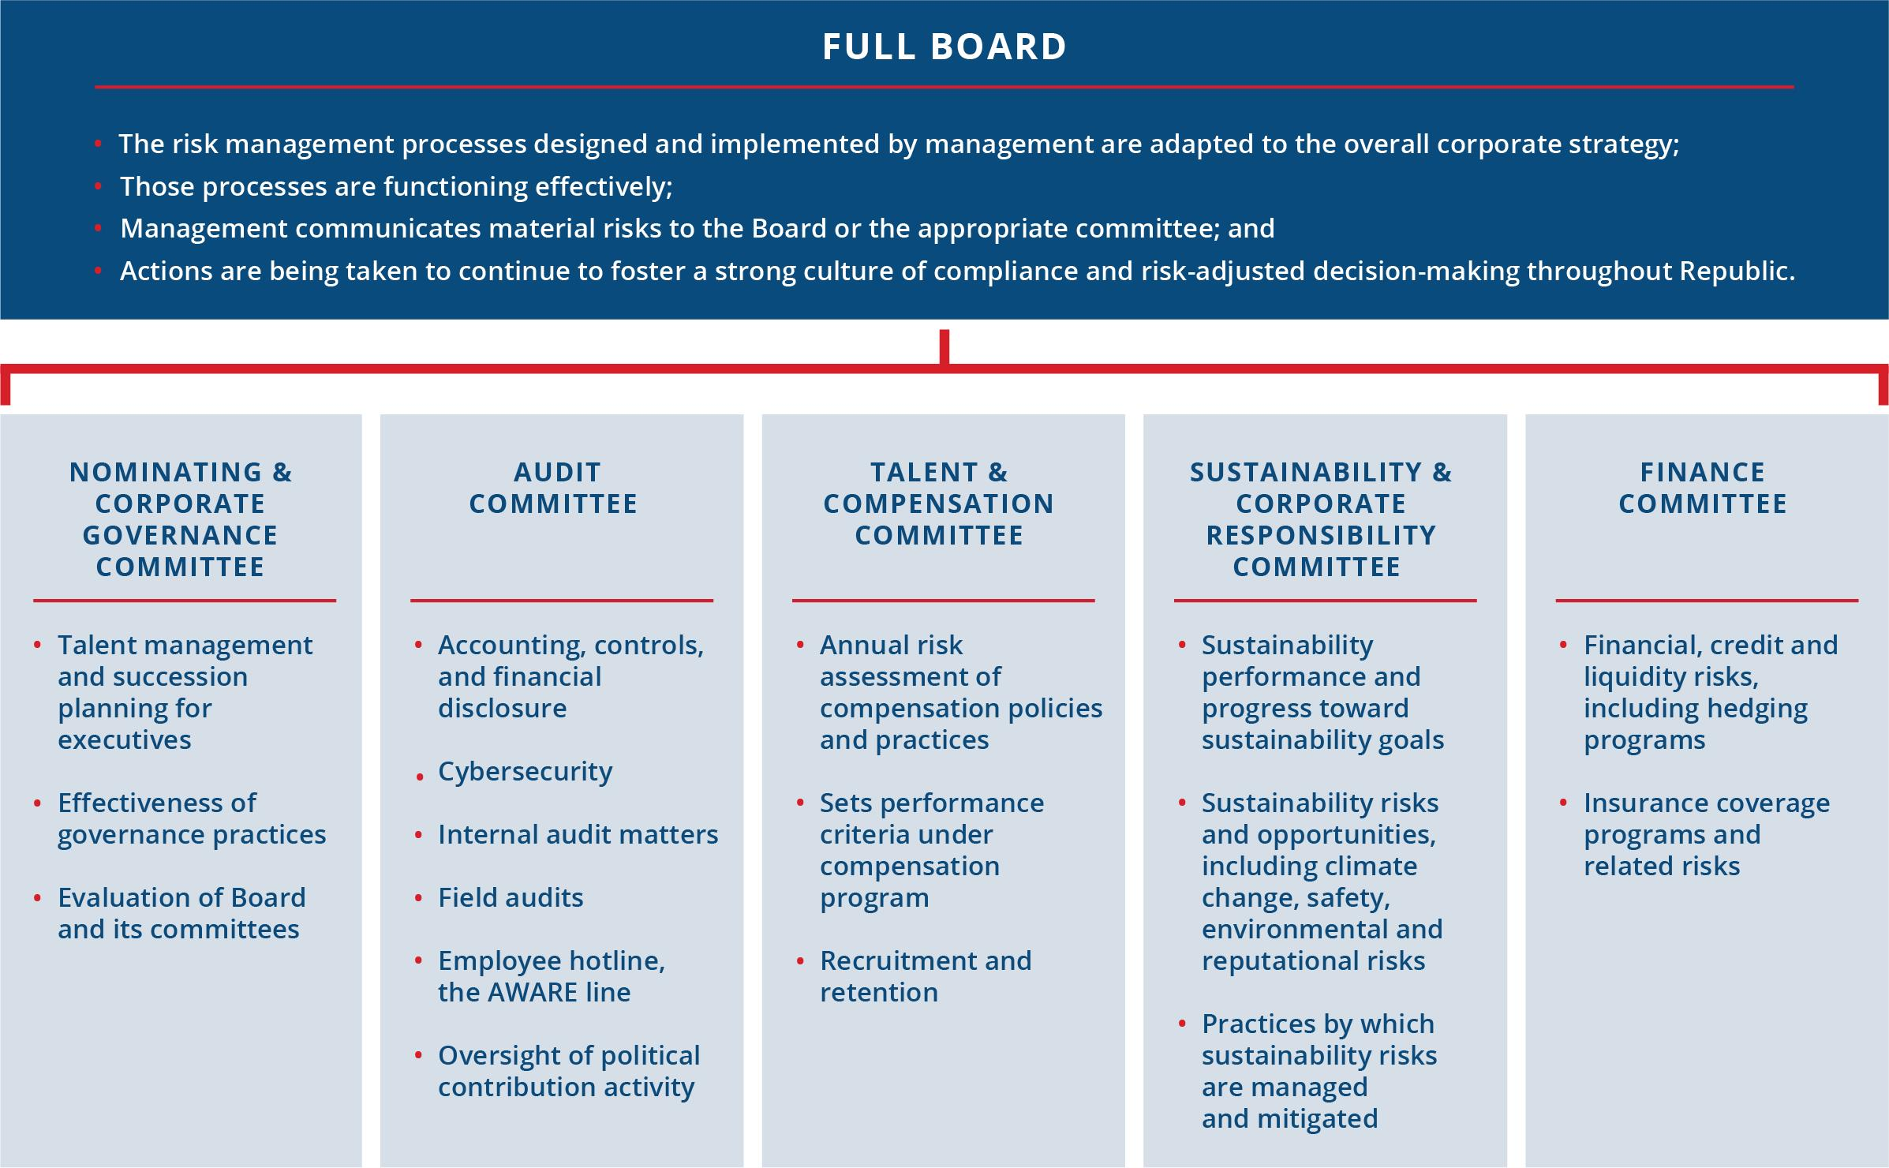

 | Republic Services, Inc. 2023 Proxy Statement | | | 35

PROXY SUMMARY |  | BOARD AND GOVERNANCE |  | EXECUTIVE COMPENSATION |  | PROPOSALS |  | MEETING INFORMATION |  | ANNEX

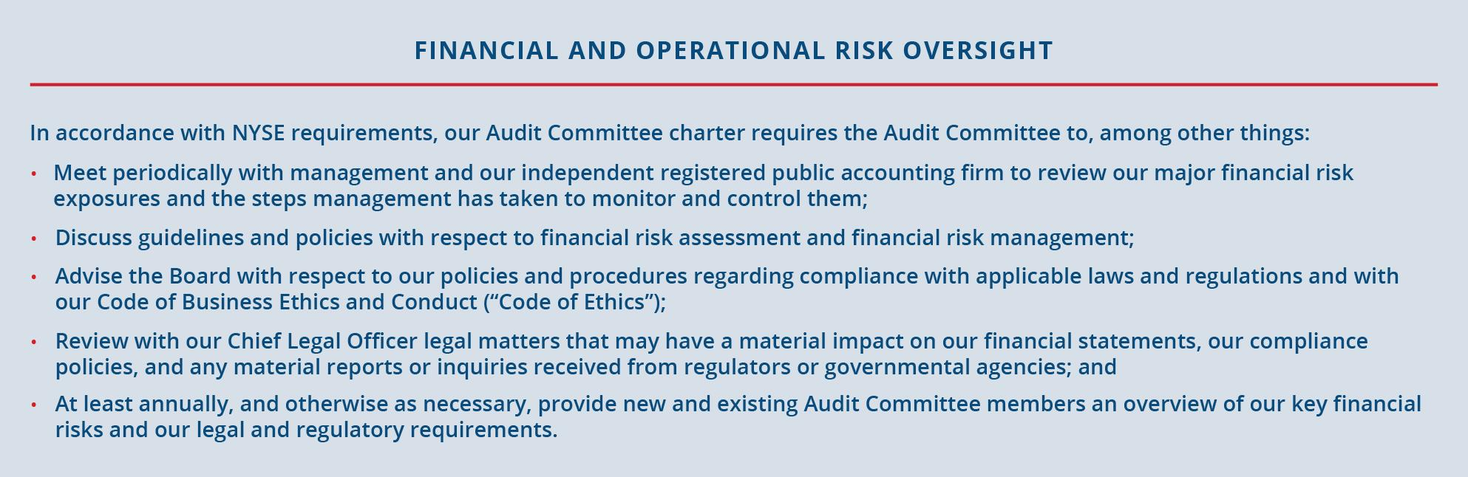
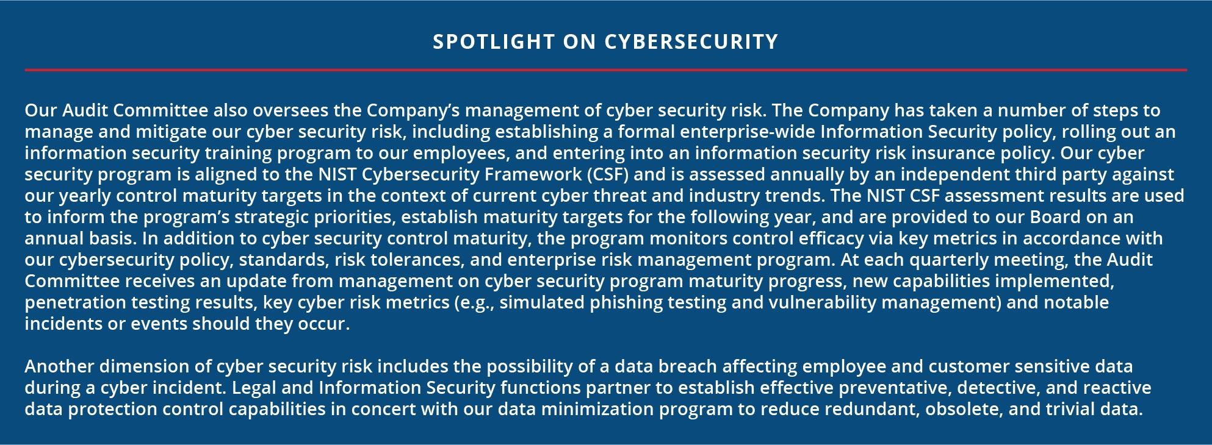
Board Oversight of SUSTAINABILITY
Our Sustainability & Corporate Responsibility Committee meets at least quarterly and takes various steps to assist the Board in fulfilling its oversight responsibility with respect to risks and opportunities, including climate change, safety, environmental and reputational risks, and the practices by which these risks are managed and mitigated.
Our Board is directly involved in the oversight of Republic’s environmental and sustainability initiatives and conducts a comprehensive review of the Company’s sustainability performance on an annual basis. Republic’s commitment to corporate sustainability also led to the formation of a dedicated Sustainability & Corporate Responsibility Committee of the Board in 2015. This committee has oversight responsibility with respect to our sustainability performance, our corporate responsibilities, our role as a socially responsible organization, and risks and opportunities related to climate change, safety, community engagement, environmental, and reputation. The Sustainability & Corporate Responsibility Committee is focused on reviewing the Company’s sustainability performance and progress toward sustainability strategic goals and objectives as well as providing guidance to management with respect to significant sustainability and corporate responsibility initiatives.

Board Oversight of talent
We believe our comprehensive talent program adds long-term value to our business, differentiates us from our peers, and ensures an inclusive and diverse culture for our employees. Building an engaged workforce starts at the top, and we have demonstrated a commitment to diversity through the people who guide our Company – five of the eleven director nominees are women or racially or ethnically diverse. Our Board, our Talent & Compensation Committee and our other committees play a role in the active oversight of the Company’s talent program.
Board Oversight of Talent our bord and committees are activity involves overseeing the Company,s talent management program. Inclusion and Diversity talent Development Employee well-being Ethics and Compliance safety Employee Engagement Talent Acquisition and Onboarding Compensation and Benefits
This is accomplished by focusing on eight key areas: safety, talent development, inclusion and diversity, employee engagement, ethics and compliance, talent acquisition and onboarding, employee wellness and compensation and benefits.
 | • | Our Board receives annual updates and provides guidance on the Company’s talent development programs.
 | • | Our Talent & Compensation Committee engages with management each quarter on critical elements of our talent program, including talent acquisition, onboarding and retention, inclusion and diversity, employee engagement, employee compensation and benefits, employee wellness, talent development and assessment and diverse pipelines for management.

36 | | | Republic Services, Inc. 2023 Proxy Statement

PROXY SUMMARY |  | BOARD AND GOVERNANCE |  | EXECUTIVE COMPENSATION |  | PROPOSALS |  | MEETING INFORMATION |  | ANNEX

 | • | Our Sustainability & Corporate Responsibility Committee engages in quarterly deep dives related to safety and security, and community engagement.
 | • | Our Audit Committee receives quarterly updates on our ethics and compliance programs.
 | • | Our Nominating & Corporate Governance Committee ensures that we are seeking director candidates who will bring a diversity of background, experience and viewpoints to our Board and reviews the composition of the current executive officers and potential successors to ensure that there is appropriate focus on maintaining a diverse team.
 | • | Our Finance Committee receives an annual update on the financial condition of the Company’s retirement benefit programs.

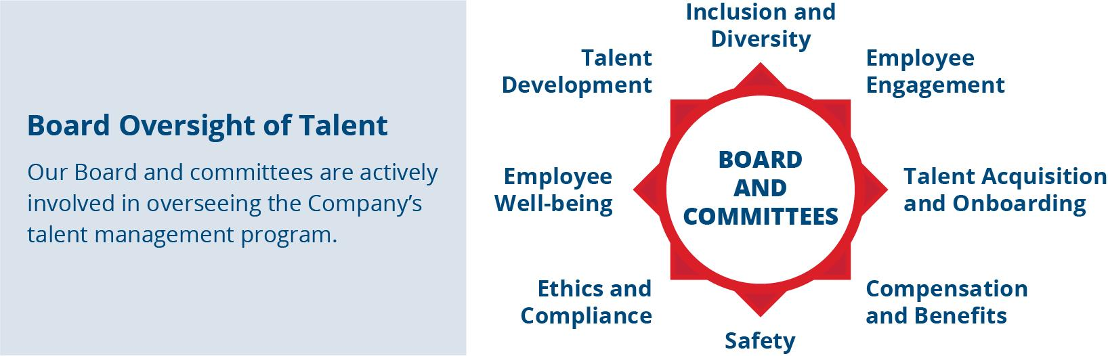

We believe that the Board and committee leadership structure we have implemented and the division of responsibilities between the Board, committees and management described in this Proxy Statement constitute the most effective approach to address the risks we face.
Ethics and Compliance
At Republic, it is our responsibility to deliver results in the right way. This means every employee is expected to act with integrity and make the right choice in every situation. We lead by example and hold ourselves to the highest ethical standards and practices in all that we do. Our Code of Ethics applies to all of our directors, officers and employees and is an integral part of Republic’s ethics and compliance program. It serves as the cornerstone of our commitment to conduct business with the highest ethical and legal standards.
Our commitment to a strong ethical and compliant culture was recently acknowledged by being named to the 2023 World’s Most Ethical Companies® List by Ethisphere, a global leader in defining and advancing the standards of ethical business practices. This is the fifth year that Republic Services has received this honor. The World’s Most Ethical Companies’ assessment is based upon the Ethisphere Institute’s Ethics Quotient (EQ) framework which offers a quantitative way to assess a company’s performance in an objective, consistent, and standardized manner. Scores are generated in five key categories: ethics and compliance program (35%), culture of ethics (20%), environmental and societal impact (20%), governance (15%), and leadership and reputation (10%), and provided to all companies who participate in the process.
If we make any substantive amendments to the Code of Ethics or grant any waiver from a provision of the Code of Ethics that applies to our CEO, Chief Financial Officer, Controller or Chief Accounting Officer, we will disclose the nature of such amendment or waiver in a Current Report on Form 8-K filed with the SEC. The Code of Ethics can be viewed on the “Investors” section of our website at www.RepublicServices.com. The information contained on our website, and in all references to our website within this Proxy Statement, shall not be deemed incorporated by reference in this Proxy Statement or in any other filing we make under Exchange Act.
We also have a standalone Supplier Code of Business Ethics and Conduct ("Supplier Code"), which is applicable to our vendors, contractors, consultants, agents, representatives, brokers, and any other third party that provides us with goods and services. Our Supplier Code outlines our expectations with respect to our suppliers' conduct when they are doing business with, or on behalf of, Republic, with an emphasis on ethical, lawful conduct in every circumstance. Our Supplier Code underscores our commitment to conducting business ethically and lawfully across our entire supply chain.

 | Republic Services, Inc. 2023 Proxy Statement | | | 37

PROXY SUMMARY |  | BOARD AND GOVERNANCE |  | EXECUTIVE COMPENSATION |  | PROPOSALS |  | MEETING INFORMATION |  | ANNEX

Sustainability and Corporate Responsibility
In addition to being committed to our customers, employees, and shareholders, we are committed to the communities we serve and to the environment. We are partnering with our customers to create a more sustainable world.
Our Commitment to Safety
Safety always tops our list of Company priorities, and we believe the success of our safety program is directly dependent on our people: employees with strong operational know-how, attention to detail, leadership accountability and a consistent focus. We reinforce our Company’s safety culture through comprehensive safety management programs, which include our Focus Together foundational safety training program, new driver training programs, our non-negotiable absolutes and standards, as well as many other programs. To solidify our commitment to the safety of our employees and communities, we have two related 2030 sustainability goals, “Safety Amplified” and “Incident Reduction.” For more information on these goals and our plans for how we will achieve them, please see our sustainability reporting available at RepublicServices.com/Sustainability. Our sustainability reporting shall not be deemed incorporated by reference into any filing under the Securities Act of 1933, as amended (the “Securities Act”) or the Exchange Act unless expressly incorporated by reference.
Sustainability Focus
We are passionate about our role as responsible stewards of our customers’ waste, and we have been steadily building on our sustainability performance for several years. Our 2030 sustainability goals are designed to significantly benefit the environment and society while enhancing the foundation and profitability of our business for the long term. These goals reaffirm our commitment to the elements of our sustainability platform: Safety, Talent, Climate Leadership and Communities. These elements support and enable our business strategy designed to generate profitable growth by sustainably managing our customers’ needs. When we manage these elements of our sustainability program, we believe we strengthen the foundation of our business for the long term and create value for all stakeholders.

We developed our 2030 sustainability goals through a comprehensive assessment that included an analysis of global trends, identification of business model dependencies and engagement with key stakeholders, including shareholders. In 2022, we concluded our third sustainability materiality assessment, continuing our ongoing engagement with stakeholders and realigning our strategy in this ever-evolving world. Our sustainability materiality assessment is one of several processes through which we engage with our employees, communities, investors and other key stakeholder groups to ensure we continue to address the environmental, social, and governance topics most important to our stakeholders, the planet, and society. We align the topics considered in these processes with internationally recognized frameworks which address critical global macrotrends, such as the United Nations’ Sustainable Development Goals. We continue on the pathway toward achieving our greenhouse gas reduction goal approved by the Science Based Targets Initiative (“SBTi”). Our 2022 sustainability report will be released later this year.

38 | | | Republic Services, Inc. 2023 Proxy Statement

PROXY SUMMARY |  | BOARD AND GOVERNANCE |  | EXECUTIVE COMPENSATION |  | PROPOSALS |  | MEETING INFORMATION |  | ANNEX

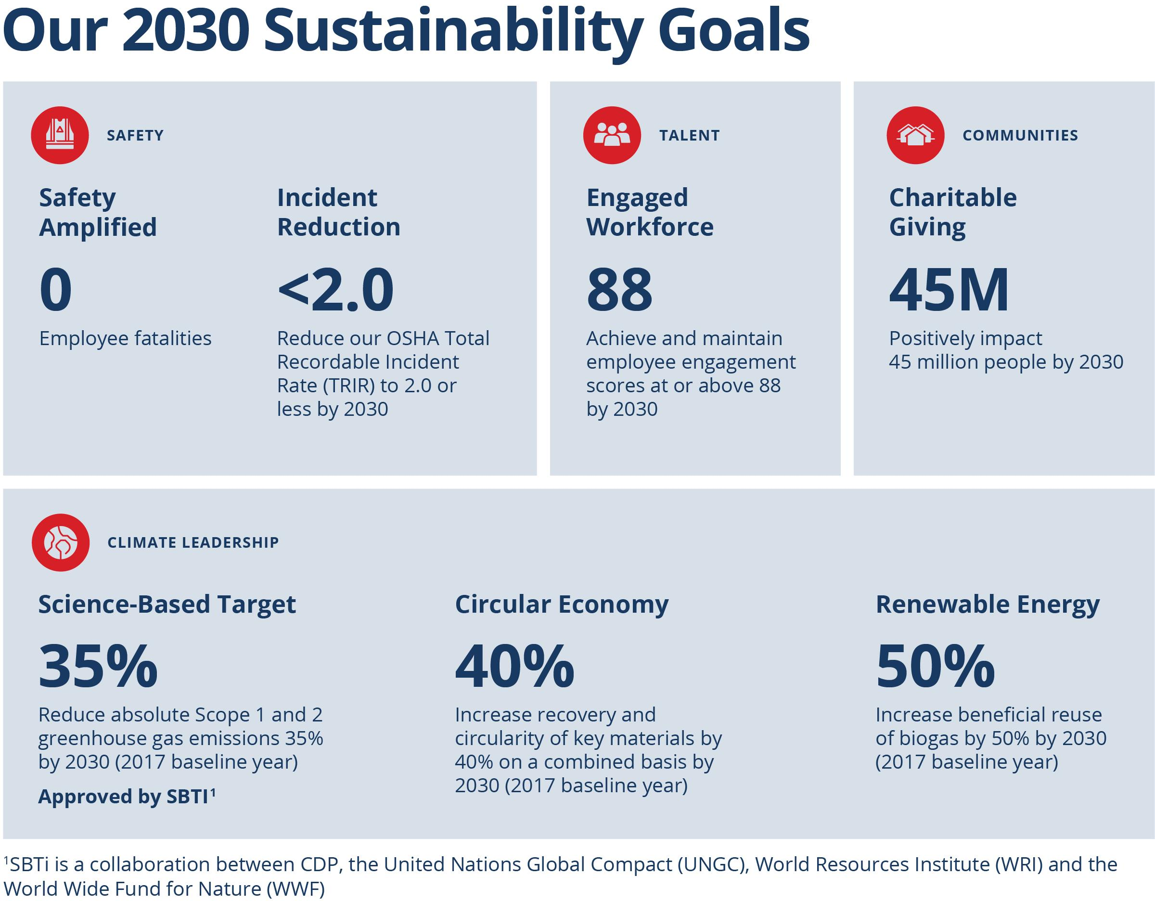
To further our progress toward our climate leadership goals, we have taken a leadership position in electric technology innovation for our fleet. In 2022, we partnered with manufacturers to pilot electric-powered recycling and solid waste trucks. This is a critical step toward reducing our environmental impact through lower fleet emissions. As part of this multi-supplier vendor strategy, we also partnered with Oshkosh Corporation to roll out fully integrated automated side-load prototypes in 2023. By 2028, we expect electric vehicles to make up half of our new truck purchases. Our investment in these innovations will benefit the environment through reduced emissions, offer cleaner and quieter operations in the neighborhoods we serve, and help our customers meet their own sustainability goals.
Republic is also advancing circularity for plastics. The Polymer Center, the nation’s first integrated plastics recycling facility, will enable us to manage the plastics stream from curbside collection to delivery of high-quality recycled content for consumer packaging.
Additionally, in 2022 Republic announced a joint venture with Archaea Energy, Inc. (recently acquired by bp) to develop 40 renewable natural gas (“RNG”) projects across the county. The partnership, the country’s largest RNG portfolio build-out to date, will convert landfill gas into pipeline-quality RNG that can be used for a variety of applications to displace gas from fossil fuels. The initiative is expected to generate substantial progress toward Republic’s long-term sustainability goal to beneficially reuse 50% more biogas by 2030.
Industry Leadership
We regularly review our environmental and social progress and performance to continue advancing our work. We were named to the North American Dow Jones Sustainability Index (“DJSI”) for a seventh consecutive year in 2022. The assessment that leads to placement on the DJSI is one of the world’s most rigorous and renowned corporate sustainability assessments. In addition, we earned a CDP Climate Leadership score, the only one of our industry peers to do so, and we were the first industry peer to advance to an “A” rating under MSCI. Our performance on these sustainability ratings is in recognition of the Company’s commitment to sustainability, including our 2030 goals, increased disclosures and achievements. These achievements demonstrate our ability to connect financial performance with environmental and social performance, including addressing various risks and opportunities posed by climate change. Our sustainability rankings also highlight Republic’s leadership in corporate governance, environmental, social and financial aspects of sustainability. We strive to

 | Republic Services, Inc. 2023 Proxy Statement | | | 39

PROXY SUMMARY |  | BOARD AND GOVERNANCE |  | EXECUTIVE COMPENSATION |  | PROPOSALS |  | MEETING INFORMATION |  | ANNEX

remain at the forefront in our approach to sustainability issues, including climate change and have aligned our reporting to Task Force on Climate-related Financial Disclosures (“TCFD”) recommendations, which we expanded in 2022 with additional physical and transition risk disclosures as we prepare to satisfy the SEC’s upcoming climate disclosure requirements. In 2022, we released our eighth Sustainability and GRI reports, and published our fifth annual SASB report. We continue to publish our EEO-1 workforce diversity data, key information related to environmental justice and our CDP Climate Change response to make critical disclosures more accessible to the public. All of our latest reports are available on our website at RepublicServices.com/sustainability.
Talent
We hold ourselves to the highest standards to ensure we are the company where the best people come to work and are engaged every day. We do this by combining meaningful experiences and programs that develop and motivate employees with attractive total rewards packages and maintaining a highly inclusive and diverse work environment. Our engagement and retention programs are designed to sustain our high engagement levels. Through learning and talent development programs, we focus on ensuring our employees have the skills necessary to be successful in their current roles through targeted onboarding and experiential learning. We also provide our employees the opportunity to learn new skills and advance within the organization through our Technical Institute, leadership training and other development programs. Finally, we continually monitor and regularly measure the progress we have made in increasing the diversity of our workforce and creating an even more inclusive culture for our employees.
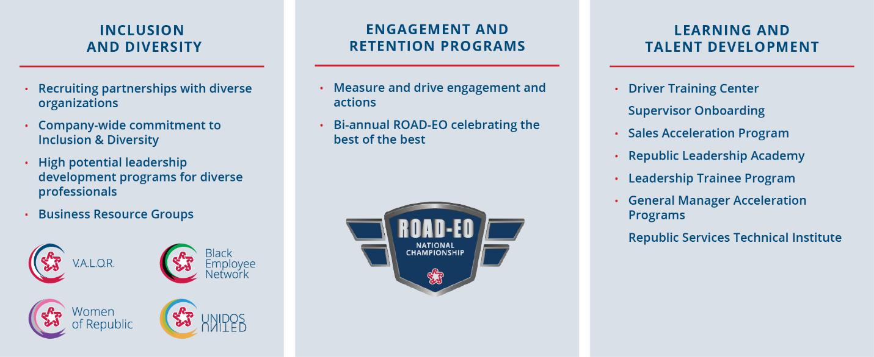

Employee Engagement
We believe an engaged workforce is key to our success. We measure employee engagement through third-party surveys, assessing employee sentiment on a variety of topics such as pride for the Company, job satisfaction and intention to stay. We have found that business units with a highly engaged workforce experience less turnover. We have also found that employees whose leaders are highly inclusive are more likely to speak up and share their perspective. In addition, we believe that engaged employees deliver better customer service and are more productive, which is directly tied to the success of our business. Our goal is to achieve and maintain employee engagement scores at or above 88 by 2030. Our employees completed two surveys in 2022. As of September 2022, our engagement score was 85, reinforcing our commitment to ensuring every voice is heard. Employee engagement is a core part of our business strategy. This helps to ensure that our leaders are held accountable and rewarded for their efforts to drive a more engaged workforce.
Inclusion and Diversity
We are proud of the diversity of our frontline workforce, as it closely represents the demographics of the communities we serve. We are committed to improving diverse representation across all levels of the Company. Our commitment to inclusion and diversity starts at the top of our organization with our Board, and is outlined in our Mission of Supporting an Inclusive Culture (MOSAIC), established in 2013, and supported by the MOSAIC Council. The MOSAIC Council consists of leaders from across the Company who serve as ambassadors and thought partners for inclusion and diversity. This enables us to continue to develop new strategies and activities that are tied to the needs of our employees, customers and business with the goal of maintaining an even more inclusive work environment and diverse workforce.

40 | | | Republic Services, Inc. 2023 Proxy Statement

PROXY SUMMARY |  | BOARD AND GOVERNANCE |  | EXECUTIVE COMPENSATION |  | PROPOSALS |  | MEETING INFORMATION |  | ANNEX

Our values reinforce who we are today, and serve as an anchor for who we aspire to be. As an employer of people from all backgrounds, our core value of “human-centered” represents our commitment to embrace the unique potential and dignity of every person at Republic Services. We believe strongly that shared values unify us as a company and help to establish expectations for how our employees treat one another and should expect to be treated. We continue to focus on developing and maintaining leadership behaviors that drive mutual understanding, connectivity and empathy within our workforce, which we know helps drive inclusion in the workplace for our existing employees, and attract diverse talent to choose Republic as their future employer. Finally, we create opportunities for our employees to be part of communities that support their needs, and we offer this connectivity through our business resource groups, including Women of Republic, VALOR (Veterans, Advocacy, Learning, Outreach and Recruiting), the Black Employee Network and UNIDOS.
We continue to receive national awards for our accomplishments in these areas and we aim to raise the bar even higher.

Committed to Serve
The COVID-19 pandemic pressure tested the resiliency of our business model and our roles as providers of an essential service. The majority of our workforce remained in the field throughout the pandemic and the Company took swift and comprehensive action to help protect our employees and communities. At the height of the pandemic, we launched our Committed to Serve Initiative, which we continued throughout 2022. Through Committed to Serve, we directed over $69 million to recognize the contributions of our frontline employees, including $3 million donated to the Republic Services Charitable Foundation, more than $11 million in gift cards given to employees to support them and the local economy, $6 million spent at local restaurants to provide two weekly meals for employees and their families, and $49 million in Committed to Serve awards to our frontline employees.ompany whose goal is to be a leader in sustainable living, helping the environment is at the heart of our mission. Jessica P. and employees link her understand this connection and volunteer t make their community a better place to live through volunteering. Jessica, along with other Republic Service employees helped remove illegally dumped material at tule springs Fossil Beds National Monument in boulder City, Nevada, clearing the way for a new trail through the national park Republic services has been a longtime supporter of tule spring and has been able to make a difference thanks to Jessica and employees link her.

 | Republic Services, Inc. 2023 Proxy Statement | | | 41

PROXY SUMMARY |  | BOARD AND GOVERNANCE |  | EXECUTIVE COMPENSATION |  | PROPOSALS |  | MEETING INFORMATION |  | ANNEX

Audit Committee Matters
Audit Committee Report
The following statement made by the Audit Committee shall not be deemed incorporated by reference into any filing under the Securities Act or the Exchange Act and shall not otherwise be deemed filed under either of these Acts.
Management is responsible for our internal controls, financial reporting processes, and compliance with laws and regulations and ethical business standards. Our independent registered public accounting firm is responsible for expressing an opinion as to the conformity of the consolidated financial statements with accounting principles generally accepted in the United States of America and for issuing its opinion on the effectiveness of our internal controls over financial reporting. The Audit Committee’s responsibility is to monitor and oversee these processes on the Board’s behalf.
In this context, the Audit Committee has reviewed and discussed the audited financial statements with management and our independent registered public accounting firm (Ernst & Young LLP). The Audit Committee has discussed with Ernst & Young LLP the matters required to be discussed by Auditing Standard No. 16, Communications with Audit Committees, as adopted by the Public Company Accounting Oversight Board.
In addition, the Audit Committee has received from Ernst & Young LLP the written disclosures required by the Public Company Accounting Oversight Board Ethics and Independence Rule 3526, Communication with Audit Committees Concerning Independence, regarding the Company’s independent registered public accounting firm’s independence, and discussed with them their independence from the Company and management. The Audit Committee has also discussed with Ernst & Young LLP the matters required to be discussed by Statement on Auditing Standards No. 61, as amended (AICPA, Professional Standards, Vol. 1, AU section 380), as adopted by the Public Company Accounting Oversight Board in Rule 3200T.
Based on the Audit Committee’s review of the matters noted above and its discussions with Ernst & Young LLP and our management, the Audit Committee recommended to the Board that the audited financial statements be included in our Annual Report on Form 10-K for the year ended December 31, 2022 for filing with the SEC.
Submitted by the Audit Committee as of March 26, 2023:
Jennifer M. Kirk (Chair)
Tomago Collins
Michael A. Duffy
Brian S. Tyler
Katharine B. Weymouth

42 | | | Republic Services, Inc. 2023 Proxy Statement

PROXY SUMMARY |  | BOARD AND GOVERNANCE |  | EXECUTIVE COMPENSATION |  | PROPOSALS |  | MEETING INFORMATION |  | ANNEX

Audit and Related Fees
Independent Registered Public Accounting Firm Fee Information
The following table discloses the fees for professional services provided by Ernst & Young LLP for the fiscal years ended December 31, 2022 and 2021:

 |  | 2022 |  | 2021
Audit Fees (1) |  | $4,439,811 |  | $3,419,305
Audit-Related Fees(2) |  | $290,000 |  | $540,000
Tax Fees (3) |  | $569,821 |  | $684,912
All Other Fees |  | — |  | —
Total Fees |  | $5,299,632 |  | $4,644,217

(1) | Audit Fees were primarily for professional services rendered for the audits of the consolidated financial statements and internal controls over financial reporting in compliance with Section 404 of the Sarbanes-Oxley Act of 2002, the review of documents filed with the SEC, consents, comfort letters and financial accounting and reporting consultations.
(2) | Audit-related fees were primarily related to pre-implementation services around the redesign of certain back-office software systems.
(3) | Tax Fees were for professional services related to general tax consultation, federal and state tax planning, and state and local tax matters.
Pre-Approval Policies and Procedures
The Audit Committee’s policy is to pre-approve all audit services, audit-related services and other services permitted by law provided by our independent registered public accounting firm. In accordance with that policy, the Audit Committee annually pre-approves a list of specific services and categories of services, including audit, audit-related and other services, for the upcoming or current fiscal year, subject to specified cost levels. Any service that is not included in the pre-approved list of services must be separately approved by the Audit Committee. In addition, if fees for any service exceed the amount that has been pre-approved, then payment of additional fees for such service must be specifically approved by the Audit Committee before the performance of the service. From time to time, the Audit Committee may delegate fee approval authority to the Audit Committee chair. All of the services performed by Ernst & Young LLP in 2022 were pre-approved in accordance with the pre-approval policy adopted by the Audit Committee.
At each regularly scheduled Audit Committee meeting, management updates the Committee on the scope and anticipated cost of
(1) any service pre-approved by the chair since the last committee meeting and (2) the projected fees for each service or group of services being provided by our independent registered public accounting firm that exceed the amount that has been pre-approved.

 | Republic Services, Inc. 2023 Proxy Statement | | | 43

PROXY SUMMARY |  | BOARD AND GOVERNANCE |  | EXECUTIVE COMPENSATION |  | PROPOSALS |  | MEETING INFORMATION |  | ANNEX

Director Compensation
When establishing and reviewing our directors’ compensation, we consider the level of work and involvement the directors have with our business. We also consider compensation paid to directors in the marketplace generally and at our peer group companies (“Peer Group”). In 2022, we compensated our directors as follows:
 | • | we paid each non-employee director an annual retainer of $100,000, plus an additional $165,000 in the case of our Chairman of the Board;
 | • | we paid an annual retainer of $20,000 to each of the chairs of the Talent & Compensation Committee, the Governance Committee, the Sustainability & Corporate Responsibility Committee and the Finance Committee;
 | • | effective October 2022, the Audit Committee chair annual retainer was increased from $20,000 to $25,000, which was prorated for the remainder of the year, resulting in a 2022 Audit Committee chair annual retainer of $21,250; and
 | • | we granted each non-employee director RSUs based on a fair market value of $230,000 as of the date of grant.
Cash retainers are prorated if a director serves less than a full year in the applicable position. The annual grant of RSUs to a newly appointed, non-employee director is prorated to the number of days remaining in the year. We do not pay meeting fees for our Board or committee meetings but we reimburse our non-employee directors for their reasonable out-of-pocket costs and travel expenses in connection with their attendance at Board and committee meetings.
All RSUs granted to non-employee directors are fully vested upon grant. RSUs granted before 2012 will be settled upon the director’s termination of service from the Board. Beginning with grants in 2012, the RSUs are settled upon the earlier of the director’s termination of service from the Board or three years after the RSUs are granted, unless they are deferred into our Deferred Compensation Plan (DCP). RSUs are settled through the issuance of shares of our common stock. After any quarter in which dividends are distributed to shareholders, the non-employee directors receive additional RSUs with a value equal to the value of dividends they would have received had they owned the shares of stock underlying the RSUs on the dividend record date. The number of additional RSUs to be received by directors due to the declaration of dividends is based on the closing price of our stock on the dividend payment date.
All compensation paid by us during 2022 to our non-employee directors is detailed below. Mr. Vander Ark’s compensation is reflected in the executive compensation tables contained in this Proxy Statement, and he did not receive any additional compensation from us for his duties as a director.

Director Compensation in 2022

DIRECTOR NAME |  | FEES EARNED OR PAID  IN CASH ($)(1) |  |  |  | STOCK AWARDS  ($)(2) |  |  |  | TOTAL ($)
Tomago Collins |  |  | 120,000 |  |  |  | 230,062 |  |  |  | 350,062
Michael A. Duffy |  |  | 100,000 |  |  |  | 230,062 |  |  |  | 330,062
Thomas W. Handley |  |  | 120,000 |  |  |  | 230,062 |  |  |  | 350,062
Manuel Kadre (Chairman) |  |  | 265,000 |  | (3) |  | 230,062 |  |  |  | 495,062
Jennifer M. Kirk |  |  | 121,250 |  | (4) |  | 230,062 |  |  |  | 351,312
Michael Larson |  |  | 120,000 |  |  |  | 230,062 |  |  |  | 350,062
Kim S. Pegula |  |  | 100,000 |  |  |  | 230,062 |  |  |  | 330,062
James P. Snee |  |  | 120,000 |  |  |  | 230,062 |  |  |  | 350,062
Brian S. Tyler |  |  | 100,000 |  |  |  | 230,062 |  |  |  | 330,062
Sandra M. Volpe |  |  | 100,000 |  |  |  | 230,062 |  |  |  | 330,062
Katharine B. Weymouth |  |  | 100,000 |  |  |  | 230,062 |  |  |  | 330,062

(1) | Includes annual cash retainers and Board and committee chairmanship retainers.
(2) | The amounts shown in this column represent the grant-date fair value of RSUs granted in 2022 calculated in accordance with FASB ASC Topic 718. See Note 12 to our Consolidated Financial Statements included in our Form 10-K for the year ended December 31, 2022 for a discussion of the relevant assumptions used in making such calculations. This does not include the value of additional RSUs received in lieu of dividends. Each non-employee director received an annual grant of 1,699 RSUs on January 3, 2022 with a grant date fair value of $135.41 per share, which was the closing price of our stock on the date of grant.
(3) | Mr. Kadre elected to defer a portion of his cash compensation in accordance with the DCP.
(4) | In October 2022, the Audit Committee chair annual retainer was increased from $20,000 to $25,000, prorated for the remainder of the year. This resulted in an Audit Committee chair annual retainer of $21,250 for Ms. Kirk.

44 | | | Republic Services, Inc. 2023 Proxy Statement

PROXY SUMMARY |  | BOARD AND GOVERNANCE |  | EXECUTIVE COMPENSATION |  | PROPOSALS |  | MEETING INFORMATION |  | ANNEX

Certain Relationships and Related Party Transactions
Our Related Party Transactions Policy stipulates that any transaction for which disclosure is required under Item 404 of Regulation S-K (an “S-K Transaction”) be approved by both our CEO and the Audit Committee. Generally speaking, an S-K Transaction is any transaction, arrangement or relationship (including any indebtedness or guarantee of indebtedness) in which Republic is a participant, the amount involved exceeds $120,000 in the aggregate, and a director, director nominee, executive officer, 5% shareholder, or immediate family member of any of the foregoing has a material interest in the transaction. The related party must disclose in writing to the Chief Legal Officer the material facts of the proposed S-K Transaction and the Chief Legal Officer (or designee) will then submit the written disclosure to the CEO and the Audit Committee for approval. If the proposed S-K Transaction involves the Chief Legal Officer, the written disclosure must be provided to the CEO. As part of its due diligence, the Audit Committee will review and determine, with the advice and assistance of such advisors as it deems appropriate, whether the S-K Transaction would present an improper conflict of interest. In making this determination, the Audit Committee may consider the following factors, among others: (1) whether the transaction terms are at least as favorable to us as those that could be obtained in a transaction between us and an unrelated party; (2) whether there are any compelling business reasons for us to enter into the transaction; and (3) whether the transaction would impair the independence of an otherwise independent director.
Entities Affiliated with Kim S. Pegula
Through several of the Company’s subsidiaries, the Company provides waste and/or recycling collection services to six facilities in which Ms. Pegula or her immediate family members have an ownership interest. In 2022, the Company received an aggregate of approximately $165,880 for services provided to these facilities. Ms. Pegula did not initiate or negotiate any of the arrangements we have with the affiliated entities, all of the business dealings were entered into in the ordinary course of business prior to Ms. Pegula assuming her role on our Board, and our arrangements with such entities are on terms no more favorable to them than terms that would be available to unaffiliated third parties under the same or similar circumstances.

 | Republic Services, Inc. 2023 Proxy Statement | | | 45

PROXY SUMMARY |  | BOARD AND GOVERNANCE |  | EXECUTIVE COMPENSATION |  | PROPOSALS |  | MEETING INFORMATION |  | ANNEX

Security Ownership of the Board of Directors and Management
The following table shows certain information as of March 15, 2023, with respect to the beneficial ownership of common stock and RSUs by (1) our current directors, (2) each of the named executive officers, and (3) all of our current directors and all executive officers as a group. We have adjusted share amounts and percentages shown for each individual in the table to give effect to shares of common stock that are not outstanding but which the individual may acquire upon exercise of options exercisable within 60 days after March 15, 2023. However, we do not deem these shares to be outstanding for the purpose of computing the percentage of outstanding shares beneficially owned by any other individual listed on the table.
RSUs and PSUs are not considered common stock that is beneficially owned for SEC disclosure purposes. We have included RSUs in this table because they are similar to or track our common stock, they represent an investment risk in the performance of our common stock, they are settled through the issuance of shares of our common stock, and they receive dividend equivalents in the form of additional RSUs each time a dividend is paid on our common stock. The Board has considered the use of RSUs as opposed to common stock for directors and believes that RSUs align the directors with our shareholders’ long-term interests as much as common stock would.

 |  | SHARES BENEFICIALLY OWNED(a)
NAME OF BENEFICIAL OWNER |  | NUMBER(b) |  |  |  | PERCENT(c) |  |  | RESTRICTED STOCK UNITS(d)(e)
Manuel Kadre |  |  | 4,245 |  |  |  | — |  |  | 35,073
Tomago Collins |  |  | 12,149 |  |  |  | — |  |  | 16,019
Michael A. Duffy |  |  | 385 |  |  |  | — |  |  | 7,276
Thomas W. Handley |  |  | 1,949 |  |  |  | — |  |  | 20,353
Jennifer M. Kirk |  |  | 4,449 |  |  |  | — |  |  | 20,353
Michael Larson |  |  | 52,215 |  |  |  | — |  |  | 41,051
Kim S. Pegula |  |  | 11,362 |  |  |  | — |  |  | 6,071
James P. Snee |  |  | 7,727 |  |  |  | — |  |  | 6,071
Brian S. Tyler |  | 5 |  |  |  |  | — |  |  | 5,315
Sandra M. Volpe |  | 100 |  |  |  |  | — |  |  | 20,353
Katharine B. Weymouth |  |  | 4,304 |  |  |  | — |  |  | 8,771
Jon Vander Ark |  |  | 65,628 |  |  |  | — |  |  | 52,644
Brian A. Bales |  |  | 20,284 |  |  |  |  |  |  | 87,336
Brian M. DelGhiaccio |  |  | 13,910 |  | (1) |  | — |  |  | 39,623
Catharine D. Ellingsen |  |  | 36,029 |  |  |  | — |  |  | 16,164
Amanda Hodges |  |  | 7,522 |  |  |  | — |  |  | 9,340
Katrina Liddell |  |  | 3,662 |  |  |  | — |  |  | 8,290
Timothy E. Stuart |  |  | 30,071 |  | (2) |  | — |  | 32,605
All current directors and all current  executive officers as a group (18 persons) |  |  | 275,996 |  | (3) |  | 0.09 |  |  | 432,708
(a) | Excludes the units in the last column of this table. Unless otherwise noted, each of our directors and executive officers has sole voting power and sole dispositive power with respect to the shares listed.
(b) | All share numbers have been rounded to the nearest whole share number and include any restricted shares.
(c) | Calculated in accordance with Rule 13d-3 under the Exchange Act, and based on 316,243,575 shares of common stock issued and outstanding at the close of business on March 15, 2023. Each of our directors and named executive officers beneficially owns less than 1% of our outstanding common stock.
(d) | The numbers in this column represent outstanding RSUs, both vested and unvested, including RSUs represented as units in the DCP’s Stock Unit Fund, and earned PSUs held in the DCP. For further discussion of RSUs and PSUs refer to “Director Compensation” and “Executive Compensation — Components of Executive Compensation.”
(e) | Excluded from this column are units in the DCP’s stock investment fund, a measurement fund under which units are equal in value to shares of the Company’s common stock and are settled in cash. These units apply for purposes of our stock ownership guidelines, and Ms. Ellingsen and Messrs. Bales and Stuart hold 20,162 units, 27,463 units and 14,084 units, respectively.
(1) | The aggregate amount of common stock beneficially owned by Mr. DelGhiaccio consists of 10,065 shares owned directly by him and 3,845 shares owned through our Employee Stock Purchase Plan (“ESPP”).
(2) | The aggregate amount of common stock beneficially owned by Mr. Stuart consists of 29,396 shares owned directly by him and 675 shares owned through our ESPP.
(3) | The aggregate amount of common stock beneficially owned by all current directors and all executive officers as a group consists of (a) 271,476 shares owned directly, and (b) 4,520 shares owned through our ESPP.

46 | | | Republic Services, Inc. 2023 Proxy Statement

PROXY SUMMARY |  | BOARD AND GOVERNANCE |  | EXECUTIVE COMPENSATION |  | PROPOSALS |  | MEETING INFORMATION |  | ANNEX

Security Ownership of Five Percent Shareholders
The following table shows certain information as of March 15, 2023, with respect to the beneficial ownership of common stock by each of our shareholders who we know is a beneficial owner of more than 5% of our outstanding common stock.

 |  | SHARES BENEFICIALLY OWNED
NAME OF BENEFICIAL OWNER |  | NUMBER | PERCENT(1)
William H. Gates III  Cascade Investment, L.L.C.  2365 Carillon Point, Kirkland, WA 98033 (2) |  | 109,812,574 | 34.7
BlackRock, Inc.  55 East 52nd Street, New York, NY 10055 (3) |  | 20,818,874 | 6.6
The Vanguard Group  100 Vanguard Boulevard, Malvern, PA 19355 (4) |  | 18,272,564 | 5.8

(1) | Calculated in accordance with Rule 13d-3 under the Exchange Act, based on 316,243,575 shares of common stock outstanding at the close of business on March 15, 2023.
(2) | Based on the Form 4, Statement of Changes in Beneficial Ownership, dated February 24, 2022, filed by Mr. Gates and Cascade Investment, L.L.C. (“Cascade”). The Schedule 13D/A filed with the SEC by Mr. Gates and Cascade on February 18, 2022, discloses that all shares of our common stock held by Cascade may be deemed to be beneficially owned by Mr. Gates as the sole member of Cascade. Mr. Gates’ address is 2365 Carillon Point, Kirkland, WA 98033. The Schedule 13D/A also discloses that, as the sole member of Cascade, Mr. Gates has sole voting power and sole dispositive power with respect to 109,175,321 shares.
(3) | Based on a Schedule 13G/A filed with the SEC on February 1, 2023, BlackRock, Inc. (“BlackRock”), 55 East 52nd Street, New York, NY 10055, is the beneficial owner of 20,818,874 shares. BlackRock reports that it has sole voting power with respect to 19,169,327 shares, shared voting power with respect to 0 shares, sole dispositive power with respect to 20,818,874 shares and shared dispositive power with respect to 0 shares, as of December 31, 2022.
(4) | Based on a Schedule 13G/A filed with the SEC on February 9, 2023, The Vanguard Group, 100 Vanguard Boulevard, Malvern, PA 19355, is the beneficial owner of 18,272,564 shares. The Vanguard Group reports that it has sole voting power with respect to 0 shares, shared voting power with respect to 296,893 shares, sole dispositive power with respect to 17,418,217 shares and shared dispositive power with respect to 854,347 shares, as of December 31, 2022.
Delinquent Section 16(a) Reports
Based solely upon a review of (1) Forms 3 and 4 and amendments to each form furnished to us pursuant to Rule 16a-3(e) under the Exchange Act, during our fiscal year ended December 31, 2022, (2) any Form 5’s and amendments to each form furnished to us with respect to such fiscal year, and (3) any written representations referred to us under subparagraph (b)(1) of Item 405 of Regulation S-K under the Exchange Act with respect to such fiscal year, no person who at any time during such fiscal year was a director, Section 16(a) officer or, to our knowledge, a beneficial owner of more than 10% of our common stock failed to file on a timely basis reports required by Section 16(a) of the Exchange Act during such fiscal year, except that Mr. Collins had one late Form 4 filing due to an administrative error in the reporting of dividend equivalents that were accrued on January 14, 2022.

 | Republic Services, Inc. 2023 Proxy Statement | | | 47





PROXY SUMMARY |  | BOARD AND GOVERNANCE |  | EXECUTIVE COMPENSATION |  | PROPOSALS |  | MEETING INFORMATION |  | ANNEX

CD&A Table of Contents

Executive Officers |  |  | 51-52
Executive Summary |  |  | 53-59
Business and Strategy Overview |  |  | 53
 | Business Strategy |  | 53
 | Foundational Elements |  | 53
 | 2022 Business and Performance Highlights |  | 54
 | Focused Capital Allocation Strategy to Increase Shareholder Value Creation |  | 54
Performance Metrics |  |  | 55
Setting Robust Performance Targets |  |  | 56
Shareholder Engagement and Board Consideration of 2022 Shareholder Vote on Executive Compensation |  |  | 57
Executive Compensation Goals and Objectives |  |  | 58
Key Compensation Governance Practices |  |  | 59
Components of Executive Compensation |  |  | 59-67
Base Salary |  |  | 60
Variable and Performance-Based Compensation Overview |  |  | 60
Annual Cash Incentive |  |  | 60
Long-Term Incentive (Performance-Based and Equity) Awards |  |  | 63
 | Restricted Stock Units |  | 63
 | Performance Shares |  | 64
Other Benefits |  |  | 66
 | Deferred Compensation Plan and Deferred Compensation Savings Program Contributions |  | 66
 | Modest Perquisites |  | 66
Other Compensation Policies |  |  | 67
 | Stock Ownership Guidelines |  | 67
 | Securities Trades by Employees |  | 67
 | Revised Compensation Recoupment (Clawback) Policy |  | 67
Compensation Process |  |  | 68-69
Peer Group and Competitive Benchmarking |  |  | 68
Evaluating Company and Executive Performance |  |  | 68
Role of the Independent Compensation Consultant and Other Advisors |  |  | 69
Other Considerations |  |  | 69-70
Employment Agreements and Executive Separation Policy |  |  | 69
Annual Risk Assessment |  |  | 69
Equity Usage (Burn Rate and Dilution) |  |  | 69
Talent & Compensation Committee Interlocks and Insider Participation |  |  | 70
Talent & Compensation Committee Report |  |  | 70

50 | | | Republic Services, Inc. 2023 Proxy Statement

PROXY SUMMARY |  | BOARD AND GOVERNANCE |  | EXECUTIVE COMPENSATION |  | PROPOSALS |  | MEETING INFORMATION |  | ANNEX

This Compensation Discussion and Analysis (“CD&A”) provides a detailed description of our executive compensation program for 2022. This CD&A focuses on the compensation of the named executive officers listed in the Summary Compensation Table.
Executive Officers
Our executive officers serve at the Board’s pleasure and are subject to annual appointment by the Board. Our current executive officers are as follows:

EXECUTIVE NAME | AGE | POSITION
Jon Vander Ark | 47 | President and Chief Executive Officer
Brian M. DelGhiaccio | 49 | Executive Vice President, Chief Financial Officer
Brian A. Bales | 60 | Executive Vice President, Chief Development Officer
Catharine D. Ellingsen | 58 | Executive Vice President, Chief Legal Officer,  Chief Ethics & Compliance Officer, and Corporate Secretary
Amanda Hodges | 50 | Executive Vice President, Chief Marketing Officer
Katrina Liddell | 42 | Executive Vice President, Chief Commercial Officer
Timothy E. Stuart | 55 | Executive Vice President, Chief Operating Officer

 |  | Jon Vander Ark  For biographical information about Mr. Vander Ark, see “Board of Directors and Corporate Governance — Biographical Information Regarding Director Nominees.”
 |  | Brian M. DelGhiaccio  Mr. DelGhiaccio was named Executive Vice President, Chief Financial Officer in June 2020. Mr. DelGhiaccio has over 20 years of experience in a variety of roles of increasing responsibility. He was named Executive Vice President and Chief Transformation Officer in June 2019. Before that, Mr. DelGhiaccio served as Vice President, Investor Relations from 2012 to 2014, progressed to Senior Vice President, Finance from 2014 to 2017 and then to Senior Vice President, Business Transformation in 2017. Prior to his time at Republic Services, Mr. DelGhiaccio was a senior consultant with Arthur Andersen.
 |  | Brian A. Bales  Mr. Bales was named Executive Vice President, Chief Development Officer in February 2015. Mr. Bales has been with Republic for over 20 years, serving as Executive Vice President, Business Development from December 2008 to February 2015, and Vice President, Corporate Development from 1998 to December 2008. Prior to his time at Republic, Mr. Bales held roles of increasing responsibility in finance and business development for Ryder System, Inc. from 1993 to 1998, and served as chief financial officer for EDIFEX & VTA Communications from 1988 through 1993. Prior to that, Mr. Bales was an accountant for PwC (formerly Price Waterhouse) from 1986 to 1988. Mr. Bales serves on the Board of Directors of Ritchie Bros. Auctioneers Incorporated.

 | Republic Services, Inc. 2023 Proxy Statement | | | 51

PROXY SUMMARY |  | BOARD AND GOVERNANCE |  | EXECUTIVE COMPENSATION |  | PROPOSALS |  | MEETING INFORMATION |  | ANNEX

 |  | Catharine D. Ellingsen  Ms. Ellingsen was named Executive Vice President, Chief Legal Officer, Chief Ethics & Compliance Officer, and Corporate Secretary in June 2016. Ms. Ellingsen joined the Company as Corporate Counsel in August 2001 and has experience in a variety of roles of increasing responsibility. She was named Managing Corporate Counsel in January 2003, Director, Legal and Associate General Counsel in January 2005, and Vice President and Deputy General Counsel in June 2007. Ms. Ellingsen was named Senior Vice President, Human Resources in August 2011 and served in that position until June 2016. Before joining the Company, Ms. Ellingsen was an attorney at Steptoe & Johnson LLP from 1996 to 2001 and at Bryan Cave LLP from 1993 to 1996. Ms. Ellingsen serves on the Boards of Directors of Daseke, Inc., Bunker Hill Group and Nebraska Distributing Company.
 |  | Amanda Hodges  Ms. Hodges was named Executive Vice President, Chief Marketing Officer in November 2020. In this role, Ms. Hodges oversees marketing, communications, product development, customer engagement, and revenue oversight for the Company. Prior to joining Republic, Ms. Hodges spent 15 years in leadership roles for Dell Technologies, most recently serving as Senior Vice President of North America Marketing and the Global Customer Briefing Program. Before joining Dell, Ms. Hodges worked as a strategy consultant for McKinsey & Company and a chemical engineer for GE Plastics.
 |  | Katrina Liddell  Ms. Liddell was named Executive Vice President, Chief Commercial Officer in June 2021. In this role, she is responsible for leading the Company’s sales organization, which includes Field Sales, National & Strategic Accounts, Manufacturing, Environmental Services, and Municipal Services. She also oversees customer experience. Prior to joining the Company, Ms. Liddell held leadership positions at XPO Logistics Inc. as President, Global Forwarding and Expedite and prior to that, as Senior Vice President, Sales – North American Transportation. Before joining XPO Logistics, Inc., Ms. Liddell spent 14 years with Johnson Controls International, where she held senior leadership roles in enterprise account management, vertical market development, operations, product development and customer relations. Ms. Liddell serves on the Board of Directors of The Kristine Pettoni Foundation.
 |  | Timothy E. Stuart  Mr. Stuart was named Executive Vice President, Chief Operating Officer in May 2019. Prior to his current role, Mr. Stuart served as Executive Vice President, Operations from January 2016 to May 2019, where he was responsible for maximizing field performance, executing the operating plan, and achieving financial and operational results across the Company. Mr. Stuart has over 20 years of experience in the waste industry. He previously served as the Company’s East Region President from September 2013 to January 2016. He joined Republic in April 2006 as Director of Operations, and has held a variety of roles with the Company, including Area President, Vice President of Customer Experience, and Region Vice President.

52 | | | Republic Services, Inc. 2023 Proxy Statement

PROXY SUMMARY |  | BOARD AND GOVERNANCE |  | EXECUTIVE COMPENSATION |  | PROPOSALS |  | MEETING INFORMATION |  | ANNEX

Executive Summary and Business Strategy
Republic is one of the largest providers of environmental services in the United States, as measured by revenue. We operate across the United States and Canada through 353 collection operations, 233 transfer stations, 71 recycling centers, 206 active landfills, 3 treatment, recovery, and disposal facilities, 20 treatment, storage and disposal facilities (TSDF), 6 saltwater disposal wells and 7 deep injection wells. We are engaged in 73 landfill gas-to-energy and other renewable energy projects and had post-closure responsibility for 128 closed landfills.
Business Strategy
Our complete set of products and services are valuable to our customers and essential for long-term sustainability. Our focus on and commitment to sustainability allows us to attract and retain the best talent, win more customers, increase loyalty, and ultimately drive increased revenue, profits, and cash flow, creating long-term shareholder value.

Our strategy is designed to generate profitable growth by partnering with customers to create a more sustainable world.

Foundational Elements
Our strategy is designed to generate profitable growth by partnering with customers to create a more sustainable world, and it is underpinned by three foundational elements – (1) market position, (2) operating model, and (3) our people and talent agenda.
Market Position – Our goal is to develop the best vertically integrated market position to enable us to build density and improve returns. We strive to have a leading market position in each of the markets we serve. In addition to organic growth, we grow through acquisition of high-quality assets.
Operating Model – Our operating model allows us to deliver a consistent, high-quality service to all our customers through the Republic Way: One Way. Everywhere. Every day. The Republic Way is the key to harnessing the best of what we do as operators and translating that across all facets of our business. Key elements of our operating model are our matrix organization, safety, fleet automation, compressed natural gas vehicles, fleet electrification and standardized maintenance.
People and Talent Agenda – Being human-centered is at the core of our robust people and talent agenda. Our approximately 40,000 employees are a critical component in successfully executing our strategy and running our operations. We strive to always be a company where the best people, with exceptional talents and diverse backgrounds, can thrive, and we foster a culture of caring where people feel respected, supported and encouraged to bring their best selves to work. We are dedicated to driving our people and talent agenda, which includes:
• representing the diversity of the communities we serve and sustaining a safe, inclusive and ethical culture;
• maintaining a highly engaged workforce;
• preparing talent through learning and development experiences; and
• offering compensation and benefits that attract, retain and motivate the best workforce.
To effectively execute our strategic plan, we prioritize the development of and investment in capabilities that will differentiate us in the marketplace.
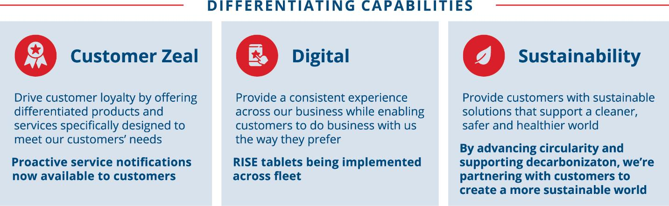illion automated customer notifications Ambitios2030 sustainability goals

 | Republic Services, Inc. 2023 Proxy Statement | | | 53

PROXY SUMMARY |  | BOARD AND GOVERNANCE |  | EXECUTIVE COMPENSATION |  | PROPOSALS |  | MEETING INFORMATION |  | ANNEX

2022 Business and Performance Highlights
During 2022, we continued to create value for our shareholders. Our performance reflects our continued progress on our strategic priorities. We continue to focus on executing our strategy designed to generate profitable growth by sustainably managing our customers’ needs, managing our cost structure, generating consistent earnings and free cash flow growth, improving return on invested capital, and increasing cash returns to our shareholders.
Highlights of the year include:
 | • | Outperformed our upwardly revised adjusted earnings per share (“EPS”) and adjusted free cash flow (“FCF”) guidance(1);
 | • | Full-year diluted EPS was $4.69 per share and full-year adjusted EPS(1) was $4.93 per share. Adjusted EPS increased 18 percent over the prior year;
 | • | Full-year cash provided by operating activities was $3.19 billion and adjusted FCF(1) was $1.74 billion;
 | • | Invested over $2.7 billion in acquisitions during 2022, including the acquisition of US Ecology;
 | • | Returned $796 million to shareholders in 2022 through dividends and share repurchases; and
 | • | Received many notable awards for our continued leadership in Environmental, Social and Governance (ESG).
(1) | Adjusted EPS and adjusted FCF are non-GAAP financial measures. For a reconciliation of such non-GAAP measures to the comparable measures calculated in accordance with GAAP, see “Reconciliation of GAAP to Non-GAAP Financial Measures” in the Annex on page 98.

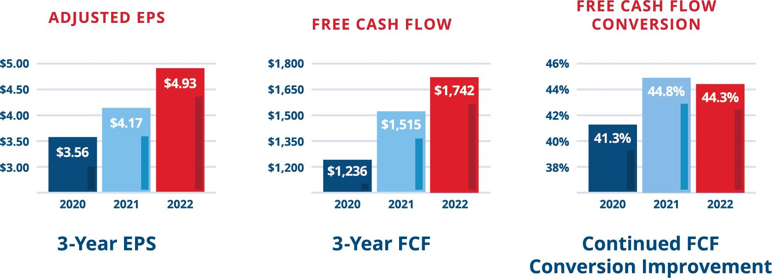

See “Reconciliation of GAAP to Non-GAAP Financial Measures” in the Annex on page 98. For comparative purposes, prior year amounts have been reclassified to conform to current year presentation.
Focused Capital Allocation Strategy to Increase Shareholder Value Creation
Our balanced capital allocation practices prioritize reinvesting into the business and then returning cash to shareholders while maintaining an investment-grade credit rating.

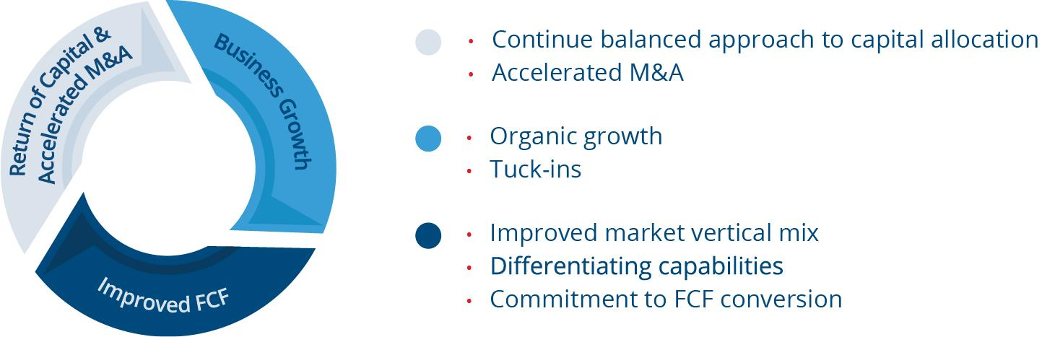

54 | | | Republic Services, Inc. 2023 Proxy Statement

PROXY SUMMARY |  | BOARD AND GOVERNANCE |  | EXECUTIVE COMPENSATION |  | PROPOSALS |  | MEETING INFORMATION |  | ANNEX

Performance Metrics
We believe the performance metrics we use for our executive compensation program are strongly aligned with shareholder interests and support our business strategy. For the past several years, our executive compensation program has used an EPS measure (“EPS Measure”) and a FCF measure (“FCF Measure”) as financial metrics for our annual cash incentive plan, and return on invested capital (“ROIC”), cash flow value creation (“CFVC”), and relative total shareholder return (“RTSR”) as financial metrics for our long-term incentive (“LTI”) plan. Our shareholders have told us that these metrics align well with their interests. Beginning in 2022, we added a sustainability adjustment to our annual incentive plan, pursuant to which the annual incentive paid to our senior executives is subject to adjustment up or down by up to 10% based on the Company’s interim performance on safety, talent and climate leadership goals. The following graphic describes the financial performance metrics applied to both the annual incentive plan and LTI plan in 2022 as well as how they align with our strategic goals:
2022 Metrics and Alignment with Strategy(1)

Annual cash incentive performance-based lti award eps measure 50% fcf measure 50% return on invested capital 40% cash flow value creation 40% relative total shareholder return 20% our annual incentive metrics are designed to encourage profitable growth and are widely accepted by the investment community as important performance. Our lti metrics are designed to grow our business with an emphasis on cash flow while maximizing investment returns and aligning interest between our executives and shareholders.

(1) | CFVC and ROIC are adjusted to exclude net gains or losses on divestitures, impairments of goodwill and other costs and impairments resulting from exiting a business, losses recorded on the extinguishment of debt instruments, costs associated with withdrawal from or termination of multi-employer pension plans, material changes caused by new accounting rules or new interpretations of previous accounting rules and other similar events or circumstances.
 | • | Annual incentive metrics are designed to encourage profitably growing the business, and are widely accepted by the investment community as two important ways to measure a company’s worth. They are:
 | • | EPS Measure (50%):
 | • | focused on growth drivers that management can control or influence; and
 | • | computed on a per-share basis, which incorporates the dilutive impact to shareholders from issuing equity.
 | • | FCF Measure (50%):
 | • | emphasizes the quality of earnings; and
 | • | incorporates the level of capital expenditures deployed to generate future growth.
 | • | Sustainability Adjustment (new in 2022):
 | • | additional adjustment, up or down by up to 10%, based on the Company’s interim performance on safety, talent and climate leadership goals.
 | • | Long-term incentive compensation metrics are designed to grow our capacity to generate future earnings rather than “harvesting the business.” This is accomplished by focusing on three-year goals based on the following metrics:
 | • | ROIC (40%):
 | • | emphasizes maximizing investment returns;
 | • | focuses management on cost controls and margin expansion; and
 | • | incentivizes management to make better use of existing assets.
 | • | CFVC – a measure of economic value added (40%):
 | • | focuses on building the business with an emphasis on cash flow;
 | • | includes a capital charge to promote disciplined capital spending; and
 | • | ensures alignment of goals and objectives at all levels of the organization.
 | • | RTSR (20%):
 | • | aligned with the investment community; and
 | • | a relative measure so management is not rewarded or penalized for broader market conditions.

Our annual incentive for senior executives including our NEOs is subject to an adjustment up or down by up to 10% based on the Company’s interim performance on safety, talent and climate leadership goals.

 | Republic Services, Inc. 2023 Proxy Statement | | | 55

PROXY SUMMARY |  | BOARD AND GOVERNANCE |  | EXECUTIVE COMPENSATION |  | PROPOSALS |  | MEETING INFORMATION |  | ANNEX

Although the FCF Measure used for our annual incentive and the CFVC used for our LTIs may appear similar, the measures are distinct and support different objectives.

 | FREE CASH FLOW | CASH FLOW VALUE CREATION
Calculation | FCF = Cash Flow from Operations – Net Capital Expenditures | CFVC = Net Operating Profit After Tax – (Average Net Assets x Capital Charge)
Rationale for Use as  Performance Metric | • Reflects strength of the Company’s cash flows on an annual basis and quality of the Company’s earnings  • Measures the Company’s ability to generate cash flow in excess of capital expenditures | • Includes a capital charge on net assets to promote business growth through disciplined investments  • Reflects creation of value over the long term

Please refer to the Annex on page 98 for details regarding the calculation of our actual results for 2020, 2021 and 2022 for the EPS Measure, FCF Measure, CFVC, and ROIC.

Setting Robust Performance Targets
We develop rigorous performance metrics on a bottom-up basis – reflecting both management initiatives and the impact of external factors. To align management incentives, our metrics and performance targets focus on factors that management can impact rather than on external factors not under management’s control or ability to mitigate.
The performance metrics used in the annual incentive plan and the PSUs (other than the RTSR metric used for the PSUs and weighted at 20%) are directly tied to management’s ability to increase shareholder value. In setting performance targets for the annual incentive plan and for the three-year PSU performance cycle, the Talent & Compensation Committee considers the macro-economic environment, industry-specific conditions, prior-year actual performance, tax conditions and changes in regulations and laws. The Talent & Compensation Committee confirms that performance targets align with our published earnings guidance, which assures that they are transparent and reward management only if management is successful in achieving financial results that align with the expectations we communicate externally. Based on this due diligence, the Talent & Compensation Committee sets rigorous, but reasonable, performance goals for the business.
Despite the potential adverse impacts arising from the COVID-19 pandemic, the Talent & Compensation Committee determined not to adjust the performance period, performance metrics or performance targets for the annual incentive plan or for any PSU performance cycle. Moreover, the Talent & Compensation Committee did not employ upward discretion to increase any annual incentive payments or PSU performance results to account for COVID-19 impacts. The Talent & Compensation Committee believed it was important to provide incentive for our NEOs to achieve metrics that due to the pandemic were naturally more challenging to achieve than when they were originally set. The Talent & Compensation Committee determined the best option to do this was through a modestly higher 2021 PSU grant for our NEOs, while maintaining the highly rigorous CVFC and ROIC targets.
Progress toward our sustainability goals is included within each of our management initiatives. As a result, there is a direct line from our sustainability initiatives to our business results, our culture and strategy and thus, to our performance-based executive compensation program. Accordingly, beginning in 2022, the annual incentives for senior executives including our NEOs are subject to adjustment up or down by up to 10% based on the Company’s interim performance on safety, talent and climate leadership goals. This sustainability modifier is “universal,” meaning the adjustment is applied consistently for all members of our senior management team, including our named executive officers.

56 | | | Republic Services, Inc. 2023 Proxy Statement

PROXY SUMMARY |  | BOARD AND GOVERNANCE |  | EXECUTIVE COMPENSATION |  | PROPOSALS |  | MEETING INFORMATION |  | ANNEX

The following table sets forth the process for setting rigorous performance targets that are aligned closely with shareholder value creation.

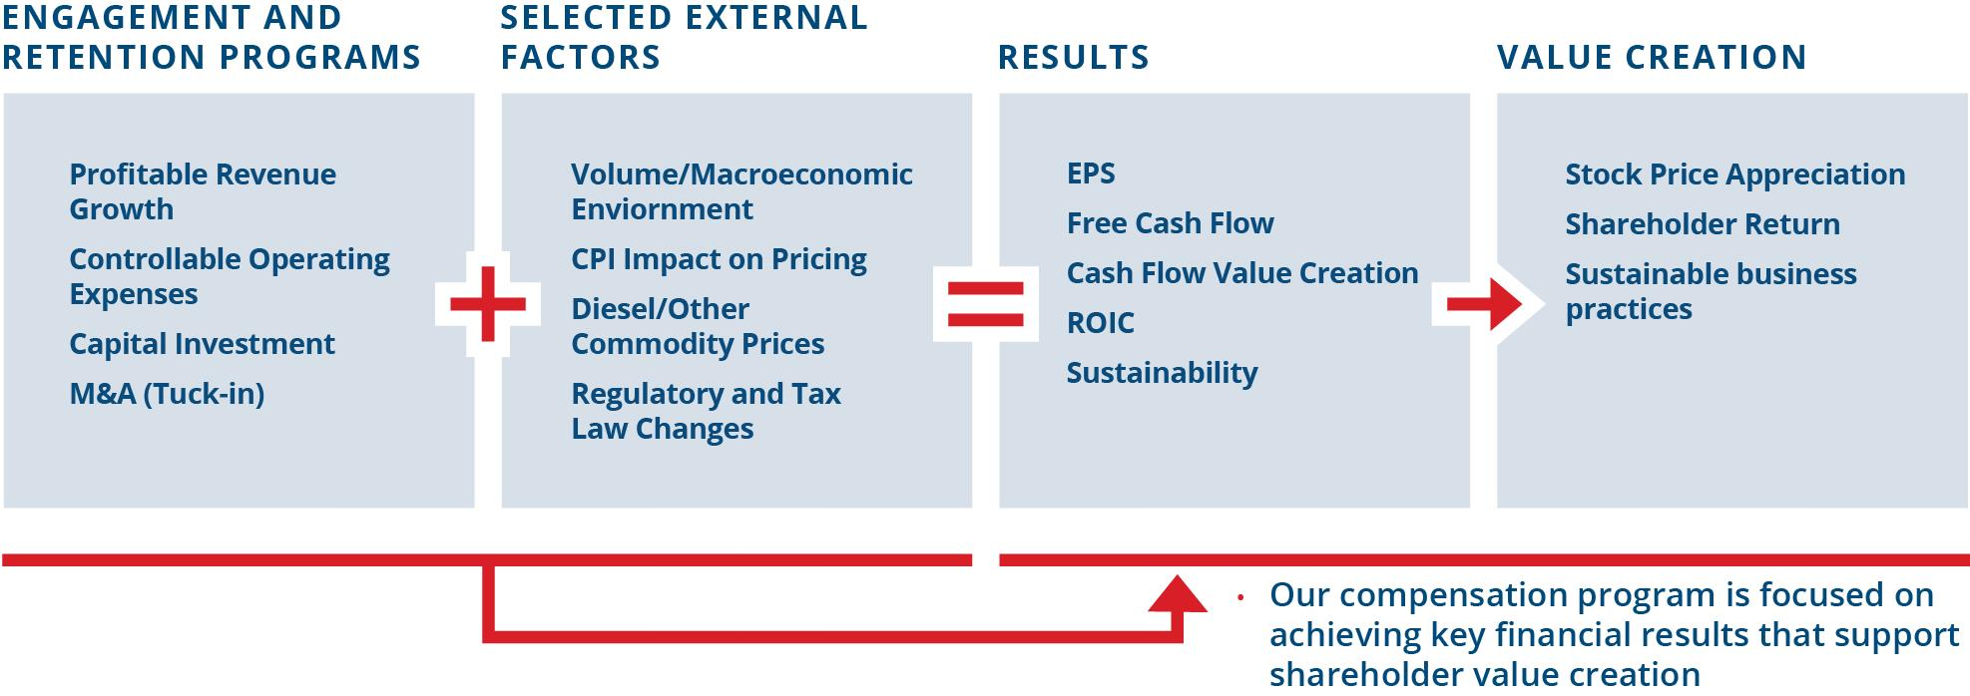

The following table compares financial metrics with actual outcomes for each performance measure in the 2020 through 2022 NEO compensation program.

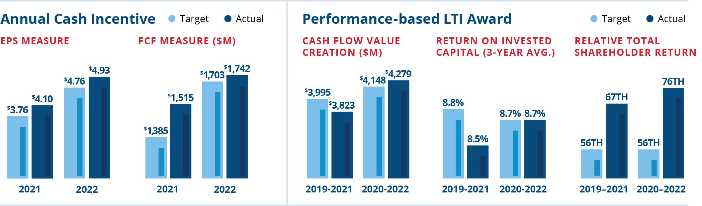

Shareholder Engagement and Board Consideration of 2022 Shareholder Vote on Executive Compensation
Republic has an active shareholder outreach program and regularly engages with shareholders on a number of matters, including executive compensation, governance and sustainability. The Board continues to consider feedback received from shareholders on executive compensation when designing and reviewing our compensation program. The Board was pleased that our 2022 non-binding advisory vote on named executive officer compensation (“say-on-pay vote”) received support from 95.4% of the shares voted. Our shareholders, both via the say-on-pay vote at the 2022 Annual Meeting and in our engagement sessions, spoke favorably of our overall compensation program and of the changes we have previously made as a direct result of prior shareholder feedback.
Our Board and senior leadership continue to actively engage with our shareholders on topics related to racial equity and environmental justice. Following these discussions, we proactively agreed to perform a civil rights assessment and we supplemented our existing disclosures regarding environmental justice. These actions are additional opportunities for us to demonstrate our commitment to sustainability, and to our communities and employees.

 | Republic Services, Inc. 2023 Proxy Statement | | | 57

PROXY SUMMARY |  | BOARD AND GOVERNANCE |  | EXECUTIVE COMPENSATION |  | PROPOSALS |  | MEETING INFORMATION |  | ANNEX

Executive Compensation Goals and Objectives
Our executive compensation philosophy and practices reflect our strong commitment to paying for performance — both short-term and long-term. A primary component of our people and talent agenda is to identify, recruit, place, develop and retain key management talent to help ensure that we have the highest caliber leadership. The Talent & Compensation Committee and the executive management team believe that a critical aspect of being able to successfully execute this strategy is maintaining a comprehensive, integrated and well-balanced executive compensation program. We believe such a program provides competitive and differentiated levels of pay based on corporate performance and aligns executives’ interests with shareholders’ interests.
EXECUTIVE COMPENSATION PROGRAM GOALS

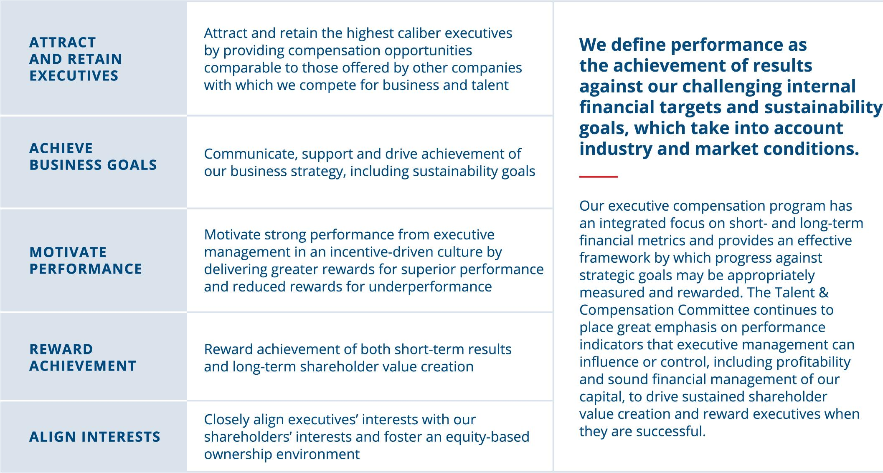
A

58 | | | Republic Services, Inc. 2023 Proxy Statement

PROXY SUMMARY |  | BOARD AND GOVERNANCE |  | EXECUTIVE COMPENSATION |  | PROPOSALS |  | MEETING INFORMATION |  | ANNEX

Key Compensation Governance Practices
The Talent & Compensation Committee independently governs the executive compensation program with the support of an independent compensation consultant and management. Our compensation program demonstrates strong governance through the following key components:

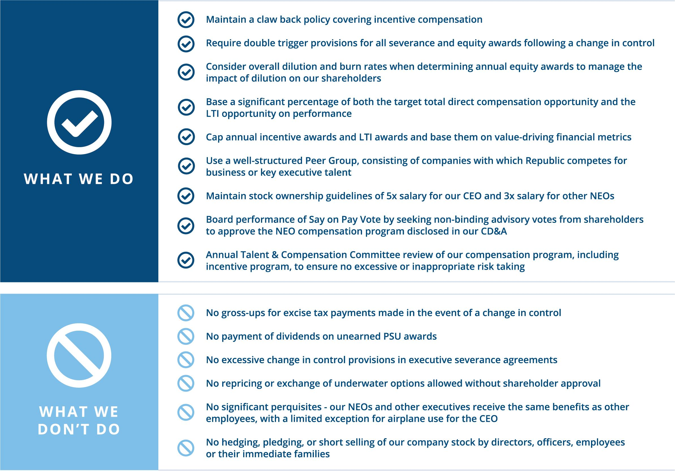

Components of Executive Compensation
In 2022, we compensated each NEO using three key forms of compensation:
 | • | base salary;
 | • | annual cash incentive based on target; and
 | • | long-term incentive awards based on target (PSUs and RSUs).
The annual and long-term incentives are variable and the amount realized is based on achieving specific performance objectives or on the performance of Republic’s stock.

 | Republic Services, Inc. 2023 Proxy Statement | | | 59

PROXY SUMMARY |  | BOARD AND GOVERNANCE |  | EXECUTIVE COMPENSATION |  | PROPOSALS |  | MEETING INFORMATION |  | ANNEX

For 2022, the target total direct compensation (“Target TDC”), comprised of annualized base salary, annual incentive and LTI awards (consisting of PSUs and RSUs), but not including retirement contributions, for Republic’s current NEOs was as follows:

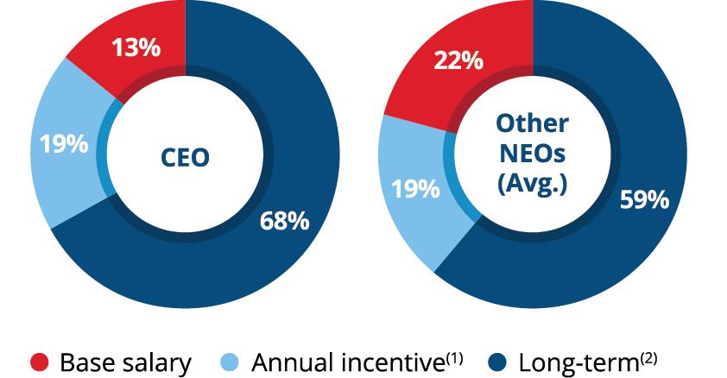 | (1)Variable annual incentive target award for 2022  (2)PSU target award for performance cycle beginning in 2022 and target value of RSU awards
Base Salary
We believe a competitive base salary attracts and retains high-caliber executive talent while providing a fixed level of compensation commensurate with the position’s responsibilities and level. The Talent & Compensation Committee annually reviews each NEO’s base salary to determine if any adjustment is warranted. This review consists of a comparison of the compensation paid to incumbents in comparable positions in our Peer Group, taking into account individual qualifications and responsibilities, internal salary levels, and individual and Company performance. Base salary levels may be adjusted when the Talent & Compensation Committee believes there is a competitive need to do so, in light of an individual’s promotion or taking into account an individual’s performance. In 2022, increases to base salaries for each of the NEOs were based on Peer Group benchmarking as well as individual performance. The table below shows the annual base salary for each NEO in 2021 and 2022, as approved by the Talent & Compensation Committee, which may be different from the amounts reflected in the Summary Compensation Table (“SCT”) in the “Salary” column.

NAME | 2021  BASE SALARY |  | 2022  BASE SALARY
Jon Vander Ark | $1,000,000 |  | $1,100,000
Brian M. DelGhiaccio | $570,000 |  | $625,000
Brian A. Bales | $505,000 |  | $520,000
Catharine D. Ellingsen | $545,000 |  | $570,000
Timothy E. Stuart | $665,000 |  | $695,000

Variable and Performance-Based Compensation Overview
The annual incentive and LTI awards link the majority of compensation to management’s performance against the financial metrics set by the Talent & Compensation Committee and the performance of Republic stock over the vesting periods of the equity-based awards. The performance metrics for the annual incentives and the PSUs and the range of opportunity relative to target payouts are consistent for all NEOs, including the CEO. These programs have both minimum performance thresholds below which no payments will be made and capped maximum payments.
Each year, management recommends that the Board approve financial performance targets that are challenging and, if achieved, can deliver superior value to shareholders. Consistent with the setting of ambitious performance targets, Republic looks to have its aggregate total Target TDC for its NEOs near or at the median of our Peer Group, taking into account experience, tenure and overall position responsibility. The Talent & Compensation Committee believes it is appropriate to reward the executive management team with compensation above the target opportunity with respect to performance-based awards if the rigorous financial targets associated with the variable pay programs are exceeded. Conversely, if those targets are not met, awards are paid at levels that result in variable compensation below target. Thus, our NEOs generally may be paid above the median of our Peer Group only if the targets are exceeded.
Annual Cash Incentive
Republic maintains an annual incentive program for its NEOs and certain other members of management. This reflects our pay-for-performance philosophy by linking a significant portion of the NEOs’ compensation to Company performance. Actual annual incentive awards earned are a function of performance relative to Talent & Compensation Committee-approved financial targets. The Talent & Compensation Committee may apply (and in some years has applied) negative discretion to adjust actual performance downward if it believes that actual results reflect the benefit of matters that, although valuable to Republic, are not the type of benefit the annual incentive plan was designed to reward.

60 | | | Republic Services, Inc. 2023 Proxy Statement

PROXY SUMMARY |  | BOARD AND GOVERNANCE |  | EXECUTIVE COMPENSATION |  | PROPOSALS |  | MEETING INFORMATION |  | ANNEX

The annual incentive program rewards the NEOs based on performance relative to targets for the EPS Measure and the FCF Measure. For 2022 compensation purposes, we defined the EPS Measure, which is not a measure determined in accordance with GAAP, as our reported EPS, adjusted to remove the impact of: (a) the loss on extinguishment of debt; (b) gains or losses (or related impairments) from divestitures, impairments of goodwill and other costs and impairments resulting from exiting a business; (c) costs associated with withdrawal from or termination of multi-employer pension plans; (d) restructuring charges; (e) US Ecology acquisition integration and deal costs; and (f) similar events or circumstances. We defined the FCF Measure, which is not a measure determined in accordance with GAAP, as cash provided by operating activities, less property and equipment received in 2022, plus proceeds from sales of property and equipment, adjusted to remove the impact of: (1) cash taxes arising from debt extinguishment; (2) tax payments related to divestitures, impairments of goodwill and other costs and impairments resulting from exiting a business; (3) payments associated with withdrawal from or termination of multi-employer pension plans; (4) restructuring payments, net of tax; (5) US Ecology acquisition integration and deal costs, net of tax; and (6) similar events or circumstances.
The following tables illustrate our 2022 targets, threshold and maximum awards for the annual incentive. For performance at and below target, the two measures are equally weighted and a participant may earn a percentage of the target award for each measure based on performance for that measure. If the EPS Measure target is exceeded, and the FCF Measure at least meets target, the annual incentive award earned may be increased above target (up to a maximum of 200% of the target amount), based on the extent to which the EPS Measure target is exceeded. No additional amount above target will be earned based on exceeding the FCF Measure target.

2022 PERCENT OF ANNUAL INCENTIVE AWARD EARNED IF EITHER MEASURE IS LESS THAN TARGET

 |  | ≥ $1,703 (T) | 50% | 62.5% | 75% | 87.5% | 100%
 |  | $1,618 | 37.5% | 50% | 62.5% | 75% | 87.5%
 |  | $1,533 | 25% | 37.5% | 50% | 62.5% | 75%
 |  | $1,448  (threshold) | 12.5% | 25% | 37.5% | 50% | 62.5%
 |  | < $1,448 | 0% | 12.5% | 25% | 37.5% | 50%
 |  |  | ≤ $4.56 (threshold) | $4.61 | $4.66 | $4.71 | ≥ $4.76 (T)
 |  |  | EPS Measure (per share)
 |  |  | T = Target level for 100% payout
Actual results for both measures in 2022 were above Target and therefore
the table above did not govern the payout determination.

 | Republic Services, Inc. 2023 Proxy Statement | | | 61

PROXY SUMMARY |  | BOARD AND GOVERNANCE |  | EXECUTIVE COMPENSATION |  | PROPOSALS |  | MEETING INFORMATION |  | ANNEX

2022 PERCENT OF ANNUAL INCENTIVE AWARD EARNED IF BOTH MEASURES ARE ABOVE OR AT TARGET

FCF Measure  ($ in millions) |  | ≥$1,703 (T) |  | 100% | 125% | 150% | 175% | 185% (A) | 200%
 |  |  |  | $4.76 (T) | $4.81 | $4.86 | $4.91 | $4.93 | $4.96  (max)
 |  |  |  | EPS Measure (per share)
T = Target level for 100% payout | A = Actual achievement in 2022
FCF Measure was $1,742 million and EPS Measure was $4.93 per share

For 2022, the actual EPS Measure performance was $4.93 per share against a target of $4.76 per share. The actual FCF Measure performance was $1,742 million against a target of $1,703 million. The above-target performance on both the EPS Measure and the FCF Measure resulted in the NEOs receiving an annual incentive payment of 185% of target. Please refer to the Annex on page 98 for details regarding the calculation of our actual results for 2020, 2021 and 2022 for the EPS Measure and the FCF Measure. The following table shows targets and actual outcomes for the annual incentive in the 2020 through 2022 NEO compensation program.

 | 2020 | 2021 | 2022
EPS MEASURE TARGET | $3.53 | $3.76 | $4.76
EPS MEASURE ACTUAL | $3.58 | $4.10 | $4.93
FCF MEASURE TARGET | $1,146 | $1,385 | $1,703
FCF MEASURE ACTUAL | $1,262 | $1,515 | $1,742
FINANCIAL INCENTIVE PAYOUT | 125% | 200% | 185%
SUSTAINABILITY MODIFIER | N/A | N/A | 0%
TOTAL ANNUAL INCENTIVE PAYOUT | 125% | 200% | 185%

Sustainability Modifier
For 2022, the Company’s performance on the sustainability modifier was assessed based on performance against sustainability objectives established by the Talent & Compensation Committee in February 2022. The Company’s actual performance against predefined safety, talent, and climate metrics determines whether there is an adjustment of the annual incentive achieved by senior executives, including our NEOs upward or downward within a range of ten percentage points. The table below lists the sustainability pillars from our 2030 sustainability goals, the metrics selected by our Talent & Compensation Committee for purposes of the 2022 annual incentive plan, the 2022 goal, target range, 2022 achievement, other considerations that the Talent & Compensation Committee took into consideration and the rating determined by the Talent & Compensation Committee.

Sustainability Pillar | Specific Metric | 2030 Goal | 2022 Goal | Target Range | 2022 Achievement | Other Considerations Impacting Rating | Rating (1)
Safety | Incident Reduction | 2.0 | 3.4 | [3.1-3.7] | 2.9 | Other company safety performance | 2
Talent | Leadership Diversity | 50% | 44% | [42.5%-45.5%] | 44.5% | Performance target in range | 3
Climate Leadership | Circular  Economy | 3.4M  Tons | 2.6M Tons | [2.4M-2.8M] | 2.4M Tons | Significant investments in LFGTE and Polymer Center | 4

1 Based on a 5-point scale, with 1 = significant performance opportunity, 5 = significant outperformance

62 | | | Republic Services, Inc. 2023 Proxy Statement

PROXY SUMMARY |  | BOARD AND GOVERNANCE |  | EXECUTIVE COMPENSATION |  | PROPOSALS |  | MEETING INFORMATION |  | ANNEX

Sustainability metrics were selected based on their measurability and their alignment with the Company’s business strategy, including the senior executives’ ability to impact them. Taking into consideration all factors related to the Company’s performance on the selected sustainability metrics, the Talent & Compensation Committee determined that no adjustment, positive or negative, should be made to the annual incentive on account of the Company’s sustainability performance in 2022.

2022 ANNUAL INCENTIVE OPPORTUNITY AS A PERCENTAGE OF SALARY AND ACTUAL PAYOUT AS A PERCENTAGE OF SALARY AND IN DOLLARS
The following table shows the NEOs’ 2022 annual incentive opportunity as a percentage of salary at various performance levels and the actual payout as a percentage of salary and in dollars. The payout amount is also reflected in the Summary Compensation Table under the column titled “Non-Equity Incentive Plan Compensation.” Further, the annual cash incentive payouts that would have been earned if the minimum, target and maximum performance level were achieved are reflected in the “Grants of Plan-Based Awards in the 2022” table on page 73 under the column titled “Estimated Future Payouts under Non-Equity Incentive Plan Awards” and associated footnotes.

NAME |  | Below  Threshold  Performance  Level | At Threshold  Performance  Level | At Target  Performance  Level | At Maximum  Performance  Level | Actual Annual  Incentive Payout  as a Percentage  of Salary (1) |  |  | Actual Annual  Incentive Payout  in $
Jon Vander Ark |  | 0% | 17.5% | 140% | 280% | 259% |  |  | 2,849,000
Brian M. DelGhiaccio |  | 0% | 10.6% | 85% | 170% | 157.3% |  |  | 982,813
Brian A. Bales |  | 0% | 10% | 80% | 160% | 148% |  |  | 769,600
Catharine D. Ellingsen |  | 0% | 10% | 80% | 160% | 148% |  |  | 843,600
Timothy E. Stuart |  | 0% | 11.3% | 90% | 180% | 166.5% |  |  | 1,157,176

(1) | The percentage is calculated utilizing base salary as of the end of the fiscal year.

For 2023, the annual incentive plan design remains very similar to prior years with the measures again consisting of the EPS Measure, the FCF Measure and a sustainability modifier.
Long-Term Incentive Awards
The Talent & Compensation Committee strongly believes in using LTI compensation to reinforce key objectives that drive financial progress and sustained shareholder value creation:
 | • | focus on the importance of shareholder returns;
 | • | promote the achievement of long-term performance goals;
 | • | encourage executive retention; and
 | • | promote meaningful levels of Republic stock ownership by executives.
To determine the overall opportunity and appropriate mix of LTI awards, the Talent & Compensation Committee considers a variety of factors, including competitive market positioning against comparable executives in the Peer Group, Peer Group LTI award practices, potential economic value realized, timing of vesting, and taxation. Our compensation program is highly performance-based, and the mix of LTI awards that are granted aligns with our target pay mix philosophy that indicates 50% or more of long-term incentive awards should be performance based. Taking this into consideration, the Talent & Compensation Committee awarded 70% of Mr. Vander Ark’s total equity in the form of PSUs and, on average, 65% of our other NEO’s total equity in the form of PSUs with the remaining in the form of RSUs.
Our LTI awards for NEOs consist of (1) an RSU grant that vests ratably over four years and (2) a PSU grant that vests based on performance over a three-year period and is payable half in cash and half in shares of common stock.
Restricted Stock Units
In February 2022, the Talent & Compensation Committee approved equity awards to our NEOs in the form of RSUs that vest ratably over four years. The full grant date fair value of RSUs granted to each NEO during 2022 is shown in the Summary Compensation Table on page 71. Additional information, including the number of shares subject to each award, is shown in the “Grants of Plan-Based Awards in 2022” table on page 73.

 | Republic Services, Inc. 2023 Proxy Statement | | | 63

PROXY SUMMARY |  | BOARD AND GOVERNANCE |  | EXECUTIVE COMPENSATION |  | PROPOSALS |  | MEETING INFORMATION |  | ANNEX

Generally, our executives and other employees who receive grants of RSUs receive dividend equivalents for any dividends we declare on our common stock following the date on which they are granted RSUs. The dividend equivalents are in the form of additional RSUs with a value equal to the value of dividends they would have received on the shares of the common stock underlying the RSUs they hold on the dividend record date.
Performance Shares
PSUs are performance-based because the number of shares of common stock ultimately earned depends on performance against predetermined goals over a three-year period and the value of the PSUs fluctuates based on our stock price. The opportunity to earn PSUs is based on three key financial metrics — CFVC, ROIC and RTSR.
The Talent & Compensation Committee established the performance and payout targets for the 2022-2024 performance periods in February 2022. We believe that the CFVC and ROIC targets for these performance periods are rigorous and appropriately reflect the Talent & Compensation Committee’s consideration of the business, and operational and regulatory environment as it existed when the targets were set. Additionally, we believe the RTSR target established by the Talent & Compensation Committee ensures that management is not rewarded or penalized for broader market conditions. Each of the components align all NEOs to performance against the financial metrics and to increasing shareholder value. Additional information, including the threshold, target, and maximum awards payable to each of the NEOs for the 2022-2024 performance period, is shown in the “Grants of Plan-Based Awards in 2022” table on page 73.
Dividends on PSUs are accrued but not earned and granted to the executives until the shares of common stock underlying the PSUs are earned, if at all, based on the achievement of the performance metrics as determined following the end of the three-year performance period.
The award value for RSUs and PSUs granted to each NEO in 2022, as approved by the Talent & Compensation Committee, are shown below and may be different from the amounts reflected in the Summary Compensation Table in the “Stock Awards” column.

EXECUTIVE NAME |  | RSU AWARDS(1)  VALUE |  |  |  | PSU AWARDS(2)  VALUE
Jon Vander Ark |  | $ | 1,700,000 |  |  | $ | 4,000,000
Brian M. DelGhiaccio |  | $ | 600,000 |  |  | $ | 1,250,000
Brian A. Bales |  | $ | 400,000 |  |  | $ | 640,000
Catharine D. Ellingsen |  | $ | 585,000 |  |  | $ | 900,000
Timothy E. Stuart |  | $ | 750,000 |  |  | $ | 1,600,000

(1) | The value of RSUs will differ from the grant date fair value of RSUs shown in the Summary Compensation Table, as we do not grant fractional shares.
(2) | The value of PSUs will differ from the grant date fair value of PSUs shown in the Summary Compensation Table. A portion of the grant date fair value of PSUs shown in the Summary Compensation Table reflects total shareholder return relative to the S&P 500, and is based on a Monte Carlo valuation model. For PSUs, the Monte Carlo valuation method replaces the Black-Scholes valuation method that had been used for prior year disclosures.

64 | | | Republic Services, Inc. 2023 Proxy Statement

PROXY SUMMARY |  | BOARD AND GOVERNANCE |  | EXECUTIVE COMPENSATION |  | PROPOSALS |  | MEETING INFORMATION |  | ANNEX

The following chart shows the performance targets and the potential payouts for PSUs granted in 2020 with a performance period of 2020–2022, for performance above and below target. It also shows the actual performance of CFVC and ROIC during the performance period of $4,279 million and 8.7%, respectively. Because our actual CFVC was above the target, and our actual ROIC was equal to target, the resulting payout based on CFVC and ROIC was 105.3% of the target payout amount. We will disclose the performance targets, potential payouts, and actual results for the 2021–2023 and 2022–2024 performance periods once the applicable performance period has concluded.
2020-2022 CFVC/ROIC EARNED PERCENTAGE

 | $4,770  or greater | 75% | 100% |  | 125% | 150%
 |  |  |  | 105.3% (A); CFVC $4,279; ROIC: 8.7%
 | $4,148 (T) | 50%
 | $4,148 (T) | 50% | 75% |  | 100% | 125%
 | $3,526 | 25% | 50% |  | 75% | 100%
 | < $3,526 | 0% | 25% |  | 50% | 75%
 |  | < 7.4% | 7.4% |  | 8.7% (T) | 10.0%
 |  | AVERAGE ROIC%
 |  | T = Target level for 100% payout | A = Actual results for 2020-2022 Performance Period

Twenty percent of the PSU payout is based on the RTSR performance to target. In 2020, the Talent & Compensation Committee set the RTSR performance target for the 2020 - 2022 performance period at the 56th percentile. |  | 2020-2022 RTSR EARNED PERCENTAGE
 |  | RTSR ATTAINED DURING  THE PERFORMANCE PERIOD |  | RTSR EARNING PERCENTAGE
The chart to the right shows the performance target and the potential payouts for performance above and below target. It also shows the actual performance of RTSR during the performance period at the 76th percentile. Because our actual performance was above the target level of performance, consistent with our pay-for-performance philosophy, the resulting payout based on RTSR was 142.2% of the target payout amount. |  | Less than 20th Percentile |  |  |  | 0%
 |  | 20th Percentile |  |  |  | 25%
 |  | 40th Percentile |  |  |  | 67%
 |  | 56th Percentile (T) |  |  |  | 100%
 |  | 60th Percentile |  |  |  | 108%
 |  | 76th Percentile |  |  |  | 142.2% |  | (A)
 |  | 80th Percentile or higher |  |  |  | 150%

T = Target level for 100% payout
A = Actual results for 2020-2022 Performance Period
Taking into consideration the combined performance of CFVC, ROIC and RTSR for the 2020-2022 performance period, the combined PSU payout was 112.7% of target. The actual payout amounts are reflected in the “PSUs and RSUs Vested in 2022” table on page 76.

 | Republic Services, Inc. 2023 Proxy Statement | | | 65

PROXY SUMMARY |  | BOARD AND GOVERNANCE |  | EXECUTIVE COMPENSATION |  | PROPOSALS |  | MEETING INFORMATION |  | ANNEX

Other Benefits
Republic makes available medical, dental and vision insurance, life insurance and short- and long-term disability insurance programs for our employees. The NEOs are eligible to participate in these programs on the same basis and with the same level of financial subsidy as our general employee population (other than those employees who are subject to different terms under a collective bargaining agreement). Like our other employees, our NEOs may participate in our 401(k) plan and may defer a portion of their base salary and annual incentive compensation, to the maximum defined level specified by the IRS, which in 2022 was $20,500 plus an additional $6,500 for those age 50 and above. Republic matches 100% of the first three percent of pay contributed and 50% of the next two percent of pay contributed by an employee. Republic’s matching contributions into the 401(k) plan for the NEOs who participated are reported in the “All Other Compensation for 2022” table on page 72.
Deferred Compensation Plan and Deferred Compensation Savings Program Contributions
Eligible employees are limited by federal law as to the amount they may contribute to their 401(k) accounts. Accordingly, we have established a Deferred Compensation Plan (“DCP”) that permits certain participants, including the NEOs, to defer additional amounts of compensation, including RSUs and PSUs, in a tax-efficient manner for retirement savings. Under the DCP, most participants are eligible for matching contributions. The matching contribution under the DCP is equal to the lesser of two percent of the participant’s eligible compensation over the established 401(k) limit ($305,000 in 2022) or 50% of the participant’s annual deferrals, excluding deferred RSUs and stock-settled PSUs.
In addition, we make discretionary retirement contributions to certain of our senior executives’ accounts in the Deferred Compensation Plan (“DCSP Contributions”). The Talent & Compensation Committee reviews the DCSP Contributions annually and may change the amounts or discontinue the contributions at any time. Each DCSP Contribution is a fixed dollar amount that depends on the participant’s position in the organization, among other considerations. Unless otherwise specified, DCSP Contributions vest in one of four ways: (1) upon a participant satisfying the age and service requirements necessary to qualify for retirement; (2) in the event of death or disability, the retirement contributions vest immediately; (3) if a participant’s employment is terminated “without cause,” the retirement contributions vest immediately but are not available to the participant until the earlier of the fifth anniversary of the termination date or the date the participant would have become eligible for retirement; or (4) if we complete a transaction that is deemed a change in control, all retirement contributions vest immediately and may be paid out depending upon the original election of the participant. Mr. Vander Ark received contributions of $100,000 in 2022 and $65,000 in 2021 and 2020. Ms. Ellingsen and Messrs. Bales, DelGhiaccio and Stuart each received a contribution of $65,000 in 2020, 2021 and 2022.
The individual contributions of the participating NEOs, including earnings on those contributions and total account balances as of the end of 2022, are shown in the “Nonqualified Deferred Compensation in 2022” table on page 76. Republic’s matching contributions and the DCSP contributions are shown in the “All Other Compensation for 2022” table on page 72.
Modest Perquisites
With the exception of (1) certain gross-up payments pursuant to our relocation policy that are applicable to all eligible employees, (2) a stipend to cover a portion of monthly health club dues that is offered on the same terms to all employees at our corporate office, and (3) concierge medical services available to vice presidents, senior vice presidents, and executive vice presidents in our corporate office for a nominal charge paid by the Company, Republic generally does not offer perquisites or other personal benefits other than the aircraft usage discussed below. All associated relocation expenses, if any, are reported in the “All Other Compensation for 2022” table on page 72. We also do not provide any additional cash compensation to any of the NEOs to reimburse them for income tax liability as a result of the receipt of any cash or equity compensation, benefit or perquisite.
Our CEO may use our airplane for non-business travel. Other NEOs may use our airplane for non-business travel if the CEO is aboard. On a quarterly basis, the Audit Committee reviews the non-business use of our airplane by our CEO and other NEOs for reasonableness. The amount reflected in the “All Other Compensation for 2022” table as “Perquisites and Other Personal Benefits” includes the incremental cost of providing aircraft to an NEO for non-business travel.

66 | | | Republic Services, Inc. 2023 Proxy Statement

PROXY SUMMARY |  | BOARD AND GOVERNANCE |  | EXECUTIVE COMPENSATION |  | PROPOSALS |  | MEETING INFORMATION |  | ANNEX

Other Compensation Policies
Stock Ownership Guidelines
The Board recognizes the importance of equity ownership by our executives to further link their interests with shareholders’ interests. Accordingly, the Board maintains stock ownership guidelines for all senior management employees (defined as President and CEO, Chief Operating Officer, Chief Financial Officer, and Chief Legal Officer, and any Executive Vice President, Senior Vice President, Vice President, Area President, and Market Vice President). The guidelines require that senior management employees achieve compliance with the ownership guidelines within five years of becoming a covered employee and maintain their ownership level thereafter. Shares included in the calculation to assess compliance with the ownership guidelines include shares owned outright and through certain trusts, shares held in the 401(k) plan, and vested stock equivalents held in the DCP.

NAME |  | MULTIPLE OF  SALARY REQUIRED | IN COMPLIANCE  OR ON TRACK
Jon Vander Ark |  | 5x | Yes
Brian M. DelGhiaccio |  | 3x | Yes
Brian A. Bales |  | 3x | Yes
Catharine D. Ellingsen |  | 3x | Yes
Timothy E. Stuart |  | 3x | Yes

Securities Trades by Employees
Executive management and the Board take seriously their responsibilities and obligations to exhibit the highest standards of behavior relative to buying and selling Republic stock. All transactions by any director or officer as defined by Section 16 of the Exchange Act (“Insiders”) must be pre-cleared by the Chief Legal Officer. Further, Insiders and other Company representatives are prohibited from trading any Republic stock while in possession of material non-public information and are generally prohibited from trading any Republic stock during quarterly blackout periods.
Additionally, our insider trading policy prohibits all Insiders, and members of their immediate family, from engaging in the following transactions relating to Republic securities or derivatives of Republic securities:
 | • | purchasing or selling puts or calls;
 | • | short sales;
 | • | placing standing orders, other than under approved 10b5-1 plans;
 | • | engaging in short-term or “in-and-out” trading;
 | • | holding Republic securities or derivatives of Republic securities in a margin account; and
 | • | pledging Republic securities or derivatives of Republic securities.
REVISED Compensation Recoupment (Clawback) Policy
Our Board established a Clawback Policy to encourage sound financial reporting and increase individual accountability and updated it in 2022 to expand the triggering events to include additional Covered Events, as defined below. As more fully described in our revised Clawback Policy, which is available on our website on the Investors page under Corporate Governance:
 | • | the policy applies to Republic’s officers as defined by Rule 16(a)-1(f) under the Exchange Act (“Covered Officers”);
 | • | the policy applies to all short- and long-term incentives and bonuses, stock options, PSUs, RSUs and other stock and stock-based awards (“Incentive Compensation”);
 | • | the policy is triggered by an accounting restatement we must make due to material noncompliance with any financial reporting requirement under the securities laws (a “Restatement”) or another defined “Covered Event”, which includes conviction of certain crimes, a material violation of Company policies, rules, or guidelines, a breach of fiduciary duty or violation of a restrictive covenant and other conduct by a Covered Officer that exposes Republic to serious actual or potential injury;
 | • | if a Restatement occurs, the Talent & Compensation Committee generally must seek to claw back vested and unvested Incentive Compensation, including gains on equity, during the 3-year period preceding the Restatement date to the extent they exceed what would have been paid to the Covered Officer under the restated financial statements;
 | • | This clawback applies if either (1) the applicable Covered Officer engaged in fraud or intentional misconduct that materially contributed to the need for the Restatement or (2) future SEC or NYSE rules require Republic to seek forfeiture; and
 | • | If a Covered Event occurs, the Talent & Compensation Committee may review all Incentive Compensation, and seek to require the forfeiture or repayment of the award, vesting or amount of Incentive Compensation, in whole or in part, vested or unvested and including gains on equity, during the 3-year period preceding the Covered Event.

 | Republic Services, Inc. 2023 Proxy Statement | | | 67

PROXY SUMMARY |  | BOARD AND GOVERNANCE |  | EXECUTIVE COMPENSATION |  | PROPOSALS |  | MEETING INFORMATION |  | ANNEX

Compensation Process
Peer Group and Competitive Benchmarking
The Talent & Compensation Committee, in consultation with its independent compensation consultant, annually reviews the composition of the Peer Group used as a reference for executive compensation decisions to ensure that the companies included are comparable in terms of business mix and complexity, revenue, market capitalization, geographic footprint, assets and number of employees. The following table reflects the Peer Group used by the Talent & Compensation Committee to establish 2022 compensation.

Air Products and Chemicals, Inc. | FedEx Corporation
American Electric Power Company, Inc. | J.B. Hunt Transport Services, Inc.
Canadian National Railway Company | Norfolk Southern Corporation
Canadian Pacific Railway Limited | Ryder System, Inc.
Cintas Corporation | Sysco Corporation
CSX Corporation | W.W. Grainger, Inc.
Ecolab Inc. | Waste Connections, Inc.
Entergy Corporation | Waste Management, Inc.
Fastenal Company
The Talent & Compensation Committee considers data and analyses prepared by its independent compensation consultant based on our current and prior performance, and the historical NEO pay and the appropriateness of that compensation compared to the NEO compensation in the Peer Group. The Talent & Compensation Committee also considers general compensation surveys compiled by external consulting firms and takes into account recommendations of our CEO for executives other than himself. The Talent & Compensation Committee uses the Peer Group and other surveys as a reference but does not target a specified percentile of compensation to be paid. After taking into account all data, and factors such as Company performance and an individual’s contribution, experience and potential, the Talent & Compensation Committee makes compensation decisions. Based on the independent consultant’s analysis, our CEO’s 2022 Target TDC was positioned near the 38t h percentile of the Peer Group which is consistent with our approach of increasing pay over time commensurate with performance and experience.
Evaluating Company and Executive Performance
The Talent & Compensation Committee, after consulting with the Board and management, has established a process for evaluating Republic’s performance, as well as the performance of each of our executive officers. Each year, the Talent & Compensation Committee approves strategic, financial and sustainability objectives for the executive officers for the upcoming year and for the long term. It also reviews and evaluates the performance against these strategic and financial objectives for the prior year and reviews the interim progress on all open three-year performance periods under the PSUs. Our CEO provides his assessment of the performance against the strategic objectives and on the individual contributions of the executive officers. The Talent & Compensation Committee considers all of these factors in reaching its compensation decisions. The Talent & Compensation Committee routinely meets in executive session without the presence of any management when considering compensation matters.

68 | | | Republic Services, Inc. 2023 Proxy Statement

PROXY SUMMARY |  | BOARD AND GOVERNANCE |  | EXECUTIVE COMPENSATION |  | PROPOSALS |  | MEETING INFORMATION |  | ANNEX

EVALUATING COMPANY AND EXECUTIVE PERFORMANCE

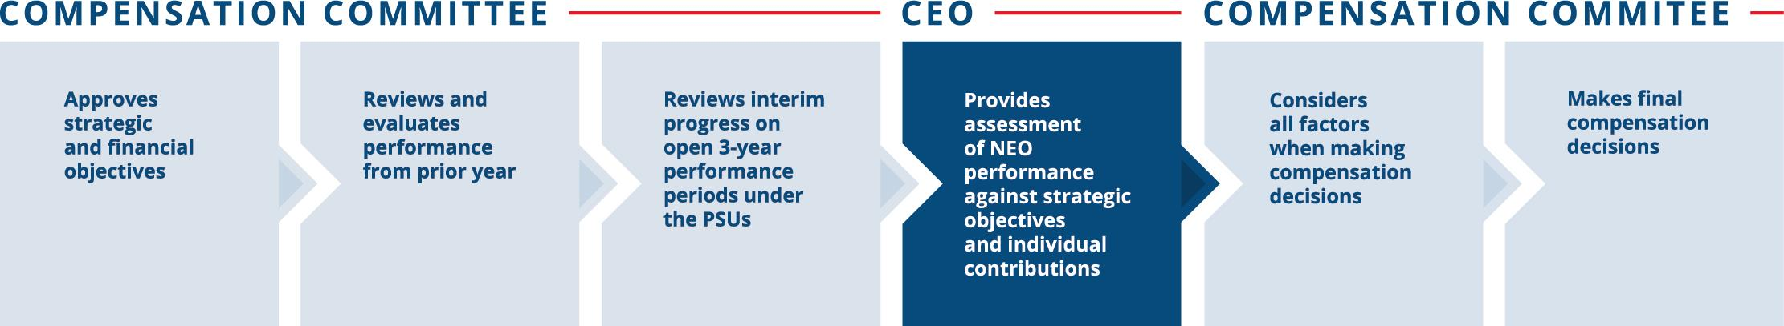

Compensation committee ceo
Role of the Independent Compensation Consultant and Other Advisors
Since 2003, the Talent & Compensation Committee has retained Pearl Meyer & Partners, LLC (“Pearl Meyer”) to assist with its review of compensation for the NEOs and other related matters. The Talent & Compensation Committee retains Pearl Meyer directly, supervises all work done by Pearl Meyer, and reviews and approves all work invoices. While Pearl Meyer provides data and analyses and makes recommendations on the form and amount of compensation, the Talent & Compensation Committee makes all decisions regarding the compensation of our NEOs.
During 2022, Pearl Meyer advised the Talent & Compensation Committee on a variety of subjects, including compensation plan design and trends, pay-for-performance analytics, Peer Group benchmarking and other related matters. Pearl Meyer reports directly to the Talent & Compensation Committee, participates in meetings as requested and communicates with the Talent & Compensation Committee chair between meetings, as necessary. Pearl Meyer also provides advice to the Governance Committee and its chair regarding director compensation. Pearl Meyer did not provide any other services during 2022 and is considered independent and free from conflict under the Dodd-Frank Wall Street Reform and Consumer Protection Act and associated standards set forth by the SEC and NYSE.
The Talent & Compensation Committee also may use market data provided by Equilar, Mercer and Willis Tower Watson for benchmarking and other purposes. This benchmarking data consists of information that is generally available to other Equilar, Mercer, and Willis Tower Watson clients. None of these consulting firms made recommendations to the Talent & Compensation Committee or management on peer group composition or on the form, amount or design of executive or director compensation in 2022.
Other Considerations
Employment Agreements and Executive Separation Policy
Except in limited circumstances, Republic does not enter into employment agreements. Our NEOs do not have employment agreements but instead are eligible to participate in the Executive Separation Policy. They also have non-competition and non-solicitation agreements with Republic. For more information regarding the employment agreements and Executive Separation Policy, see “Executive Compensation — Employment Agreements and Post-Employment Compensation.”
Annual Risk Assessment
Management conducted a risk assessment of Republic’s policies and programs relating to the compensation of employees, including those that apply to our executive officers. In particular, management considered the following factors of our compensation policies, practices and programs: the Talent & Compensation Committee’s robust governance controls; our balanced mix of long-term and short-term programs; our use of objective standards that are applied consistently from year to year; peer group benchmarking for stock performance; caps on PSU awards and annual incentives to limit windfalls; and clawback provisions designed to recoup compensation in circumstances set forth in the Company’s clawback policy.
Management discussed the findings of the risk assessment with the Talent & Compensation Committee. Based on the assessment, we believe that our compensation policies and practices create an appropriate balance between our base salary compensation, short-term incentive compensation and long-term incentive compensation, thereby reducing the possibility of imprudent risk-taking and that our compensation policies and practices do not create risks that are reasonably likely to have a material adverse effect on Republic.
Equity Usage (Burn Rate and Dilution)
Under our 2021 Stock Incentive Plan, as approved by our shareholders in May 2020 (the “SIP”), the total number of shares of equity-based awards granted in 2022 was approximately 0.09% of the diluted weighted average number of shares outstanding for the year and within the limitations set by the SIP. As of December 31, 2022, the total number of shares that could be issued under the SIP, and all predecessor plans, was approximately 3.8% of the diluted weighted average number of shares outstanding for the year. Republic’s diluted EPS reflects all potentially dilutive shares.

 | Republic Services, Inc. 2023 Proxy Statement | | | 69

PROXY SUMMARY |  | BOARD AND GOVERNANCE |  | EXECUTIVE COMPENSATION |  | PROPOSALS |  | MEETING INFORMATION |  | ANNEX

Talent & Compensation Committee Interlocks and Insider Participation
Messrs. Handley, Larson and Snee and Mses. Pegula and Weymouth served as members of the Talent & Compensation Committee during 2022. No member of the Talent & Compensation Committee is, or has ever been, an officer or employee of Republic. During 2022, none of our NEOs served as a member of the Talent & Compensation Committee (or other board committee performing equivalent functions) or as a director of another entity where an executive officer of such entity served either on our Board or on our Talent & Compensation Committee.
Talent & Compensation Committee Report
The following statement made by the Talent & Compensation Committee shall not be deemed incorporated by reference into any filing under the Securities Act or the Exchange Act and shall not otherwise be deemed filed under either of these Acts.
The Talent & Compensation Committee has reviewed and discussed with management the Compensation Discussion and Analysis required by Item 402(b) of Regulation S-K. Based on such review and discussions, the Talent & Compensation Committee recommended to the Board that this CD&A be included in this Proxy Statement.

Submitted by the Talent & Compensation Committee as of March 26, 2023:
Thomas W. Handley (Chair)
Michael Larson
James P. Snee
Katharine B. Weymouth

70 | | | Republic Services, Inc. 2023 Proxy Statement

PROXY SUMMARY |  | BOARD AND GOVERNANCE |  | EXECUTIVE COMPENSATION |  | PROPOSALS |  | MEETING INFORMATION |  | ANNEX

2022 Summary Compensation Table
The following Summary Compensation Table shows information about the compensation we paid to our CEO, CFO and other named executive officers during 2022, 2021 and 2020. We refer to the individuals shown in the table below as the named executive officers (“NEOs”).

NAME AND PRINCIPAL  2022 POSITIONS |  | Year | Salary  ($)(1) |  |  |  | Stock  Awards  ($)(2) |  |  |  | Non-Equity  Incentive Plan  Compensation  ($)(3) |  |  |  | All Other  Compensation  ($) |  |  |  | Total ($)
Jon Vander Ark(4) |  | 2022 |  | 1,075,000 |  |  |  | 5,660,534 |  |  |  | 2,849,000 |  |  |  | 250,787 |  |  |  | 9,835,321
President and Chief Executive |  | 2021 |  | 906,539 |  |  |  | 4,613,538 |  |  |  | 2,191,780 |  |  |  | 161,803 |  |  |  | 7,873,660
Officer |  | 2020 |  | 799,327 |  |  |  | 2,555,906 |  |  |  | 950,000 |  |  |  | 113,890 |  |  |  | 4,419,123
Brian M. DelGhiaccio |  | 2022 |  | 610,866 |  |  |  | 1,837,795 |  |  |  | 1,380,550 |  |  |  | 106,877 |  |  |  | 3,936,088
Executive Vice President, |  | 2021 |  | 569,308 |  |  |  | 1,485,304 |  |  |  | 1,132,033 |  |  |  | 94,760 |  |  |  | 3,281,405
Chief Financial Officer |  | 2020 |  | 497,212 |  |  |  | 862,926 |  |  |  | 601,083 |  |  |  | 91,230 |  |  |  | 2,052,451
Brian A. Bales(5) |  | 2022 |  | 509,423 |  |  |  | 1,033,815 |  |  |  | 769,600 |  |  |  | 104,150 |  |  |  | 2,416,988
Executive Vice President, |  | 2021 |  | — |  |  |  | — |  |  |  | — |  |  |  | — |  |  |  | —
Chief Development Officer |  | 2020 |  | — |  |  |  | — |  |  |  | — |  |  |  | — |  |  |  | —
Catharine D. Ellingsen |  | 2022 |  | 558,077 |  |  |  | 1,476,037 |  |  |  | 843,600 |  |  |  | 111,230 |  |  |  | 2,988,944
Executive Vice President, Chief Legal Officer, Chief |  | 2021 |  | 544,654 |  |  |  | 1,474,013 |  |  |  | 872,000 |  |  |  | 100,268 |  |  |  | 2,990,935
Ethics & Compliance Officer and Corporate Secretary |  | 2020 |  | 534,462 |  |  |  | 1,360,545 |  |  |  | 535,000 |  |  |  | 116,791 |  |  |  | 2,546,798
Timothy E. Stuart |  | 2022 |  | 680,481 |  |  |  | 2,334,395 |  |  |  | 1,157,176 |  |  |  | 109,672 |  |  |  | 4,281,724
Executive Vice President, |  | 2021 |  | 664,481 |  |  |  | 2,368,419 |  |  |  | 1,197,000 |  |  |  | 98,529 |  |  |  | 4,328,429
Chief Operating Officer |  | 2020 |  | 649,327 |  |  |  | 2,196,069 |  |  |  | 690,625 |  |  |  | 98,619 |  |  |  | 3,634,640

(1) | Amounts reflect base salary paid in the year.
(2) | Included in the Stock Awards column are the grant date fair values of RSU and PSU awards granted in 2022, 2021 and 2020, determined in accordance with FASB ASC Topic 718. See Note 12 to our Consolidated Financial Statements included in our Form 10-K for the fiscal year ended December 31, 2022 for a discussion of the relevant assumptions used in calculating grant date fair value. The amounts shown in the table above reflect grant date fair value and may not correspond to the actual value that will be realized by the NEOs. For purposes of calculating the grant date fair value of PSU awards, we have assumed that we will achieve target performance levels. The grant date fair values of the PSU awards have been restated from prior year disclosures.
(3) | The amounts shown for each of the years reflect the annual cash incentive earned for the year and, if applicable, the three-year long-term cash incentive earned for the performance cycle that ended in that year. At the time of his promotion to Executive Vice President, Chief Financial Officer in June 2020, Mr. DelGhiaccio was granted long-term cash incentives (“Supplemental LTIP”) for the 2018-2020, 2019-2021, and 2020-2022 performance periods. The Supplemental LTIP awards were granted in addition to his PSU and annual cash incentive awards for the applicable performance periods and increased his target awards for such periods to take into account his time in his new role for a portion of the applicable performance periods.
(4) | Mr. Vander Ark was named President and Chief Executive Officer effective June 25, 2021.
(5) | Mr. Bales was not an NEO in 2020 and 2021.

The non-equity incentive plan compensation amounts earned by each of the NEOs for 2022 are shown below:

NAME |  | 2022 ANNUAL  CASH INCENTIVE ($) |  |  |  |  | 2020 – 2022  SUPPLEMENTAL LTIP ($)
Jon Vander Ark |  |  | 2,849,000 |  |  |  | -
Brian M. DelGhiaccio |  |  | 982,813 |  |  |  |  | 397,737
Brian A. Bales |  |  | 769,600 |  |  |  | -
Catharine D. Ellingsen |  |  | 843,600 |  |  |  | -
Timothy E. Stuart |  |  | 1,157,176 |  |  |  | -

 | Republic Services, Inc. 2023 Proxy Statement | | | 71

PROXY SUMMARY |  | BOARD AND GOVERNANCE |  | EXECUTIVE COMPENSATION |  | PROPOSALS |  | MEETING INFORMATION |  | ANNEX

All Other Compensation for 2022

NAME | Matching  Contribution  to 401(k) Plan ($) |  |  |  | Matching  Contribution to  Deferred  Compensation  Plan ($) |  |  |  | Retirement  Contribution to  Deferred  Compensation  Plan ($) |  |  |  | Value of  Life Insurance  Premiums ($) |  |  |  | Perquisites and Other Personal Benefits  ($)(1) |  |  |  | Total ($)(2)
Jon Vander Ark |  | 12,200 |  |  |  | 83,094 |  |  |  | 100,000 |  |  |  | 760 |  |  |  | 54,733 |  |  |  | 250,787
Brian M. DelGhiaccio |  | 12,200 |  |  |  | 28,998 |  |  |  | 65,000 |  |  |  | 679 |  |  |  |  |  |  |  | 106,877
Brian A. Bales |  | 12,200 |  |  |  | 26,385 |  |  |  | 65,000 |  |  |  | 565 |  |  |  |  |  |  |  | 104,150
Catharine D. Ellingsen |  | 12,200 |  |  |  | 33,411 |  |  |  | 65,000 |  |  |  | 619 |  |  |  |  |  |  |  | 111,230
Timothy E. Stuart |  | 12,200 |  |  |  | 31,717 |  |  |  | 65,000 |  |  |  | 755 |  |  |  |  |  |  |  | 109,672

(1) | Includes perquisites and personal benefits received by an NEO, to the extent that the total value of such perquisites and personal benefits was at least $10,000. The amounts shown for Mr. Vander Ark reflect the incremental cost of providing Company-owned aircraft for non-business travel. This valuation differs from the valuation under applicable tax guidelines. Aggregate incremental cost includes the cost of in-flight catering, landing and ground handling fees, hangar or parking costs, and fuel costs based on the average annual cost of fuel per hour flown. Fixed costs that do not change based on usage are not included.
(2) | NEOs and other executives are entitled to participate in a concierge medical services program at an estimated cost per participant of $162. The cost is paid by the Company on behalf of the participant, and it is not included in the table shown above.

72 | | | Republic Services, Inc. 2023 Proxy Statement

PROXY SUMMARY |  | BOARD AND GOVERNANCE |  | EXECUTIVE COMPENSATION |  | PROPOSALS |  | MEETING INFORMATION |  | ANNEX

Grants of Plan-Based Awards in 2022
The following table sets forth information concerning each grant of an award to an NEO during the year ended December 31, 2022 under the Executive Incentive Plan or the SIP. Information regarding our awards under these plans also is included in our Compensation Discussion and Analysis.

 |  |  |  |  |  | Estimated Future Payouts  Under Non-Equity |  |  |  |  |  |  |  |  |  |  |  | Estimated Future Payouts  Under Equity Incentive |  |  |  |  |  |  |  |  |  |  |  | All Other  Stock  Awards:  Number of |  |  |  | Grant Date  Fair Value
 |  |  |  |  |  | Incentive Plan Awards |  |  |  |  |  |  |  |  |  |  |  | Plan Awards(4)(5) |  |  |  |  |  |  |  |  |  |  |  | Shares of |  |  |  | of Stock
NAME |  | Award  Type (1) |  | Grant  Date |  | Threshold  ($)(2) |  |  |  | Target  ($) |  |  |  | Maximum  ($)(3) |  |  |  | Threshold  (#) |  |  |  | Target  (#) |  |  |  | Maximum  (#) |  |  |  | Stock or  Units (#) |  |  |  | and Option  Awards(6) ($)
 |  | RSUs |  | 2/11/2022 |  |  |  |  |  |  |  |  |  |  |  |  |  |  |  |  |  |  |  |  |  |  |  |  |  |  | 14,146 |  |  |  | 1,700,066
Jon |  | PSUs |  | 2/11/2022 |  |  |  |  |  |  |  |  |  |  |  |  |  |  | 8,321 |  |  |  | 33,284 |  |  |  | 49,926 |  |  |  |  |  |  |  | 3,960,468
Vander Ark |  | Annual Cash Incentive |  |  |  |  | 192,500 |  |  |  | 1,540,000 |  |  |  | 3,080,000
 |  | RSUs |  | 2/11/2022 |  |  |  |  |  |  |  |  |  |  |  |  |  |  |  |  |  |  |  |  |  |  |  |  |  |  | 4,993 |  |  |  | 600,059
Brian M. |  | PSUs |  | 2/11/2022 |  |  |  |  |  |  |  |  |  |  |  |  |  |  | 2,601 |  |  |  | 10,402 |  |  |  | 15,603 |  |  |  |  |  |  |  | 1,237,736
DelGhiaccio |  | Annual Cash Incentive |  |  |  |  | 66,406 |  |  |  | 531,250 |  |  |  | 1,062,500
 |  | RSUs |  |  |  |  |  |  |  |  |  |  |  |  |  |  |  |  |  |  |  |  |  |  |  |  |  |  |  |  | 3,329 |  |  |  | 400,079
Brian A. |  | PSUs |  |  |  |  |  |  |  |  |  |  |  |  |  |  |  |  | 1,332 |  |  |  | 5,326 |  |  |  | 7,989 |  |  |  |  |  |  |  | 633,736
Bales |  | Annual Cash Incentive |  |  |  |  | 52,000 |  |  |  | 416,000 |  |  |  | 832,000
 |  | RSUs |  | 2/11/2022 |  |  |  |  |  |  |  |  |  |  |  |  |  |  |  |  |  |  |  |  |  |  |  |  |  |  | 4,868 |  |  |  | 585,036
Catharine D. |  | PSUs |  | 2/11/2022 |  |  |  |  |  |  |  |  |  |  |  |  |  |  | 1,872 |  |  |  | 7,488 |  |  |  | 11,232 |  |  |  |  |  |  |  | 891,001
Ellingsen |  | Annual Cash Incentive |  |  |  |  | 57,000 |  |  |  | 456,000 |  |  |  | 912,000
 |  | RSUs |  | 2/11/2022 |  |  |  |  |  |  |  |  |  |  |  |  |  |  |  |  |  |  |  |  |  |  |  |  |  |  | 6,241 |  |  |  | 750,043
Timothy E. |  | PSUs |  | 2/11/2022 |  |  |  |  |  |  |  |  |  |  |  |  |  |  | 3,329 |  |  |  | 13,315 |  |  |  | 19,973 |  |  |  |  |  |  |  | 1,584,352
Stuart |  | Annual Cash Incentive |  |  |  |  | 78,188 |  |  |  | 625,500 |  |  |  | 1,251,000

(1) | All equity awards granted in 2022 were granted under the SIP. For all NEOs, the annual cash incentive award was granted under the Executive Incentive Plan. For further details regarding annual compensation, see “Executive Compensation — Components of Executive Compensation.” The RSU awards shown above are scheduled to vest in equal annual installments over four years, beginning on the first anniversary of the grant date. The PSU awards shown above are scheduled to vest at the end of the three-year performance period based on performance for the 2022-2024 period.
(2) | This column shows the annual cash incentive payouts that would be earned if the minimum performance level were achieved. If at least the minimum level of performance is not achieved, no payout is made.
(3) | If the maximum level of performance is achieved under the annual cash incentive plan, the maximum payout would be 200% of target.
(4) | Represents the potential number of shares earned based on achievement of performance criteria for PSU awards granted under the SIP. The earned number of shares is payable half in cash and half in shares for all NEOs. No exercise price or other consideration is paid by the NEOs with respect to PSU awards. The PSU award measurement period is the three-year period beginning January 1, 2022 and ending December 31, 2024. PSUs accrue dividend equivalents, which are paid out based on the number of shares actually earned, if any, at the end of the performance period. If at least the minimum level of performance is not achieved, no payout will be made. See “Executive Compensation — Components of Executive Compensation” for further details regarding PSUs.
(5) | Included in the Estimated Future Payouts Under Equity Incentive Plan Awards column are the grant date fair values of RSU and PSU awards granted in 2022, 2021 and 2020, determined in accordance with FASB ASC Topic 718. See Note 12 to our Consolidated Financial Statements included in our Form 10-K for the fiscal year ended December 31, 2022 for a discussion of the relevant assumptions used in calculating grant date fair value. The amounts shown in the table above reflect grant date fair value and may not correspond to the actual value that will be realized by the NEOs. For purposes of calculating the grant date fair value of PSU awards, we have assumed that we will achieve target performance levels.
(6) | The value of PSUs will differ from the grant date fair value of PSUs shown in the Long-Term Incentive Awards table. A portion of the grant date fair value of PSUs shown here reflects total shareholder return relative to the S&P 500, and is based on a Monte Carlo valuation model.

 | Republic Services, Inc. 2023 Proxy Statement | | | 73

PROXY SUMMARY |  | BOARD AND GOVERNANCE |  | EXECUTIVE COMPENSATION |  | PROPOSALS |  | MEETING INFORMATION |  | ANNEX

Outstanding Equity Awards at Fiscal Year End
The following table reflects RSU and PSU awards granted to the NEOs that were outstanding as of December 31, 2022.

STOCK AWARDS(1)(2)
NAME | Grant Date |  | Number of Shares or Units of Stock that Have Not Vested |  |  |  | Market Value of Shares or Units of Stock that Have Not Vested ($) |  |  |  | Equity Incentive Plan Awards: Number of Shares, Units or Other Rights that Have Not Vested |  |  |  | Equity Incentive Plan: Market or Payout Value of Unearned Shares, Units or Rights that Have Not Vested ($)
Jon Vander Ark | 2/8/2019 |  |  | 2,344 |  |  |  | 302,353 |  |  |  | — |  |  |  | —
 | 2/14/2020 |  |  | 4,167 |  |  |  | 537,501 |  |  |  | 17,774 |  |  |  | 2,292,668
 | 2/23/2021 |  |  | 8,653 |  |  |  | 1,116,150 |  |  |  | 27,968 |  |  |  | 3,607,592
 | 6/25/2021 |  |  | 2,819 |  |  |  | 363,623 |  |  |  | 8,015 |  |  |  | 1,033,855
 | 2/11/2022 |  |  | 14,301 |  |  |  | 1,844,686 |  |  |  | 33,784 |  |  |  | 4,357,798
Brian M. DelGhiaccio (3) | 2/8/2019 |  |  | 556 |  |  |  | 71,718 |  |  |  | — |  |  |  | —
 | 2/14/2020 |  |  | 1,355 |  |  |  | 174,781 |  |  |  | 4,078 |  |  |  | 526,021
 | 6/1/2020 |  |  | 1,224 |  |  |  | 157,884 |  |  |  | — |  |  |  | —
 | 2/23/2021 |  |  | 4,978 |  |  |  | 642,112 |  |  |  | 10,787 |  |  |  | 1,391,415
 | 2/11/2022 |  |  | 5,049 |  |  |  | 651,271 |  |  |  | 10,558 |  |  |  | 1,361,876
Brian A. Bales (4) | 2/8/2019 |  |  | 1,302 |  |  |  | 167,945 |  |  |  | — |  |  |  | —
 | 2/14/2020 |  |  | 1,954 |  |  |  | 252,046 |  |  |  | 5,857 |  |  |  | 755,494
 | 2/23/2021 |  |  | 3,460 |  |  |  | 446,305 |  |  |  | 7,991 |  |  |  | 1,030,759
 | 2/11/2022 |  |  | 3,366 |  |  |  | 434,180 |  |  |  | 5,406 |  |  |  | 697,320
Catharine D. Ellingsen | 2/8/2019 |  |  | 1,737 |  |  |  | 224,056 |  |  |  | — |  |  |  | —
 | 2/14/2020 |  |  | 2,916 |  |  |  | 376,135 |  |  |  | 8,105 |  |  |  | 1,045,464
 | 2/23/2021 |  |  | 4,974 |  |  |  | 641,596 |  |  |  | 10,656 |  |  |  | 1,374,517
 | 2/11/2022 |  |  | 4,921 |  |  |  | 634,760 |  |  |  | 7,601 |  |  |  | 980,453
Timothy E. Stuart | 2/8/2019 |  |  | 1,947 |  |  |  | 251,144 |  |  |  | — |  |  |  | —
 | 2/14/2020 |  |  | 3,905 |  |  |  | 503,706 |  |  |  | 14,639 |  |  |  | 1,888,285
 | 2/23/2021 |  |  | 6,488 |  |  |  | 836,887 |  |  |  | 19,180 |  |  |  | 2,474,028
 | 2/11/2022 |  |  | 6,309 |  |  |  | 813,798 |  |  |  | 13,514 |  |  |  | 1,743,171

(1) | The values of the RSUs and PSUs are based on $128.99 per share, which was the closing price of Republic’s stock on December 30, 2022, the last trading day of our fiscal year.
(2) | Includes PSUs for the 2021-2023 and 2022-2024 performance periods. Subsequent to the end of a performance period, PSU payouts are generally made in February of the succeeding year after the Talent & Compensation Committee has determined the achievement of performance metrics. The PSUs for 2020-2022 performance period are not included in the table as they are considered vested as of December 31, 2022 for proxy statement disclosure purposes; instead, such PSUs are included in the “Option Exercises and Stock Vested In 2022” table.
(3) | Mr. DelGhiaccio deferred 100% of his RSU award granted in 2019 and deferred 50% of his RSU award granted in 2021 and 2022.
(4) | Mr. Bales deferred 100% of his RSU award granted in 2019, 2021, and 2022.

74 | | | Republic Services, Inc. 2023 Proxy Statement

PROXY SUMMARY |  | BOARD AND GOVERNANCE |  | EXECUTIVE COMPENSATION |  | PROPOSALS |  | MEETING INFORMATION |  | ANNEX

The vesting dates and number of shares vesting for the RSUs and PSUs are shown in the following table.

 | RSUs |  |  |  | PSUs
NAME | Vesting Date | Shares Vesting |  |  | Vesting Date | Shares Vesting
 | 2/8/2023 |  | 2,344 |  | 12/31/2023 |  | 35,983
 | 2/11/2023 |  | 3,574 |  | 12/31/2024 |  | 33,784
 | 2/14/2023 |  | 2,083
 | 2/23/2023 |  | 2,883
 | 6/25/2023 |  | 939
 | 2/11/2024 |  | 3,575
Jon Vander Ark | 2/14/2024 |  | 2,083
 | 2/23/2024 |  | 2,884
 | 6/25/2024 |  | 939
 | 2/11/2025 |  | 3,575
 | 2/23/2025 |  | 2,884
 | 6/25/2025 |  | 941
 | 2/11/2026 |  | 3,576
 | 2/8/2023 |  | 556 |  | 12/31/2023 |  | 10,787
 | 2/11/2023 |  | 1,260 |  | 12/31/2024 |  | 10,558
 | 2/14/2023 |  | 677
 | 2/23/2023 |  | 1,658
 | 6/1/2023 |  | 611
Brian M. DelGhiaccio(1) | 2/11/2024 |  | 1,262
 | 2/14/2024 |  | 677
 | 2/23/2024 |  | 1,658
 | 6/1/2024 |  | 612
 | 2/11/2025 |  | 1,262
 | 2/23/2025 |  | 1,658
 | 2/11/2026 |  | 1,264
 | 2/8/2023 |  | 1,302 |  | 12/31/2023 |  | 7,991
 | 2/11/2023 |  | 840 |  | 12/31/2024 |  | 5,406
 | 2/14/2023 |  | 977
 | 2/23/2023 |  | 1,153
Brian A. Bales(2) | 2/11/2024 |  | 841
 | 2/14/2024 |  | 977
 | 2/23/2024 |  | 1,153
 | 2/11/2025 |  | 842
 | 2/23/2025 |  | 1,154
 | 2/11/2026 |  | 842
 | 2/8/2023 |  | 1,737 |  | 12/31/2023 |  | 10,656
 | 2/11/2023 |  | 1,230 |  | 12/31/2024 |  | 7,601
 | 2/14/2023 |  | 1,458
 | 2/23/2023 |  | 1,657
Catharine D. Ellingsen | 2/11/2024 |  | 1,230
 | 2/14/2024 |  | 1,458
 | 2/23/2024 |  | 1,658
 | 2/11/2025 |  | 1,230
 | 2/23/2025 |  | 1,659
 | 2/11/2026 |  | 1,231
 | 2/8/2023 |  | 1,947 |  | 12/31/2023 |  | 19,180
 | 2/11/2023 |  | 1,576 |  | 12/31/2024 |  | 13,514
 | 2/14/2023 |  | 1,952
 | 2/23/2023 |  | 2,162
Timothy E. Stuart | 2/11/2024 |  | 1,577
 | 2/14/2024 |  | 1,952
 | 2/23/2024 |  | 2,162
 | 2/11/2025 |  | 1,577
 | 2/23/2025 |  | 2,164
 | 2/11/2026 |  | 1,578

(1) | Mr. DelGhiaccio has deferral arrangements for his awards with the following vesting dates: 2/8/23: Deferred 100%; 2/11/23: Deferred 50%; 2/23/23: Deferred 50%; 2/11/24: Deferred 50%; 2/23/24: Deferred 50%; 2/11/25: Deferred 50%; 2/23/25: Deferred 50%, 2/11/26: Deferred 50%.
(2) | Mr. Bales has deferral arrangements for his RSU awards with the following vesting dates: 2/8/23: Deferred 100%; 2/11/23: Deferred 100%; 2/23/23: Deferred 100%; 2/11/24: Deferred 100%; 2/23/24: Deferred 100%; 2/11/25: Deferred 100%; 2/23/25: Deferred 100%, 2/11/26: Deferred 100%.

 | Republic Services, Inc. 2023 Proxy Statement | | | 75

PROXY SUMMARY |  | BOARD AND GOVERNANCE |  | EXECUTIVE COMPENSATION |  | PROPOSALS |  | MEETING INFORMATION |  | ANNEX

PSUs and RSUs Vested in 2022
The following table reflects the vesting of previously granted RSUs and PSUs for each of the NEOs during the year ended December 31, 2022. The value represented by the vesting of the RSUs or PSUs is based on the closing price of our stock on the vesting date.

 | STOCK AWARDS(1)
NAME | Number of  Shares Acquired  on Vesting |  |  |  | Value Realized  on Vesting ($)
Jon Vander Ark |  | 117,995 |  |  |  | 15,659,965
Brian M. DelGhiaccio |  | 8,378 |  |  |  | 1,059,907
Brian A. Bales |  | 15,586 |  |  |  | 1,944,321
Catharine D. Ellingsen |  | 11,440 |  |  |  | 1,426,265
Timothy E. Stuart |  | 76,995 |  |  |  | 10,170,382

(1) | The amounts reflected in this table include the vesting in 2022 of PSUs granted for the 2020-2022 performance period. Upon vesting, 50% of the PSU awards settled in cash on February 8, 2023, and 50% of the PSU awards settled in shares on February 17, 2023.
Nonqualified Deferred Compensation in 2022
The following table reflects information concerning the participation of our NEOs in our nonqualified Deferred Compensation Plan. For a description of that plan, see “Executive Compensation — Compensation Discussion and Analysis — Components of Executive Compensation — Deferred Compensation Plan and Deferred Compensation Savings Program Contributions.”

NAME | Executive  Contributions  in Last Fiscal  Year ($)(1) |  |  |  | Registrant  Contributions  in Last Fiscal  Year ($)(2) |  |  |  | Aggregate  Earnings in  Last Fiscal  Year ($)(3) |  |  |  | Aggregate  Withdrawals/  Distributions ($) |  |  |  | Aggregate  Balance at Last  Fiscal Year End  ($)(4)
Jon Vander Ark |  | 167,426 |  |  |  | 183,094 |  |  |  | (430,047 | ) |  |  | — |  |  |  | 3,709,209
Brian M. DelGhiaccio |  | 522,873 |  |  |  | 93,998 |  |  |  | (462,250 | ) |  |  | — |  |  |  | 4,923,206
Brian A. Bales |  | 891,919 |  |  |  | 91,385 |  |  |  | (940,370 | ) |  |  | — |  |  |  | 13,319,247
Catharine D. Ellingsen |  | 77,742 |  |  |  | 98,411 |  |  |  | (452,154 | ) |  |  | — |  |  |  | 3,951,420
Timothy E. Stuart |  | 1,832,611 |  |  |  | 96,717 |  |  |  | (514,622 | ) |  |  | — |  |  |  | 5,709,866

(1) | All amounts contributed to the DCP by the NEOs in 2022 have been included in the Summary Compensation Table as Salary, Stock Awards or Non-Equity Incentive Plan Compensation.
(2) | This column includes retirement contributions of $100,000 for Mr. Vander Ark and $65,000 for each of Ms. Ellingsen and Messrs. DelGhiaccio, Bales and Stuart that were made by Republic to the plan on behalf of the executive. These amounts vest in accordance with the terms of the plan described in the CD&A. All other amounts in this column relate to matching contributions made by Republic during 2023 that are attributable to 2022 executive contributions.
(3) | For deferrals of RSUs and stock-settled PSUs, earnings are calculated based on the change in the price of our common stock during 2022. For cash deferrals, earnings are calculated based on the performance of the measurement funds selected by the participants.
(4) | For Ms. Ellingsen and Messrs. Vander Ark, DelGhiaccio and Stuart, these amounts include the following amounts reported as compensation in 2020 and 2021 in the Summary Compensation Table: Mr. Vander Ark: $177,513; Mr. DelGhiaccio: $847,532; Ms. Ellingsen: $207,207; and Mr. Stuart: $206,789.

76 | | | Republic Services, Inc. 2023 Proxy Statement

PROXY SUMMARY |  | BOARD AND GOVERNANCE |  | EXECUTIVE COMPENSATION |  | PROPOSALS |  | MEETING INFORMATION |  | ANNEX

Employment Agreements and Post-Employment Compensation
Employment Agreements
We do not have employment agreements with any of our NEOs.
Executive Separation Policy
The Talent & Compensation Committee adopted a revised Executive Separation Policy (the “Separation Policy”) in February 2023 to ensure we are able to attract and retain the most qualified and capable professionals to serve in key executive positions to maximize the value of Republic for the benefit of our shareholders. The Separation Policy is in effect for our Executive Officers, each Executive Vice President who is not an Executive Officer, and each Senior Vice President, Area President and Vice President. The Talent & Compensation Committee may, in its discretion, make the Separation Policy applicable to other members of management.
Each of our NEOs (collectively, the “Covered Executives”) participate in our Separation Policy. Severance benefits under the Separation Policy are subject to the following requirements: (1) having an agreement containing non-solicitation, confidentiality and arbitration provisions and, if appropriate, a non-competition provision (which each has done); (2) executing a separation agreement containing a full release of legal claims; (3) refraining from disparaging Republic following their employment with us; and (4) providing reasonable cooperation and assistance concerning legal or business matters as requested by Republic following their employment.
Under the Separation Policy, together with the applicable plans and award agreements, the Covered Executive will receive the following compensation for each respective scenario:
Death: Upon the Covered Executive’s death:
 | • | the Company will pay all base salary earned, but not yet paid;
 | • | the Company will pay the employer contributions to the DCP made on the Covered Executive’s behalf and earnings on those amounts;
 | • | the Covered Executive’s annual cash incentive awards will vest and be payable at target, except that any awards determined to be earned prior to death will be payable following the end of the applicable performance period at the actual amount to be determined;
 | • | the Covered Executive’s outstanding equity awards will immediately vest;
 | • | the Covered Executive’s earned PSUs will vest on a prorated schedule;
 | • | for Mr. DelGhiaccio, the Supplemental LTIP award will vest on prorated schedule; and
 | • | the Covered Executive’ s qualified beneficiaries will receive continued coverage under certain welfare plans in accordance with our benefit continuation policy under COBRA.
Disability: If the Covered Executive’s employment is terminated due to disability:
 | • | the Company will pay all base salary earned, but not yet paid;
 | • | the Company will pay the employer contributions to the DCP made on the Covered Executive’s behalf and earnings on those amounts;
 | • | the Covered Executive’s annual cash incentive awards will vest and be payable on a prorated basis in an amount determined by the Talent & Compensation Committee, based on actual Company performance, payable following the end of the performance period, except that any awards determined to be earned prior to any disability will be payable following the end of the applicable performance period at the actual amount to be determined;
 | • | the Covered Executive’s outstanding equity awards will immediately vest;
 | • | the Covered Executive’s earned PSUs will vest on a prorated schedule;
 | • | for Mr. DelGhiaccio, the Supplemental LTIP award will vest on prorated schedule; and
 | • | the Covered Executive and his or her qualified beneficiaries will receive continued coverage under certain welfare plans in accordance with our benefit continuation policy under COBRA.
Without Cause by the Company: If the Covered Executive’s employment is terminated without cause (as such term is defined in the Separation Policy):
 | • | the Company will pay all base salary earned, but not yet paid;
 | • | the Company will pay the employer contributions to the DCP made on the Covered Executive’s behalf and earnings on those amounts;
 | • | the Covered Executive will receive continued base salary for two years (provided that Mr. Vander Ark would receive continued base salary plus target annual bonus for two years);
 | • | except for Mr. Vander Ark, all annual cash incentive awards will vest and be payable on a prorated basis in an amount determined by the Talent & Compensation Committee, based on actual Company performance, payable following the end of the performance period;
 | • | the Covered Executive’s outstanding equity awards will continue to vest for up to one year following termination;

 | Republic Services, Inc. 2023 Proxy Statement | | | 77

PROXY SUMMARY |  | BOARD AND GOVERNANCE |  | EXECUTIVE COMPENSATION |  | PROPOSALS |  | MEETING INFORMATION |  | ANNEX

 | • | the Covered Executive’s earned PSUs will vest on a prorated schedule;
 | • | for Mr. DelGhiaccio, the Supplemental LTIP award will vest on a prorated schedule; and
 | • | the Covered Executive and his or her qualified beneficiaries will receive continued coverage under certain welfare plans for up to two years.
Without Cause by the Company or by the Covered Executive for Good Reason – Change in Control: If the Covered Executive’s employment is terminated without cause or by the Covered Executive for good reason (as such terms are defined in the Separation Policy) within one year after a change in control, then:
 | • | the Company will pay all base salary earned, but not yet paid;
 | • | the Company will pay the employer contributions to the DCP made on the Covered Executive’s behalf and earnings on those amounts;
 | • | the Covered Executive will receive a lump sum payment in the amount of two times the sum of the current base salary and the target annual cash incentive award for the year in which termination occurs, payable six months following termination;
 | • | all annual cash awards outstanding as of the change in control will vest and become payable at target no later than ten days following the change in control;
 | • | all PSUs outstanding as of the termination date will vest and become payable at target and without proration;
 | • | the Covered Executive’s outstanding equity, including RSUs outstanding as of the termination date, will immediately vest;
 | • | for Mr. DelGhiaccio, the Supplemental LTIP award outstanding as of the termination date will vest and become payable at target and without proration; and
 | • | the Covered Executive and his or her qualified beneficiaries will receive continued coverage under certain welfare plans for up to two years.
For Cause by the Company or if the Covered Employee Resigns Without Good Reason: If the Covered Executive is terminated for cause by Republic or resigns without good reason:
 | • | the Covered Executive will receive all base salary earned, but not yet paid;
 | • | the Covered Executive will receive the employer contributions to the DCP made on the Covered Executive’s behalf and earnings on those amounts if the Covered Executive meets the definition of “retirement”, as defined by the DCP; and
 | • | the Covered Executive and his or her qualified beneficiaries will receive continued coverage under certain welfare plans in accordance with our benefit continuation policy under COBRA.
The Talent & Compensation Committee may use its discretion to make post-termination payments to executive officers that may not be required pursuant to the terms of the Separation Policy if such payments are determined to be in Republic’s best interests.
Retirement
Upon satisfying Republic’s definition of “retirement” and providing proper notice to the Company:
 | • | the NEO will receive all base salary earned, but not yet paid;
 | • | the NEO’s outstanding RSUs will immediately vest;
 | • | the NEO’s earned PSUs will vest in full; and
 | • | the Covered Executive and his or her qualified beneficiaries will receive continuation coverage under certain welfare plans in accordance with our benefit continuation policy under COBRA.
Additionally, Republic will pay the employer contributions to the DCP made on the executive’s behalf and earnings on those amounts if the executive meets the definition of “retirement”, as defined by the DCP, and will provide continued coverage under certain welfare plans in accordance with our benefit continuation policy under COBRA.
Potential Payments upon Termination
Described below is the post-employment consideration payable to Ms. Ellingsen and Messrs. Vander Ark, DelGhiaccio, Bales and Stuart under applicable policies in the event of a covered termination, and assuming the specified events occurred on December 31, 2022. We have not quantified the estimated welfare benefits payable because we do not believe any estimates would be meaningful.
We can terminate an NEO’s employment without cause at any time. Ms. Ellingsen and Messrs. Vander Ark , DelGhiaccio, Bales and Stuart can terminate their employment for good reason during the one-year period following a change in control if we reduce their salary, incentive opportunity or title.
For purposes of the calculations in the following table related to our common stock, the value of RSUs and the value of PSUs for the 2021-2023 and 2022-2024 performance periods is based on a price of $128.99, the closing price of our stock on December 30, 2022, the last trading day of our 2022 fiscal year. Also, because actual payouts for the 2021-2023 and 2022-2024 PSUs performance periods have not yet been determined, calculations based on actual payouts of such performance periods assume that payouts will be at target. The balance of Company contributions to the DCP that were not previously vested will become vested and payable in accordance with the terms of the DCP. The following table does not include amounts contributed by the executives into their DCP accounts.

78 | | | Republic Services, Inc. 2023 Proxy Statement

PROXY SUMMARY |  | BOARD AND GOVERNANCE |  | EXECUTIVE COMPENSATION |  | PROPOSALS |  | MEETING INFORMATION |  | ANNEX

POTENTIAL PAYMENTS UPON TERMINATION TABLE(1,5)

NAME |  | DEATH |  |  |  |  | DISABILITY |  |  |  |  |  | COMPANY  TERMINATION  W/O CAUSE  OR FOR GOOD  REASON(5) |  |  |  |  |  | CHANGE IN  CONTROL(8) |  |  |  |  |  | RETIREMENT(12)
Jon Vander Ark
Severance |  |  | — |  |  |  |  |  | — |  |  |  |  |  | 5,280,000 |  | (7) |  |  |  | 5,280,000 |  | (11) |  |  |  | —
Stock Awards |  |  | 11,279,152 |  | (1) |  |  |  | 11,279,152 |  | (1) |  |  |  | 8,640,371 |  | (6) |  |  |  | 15,456,227 |  | (9) |  |  |  | —
Non Equity Incentive Plan |  |  | 1,540,000 |  | (2) |  |  |  | 2,849,000 |  | (4) |  |  |  | 2,849,000 |  | (4) |  |  |  | 1,540,000 |  | (10) |  |  |  | —
Deferred Compensation |  |  | 945,793 |  | (3) |  |  |  | 945,793 |  | (3) |  |  |  | 945,793 |  | (3) |  |  |  | 945,793 |  | (3) |  |  |  | —
TOTAL COMPENSATION PAYABLE |  |  | 13,764,945 |  |  |  |  |  | 15,073,945 |  |  |  |  |  | 17,715,164 |  |  |  |  |  | 23,222,020 |  |  |  |  |  | —
Brian M. DelGhiaccio
Severance |  |  | — |  |  |  |  |  | — |  |  |  |  |  | 1,250,000 |  | (7) |  |  |  | 2,312,500 |  | (11) |  |  |  | —
Stock Awards |  |  | 3,404,792 |  | (1) |  |  |  | 3,404,792 |  | (1) |  |  |  | 2,321,931 |  | (6) |  |  |  | 4,977,079 |  | (9) |  |  |  | —
Non Equity Incentive Plan |  |  | 928,987 |  | (2) |  |  |  | 1,380,550 |  | (4) |  |  |  | 1,380,550 |  | (4) |  |  |  | 864,583 |  | (10) |  |  |  | —
Deferred Compensation |  |  | 644,265 |  | (3) |  |  |  | 644,265 |  | (3) |  |  |  | 644,265 |  | (3) |  |  |  | 644,265 |  | (3) |  |  |  | —
TOTAL COMPENSATION PAYABLE |  |  | 4,978,044 |  |  |  |  |  | 5,429,607 |  |  |  |  |  | 5,199,009 |  |  |  |  |  | 8,798,427 |  |  |  |  |  | —
Brian A. Bales
Severance |  |  | — |  |  |  |  |  | — |  |  |  |  |  | 1,040,000 |  | (7) |  |  |  | 1,872,000 |  | (11) |  |  |  | —
Stock Awards |  |  | 3,544,891 |  | (1) |  |  |  | 3,544,891 |  | (1) |  |  |  | 2,595,299 |  | (6) |  |  |  | 4,142,643 |  | (9) |  |  |  | 4,353,400 |  | (13)
Non Equity Incentive Plan |  |  | 416,000 |  | (2) |  |  |  | 769,600 |  | (4) |  |  |  | 769,600 |  | (4) |  |  |  | 416,000 |  | (10) |  |  |  | 769,600 |  | (14)
Deferred Compensation |  |  | 3,359,211 |  | (3) |  |  |  | 3,359,211 |  | (3) |  |  |  | 3,359,211 |  | (3) |  |  |  | 3,359,211 |  | (3) |  |  |  | 3,359,211 |  | (3)
TOTAL COMPENSATION PAYABLE |  |  | 7,320,102 |  |  |  |  |  | 7,673,702 |  |  |  |  |  | 7,764,110 |  |  |  |  |  | 9,789,854 |  |  |  |  |  | 8,482,211
Catharine D. Ellingsen
Severance |  |  | — |  |  |  |  |  | — |  |  |  |  |  | 1,140,000 |  | (7) |  |  |  | 2,052,000 |  | (11) |  |  |  | —
Stock Awards |  |  | 3,608,853 |  | (1) |  |  |  | 3,608,853 |  | (1) |  |  |  | 2,993,055 |  | (6) |  |  |  | 4,642,221 |  | (9) |  |  |  | 4,720,618 |  | (13)
Non Equity Incentive Plan |  |  | 456,000 |  | (2) |  |  |  | 843,600 |  | (4) |  |  |  | 843,600 |  | (4) |  |  |  | 456,000 |  | (10) |  |  |  | 843,600 |  | (14)
Deferred Compensation |  |  | 1,732,600 |  | (3) |  |  |  | 1,732,600 |  | (3) |  |  |  | 1,732,600 |  | (3) |  |  |  | 1,732,600 |  | (3) |  |  |  | 1,732,600 |  | (3)
TOTAL COMPENSATION PAYABLE |  |  | 5,797,453 |  |  |  |  |  | 6,185,053 |  |  |  |  |  | 6,709,255 |  |  |  |  |  | 8,882,821 |  |  |  |  |  | 7,296,818
Timothy E. Stuart
Severance |  |  | — |  |  |  |  |  | — |  |  |  |  |  | 1,390,000 |  | (7) |  |  |  | 2,641,000 |  | (11) |  |  |  | —
Stock Awards |  |  | 6,573,055 |  | (1) |  |  |  | 6,573,055 |  | (1) |  |  |  | 5,152,929 |  | (6) |  |  |  | 8,591,637 |  | (9) |  |  |  | —
Non Equity Incentive Plan |  |  | 625,500 |  | (2) |  |  |  | 1,157,176 |  | (4) |  |  |  | 1,157,176 |  | (4) |  |  |  | 625,500 |  | (10) |  |  |  | —
Deferred Compensation |  |  | 923,652 |  | (3) |  |  |  | 923,652 |  | (3) |  |  |  | 923,652 |  | (3) |  |  |  | 923,652 |  | (3) |  |  |  | —
TOTAL COMPENSATION PAYABLE |  |  | 8,122,207 |  |  |  |  |  | 8,653,883 |  |  |  |  |  | 8,623,757 |  |  |  |  |  | 12,790,789 |  |  |  |  |  | —

(1) | Amounts include the prorated vesting in a portion of earned PSUs for the 2021-2023 and 2022-2024 performance periods (calculated using target for purposes of the table above) and the vesting in the full number of earned PSUs for the 2020-2022 performance period (based on the closing prices of our stock of $124.42 on February 8, 2023 for cash-settled PSUs and $131.96 on February 17, 2023 for stock-settled PSUs). Amounts also include the immediate vesting of outstanding RSUs.
(2) | For Ms. Ellingsen and Messrs. Vander Ark, Bales and Stuart, amounts reflect the target 2022 annual cash incentive award. For Mr. DelGhiaccio, amount reflects target 2022 annual cash incentive award and actual Supplemental LTIP award for the 2020-2022 performance period.
(3) | This includes the employer contributions to the DCP made on the executive’s behalf and earnings on those amounts. The amount will be paid to the executive’s beneficiary upon the executive’s death. This amount does not include amounts that have been previously earned and deferred by the executive, nor does it include any unvested RSUs or PSUs that the executive has elected to defer (the early vesting of which is reflected in the “Stock Awards” row for each respective executive).
(4) | For Ms. Ellingsen and Messrs. Vander Ark, Bales and Stuart, amounts include the actual 2022 annual cash incentive award. For Mr. DelGhiaccio, amount reflects actual 2022 annual cash incentive award and actual Supplemental LTIP award for the 2020-2022 performance period.
(5) | Absent a change in control, no NEO may terminate for “good reason”, and the consideration described in this column would only be provided in the event of a termination by the Company without cause.
(6) | For each of the NEOs, the table includes outstanding RSUs that will continue to vest for up to one year following termination. For each of the NEOs, Stock Awards include amounts for the prorated vesting in a portion of earned PSUs for the 2021-2023 and 2022-2024 performance periods (calculated using target for purposes of the table above) and the vesting in the full number of

 | Republic Services, Inc. 2023 Proxy Statement | | | 79

PROXY SUMMARY |  | BOARD AND GOVERNANCE |  | EXECUTIVE COMPENSATION |  | PROPOSALS |  | MEETING INFORMATION |  | ANNEX

earned PSUs for the 2020-2022 performance period (based on the closing price of our stock of $124.42 on February 8, 2023 for cash-settled PSUs and $131.96 on February 17, 2023 for stock-settled PSUs).
(7) | For Mr. Vander Ark, the amount reflects continued base salary plus target annual bonus for two years. For Ms. Ellingsen and Messrs. Bales, DelGhiaccio and Stuart, the amounts reflect continued base salary for two years.
(8) | The payments set forth in this column assume a change in control and a termination without cause or a resignation for good reason occurring on December 31, 2022.
(9) | Amounts reflect target PSU awards for the 2020-2022, 2021-2023 and 2022-2024 performance periods and immediate vesting of outstanding RSU awards.
(10) | For Ms. Ellingsen and Messrs. Vander Ark, Bales and Stuart, amounts reflect target 2022 annual cash incentive award. For Mr. DelGhiaccio, amount reflects target 2022 annual cash incentive award and target Supplemental LTIP awards for the 2020-2022 and 2021-2023 performance periods.
(11) | Amounts reflect a lump sum payment in the amount of two times the sum of current base salary and target annual cash incentive award for the year in which termination occurs, payable six months following termination.
(12) | As of December 31, 2022, Ms. Ellingsen and Mr. Bales have met the age and service requirements to be eligible for retirement, but they have not met the notice requirement to be eligible for retirement. The payments set forth in the table above assume that Ms. Ellingsen and Mr. Bales have met the notice requirement as of December 31, 2022.
(13) | Amounts reflect vesting in the full number of earned PSUs for the 2020-2022 performance period (based on the closing price of our stock of $124.42 on February 8, 2023 for cash-settled PSUs and $131.96 on February 17, 2023 for stock-settled PSUs), vesting in the full number of earned PSUs for the 2021-2023 and 2022-2024 performance periods (calculated using target for purposes of the table above) and the immediate vesting of outstanding RSUs upon retirement.
(14) | Amounts reflect actual 2022 annual cash incentive award for Ms. Ellingsen and Mr. Bales.
CEO Pay Ratio
We determined that the 2022 annual total compensation of the individual identified as our median compensated employee was $71,600; our CEO’s 2022 annual total compensation was $9,835,321, and the ratio of these amounts was 1-to-137.
In accordance with SEC requirements, we determined that there have been no changes to our employee population or compensation arrangements in 2022 that we believe would significantly affect our pay ratio disclosure. In determining our pay ratio for 2022, we used the same median employee as we identified last year according to the process identified below. With respect to the annual total compensation of the median employee, we identified and calculated the elements of such employee’s compensation for 2022 in accordance with SEC rules.
To identify our median employee for purposes of this analysis, we made the following assumptions:
 | • | We included all individuals (excluding our CEO) employed on December 31, 2021 who had received a W-2 from the Company during 2021;
 | • | We utilized W-2, Box 5 payroll data for 2022 as our consistently applied compensation measure, annualizing pay for those individuals employed less than a full calendar year.
This pay ratio is a reasonable estimate calculated in a manner consistent with SEC rules. The SEC rules for identifying the median compensated employee and calculating the pay ratio based on that employee’s annual total compensation allow companies to adopt a variety of methodologies, to apply certain exclusions, and to make reasonable estimates and assumptions that reflect their compensation practices. As such, the pay ratio reported by other companies may not be comparable to the pay ratio reported above, as other companies may have different employment and compensation practices and may utilize different methodologies, exclusions, estimates and assumptions in calculating their own pay ratios.

80 | | | Republic Services, Inc. 2023 Proxy Statement

PROXY SUMMARY |  | BOARD AND GOVERNANCE |  | EXECUTIVE COMPENSATION |  | PROPOSALS |  | MEETING INFORMATION |  | ANNEX

Pay versus Performance
As required by Section 953(a) of the Dodd-Frank Act and Item 402(v) of Regulation S-K, we are providing the following pay versus performance (“PVP”) table and related information, including “compensation actually paid” (as defined by the SEC and further described below) or “CAP”. For details about the Company’s pay-for-performance philosophy and how the Compensation Committee makes its decisions about executive pay, you should refer to the CD&A.
PVP Table

Value of Initial Fixed $100
Investment Based On:
Year |  | SCT Total  for PEO  (Slager) (1) |  | CAP to PEO  (Slager) (1) (2) |  | SCT total  for PEO  (Vander  Ark) (3) |  | CAP to PEO (Vander  Ark) (2) (3) |  | Average  SCT Total  for Non-PEO  NEOs (4) |  | Average  CAP to  Non-PEO  NEOs (4) |  | Total  Shareholder  Return |  | Peer  Group(5)  Total  Shareholder  Return |  | Net  Income |  | Adjusted  Free Cash  Flow(6)
2022 |  | N/A |  | N/A |  | $9,835,321 |  | $11,406,427 |  | $3,405,956 |  | $3,585,526 |  | $151.12 |  | $134.88 |  | $1,487.6 |  | $1,742.4
2021 |  | $15,027,945 |  | $33,585,755 |  | $7,873,660 |  | $18,049,267 |  | $3,365,003 |  | $6,863,359 |  | $161.05 |  | $145.53 |  | $1,290.4 |  | $1,515.2
2020 |  | $12,937,163 |  | $13,522,931 |  | N/A |  | N/A |  | $3,126,908 |  | $3,358,427 |  | $109.53 |  | $122.44 |  | $967.2 |  | $1,235.9

(1) | Reflects compensation for our former Chief Executive Officer, Mr. Slager, who served as our Principal Executive Officer (PEO) throughout 2020 and part of 2021 until his retirement effective June 25, 2021.
(2) | CAP is calculated by making the following adjustments from the SCT totals as follows:

PEOs:

Item and Value Added (Deducted) |  | 2022  Vander Ark | 2021  Vander Ark | 2021  Slager | 2020  Slager
- SCT Stock Awards Column Value |  | ($5,660,534) | ($4,613,538) | ($10,004,991) | ($9,159,438)
+ Year-End Fair Value of Outstanding Equity Awards Granted in Covered Year |  | $6,862,648 | $8,543,250 | $14,959,599 | $7,904,205
+/- Change in Fair Value of Outstanding Equity Awards Granted in Prior Years |  | ($131,216) | $5,164,238 | $4,211,103 | $516,319
+/- Change in Fair Value of Prior-Year Equity Awards Vested in Covered Year |  | ($686,831) | $902,692 | $4,485,722 | $503,251
+ Fair Value as of Vesting Date of Equity Awards Granted and Vested in Covered Year |  | $0 | $0 | $3,632,397 | $0
+ Average Value of Dividends Paid on Equity Awards not Otherwise Reflected in Fair Value of Total Compensation |  | $1,187,039 | $178,966 | $1,273,980 | $821,431

 | Republic Services, Inc. 2023 Proxy Statement | | | 81

PROXY SUMMARY |  | BOARD AND GOVERNANCE |  | EXECUTIVE COMPENSATION |  | PROPOSALS |  | MEETING INFORMATION |  | ANNEX

Average Non-PEO NEOs:

Item and Value Added (Deducted) |  | 2022 | 2021 | 2020
- SCT Stock Awards Column Value |  | ($1,670,511) | ($1,673,751) | ($1,717,272)
+ Year-End Fair Value of Outstanding Equity Awards Granted in Covered Year |  | $1,928,470 | $3,219,620 | $1,503,029
+/- Change in Fair Value of Outstanding Equity Awards Granted in Prior Years |  | ($75,670) | $1,472,118 | $255,451
+/- Change in Fair Value of Prior-Year Equity Awards Vested in Covered Year |  | ($232,884) | $381,819 | $73,862
+ Average Value of Dividends Paid on Equity Awards not Otherwise Reflected in Fair Value of Total Compensation |  | $230,184 | $98,550 | $116,450

Pay versus performance measurement date fair values were determined based on the same methodology used for grant date fair value purposes. Restricted stock units were valued based on the closing stock price on the relevant measurement date. Performance stock units were valued using a fair value per share determined using a Monte Carlo model run on the relevant measurement date. On the vesting date, the final payout factor is applied to the closing stock price on that date.

(3) | Reflects compensation for our President and Chief Executive Officer, Mr. Vander Ark, who has served as our PEO since June 25, 2021. The compensation reflected includes Mr. Vander Ark’s pay as a non-PEO NEO in 2021.
(4) | The Company’s non-PEO NEOs for 2020-2022 were:
 | 2020: | Brian M. DelGhiaccio, Catharine D. Ellingsen, Charles F. Serianni, Timothy E. Stuart and Jon Vander Ark
 | 2021: | Brian M. DelGhiaccio, Catharine D. Ellingsen, Jeffrey A. Hughes and Timothy E. Stuart
 | 2022: | Brian M. DelGhiaccio, Brian A. Bales, Catharine D. Ellingsen and Timothy E. Stuart
(5) | The Company has used its peer group from the CD&A for purposes of this comparison. The companies that comprised the peer group selected by the Compensation Committee in our CD&A were as follows:
 | 2021 & 2022: | Air Products and Chemicals, Inc., American Electric Power Company, Inc., Canadian National Railway Company, Canadian Pacific Railway Limited, Cintas Corporation, CSX Corporation, Ecolab Inc., Entergy Corporation, Fastenal Company, FedEx Corporation, J.B. Hunt Transport Services, Inc., Norfolk Southern Corporation, Ryder System, Inc., Sysco Corporation, W.W. Grainger, Inc., Waste Connections, Inc. and Waste Management, Inc.
 | 2020: | Air Products and Chemicals, Inc., Canadian National Railway Company, Canadian Pacific Railway Limited, CSX Corporation, FedEx Corporation, J.B. Hunt Transport Services, Inc., Norfolk Southern Corporation, Ryder System, Inc., Stericycle, Inc., Sysco Corporation, W.W. Grainger, Inc., Waste Connections, Inc. and Waste Management, Inc.
(6) | The Company Selected Measure is adjusted free cash flow, as described in the CD&A section. Adjusted free cash flow is a non-GAAP financial measure. For a reconciliation of adjusted free cash flow to its comparable GAAP measure, see “Reconciliation of GAAP to Non-GAAP Financial Measures” in the Annex on page 98.

82 | | | Republic Services, Inc. 2023 Proxy Statement

PROXY SUMMARY |  | BOARD AND GOVERNANCE |  | EXECUTIVE COMPENSATION |  | PROPOSALS |  | MEETING INFORMATION |  | ANNEX

The charts below describe the relationship between the PEO and other NEOs’ CAP to Company and Peer Group Total Shareholder Return, Net Income and Adjusted Free Cash Flow. In the case of Total Shareholder Return, amount assumes $100 invested on January 1, 2020 assuming reinvestment of all dividends.

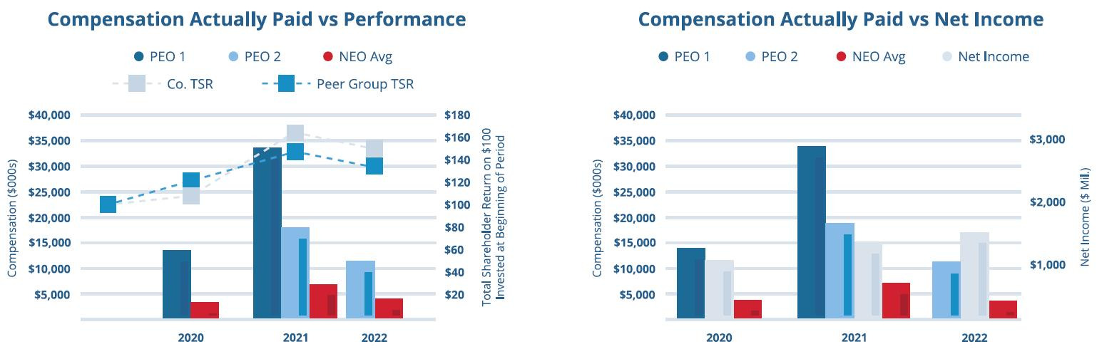

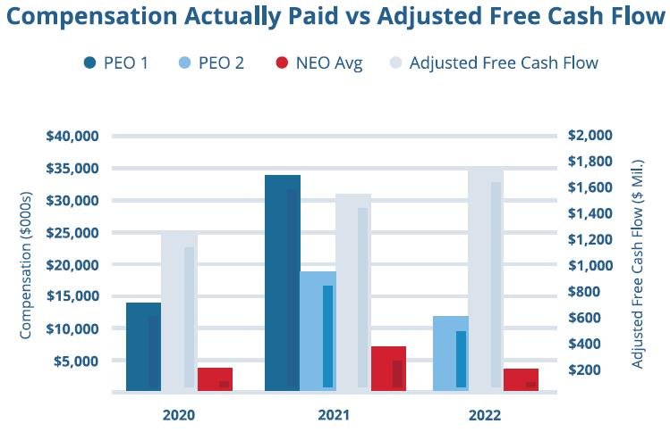

Tabular List of Company Performance Measures

The table below lists in alphabetical order the financial performance measures that we believe represent the most important performance measures used to link CAP to our named executive officers to our performance for the most recently completed fiscal year. See our CD&A at pages 51-70 for a further discussion of these performance measures.
Adjusted Earnings Per Share
Adjusted Free Cash Flow
Cash Flow Value Creation
Return on Invested Capital
Total Shareholder Return

For a more comprehensive discussion of how the Compensation Committee views the relationship between named executive officer pay and performance, please see our CD&A at pages 51-70 of this Proxy Statement.

 | Republic Services, Inc. 2023 Proxy Statement | | | 83





Proposals
Proposals

PROXY SUMMARY |  | BOARD AND GOVERNANCE |  | EXECUTIVE COMPENSATION |  | PROPOSALS |  | MEETING INFORMATION |  | ANNEX

PROPOSALS TO BE VOTED ON AT THE MEETING

Proposal 1: Election of Directors
The Board has nominated 11 directors (the “Nominees”) based on the recommendation of the Board’s Governance Committee. If elected, each director will hold office until our next annual meeting or until his or her successor is elected and qualified to serve on the Board. Each Nominee has consented to be named in this Proxy Statement and has agreed to serve as a director if elected.

The Board recommends a vote “FOR” the election of the 11 Nominees listed below:

DIRECTOR NAME | AGE | DIRECTOR  SINCE | PRINCIPAL OCCUPATION
Manuel Kadre (Chairman) | 57 | 2014 | CEO, MBB Auto, LLC
Tomago Collins | 51 | 2013 | Executive Vice President, Communications and Business Development,  Kroenke Sports & Entertainment
Michael A. Duffy | 53 | 2020 | CEO, FleetPride, Inc.  CEO, LaserShip/OnTrac
Thomas W. Handley | 68 | 2016 | Chief Operating Officer to the investment  operations of the Bill & Melinda Gates Foundation Trust
Jennifer M. Kirk | 48 | 2016 | Senior Vice President, Global Controller and Chief Accounting Officer, Medtronic
Michael Larson | 63 | 2009 | Chief Investment Officer to the investment  operations of the Bill & Melinda Gates Foundation Trust
James P. Snee | 56 | 2018 | Chairman, President and CEO, Hormel Foods Corporation
Brian S. Tyler | 56 | 2021 | CEO, McKesson Corporation
Sandra M. Volpe | 55 | 2016 | Former Senior Vice President, Strategic Planning,  Communications and Business Development Solutions,  FedEx Ground
Jon Vander Ark | 47 | 2021 | President and CEO of Republic Services, Inc.
Katharine B. Weymouth | 56 | 2018 | Chief Operating Officer, FamilyCare

The Nominees who receive a majority of the votes cast by the holders of our common stock represented at the Annual Meeting, without giving effect to abstentions, will be elected directors. According to our Bylaws, “majority of the votes cast” means that the number of votes cast “for” a director’s election exceeds the number of votes cast “against” that director’s election (with abstentions and broker non-votes not counted as a vote cast either “for” or “against” that director’s election).
Under our Bylaws, the number of directors is fixed from time to time by Board resolution and shall be not more than 13 (the majority of whom must be independent of Republic for purposes of the NYSE rules). Our Board currently consists of the 11 nominees named above, in addition to Ms. Pegula who will not stand for re-election at the Annual Meeting. Proxies cannot be voted for a greater number of persons than the number of Nominees named in this Proxy Statement.

86 | | | Republic Services, Inc. 2023 Proxy Statement

PROXY SUMMARY |  | BOARD AND GOVERNANCE |  | EXECUTIVE COMPENSATION |  | PROPOSALS |  | MEETING INFORMATION |  | ANNEX

Proposal 2: Advisory Vote on Named Executive Officer Compensation
In accordance with the requirements of Section 14A of the Exchange Act and the related SEC rules, we are asking our shareholders to cast a vote to approve the compensation of our NEOs. This proposal, commonly referred to as a “say-on-pay” proposal, gives you the opportunity to approve, not approve, or abstain from voting on our NEO compensation. This vote is not intended to address any specific item of compensation, but rather the overall compensation of our NEOs and the compensation principles, policies, and practices described in this Proxy Statement. Section 14A requires that we submit a proposal to shareholders similar to this one at least every three years. Based on the recommendation of our shareholders, we intend to submit a proposal similar to this one to our shareholders every year.
In considering your vote, you should review with care the information regarding our NEOs’ compensation appearing under the caption “Executive Compensation” on pages 50 through 83, including the CD&A beginning on page 50.
We have designed our executive compensation program to attract and retain our executives and to motivate them to increase shareholder value on both an annual and long-term basis primarily by improving our earnings and return on invested capital and generating increasing levels of free cash flow. The Talent & Compensation Committee believes our executive compensation program reflects a strong pay-for-performance philosophy and drives the alignment of shareholder and management interests.
Accordingly, we are submitting the following resolution for shareholder vote at the Annual Meeting:
“RESOLVED, that the shareholders of Republic approve, on an advisory basis, the compensation of Republic’s NEOs as disclosed in the proxy statement for the 2023 Annual Meeting under the heading “Executive Compensation,” including the Compensation Discussion and Analysis, the Summary Compensation Table, and the other tables and narrative disclosures set forth thereunder.”
The affirmative vote of a majority of the holders represented at the Annual Meeting and entitled to vote is required to approve this proposal. Abstentions will have the effect of a vote against Proposal 2 and broker non-votes have no effect on the proposal. This vote is an advisory vote only, and the result will not be binding on us. Although the vote is non-binding, the Talent & Compensation Committee values shareholders’ opinions. Accordingly, the Talent & Compensation Committee will review the results of voting on this proposal, seek to determine the cause or causes of any significant negative voting results and consider those matters when making future NEO compensation decisions.

The Board recommends a vote “FOR” approval of the compensation of our NEOs.

 | Republic Services, Inc. 2023 Proxy Statement | | | 87

PROXY SUMMARY |  | BOARD AND GOVERNANCE |  | EXECUTIVE COMPENSATION |  | PROPOSALS |  | MEETING INFORMATION |  | ANNEX

Proposal 3: Advisory Vote on the Frequency of An Advisory Vote on Named Executive Officer Compensation

Section 14A of the Exchange Act and related SEC rules require that we provide our shareholders with the opportunity to vote every six years, on a nonbinding, advisory basis, for their preference as to how frequently we should seek future advisory say-on-pay votes on the compensation of our NEOs. This advisory vote last occurred in 2017. This year we are once again asking our shareholders to indicate, on a nonbinding, advisory basis, whether they would prefer an advisory say-on-pay vote on the compensation of our NEOs to occur every one, two or three years. Shareholders also may, if they wish, abstain from casting a vote on this proposal.

Our Board of Directors has determined that an advisory say-on-pay vote on the compensation of our NEOs that occurs on an annual basis is the most appropriate option for Republic. Accordingly, our Board of Directors recommends that the advisory vote on the compensation of our NEOs occurs every one year. Our Board of Directors believes that an annual advisory say-on-pay vote will allow our shareholders to provide timely, direct input on our executive compensation philosophy, policies and practices as disclosed in the proxy statement each year.

You may cast your vote by choosing the option of one year, two years, three years or abstain from voting in response to the following resolution:

Accordingly, we are submitting the following resolution for shareholder vote at the Annual Meeting:
“RESOLVED, that the shareholders of Republic Services, Inc. determine, on an advisory basis, whether the preferred frequency for holding an advisory vote on the compensation of Republic’s NEOs, as disclosed pursuant to Item 402 of Regulation S-K of the Securities Act of 1933, as amended, including the Compensation Discussion and Analysis, the Summary Compensation Table and other related tables and narrative disclosures in the proxy statement, should be every one year, every two years, or every three years.”

The option (i.e., one year, two years or three years) that receives the greatest number of votes cast by shareholders will be considered to be the shareholders’ preferred frequency for the advisory vote on the compensation of our NEOs. Abstentions and broker non-votes will have no effect on this proposal. Because the vote is advisory, however, it will not be binding on the Board of Directors, the Talent & Compensation Committee or Republic. The Board of Directors may decide, in its sole discretion, that it is in the best interests of Republic and its shareholders to hold an advisory say-on-pay vote on the compensation of our NEOs more or less frequently than the option receiving the most votes cast by our shareholders.

The Board recommends a vote for conducting advisory votes on Named Executive Officer Compensation every “ONE YEAR”.

88 | | | Republic Services, Inc. 2023 Proxy Statement

PROXY SUMMARY |  | BOARD AND GOVERNANCE |  | EXECUTIVE COMPENSATION |  | PROPOSALS |  | MEETING INFORMATION |  | ANNEX

Proposal 4: Ratification of Independent Registered Public Accounting Firm
Our Audit Committee has selected Ernst & Young LLP as our independent registered public accounting firm for the fiscal year ending December 31, 2023. This selection will be presented to the shareholders for ratification at the Annual Meeting. You may vote for, vote against, or abstain from voting with respect to this proposal. The affirmative vote of a majority of the holders represented at the Annual Meeting and entitled to vote is required to ratify the appointment. Abstentions will have the effect of a vote against Proposal 4 and broker non-votes have no effect on the proposal. If the shareholders do not ratify the appointment of Ernst & Young LLP, our Audit Committee may reconsider the selection of our independent registered public accounting firm.
The Audit Committee is directly responsible for the appointment, compensation, retention, and oversight of our independent registered public accounting firm retained to audit our financial statements. The Audit Committee has appointed Ernst & Young LLP as our independent registered public accounting firm for 2023. Ernst & Young LLP has been retained as our independent registered public accounting firm continuously since June 2002. The Audit Committee is responsible for the audit fee negotiations associated with our retention of Ernst & Young LLP. In order to assure continuing auditor independence, the Audit Committee periodically considers whether there should be a regular rotation of the independent registered public accounting firm. In conjunction with the mandated rotation of the audit firm’s lead engagement partner, the Audit Committee and the chair of the Audit Committee are directly involved in the selection of Ernst & Young LLP’s new lead engagement partner. The members of the Audit Committee and the Board believe that the continued retention of Ernst & Young LLP to serve as our independent registered public accounting firm is in the best interests of the Company and our shareholders. Representatives of Ernst & Young LLP are expected to be present at our Annual Meeting, will have the opportunity to make a statement if they desire to do so, and are expected to be available to respond to appropriate questions.

The Board recommends a vote “FOR” ratification of the appointment of Ernst & Young LLP as our independent registered public accounting firm for 2023.

 | Republic Services, Inc. 2023 Proxy Statement | | | 89


Meeting Information

Republic services Technical Institute



PROXY SUMMARY |  | BOARD AND GOVERNANCE |  | EXECUTIVE COMPENSATION |  | PROPOSALS |  | MEETING INFORMATION |  | ANNEX

Questions and Answers and Information about the Annual Meeting
What is the record date and who may vote at the Annual Meeting?
Our only voting stock currently outstanding is our common stock. You may vote if you were a holder of record of Republic common stock as of the close of business on March 15, 2023 (the “Record Date”). During the Annual Meeting, a list of such shareholders will be available by visiting www.virtualshareholdermeeting.com/RSG2023 and entering the 16-digit control number included in our Notice of Internet Availability of Proxy Materials, on your proxy card or in the instructions that accompanied your proxy materials and following the instructions provided.
The trustee of our 401(k) Plan will vote shares held in each participant’s account in accordance with instructions provided by the participant on a completed proxy card. If a participant does not provide a completed proxy card, the trustee of the 401(k) Plan will vote the shares in a participant’s account in the same proportion that it votes shares for which it received valid and timely proxy cards from other participants or as otherwise required by applicable law.
How do I participate in the Annual Meeting?
This year’s Annual Meeting will be held in a virtual format through a live webcast. You are entitled to participate in the Annual Meeting if you were a shareholder as of the close of business on the Record Date or hold a valid proxy for the meeting. To be admitted to the Annual Meeting at www.virtualshareholdermeeting.com/RSG2023 you must enter the 16-digit control number found next to the label “Control Number” on your Notice of Internet Availability, proxy card, or voting instruction form, or in the email sending you the Proxy Statement. If you are a beneficial shareholder, you may contact the bank, broker or other institution where you hold your account if you have questions about obtaining your control number.
We encourage you to access the Annual Meeting before it begins. Online check-in will start approximately fifteen minutes before the meeting on May 12, 2023. If you encounter difficulties accessing the virtual meeting, please call the technical support number that will be posted on the Virtual Shareholder Meeting page.
How Do I Ask a Question at the Meeting?
Shareholders may submit questions during the Annual Meeting using the “Ask a Question” field on the virtual meeting website. You will need to log in with your control number found on the Notice of Internet Availability of Proxy Materials, the proxy card or the voting instruction form to submit a question.
During the Q&A session of the Annual Meeting, we will answer questions pertinent to meeting matters as they come in and as time permits. Any questions pertinent to meeting matters that cannot be answered during the meeting due to time constraints will be posted online and answered on our investor relations page at investor.republicservices.com under “2023 Annual Meeting of Shareholders” as soon as practicable following the meeting and will remain available for one week after posting. Please refer to our Meeting Rules of Conduct for more information on how to ask questions which will be available during the Annual Meeting at www.virtualshareholdermeeting.com/RSG2023.
What will I be voting on?
The following proposals will be considered at the Annual Meeting:
 | • | election of directors (Proposal 1);
 | • | advisory vote to approve our named executive officer compensation (Proposal 2);
 | • | advisory vote on the frequency of the advisory vote on named executive officer compensation (Proposal 3); and
 | • | ratification of the appointment of our independent registered public accounting firm for 2023 (Proposal 4).
How many votes do I have?
You will have one vote for every share of our common stock you owned as of the close of business on March 15, 2023.

92 | | | Republic Services, Inc. 2023 Proxy Statement

PROXY SUMMARY |  | BOARD AND GOVERNANCE |  | EXECUTIVE COMPENSATION |  | PROPOSALS |  | MEETING INFORMATION |  | ANNEX

What constitutes a quorum for the Annual Meeting?
As of the Record Date, 316,243,575 shares of our common stock were outstanding and entitled to vote. A quorum is at least a majority of the voting power represented by the shares of our common stock, or 158,121,788 shares. Abstentions and broker shares, which are shares held in street name, that are voted as to any matter presented at the meeting will be included in determining the number of shares present or represented at the Annual Meeting. Broker shares that are not voted on any matter at the Annual Meeting will not be included in determining the number of shares present or represented. A quorum must be present or represented at the Annual Meeting for any action to be taken. If a quorum is not present or represented, the holders of a majority of the shares entitled to vote who are present or represented at the Annual Meeting, or the chairman of the meeting, may adjourn the Annual Meeting until a quorum is present or represented. The time and place of the adjourned meeting will be announced when the adjournment is taken, and no other notice will be given.
How many votes are required to approve the proposals, assuming a quorum?
The affirmative vote of the majority of votes cast with respect to that director’s election at the Annual Meeting is required for the election of each director (Proposal 1). The affirmative vote of the holders of a majority of the voting power of the shares of common stock present or represented by proxy and entitled to vote is required for approval of Proposals 2 and 4. The option (i.e., one year, two years or three years) that receives the greatest number of votes cast by shareholders will be considered to be the shareholders’ preferred frequency for the advisory vote on the compensation of our NEOs in Proposal 3.
How do I vote?
The internet and telephone voting procedures have been designed to verify shareholders’ identities and allow shareholders to confirm their voting instructions have been properly recorded. Shareholders whose shares are held for them by brokers, banks or other nominees should follow the instructions provided by the nominees.
Submitting your proxy or voting instructions before the Annual Meeting will not affect your right to vote in person if you decide to attend the Annual Meeting. If, however, you hold your shares in street name, you must request a valid proxy from your broker, bank or other nominee to vote in person at the Annual Meeting.

Your vote is very important. Regardless of whether you plan to attend the Annual Meeting, please ensure that your vote is counted.
What if I do not give specific voting instructions?
Shareholders of Record. If you are a shareholder of record and you return a signed proxy card but do not indicate how you wish to vote on a particular matter, your shares will be voted in accordance with the Board’s recommendations on all matters presented in this Proxy Statement. Your shares will be voted as the proxy holders determine in their discretion regarding any matters not presented in this Proxy Statement that are properly presented for a vote at the Annual Meeting.
Beneficial Owners. If you are a beneficial owner and hold your shares in street name and do not provide your broker, bank or other nominee with voting instructions, the nominee will determine if it has the discretionary authority to vote on the particular matter. Under applicable rules, brokers have the discretion to vote on “routine” matters, but do not have discretion to vote on “non-routine” matters. The ratification of the appointment of our independent registered public accounting firm for 2023 (Proposal 4) is a matter considered “routine” under applicable rules. The election of directors (Proposal 1), the advisory vote to approve named executive officer compensation (Proposal 2), and the advisory vote on the frequency of the advisory vote on named executive officer compensation (Proposal 3) are matters considered “non-routine” under applicable rules. Thus, there will likely be broker non-votes on Proposals 1, 2, and 3.
401(k) Plan Participants. If you are a participant in our 401(k) Plan and do not provide the trustee with voting instructions, the trustee will vote the shares in your account in the same proportion that it votes shares for which it received valid and timely proxy cards from other participants or as otherwise required by applicable law.
What are broker non-votes?
The NYSE permits brokers to vote their customers’ shares on “routine” matters when the brokers have not received voting instructions from their customers. Brokers may not vote their customers’ shares on “non-routine” matters unless they have received voting instructions from their customers. Non-voted shares on non-routine matters are referred to as broker non-votes.
How are broker non-votes and abstentions counted?
Abstentions and broker non-votes will have no effect on Proposal 1, as the election is determined by counting the votes actually cast where abstentions and broker non-votes are not treated as votes cast. Abstentions will have the effect of a vote against Proposals 2, and 4, as the standard for the approval of these proposals is a majority of shares present and entitled to vote, and broker non-votes have no effect on these proposals. Abstentions and broker non-votes will have no effect on Proposal 3, as the advisory vote on the frequency of the advisory vote on our NEO compensation will be determined by the greatest number of votes cast.

 | Republic Services, Inc. 2023 Proxy Statement | | | 93

PROXY SUMMARY |  | BOARD AND GOVERNANCE |  | EXECUTIVE COMPENSATION |  | PROPOSALS |  | MEETING INFORMATION |  | ANNEX

Can I change my vote?
Yes. If you have submitted your proxy, you may revoke your proxy at any time until it is voted at the Annual Meeting. If you are a shareholder of record, you may do this in one of three ways: (1) you can send us a written notice stating that you would like to revoke your proxy; (2) you can complete and submit a new proxy card, or cast a new vote by telephone or internet; or (3) you can attend the Annual Meeting and vote in person. Your attendance alone, however, will not revoke your proxy. If you have instructed a broker to vote your shares, you must follow the procedure provided by your broker to change these instructions.
Do I need to attend the Annual Meeting?
No. Although you are welcome to attend virtually, it is not necessary for you to log on to the Annual Meeting to vote your shares.
How does the Board recommend I vote on the proposals?
The Board recommends you vote:

FOR  the election of the 11 nominees to the Board  (Proposal 1) | FOR  approval of our named executive officer compensation  (Proposal 2) | FOR  conducting advisory votes on our named executive officer compensation every “ONE YEAR” (Proposal 3) | FOR  ratification of the appointment of our independent registered public accounting firm for 2023 (Proposal 4)

Where can I find more information about Republic?
We file reports and other information with the SEC. This information is also available at our website at www.RepublicServices.com (click on “Investors”) and at the SEC’s website at www.sec.gov.
The information contained on, or that may be accessed through, our website is not a part of, or incorporated by reference in this Proxy Statement.
Who can help answer my questions?
If you have questions about the Annual Meeting or the proposals, or need help voting your shares, you can call Innisfree M&A Incorporated, which is the firm assisting us with our proxy solicitation, toll-free at (877) 456-3427.
Expenses of Solicitations
Republic will bear the cost of soliciting proxies. In addition to solicitations by mail, our regular employees may solicit proxies in person or by telephone without additional compensation. We will pay all costs of solicitation, including certain expenses of brokers and nominees who mail proxy materials to their customers or principals. Also, we have engaged Innisfree M&A Incorporated to help in the solicitation of proxies for a fee of approximately $20,000 plus associated costs and expenses.
Proxy Statement Mailing Information and Householding
The SEC allows us to deliver a single Notice of Internet Availability of Proxy Materials to one address shared by two or more shareholders. This delivery method is referred to as “householding” and can result in cost savings for us. We deliver a single package containing Notices of Internet Availability of Proxy Materials to multiple shareholders who share an address. If you prefer to receive separate packages containing the Notices of Internet Availability of Proxy Materials, or if you currently are a shareholder sharing an address with another shareholder and wish to receive only one package containing future Notices of Internet Availability of Proxy Materials for your household, please contact Broadridge, toll free at 1-866-540-7095. You may also write to: Broadridge, Householding Department, 51 Mercedes Way, Edgewood, New York 11717.
As permitted by SEC rules, we are making our Proxy Statement and our Annual Report on Form 10-K for the year ended December 31, 2022 available in digital form online. On or about March 29, 2023, we are mailing to our shareholders a Notice of Internet Availability of Proxy Materials containing instructions on how to access this Proxy Statement and our Annual Report on Form 10-K and how to vote online. Shareholders who receive the notice will not receive a printed copy of the proxy materials in the mail. If you would like to receive a printed copy, please follow the instructions included in the Notice of Internet Availability of Proxy Materials.

94 | | | Republic Services, Inc. 2023 Proxy Statement

PROXY SUMMARY |  | BOARD AND GOVERNANCE |  | EXECUTIVE COMPENSATION |  | PROPOSALS |  | MEETING INFORMATION |  | ANNEX

Submission of Shareholder Proposals for Our 2024 Annual Meeting
Any shareholder who wishes to present a proposal for action at our next annual meeting of shareholders, presently scheduled for May 2024, or who wishes to nominate a candidate for our Board, must submit such proposal or nomination in writing to: Attention: Office of the Corporate Secretary, Republic Services, Inc., 18500 North Allied Way, Phoenix, Arizona 85054. The proposal or nomination should comply with the time period and information requirements as set forth in our Bylaws relating to shareholder business or shareholder nominations, as applicable. Shareholders interested in submitting a proposal for inclusion in the proxy statement for the 2024 annual meeting of shareholders may do so by following the procedures prescribed in our Bylaws and in accordance with the applicable rules under the Exchange Act. Shareholder proposals must be received by our Corporate Secretary:
 | • | no later than November 30, 2023, if the proposal is submitted for inclusion in our proxy materials pursuant to Rule 14a-8 under the Exchange Act;
 | • | between January 13, 2024 and February 12, 2024, if the proposal is submitted under our Bylaws, in which case we are not required to include the proposal in our proxy materials; or
 | • | between October 31, 2023 and November 30, 2023, if the proposal is submitted pursuant to our proxy access Bylaw provision.
Miscellaneous Matters
Our Annual Report on Form 10-K covering the fiscal year ended December 31, 2022 is available electronically with this Proxy Statement. It contains financial and other information about us, but is not incorporated into this Proxy Statement and is not to be considered a part of these proxy soliciting materials or subject to Regulations 14A or 14C or to the liabilities of Section 18 of the Exchange Act. The information contained in the “Talent & Compensation Committee Report,” the “Audit Committee Report” or any hyperlinks contained in this Proxy Statement shall not be deemed “filed” with the SEC or subject to Regulations 14A or 14C or to the liabilities of Section 18 of the Exchange Act.
We will mail upon written request, without charge, to each shareholder of record as of the Record Date, a copy of our Annual Report on Form 10-K for the fiscal year ended December 31, 2022, as filed with the SEC. Any exhibits listed in the Form 10-K report also will be furnished upon request at the actual expense we incur in furnishing such exhibits. Any such requests should be directed to Attention: Office of the Corporate Secretary, Republic Services, Inc., 18500 North Allied Way, Phoenix, Arizona 85054. Our Annual Report on Form 10-K and exhibits thereto also are available on our website at www.RepublicServices.com or at the SEC’s website at www.sec.gov.
You are again invited to attend the Annual Meeting. We will hold the virtual Annual Meeting at 10:30 a.m., Pacific Time, on Friday, May 12, 2023 online at www.virtualshareholdermeeting.com/RSG2023.
Other than the items described herein, management does not intend to present any other items of business and knows of no other matters that will be brought before the Annual Meeting. However, if any additional matters are properly brought before the Annual Meeting, the persons named in the proxy shall vote the proxies in their discretion in the manner they believe to be in our best interest. We have prepared the accompanying form of proxy at the Board’s direction and provide it to you at the Board’s request. Your Board has designated the proxies named therein.

 | Republic Services, Inc. 2023 Proxy Statement | | | 95

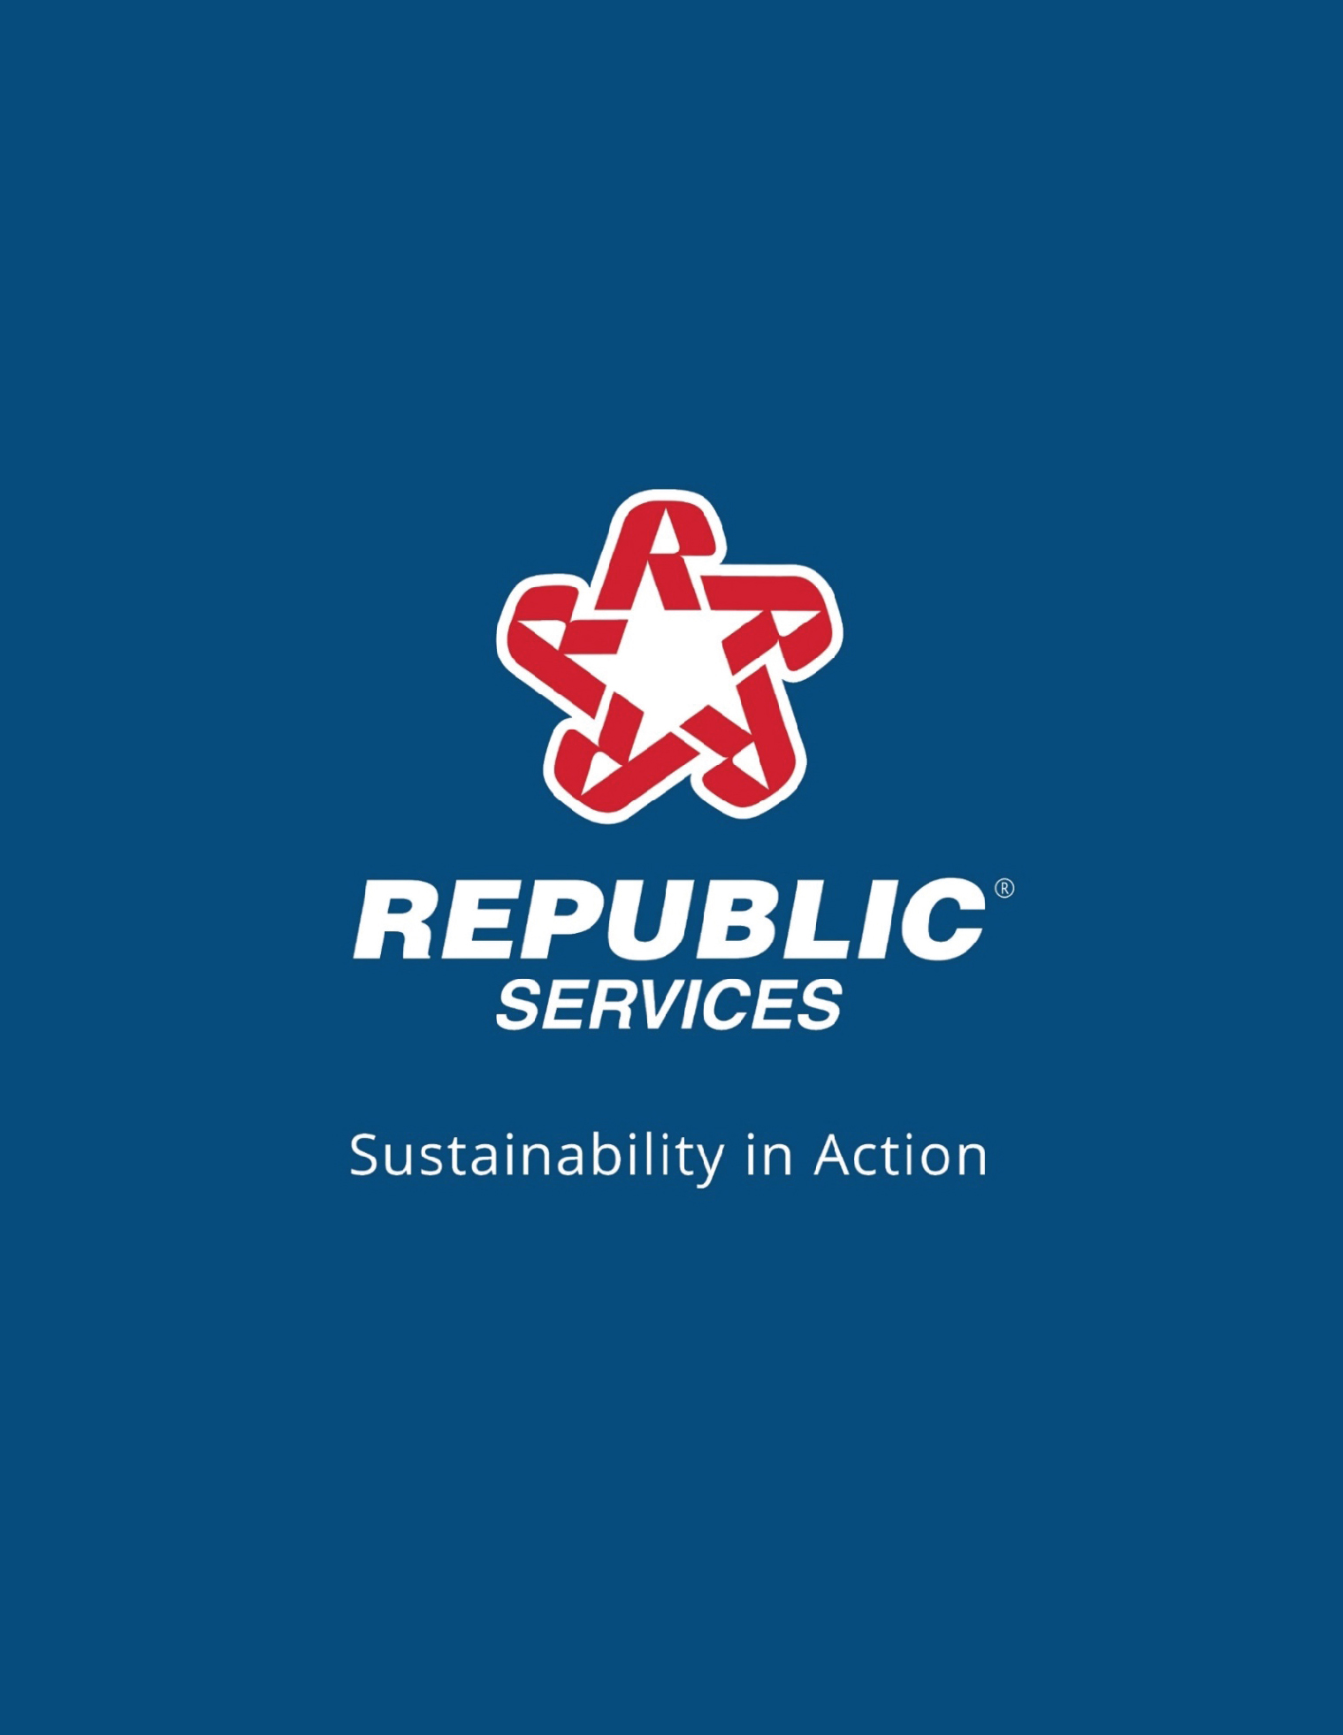
Republic® services Sustainability in Action


Annex

PROXY SUMMARY |  | BOARD AND GOVERNANCE |  | EXECUTIVE COMPENSATION |  | PROPOSALS |  | MEETING INFORMATION |  | ANNEX

Annex—CD&A APPENDIX
Reconciliation of GAAP to Non-GAAP Financial Measures

ADJUSTED DILUTED EARNINGS PER SHARE |  |  | FY 2020 |  |  | FY 2021 |  |  | FY 2022
Diluted earnings per share—as reported |  |  | $3.02 |  |  | $4.04 |  |  |  | $4.69
Loss on extinguishment of debt and other related costs |  |  | 0.23 |  |  | — |  |  |  | —
Bridgeton insurance recovery, net |  |  | (0.03) |  |  | — |  |  |  | —
Restructuring charges |  |  | 0.05 |  |  | 0.04 |  |  |  | 0.06
Loss (gain) on business divestitures and asset impairments, net |  |  | 0.21 |  |  | 0.02 |  |  |  | (0.01)
Adjustment to withdrawal liability for a multiemployer pension fund |  |  | 0.08 |  |  | — |  |  |  | —
Accelerated vesting of compensation expense for CEO transition |  |  | — |  |  | 0.07 |  |  |  | —
US Ecology acquisition integration and deal costs |  |  | — |  |  | — |  |  |  | 0.19
Diluted earnings per share—as adjusted |  |  | $3.56 |  |  | $4.17 |  |  |  | $4.93

ADJUSTED FREE CASH FLOW (IN MILLIONS) |  |  | FY 2020 |  |  | FY 2021 |  |  | FY 2022
Cash provided by operating activities |  |  | $2,471.6 |  |  | $2,786.7 |  |  |  | $3,190
Property and equipment received |  |  | (1,240.6) |  |  | (1,303.6) |  |  |  | (1,552.5)
Proceeds from sales of property and equipment |  |  | 30.1 |  |  | 19.5 |  |  |  | 32.8
Divestiture related tax (payments) benefits |  |  | (9.7) |  |  | (0.1) |  |  |  | 2.5
Cash tax benefit for debt extinguishment and other related costs |  |  | (26.0) |  |  | — |  |  |  | —
Adjustment to withdrawal liability for a multiemployer pension fund, net of tax |  |  | 25.4 |  |  | — |  |  |  | 2.2
Restructuring payments, net of tax |  |  | 11.5 |  |  | 12.7 |  |  |  | 14.6
Bridgeton insurance recovery, net of tax |  |  | (26.4) |  |  | — |  |  |  | —
US Ecology acquisition integration and deal costs, net of tax |  |  | — |  |  | — |  |  |  | 52.8
Free cash flow - as adjusted |  |  | $1,235.9 |  |  | $1,515.2 |  |  |  | $1,742.4

98 | | | Republic Services, Inc. 2023 Proxy Statement

PROXY SUMMARY |  | BOARD AND GOVERNANCE |  | EXECUTIVE COMPENSATION |  | PROPOSALS |  | MEETING INFORMATION |  | ANNEX

ADJUSTED EBITDA (IN MILLIONS) |  |  | FY 2020 |  |  | FY 2021 |  |  | FY 2022
Net Income attributable to Republic Services, Inc. |  |  | $967.2 |  |  | $1,290.4 |  |  |  | $1,487.6
Net income attributable to non-controlling interests |  |  | 2.4 |  |  | 1.9 |  |  |  | —
Provision for income taxes |  |  | 173.1 |  |  | 282.8 |  |  |  | 343.9
Other (income) expense, net |  |  | (4.1) |  |  | 0.5 |  |  |  | 2.3
Interest income |  |  | (5.2) |  |  | (2.5) |  |  |  | (3.3)
Interest expense |  |  | 355.6 |  |  | 314.6 |  |  |  | 395.6
Depreciation, amortization and depletion |  |  | 1,075.9 |  |  | 1,185.5 |  |  |  | 1,351.6
Accretion |  |  | 82.9 |  |  | 82.7 |  |  |  | 89.6
Loss from unconsolidated equity method investment |  |  | 118.2 |  |  | 188.5 |  |  |  | 165.6
Loss on extinguishment of debt and other related costs |  |  | 101.9 |  |  | — |  |  |  | —
Restructuring charges |  |  | 20.0 |  |  | 16.6 |  |  |  | 27
Loss (gain) on business divestitures and impairments, net |  |  | 77.7 |  |  | 0.5 |  |  |  | (6.3)
Accelerated vesting of compensation expense for CEO transition |  |  | — |  |  | 22.0 |  |  |  | —
Adjustment to withdrawal liability for a multiemployer pension fund |  |  | 34.5 |  |  | — |  |  |  | (1.6)
Bridgeton insurance recovery |  |  | (10.8) |  |  | — |  |  |  | —
US Ecology acquisition integration and deal costs |  |  | — |  |  | — |  |  |  | 77.3
Adjusted EBITDA |  |  | $2,989.3 |  |  | $3,383.5 |  |  |  | $3,929.3

 | Republic Services, Inc. 2023 Proxy Statement | | | 99

PROXY SUMMARY |  | BOARD AND GOVERNANCE |  | EXECUTIVE COMPENSATION |  | PROPOSALS |  | MEETING INFORMATION |  | ANNEX

Calculation of Actual Results for Annual Incentive Performance Measures and GAAP Reconciliation

EARNINGS PER SHARE MEASURE |  |  | FY 2020 |  |  | FY 2021 |  |  | FY 2022
Diluted earnings per share—as reported |  |  | $3.02 |  |  | $4.04 |  |  | $4.69
Loss on extinguishment of debt and other related costs |  |  | 0.23 |  |  | — |  |  | —
Restructuring charges |  |  | 0.05 |  |  | 0.04 |  |  | 0.06
Adjustment to withdrawal liability for a multiemployer pension fund |  |  | 0.08 |  |  | — |  |  | —
Loss (gain) on business divestitures and asset impairments, net |  |  | 0.20 |  |  | 0.02 |  |  | (0.01)
US Ecology acquisition integration and deal costs |  |  | — |  |  | — |  |  | 0.19
Earnings per share measure |  |  | $3.58 |  |  | $4.10 |  |  | $4.93
FREE CASH FLOW MEASURE (IN MILLIONS) |  |  | FY 2020 |  |  | FY 2021 |  |  | FY 2022
Cash provided by operating activities |  |  | $2,471.6 |  |  | $2,786.7 |  |  | $3,190.0
Property and equipment received |  |  | (1,240.6) |  |  | (1,303.6) |  |  | (1,552.5)
Proceeds from sales of property and equipment |  |  | 30.1 |  |  | 19.5 |  |  | 32.8
Divestiture related tax (payments) benefits |  |  | (9.7) |  |  | (0.1) |  |  | 2.5
Cash tax benefit for debt extinguishment |  |  | (26.0) |  |  | — |  |  | —
Adjustment to withdrawal liability for a multiemployer pension fund |  |  | 25.4 |  |  | — |  |  | 2.2
Restructuring payments, net of tax |  |  | 10.8 |  |  | 12.7 |  |  | 14.6
US Ecology acquisition integration and deal costs, net of tax |  |  | — |  |  | — |  |  | 52.8
Free cash flow measure |  |  | $1,261.6 |  |  | $1,515.2 |  |  | $1,742.4

100 | | | Republic Services, Inc. 2023 Proxy Statement

PROXY SUMMARY |  | BOARD AND GOVERNANCE |  | EXECUTIVE COMPENSATION |  | PROPOSALS |  | MEETING INFORMATION |  | ANNEX

Calculation of Actual Results for 2020-2022 PSU Performance Measures*

THREE YEAR CASH FLOW VALUE CREATION MEASURE (IN MILLIONS) |  |  | FY 2020 |  |  | FY 2021 |  |  | FY 2022
Net Income per LTI definition |  |  | $1,131 |  |  | $1,293 |  |  | $1,480
Add: after tax interest expense per LTI definition |  |  | 296 |  |  | 257 |  |  | 319
Add: DD&A and accretion |  |  | 1,159 |  |  | 1,272 |  |  | 1,445
Operating cash flow |  |  | 2,586 |  |  | 2,823 |  |  | 3,244
Less: capital charge |  |  | (1,356) |  |  | (1,429) |  |  | (1,588)
Cash flow value creation |  |  | $1,230 |  |  | $1,393 |  |  | $1,656
Three year cash flow value creation measure |  |  |  |  |  |  |  |  | $4,279

THREE YEAR RETURN ON INVESTED CAPITAL MEASURE  (IN MILLIONS EXCEPT WHERE NOTED AS A PERCENTAGE) |  |  | FY 2020 |  |  | FY 2021 |  |  | FY 2022
Net Income per LTI definition |  |  | $1,131 |  |  | $1,293 |  |  | $1,480
Add: after tax interest expense per LTI definition |  |  | 296 |  |  | 257 |  |  | 319
Adjusted net income |  |  | 1,427 |  |  | 1,551 |  |  | 1,799
Average net assets per LTI definition |  |  | $16,950 |  |  | $17,868 |  |  | $19,846
Return on Invested Capital |  |  | 8.4% |  |  | 8.7% |  |  | 9.1%
Sum of three year adjusted net income |  |  |  |  |  |  |  |  | $4,777
Sum of three year average net assets |  |  |  |  |  |  |  |  | $54,664
Three year return on invested capital |  |  |  |  |  |  |  |  | 8.7%

* | CFVC and ROIC are adjusted to exclude net gains or losses on divestitures and impairments, losses recorded on the extinguishment of debt instruments, and costs associated with withdrawal from or termination of multi-employer pension plans.

 | Republic Services, Inc. 2023 Proxy Statement | | | 101


REPUBLIC SERVICES Sustainability in Action 18500 N. Allied Way Phoenix, Arizona 85054 480-627-2700 RepublicServices.com

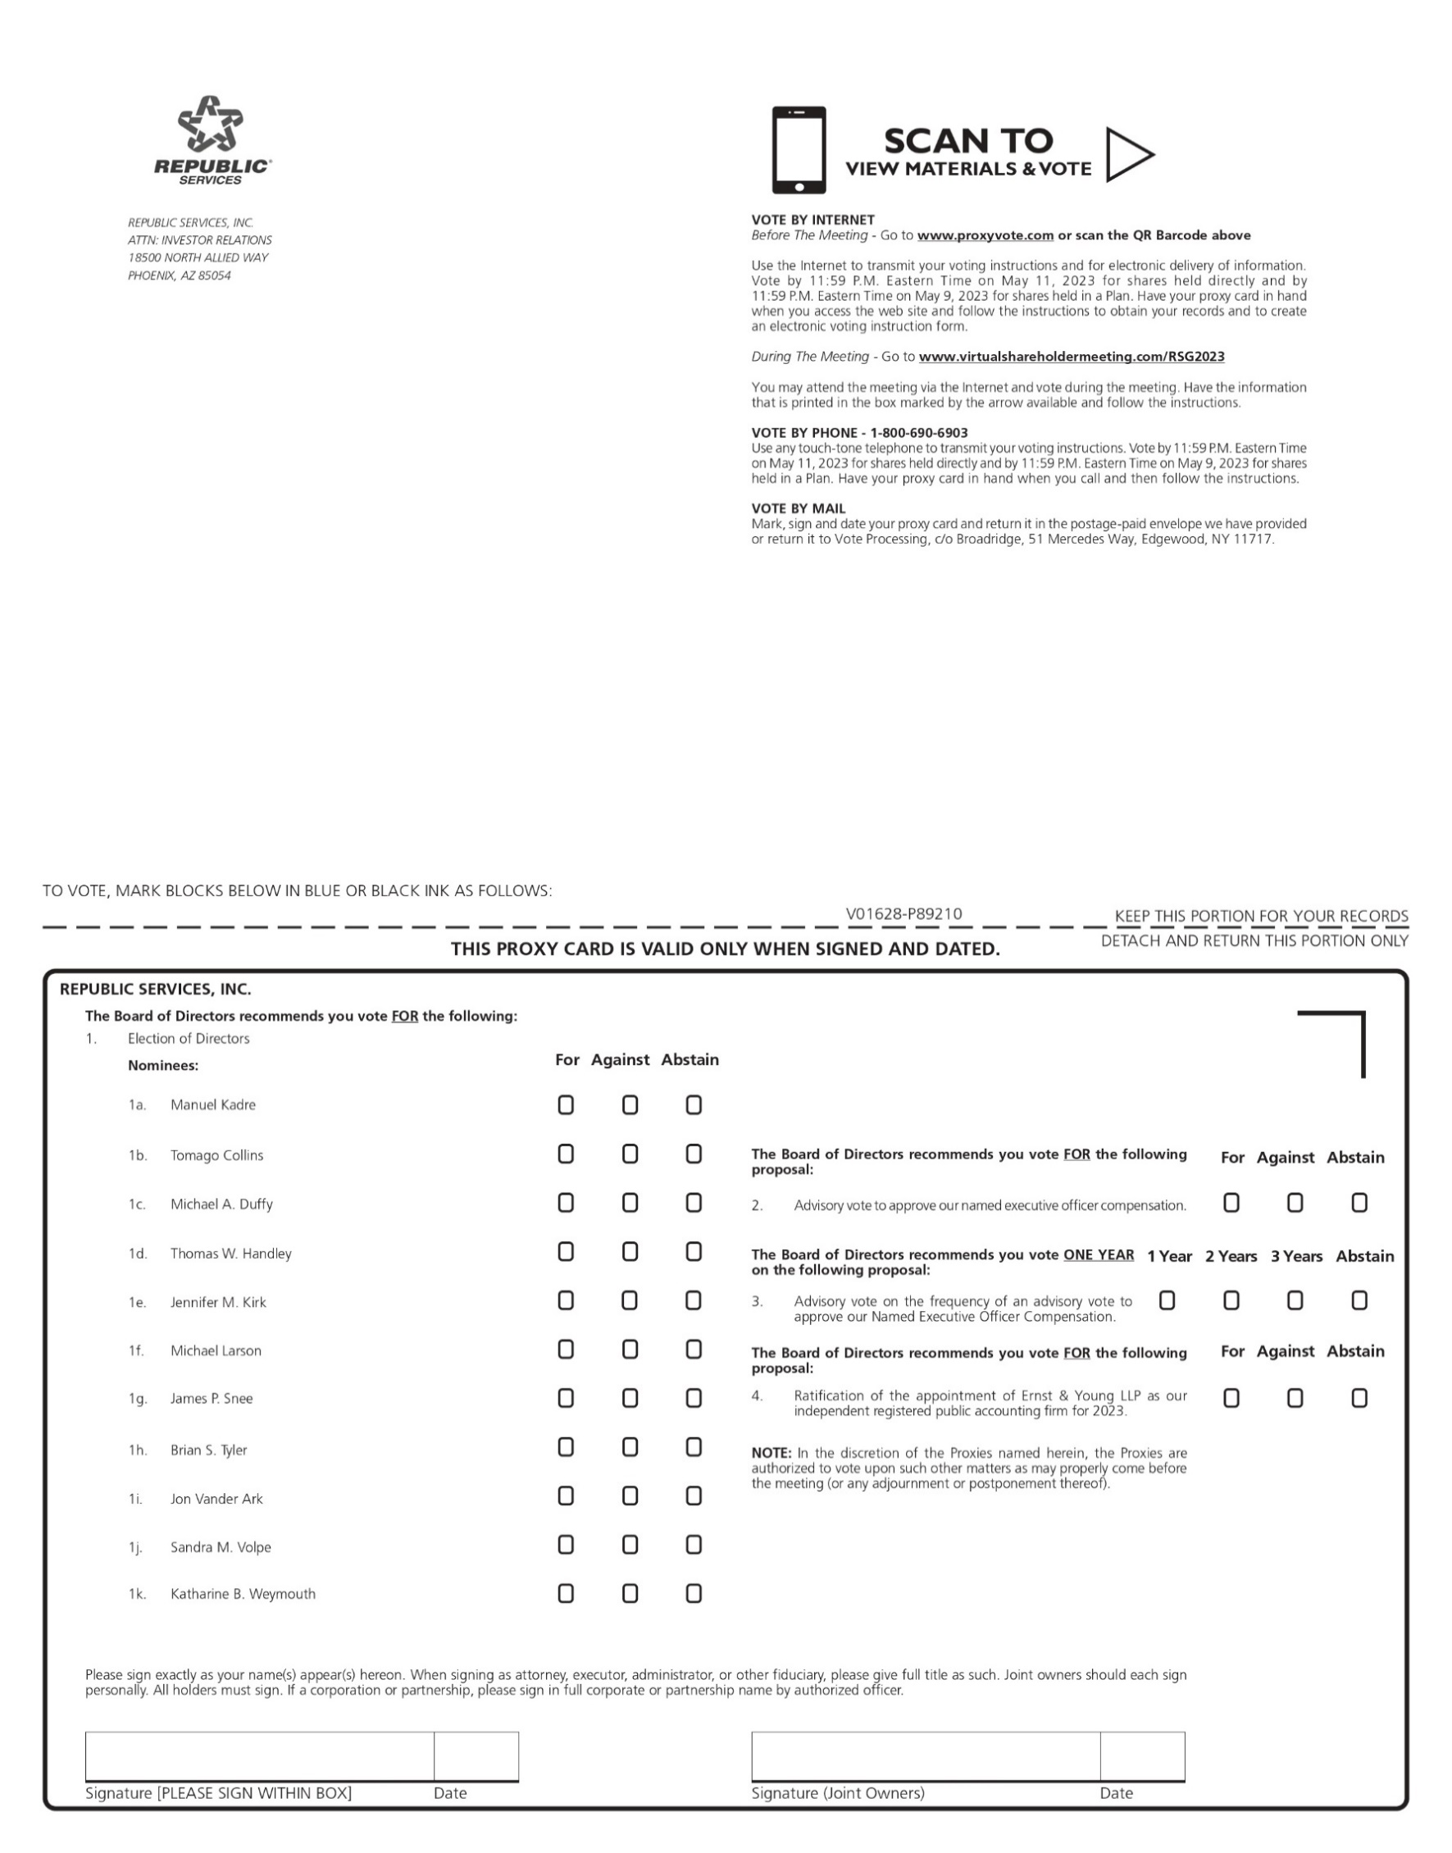
REPUBLIC ® SERVICES REPUBLIC SERVICES, INC. ATTN: INVESTOR RELATIONS 18500 NORTH ALLIED WAY PHOENIX, AZ 85054 SCAN TO VIEW MATERIALS & VOTE VOTE BY INTERNET Before The Meeting - Go to www.proxyvote.com or scan the QR Barcode above Use the Internet to transmit your voting instructions and for electronic delivery of information. Vote by 11:59 P.M. Eastern Time on May 11, 2023 for shares held directly and by 11:59 P.M. Eastern Time on May 9, 2023 for shares held in a Plan. Have your proxy card in hand when you access the web site and follow the instructions to obtain your records and to create an electronic voting instruction form. During The Meeting - Go to www.virtualshareholdermeeting.com/RSG2023 You may attend the meeting via the Internet and vote during the meeting. Have the information that is printed in the box marked by the arrow available and follow the instructions. VOTE BY PHONE - 1-800-690-6903 Use any touch-tone telephone to transmit your voting instructions. Vote by 11:59 P.M. Eastern Time on May 11, 2023 for shares held directly and by 11:59 P.M. Eastern Time on May 9, 2023 for shares held in a Plan. Have your proxy card in hand when you call and then follow the instructions. VOTE BY MAIL Mark, sign and date your proxy card and return it in the postage-paid envelope we have provided or return it to Vote Processing, c/o Broadridge, 51 Mercedes Way, Edgewood, NY 11717. TO VOTE, MARK BLOCKS BELOW IN BLUE OR BLACK INK AS FOLLOWS: V01628-P89210 KEEP THIS PORTION FOR YOUR RECORDS THIS PROXY CARD IS VALID ONLY WHEN SIGNED AND DATED. DETACH AND RETURN THIS PORTION ONLY REPUBLIC SERVICES, INC. The Board of Directors recommends you vote FOR the following: 1. Election of Directors Nominees: For Against Abstain 1a. Manuel Kadre 1b. Tomago Collins 1c. Michael A. Duffy 1d. Thomas W. Handley 1e. Jennifer M. Kirk 1f. Michael Larson 1g. James P. Snee 1h. Brian S. Tyler 1i. Jon Vander Ark 1j. Sandra M. Volpe 1k. Katharine B. Weymouth The Board of Directors recommends you vote FOR the following proposal: For Against Abstain 2. Advisory vote to approve our named executive officer compensation. The Board of Directors recommends you vote ONE YEAR on the following proposal: 1 Year 2 Years 3 Years Abstain 3. Advisory vote on the frequency of an advisory vote to approve our Named Executive Officer Compensation. The Board of Directors recommends you vote FOR the following proposal: Against Abstain For 4. Ratification of the appointment of Ernst & Young LLP as our independent registered public accounting firm for 2023. NOTE: In the discretion of the Proxies named herein, the Proxies are authorized to vote upon such other matters as may properly come before the meeting (or any adjournment or postponement thereof). Please sign exactly as your name(s) appear(s) hereon. When signing as attorney, executor, administrator, or other fiduciary, please give full title as such. Joint owners should each sign personally. All holders must sign. If a corporation or partnership, please sign in full corporate or partnership name by authorized officer. Signature [PLEASE SIGN WITHIN BOX] Date Signature (Joint Owners) Date

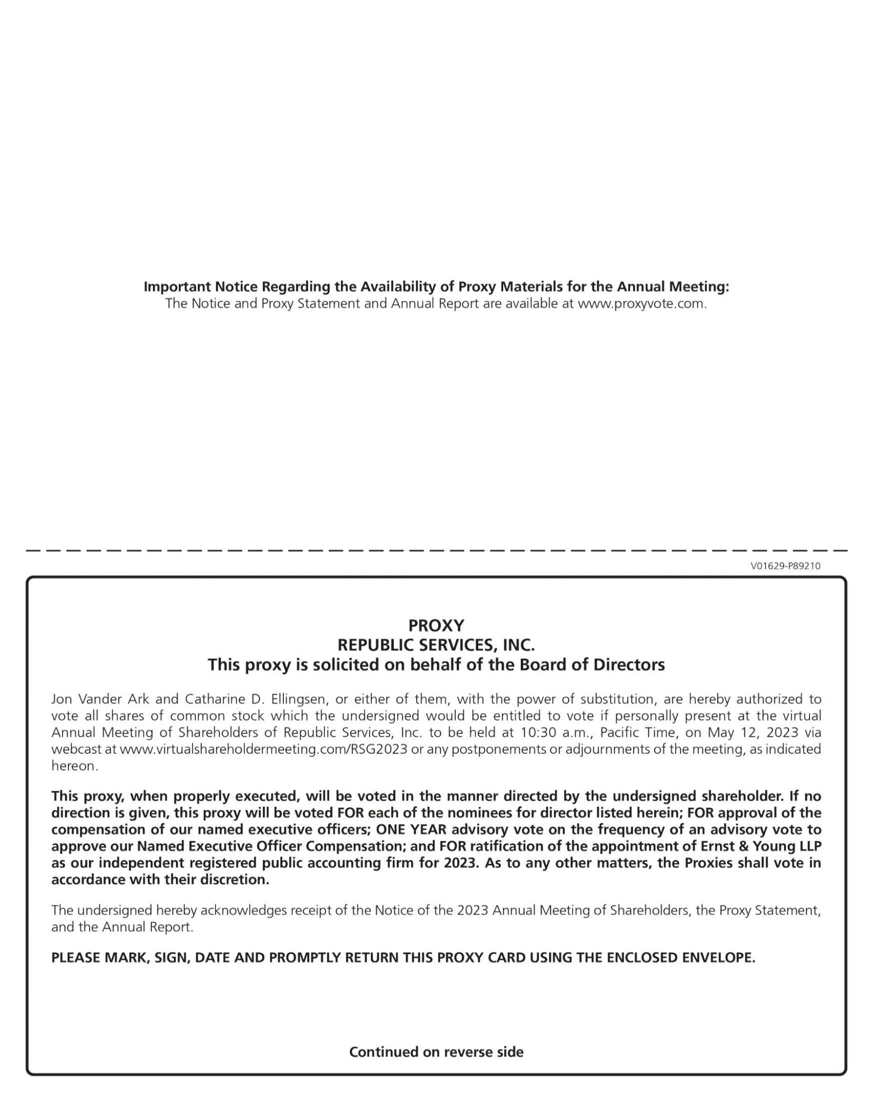
Important Notice Regarding the Availability of Proxy Materials for the Annual Meeting: The Notice and Proxy Statement and Annual Report are available at www.proxyvote.com. V01629-P89210 PROXY REPUBLIC SERVICES, INC. This proxy is solicited on behalf of the Board of Directors Jon Vander Ark and Catharine D. Ellingsen, or either of them, with the power of substitution, are hereby authorized to vote all shares of common stock which the undersigned would be entitled to vote if personally present at the virtual Annual Meeting of Shareholders of Republic Services, Inc. to be held at 10:30 a.m., Pacific Time, on May 12, 2023 via webcast at www.virtualshareholdermeeting.com/RSG2023 or any postponements or adjournments of the meeting, as indicated hereon. This proxy, when properly executed, will be voted in the manner directed by the undersigned shareholder. If no direction is given, this proxy will be voted FOR each of the nominees for director listed herein; FOR approval of the compensation of our named executive officers; ONE YEAR advisory vote on the frequency of an advisory vote to approve our Named Executive Officer Compensation; and FOR ratification of the appointment of Ernst & Young LLP as our independent registered public accounting firm for 2023. As to any other matters, the Proxies shall vote in accordance with their discretion. The undersigned hereby acknowledges receipt of the Notice of the 2023 Annual Meeting of Shareholders, the Proxy Statement, and the Annual Report. PLEASE MARK, SIGN, DATE AND PROMPTLY RETURN THIS PROXY CARD USING THE ENCLOSED ENVELOPE. Continued on reverse side

