Table of Contents

UNITED STATES
SECURITIES AND EXCHANGE COMMISSION
Washington, D.C. 20549

SCHEDULE 14A
Proxy Statement Pursuant to Section 14(a) of the
Securities Exchange Act of 1934
(Amendment No. )

Filed by the Registrant
☒
Filed by a Party other than the Registrant
☐
Check the appropriate box:

☐ | Preliminary Proxy Statement

☐ | Confidential, for Use of the Commission Only (as permitted by Rule 14a-6(e)(2))

☒ | Definitive Proxy Statement

☐ | Definitive Additional Materials

☐ | Soliciting Material Pursuant to §240.14a-12
REPUBLIC SERVICES, INC.
(Name of Registrant as Specified In Its Charter)
(Name of Person(s) Filing Proxy Statement, if other than the Registrant)
Payment of Filing Fee (Check the appropriate box):

☒ | No fee required.

☐ | Fee paid previously with preliminary materials:

☐ | Fee computed on table in exhibit required by Item 25(b) per Exchange Act Rules 14a-6(i)(1)  and  0-11

Table of Contents
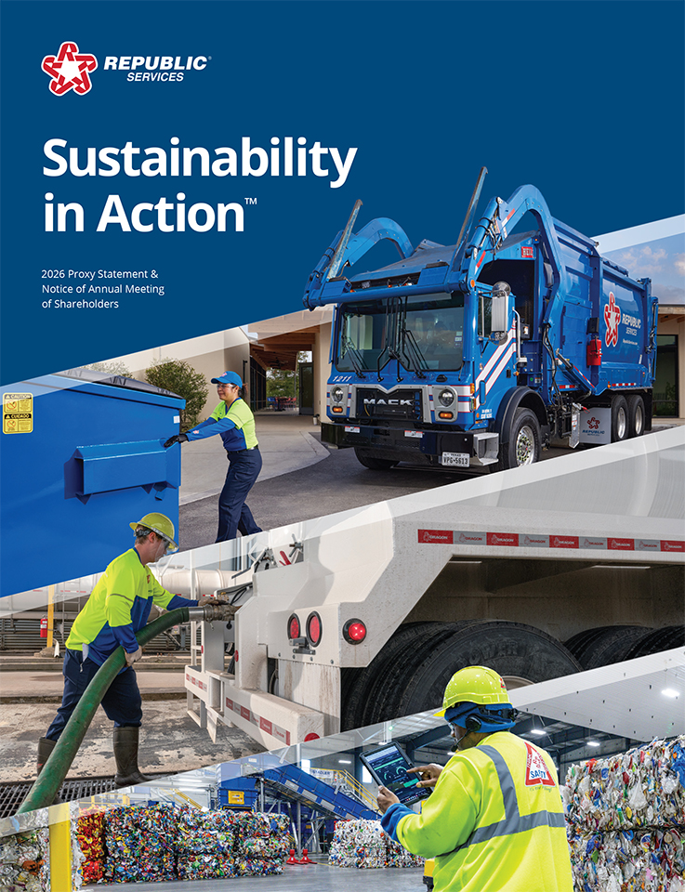

Table of Contents


Table of Contents
PARTNERING WITH CUSTOMERS TO CREATE A MORE SUSTAINABLE WORLD
Dear Shareholders,
Republic Services achieved another strong year in 2025 through disciplined execution of our strategy, the power of our differentiating capabilities and the steady dedication of our team. We had a positive impact on our customers and communities, strengthened our business, and generated long-term value for our shareholders. Our 2025 financial highlights include:

- |  | 3.5% revenue growth versus 2024
- |  | $6.85 earnings per share, a 5.5% year-over-year increase, and $7.02 adjusted earnings per share(1), an 8.7% increase vs. 2024
- |  | $4.30 billion in cash flow from operations, a 9.2% year-over-year increase, and $2.43 billion in adjusted free cash flow(1), an 11.5% increase vs. 2024
- |  | $1.6 billion returned to shareholders through dividends and share repurchases
- |  | $1.1 billion in strategic acquisitions
Positioned for Growth
Our integrated growth approach unites recycling and waste, environmental solutions, and sustainability innovation to provide comprehensive services and create growth opportunities across our business. Fused with our differentiating capabilities — Customer Zeal, Digital and Sustainability — we’re capturing new opportunities and sustaining high customer retention.
We made meaningful progress toward our 2030 Sustainability Goals and advanced our leadership in circularity and decarbonization:

- |  | Bottle-to-bottle plastics circularity through our innovative polymer center network
- |  | Sustainable packaging solutions through custom-blended recycled resin from the Blue Polymers joint venture with Ravago
- |  | Gas-to-energy projects at landfills throughout North America
- |  | Fleet electrification with the industry’s largest EV collection fleet
Values-Driven Team
Our values guide the daily actions of our 42,000 team members and the success of our company: Safe, Committed to Serve, Environmentally Responsible, Driven and Human-Centered. In 2025, employee engagement continued to exceed national benchmarks, and employee turnover reached a record low.
We’re delivering results the right way, helping customers achieve their sustainability commitments while creating sustainable value for our shareholders. Thank you for your trust in us. With our integrated growth approach, differentiating capabilities and high-performing team, we are well positioned for continued growth and long-term value creation. We are Sustainability in Action.
Join us for our virtual Annual Meeting of Shareholders at 10:30 a.m. Pacific Time on Thursday, May 7, 2026, via webcast at www.virtualshareholdermeeting.com/RSG2026.

 |  |   MANNY KADRE  Chairman of the Board |  |  |  |  |  | 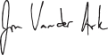  JON VANDER ARK  President and Chief Executive  Officer

(1) | Adjusted earnings per share (“EPS”) and adjusted free cash flow are non-GAAP financial measures. For a reconciliation of these non-GAAP measures to the comparable measures in accordance with GAAP, see “Reconciliation of GAAP to Non-GAAP Financial Measures” in the Annex on page 105.

 |  |  |  | Republic Services, Inc. 2026 Proxy Statement |  |  | | |  |  |  | 3

Table of Contents


Table of Contents
Notice of the 2026 Annual Meeting of Shareholders
IMPORTANT NOTICE REGARDING THE AVAILABILITY OF PROXY MATERIALS FOR THE 2026 ANNUAL MEETING OF SHAREHOLDERS (THE “ANNUAL MEETING”) OF REPUBLIC SERVICES, INC., A DELAWARE CORPORATION (THE “COMPANY”). THIS PROXY STATEMENT RELATING TO THE ANNUAL MEETING AND THE COMPANY’S ANNUAL REPORT ON FORM 10-K FOR THE YEAR ENDED DECEMBER 31, 2025 ARE AVAILABLE AT WWW.PROXYVOTE.COM.
DATE: Thursday, May 7, 2026
TIME: 10:30 a.m., Pacific Time
PLACE: Via webcast at www.virtualshareholdermeeting.com/RSG2026
ITEMS OF BUSINESS

1. | To elect the 13 director nominees listed in this proxy statement to serve until the 2027 annual meeting of shareholders or until their respective successors are duly elected and qualified;
2. | To hold an advisory vote to approve our named executive officer compensation;
3. | To ratify the appointment of our independent registered public accounting firm for 2026; and
4. | To transact such other business as may properly come before the Annual Meeting or any adjournment thereof.
RECORD DATE
Only shareholders of record at the close of business on March 9, 2026 are entitled to notice of and to vote at the Annual Meeting or any adjournment of it. A list of such shareholders will be available commencing March 24, 2026 and may be examined prior to the Annual Meeting at our corporate headquarters during normal business hours.
AVAILABILITY OF PROXY MATERIALS
We are pleased to utilize Securities and Exchange Commission rules that allow us to furnish these proxy materials and our Annual Report on Form 10-K in digital form online. Shareholders of record will be mailed a Notice of Internet Availability of Proxy Materials, which provides instructions on how to access the proxy materials and our Annual Report on Form 10-K online and, if they prefer, how to request paper copies of these materials. We believe providing these materials online enables us to reduce the environmental impact of our Annual Meeting and lower our printing and delivery costs while providing shareholders with the information they need more quickly and efficiently.
PROXY VOTING
Your participation at our Annual Meeting is important. To ensure your representation, if you do not expect to participate in the virtual meeting, please vote your shares as instructed in your Notice of Internet Availability of Proxy Materials, proxy card or voting instruction card at your earliest convenience. Your prompt return of proxies will ensure a quorum and save us the expense of further solicitation.
VIRTUAL MEETING
We will hold this year’s Annual Meeting in a virtual meeting format only. Shareholders of record at the close of business on March 9, 2026 may attend the Annual Meeting as well as vote and submit questions during the live webcast of the meeting by visiting www.virtualshareholdermeeting.com/RSG2026 and entering the 16-digit control number included in our Notice of Internet Availability of Proxy Materials, on your proxy card or in the instructions that accompanied your proxy materials. The format of the Annual Meeting will ensure that shareholders are afforded the same rights and opportunities to participate as they would at an in-person meeting.
By Order of the Board of Directors,
CATHARINE D. ELLINGSEN
Executive Vice President, Chief Legal Officer,
Chief Ethics & Compliance Officer, and Corporate Secretary
Phoenix, AZ
March 24, 2026

 |  |  |  | Republic Services, Inc. 2026 Proxy Statement |  |  | | |  |  |  | 5

Table of Contents
Table of Contents

Proxy Summary |  |  | 8-13
Board of Directors and Corporate Governance |  |  | 15-54
Republic’s Board of Directors |  |  | 15
Director Skills, Experience, and Background |  |  | 16
Biographical Information Regarding Director Nominees |  |  | 18
Board of Directors and Corporate Governance Matters |  |  | 31
Board Leadership Structure |  |  | 31
Board Meetings and Committees |  |  | 31
Meeting Participation |  |  | 31
Committee Composition |  |  | 31
Board Refreshment and Director Succession Planning |  |  | 32
Director Nomination Procedures Relating to Board Candidacy |  |  | 33
Director Onboarding Process |  |  | 33
Continuing Director Education |  |  | 33
Board Evaluation Process |  |  | 33
Executive Succession Planning and Leadership Development |  |  | 35
Stock Ownership Guidelines and Anti-Hedging and Anti-Pledging Policies |  |  | 35
Director Independence |  |  | 35
Service on Other Public Company Boards |  |  | 36
Shareholder Engagement |  |  | 36
Additional Board Policies |  |  | 37
Shareholder Director Recommendation Policy |  |  | 37
Proxy Access Director Nominations |  |  | 37
Director Resignation Policy |  |  | 38
Communications with the Board of Directors |  |  | 38
Attendance at Annual Meetings Policy |  |  | 38
Risk Oversight |  |  | 39
Board Oversight of Sustainability |  |  | 40
Board Oversight of Joint Ventures |  |  | 40
Board Oversight of Talent |  |  | 42
Ethics and Compliance |  |  | 44
Sustainability and Corporate Responsibility |  |  | 44

Talent |  |  | 47
Audit Committee Matters |  |  | 49
Director Compensation |  |  | 51
Certain Relationships and Related Party Transactions |  |  | 52
Security Ownership of the Board of Directors And Management |  |  | 53
Security Ownership of Five Percent Shareholders |  |  | 54
Delinquent Section 16(a) Reports |  |  | 54
Executive Compensation |  |  | 55-94
CD&A Table of Contents |  |  | 56
Compensation Discussion & Analysis |  |  | 58
2025 Summary Compensation Table |  |  | 80
All Other Compensation for 2025 |  |  | 81
Grants of Plan-Based Awards in 2025 |  |  | 82
Outstanding Equity Awards at Fiscal Year End |  |  | 83
PSUs and RSUs Vested in 2025 |  |  | 85
Nonqualified Deferred Compensation in 2025 |  |  | 86
Employment Agreements and Post-Employment Compensation |  |  | 86
Potential Payments Upon Termination Table |  |  | 90
CEO Pay Ratio |  |  | 91
Pay versus Performance |  |  | 92
Proposals to be Voted on at the Meeting |  |  | 96-98
Proposal 1: Election of Directors |  |  | 96
Proposal 2: Advisory Vote on Named Executive Officer Compensation |  |  | 97
Proposal 3: Ratification of Independent Registered Public Accounting Firm |  |  | 98
Meeting Information |  |  | 99-103
Annex – CD&A Appendix |  |  | 105-107
Important notice regarding the availability of proxy materials for the Annual Meeting of Shareholders to be held on May 7, 2026: This Proxy Statement relating to the 2026 Annual Meeting of Shareholders and the Annual Report on Form 10-K for the year ended December 31, 2025 are available at www.proxyvote.com.

Key Proxy
Information
Director Skills,
Experience, and
Background
(page 16)
Shareholder
Engagement
(page 36)
Risk
Oversight
(page 39)
Sustainability and
Corporate
Responsibility
(page 44)

Talent
(page 47)
Compensation
Discussion &
Analysis
(page 58)

FORWARD-LOOKING STATEMENTS
This Proxy Statement contains certain forward-looking information about us that is intended to be covered by the safe harbor for “forward-looking statements” provided by the Private Securities Litigation Reform Act of 1995. Forward-looking statements are statements that are not historical facts. Words such as “expect,” “will,” “may,” “anticipate,” “plan,” “estimate,” “project,” “intend,” “should,” “can,” “likely,” “could,” and similar expressions are intended to identify forward-looking statements. These statements include information about our plans, strategies and prospects. Forward-looking statements are not guarantees of performance. These statements are based upon the current beliefs and expectations of our management and are subject to risk and uncertainties that could cause actual results to differ materially from those expressed in, or implied or projected by, the forward-looking information and statements. Although we believe that the expectations reflected in the forward-looking statements are reasonable, such expectations may not prove to be correct. Among the factors that could cause actual results to differ materially from the expectations expressed in the forward-looking statements are general economic and market conditions, including inflation and changes in fuel, interest rates, labor, risk, health insurance and other variable costs that generally are not within our control, our ability to effectively integrate and manage companies we acquire and to realize the anticipated benefits of any such acquisitions, acts of war, riots or terrorism, and the impact of these acts on economic, financial and social conditions in North America, as well as our dependence on large, long-term collection, transfer and disposal contracts. More information on factors that could cause actual results or events to differ materially from those anticipated is included in our reports filed with the Securities and Exchange Commission, including our Annual Report on Form 10-K for the year ended December 31, 2025, particularly under Part I, Item 1A – Risk Factors. Additionally, new risk factors emerge from time to time and it is not possible for us to predict all such risk factors, or to assess the impact such risk factors might have on our business. We undertake no obligation to update or publish revised forward-looking statements whether as a result of new information, future events or otherwise, except as required by law.

Table of Contents


Table of Contents
PROXY SUMMARY |  |  |  | BOARD AND GOVERNANCE |  |  |  | EXECUTIVE COMPENSATION |  |  |  | PROPOSALS |  |  |  | MEETING INFORMATION |  |  |  | ANNEX

Proxy Summary
We are providing this proxy statement (“Proxy Statement”) to shareholders in connection with the solicitation by the Board of Directors (the “Board”) of Republic Services, Inc., a Delaware corporation (“Republic,” “Republic Services,” the “Company,” “we,” “us” or “our”), of proxies to be voted at the annual meeting of shareholders to be held virtually on May 7, 2026 (the “Annual Meeting”), and at any adjournment thereof, for the purposes set forth in the accompanying notice. This proxy summary is intended to provide an overview of the items contained in this Proxy Statement. We encourage you to read the entire Proxy Statement prior to voting your shares.
ANNUAL MEETING OF SHAREHOLDERS

DATE AND TIME: |  | Thursday, May 7, 2026 at 10:30 a.m., Pacific Time
PLACE: |  | Via webcast at www.virtualshareholdermeeting.com/RSG2026
RECORD DATE: |  | Shareholders as of March 9, 2026 are entitled to attend and vote

Proposals and Board Recommendations |  |  |  | BOARD’S  RECOMMENDATION |  | PAGE  REFERENCE
Proposal 1 |  | Election of the 13 Director Nominees in this Proxy Statement |  | FOR |  | 96
Proposal 2 |  | Advisory Vote on Named Executive Officer Compensation |  | FOR |  | 97
Proposal 3 |  | Ratification of Independent Registered Public Accounting Firm for 2026 |  | FOR |  | 98
2025 Business and Performance Highlights
We delivered another strong year of results in 2025, continuing to create value for our shareholders. Our performance reflects the resilience of our business model and the strength of our differentiated capabilities. We remain focused on executing our strategy designed to generate profitable growth by sustainably managing our customers’ needs, managing our cost structure, generating consistent earnings and free cash flow growth, improving return on invested capital, and increasing cash returns to our shareholders. We outperformed our adjusted earnings per share (“EPS”) and our upwardly revised adjusted free cash flow (“FCF”) guidance. Highlights of the year include:

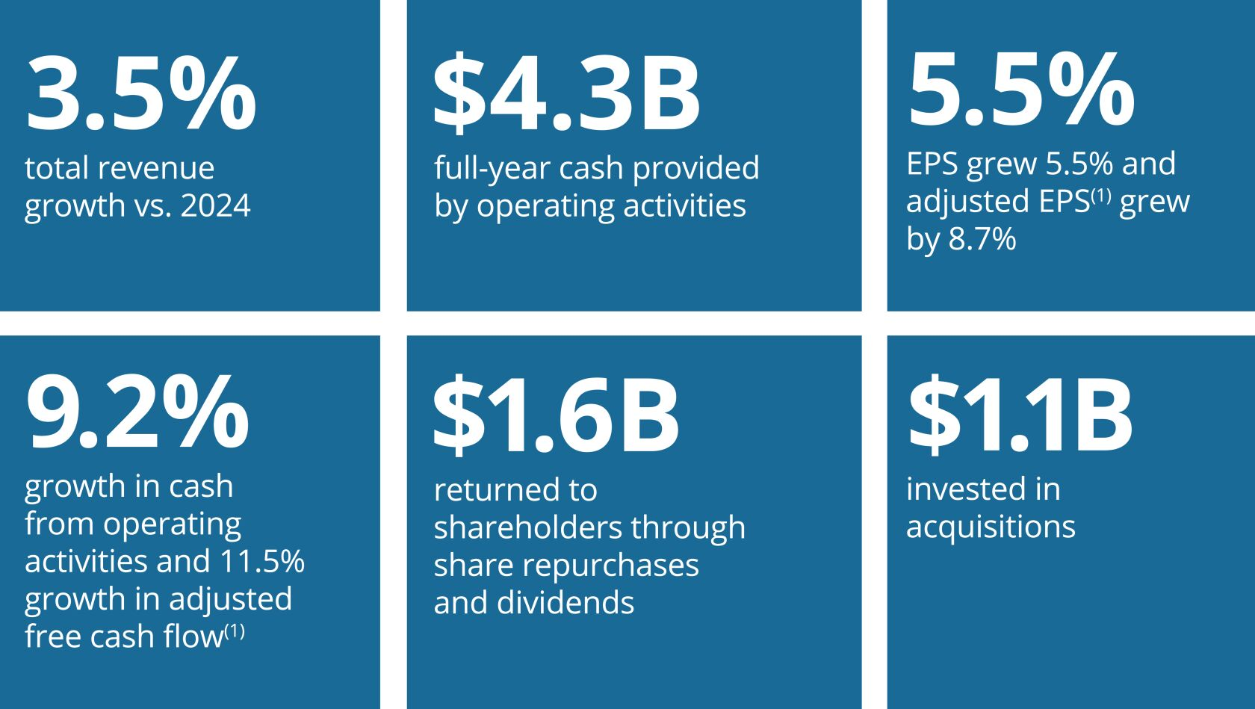

 | (1) | Adjusted EPS and adjusted free cash flow are non-GAAP financial measures. For a reconciliation of these non-GAAP measures to the comparable measures in accordance with GAAP, see “Reconciliation of GAAP to Non-GAAP Financial Measures” in the Annex on page 105.

8 |  |  | | |  |  | Republic Services, Inc. 2026 Proxy Statement

Table of Contents
PROXY SUMMARY |  |  |  | BOARD AND GOVERNANCE |  |  |  | EXECUTIVE COMPENSATION |  |  |  | PROPOSALS |  |  |  | MEETING INFORMATION |  |  |  | ANNEX

Talent Management Highlights
We’re dedicated to maintaining and expanding the human-centered practices that make us an employer of choice. In 2025, we continued to focus our talent management efforts on the core pillars of engagement, safety, inclusivity, recruitment, and continued development. Highlights of the year include:

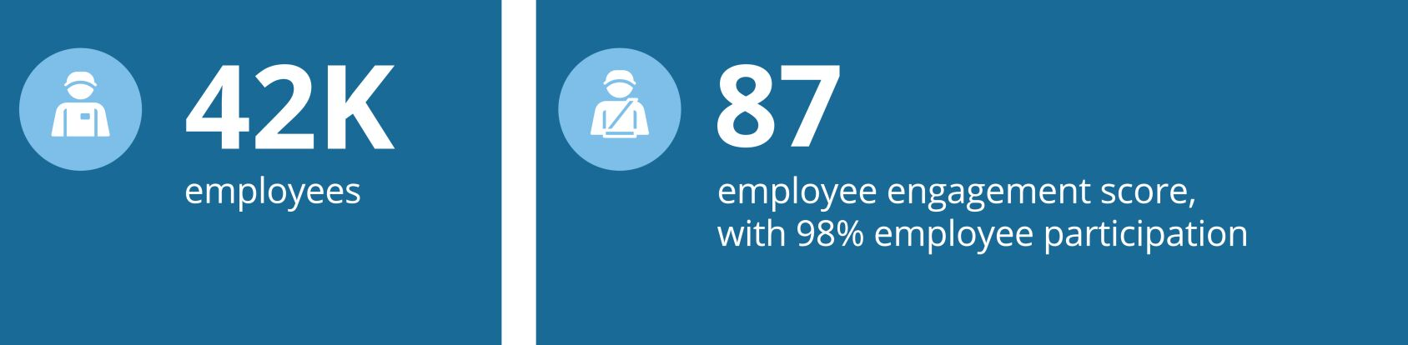
Sustainability Leadership
Our sustainability goals and practices are core to our business and are integrated into our business strategy as well as our long-term financial targets. Sustainable business practices are embedded in our day-to-day operations, which we believe improve our profitability and support long-term value creation for our shareholders. The Board is responsible for overseeing our management’s handling of environmental, social and enterprise risks, including physical and transition risks and opportunities associated with climate change. As a result of this ongoing commitment, we have been recognized for our leading performance in several key areas including employee engagement, ethics, innovation and climate change management and resiliency.

   |  |     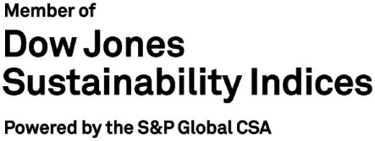 |  |     
SUSTAINABILITY IN ACTION
We are partnering with our customers to create a more sustainable world. We are passionate about our role as responsible stewards of our customers’ waste, and we continue to make progress on our 2030 Sustainability Goals. These goals reaffirm our commitment to the elements of our sustainability platform: Safety, Talent, Climate Leadership and Communities.

 |  |  |  | Republic Services, Inc. 2026 Proxy Statement |  |  | | |  |  |  | 9

Table of Contents
PROXY SUMMARY |  |  |  | BOARD AND GOVERNANCE |  |  |  | EXECUTIVE COMPENSATION |  |  |  | PROPOSALS |  |  |  | MEETING INFORMATION |  |  |  | ANNEX

Director Nominees and Corporate Governance Highlights
The table below lists the names of our director nominees and the standing committees on which they serve as of the date of this Proxy Statement.

DIRECTOR  NAME |  |  |  | AGE |  | DIRECTOR  SINCE |  | COMMITTEES |  | INDEPENDENT
Manny Kadre  (Chairman) |  |  |  | 60 |  | 2014 |  | — |  | ✓
Ian Craig |  |  |  | 53 |  | 2026 |  | Audit Committee and  Sustainability & Corporate  Responsibility Committee |  | ✓
Michael A. Duffy |  |  |  | 56 |  | 2020 |  | Audit Committee and  Sustainability & Corporate  Responsibility Committee |  | ✓
Thomas W. Handley |  |  |  | 71 |  | 2016 |  | Talent & Compensation  Committee (Chair) and  Nominating & Corporate  Governance Committee |  | ✓
Jennifer M. Kirk |  |  |  | 51 |  | 2016 |  | Audit Committee (Chair) and  Nominating & Corporate  Governance Committee |  | ✓
Michael Larson |  |  |  | 66 |  | 2009 |  | Nominating & Corporate Governance  Committee (Chair), Finance Committee  and Talent & Compensation Committee |  | ✓
Norman Thomas Linebarger |  |  |  | 63 |  | 2024 |  | Audit Committee and  Sustainability & Corporate  Responsibility Committee |  | ✓
Meg Reynolds |  |  |  | 61 |  | 2023 |  | Audit Committee and  Sustainability & Corporate  Responsibility Committee |  | ✓
James P. Snee |  |  |  | 59 |  | 2018 |  | Finance Committee (Chair),  Nominating & Corporate  Governance Committee and  Talent & Compensation Committee |  | ✓
Brian S. Tyler |  |  |  | 59 |  | 2021 |  | Finance Committee, Sustainability &  Corporate Responsibility Committee and  Talent & Compensation Committee |  | ✓
Jon Vander Ark |  |  |  | 50 |  | 2021 |  | —
Sandra M. Volpe |  |  |  | 58 |  | 2016 |  | Sustainability & Corporate Responsibility  Committee (Chair), Finance Committee and  Nominating & Corporate Governance  Committee |  | ✓
Katharine B. Weymouth |  |  |  | 59 |  | 2018 |  | Audit Committee, Finance Committee and  Talent & Compensation Committee |  | ✓

10 |  |  | | |  |  | Republic Services, Inc. 2026 Proxy Statement

Table of Contents
PROXY SUMMARY |  |  |  | BOARD AND GOVERNANCE |  |  |  | EXECUTIVE COMPENSATION |  |  |  | PROPOSALS |  |  |  | MEETING INFORMATION |  |  |  | ANNEX

Board Highlights
Our Board is comprised of highly engaged and skilled directors with varied experiences and backgrounds, who bring diverse perspectives to their oversight of our business, while representing the long-term interests of our shareholders.
BOARD REFRESHMENT
We are committed to maintaining a Board that has a balanced mix of skills and attributes. We accomplish this through our active refreshment and director succession planning process. In February 2026, we added Ian Craig, CEO of Coca-Cola FEMSA, to our Board. Mr. Craig’s executive experience and sustainability focus enables him to offer the Board valuable insight into Republic’s strategic direction and growth.
BOARD PRACTICES
Our Board has developed a robust set of practices to help ensure appropriate composition and effective functioning. The Board maintains a regular Board evaluation process that is closely linked with ongoing succession planning and is committed to regular Board refreshment based on the Company’s current and future needs and strategic priorities. The following charts summarize the independence, tenure, age and diversity of our director nominees.

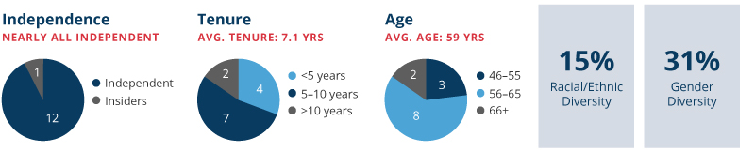
Corporate Governance Highlights
We continuously monitor developments and best practices in corporate governance and enhance our practices as warranted and based on shareholder feedback. Key features of our corporate governance practices are noted below:

✓ |  | Shareholder Engagement Program with select participation of independent directors |  | ✓ |  | Clawback Policy More Robust than SEC and NYSE Requirements
✓ |  | Proxy Access Right |  | ✓ |  | Board Evaluation Process
✓ |  | Independent Board Chairman |  | ✓ |  | Formal Onboarding Program for New Directors
✓ |  | Director and Executive Succession Planning |  | ✓ |  | Majority Vote Standard
✓ |  | Majority Independent Board (12 of 13 director nominees) |  | ✓ |  | Deferral of Compensation for Directors (restricted stock units or cash)
✓ |  | No Supermajority Vote Requirements |  | ✓ |  | One Share, One Vote Structure
✓ |  | Shareholder Action by Written Consent |  | ✓ |  | Political Contributions Policy
✓ |  | Independent Board Committees |  | ✓ |  | Mandatory Retirement Age for Directors
✓ |  | Annual Director Elections |  | ✓ |  | Anti-Hedging and Anti-Pledging Policies
✓ |  | Human Rights Policy |  | ✓ |  | Code of Business Ethics and Conduct for Board and Company employees
✓ |  | Policy Limiting Directors’ Service on Other Public Company Boards |  | ✓ |  | Supplier Code of Business Ethics and Conduct

 |  |  |  | Republic Services, Inc. 2026 Proxy Statement |  |  | | |  |  |  | 11

Table of Contents
PROXY SUMMARY |  |  |  | BOARD AND GOVERNANCE |  |  |  | EXECUTIVE COMPENSATION |  |  |  | PROPOSALS |  |  |  | MEETING INFORMATION |  |  |  | ANNEX

Executive Compensation Highlights
COMPONENTS OF OUR EXECUTIVE COMPENSATION PROGRAM
The Talent & Compensation Committee is committed to a performance-based executive compensation program that enables us to attract, retain and motivate our leadership team to drive financial success and sustained shareholder value creation. The core compensation elements for the executive officers listed in the Summary Compensation Table (referred to as “named executive officers” or “NEOs”) are:
 | • |  | base salary;
 | • |  | annual cash incentive based on target; and
 | • |  | long-term incentive (“LTI”) awards based on targets, which are delivered in performance share units (“PSUs”) and restricted stock units (“RSUs”).
Our annual incentive metrics are designed to encourage profitable growth and are widely accepted by the investment community as important performance metrics, while our LTI metrics are designed to grow our business with an emphasis on cash flow while maximizing investment returns and aligning interests between our executives and shareholders. Together, these metrics provide the appropriate balance in target total direct compensation (“Target TDC”) to drive financial and operational performance that will build long-term value for our shareholders.

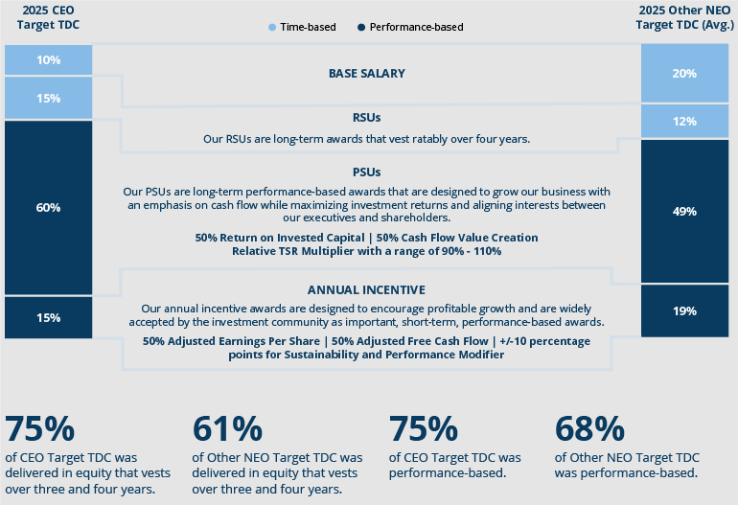

12 |  |  | | |  |  | Republic Services, Inc. 2026 Proxy Statement

Table of Contents
PROXY SUMMARY |  |  |  | BOARD AND GOVERNANCE |  |  |  | EXECUTIVE COMPENSATION |  |  |  | PROPOSALS |  |  |  | MEETING INFORMATION |  |  |  | ANNEX

EXECUTIVE COMPENSATION LINK TO STRATEGY
Our compensation program is focused on achieving key financial results that support shareholder value creation. We maintain rigorous performance goals on a bottom-up basis, reflecting management initiatives, such as profitable revenue growth, controlled operating expenses, capital investment and M&A, and the impact of anticipated external factors, such as the macroeconomic environment, the Consumer Price Index (“CPI”) impact on pricing, commodity pricing and regulatory changes. Progress towards our sustainability goals is included within each of our management initiatives and therefore directly linked to our executive compensation. To align management incentives, our metrics and performance targets focus on factors that management can influence, rather than external factors that are outside of management’s control or ability to mitigate.
Annual incentives for senior executives including our NEOs are subject to adjustment, positively or negatively, of up to 10 percentage points based on the Company’s interim performance on sustainability and performance goals focused on safety, talent, climate leadership and customer zeal. See the Executive Compensation Section of the Proxy Statement for further information regarding the Sustainability and Performance Modifier of our annual incentive program.
Compensation Governance Highlights
We have established a number of compensation best practices that help ensure our compensation program remains aligned with shareholder interests. Key features of these practices are noted below:

ü |  | Pay-for-Performance Incentive Structures |  | ü |  | Active Management of Dilution from Equity Plans
ü |  | Stock Ownership Guidelines for Senior Management and Directors |  | ü |  | No Dividends on Unearned PSUs
ü |  | Sustainability and Performance Modifier in Annual Incentive Program for Senior Management |  | ü |  | Limited Perquisites
ü |  | Independent Compensation Consultant |  | ü |  | No Excise Tax Gross-Ups
ü |  | Clawback Policy More Robust than SEC and NYSE Requirements |  | ü |  | No Hedging, Pledging or Short Sales
ü |  | Double Trigger Change in Control Provisions |  | ü |  | Annual Risk Assessment of Compensation Program
We encourage you to read the entire Proxy Statement for additional information prior to voting your shares.

 |  |  |  | Republic Services, Inc. 2026 Proxy Statement |  |  | | |  |  |  | 13

Table of Contents


Table of Contents
PROXY SUMMARY |  |  |  | BOARD AND GOVERNANCE |  |  |  | EXECUTIVE COMPENSATION |  |  |  | PROPOSALS |  |  |  | MEETING INFORMATION |  |  |  | ANNEX

Board of Directors and Corporate Governance
REPUBLIC’S BOARD OF DIRECTORS
Republic’s Board currently consists of 13 directors.
The Board’s Nominating & Corporate Governance Committee (the “Governance Committee”) evaluated our 13 director nominees in accordance with the Governance Committee’s charter and our Corporate Governance Guidelines and submitted the nominees to the full Board for approval. We believe that each of our director nominees is highly qualified and collectively, they represent an ideal mix of experience, wisdom, integrity, and ability to advance Republic’s strategy and serve the interests of all our stakeholders.



 |  |  |  | Republic Services, Inc. 2026 Proxy Statement |  |  | | |  |  |  | 15

Table of Contents
PROXY SUMMARY |  |  |  | BOARD AND GOVERNANCE |  |  |  | EXECUTIVE COMPENSATION |  |  |  | PROPOSALS |  |  |  | MEETING INFORMATION |  |  |  | ANNEX

DIRECTOR SKILLS, EXPERIENCE, AND BACKGROUND
Republic is an environmental services company providing essential services to customers. We operate in a highly technical, regulated, and competitive industry. As such, we require a Board that possesses a wide array of relevant skill sets to help us drive forward our long-term strategy. We seek directors who have a growth mindset, sound business judgment, integrity, professionalism, and a diverse set of experiences and perspectives.

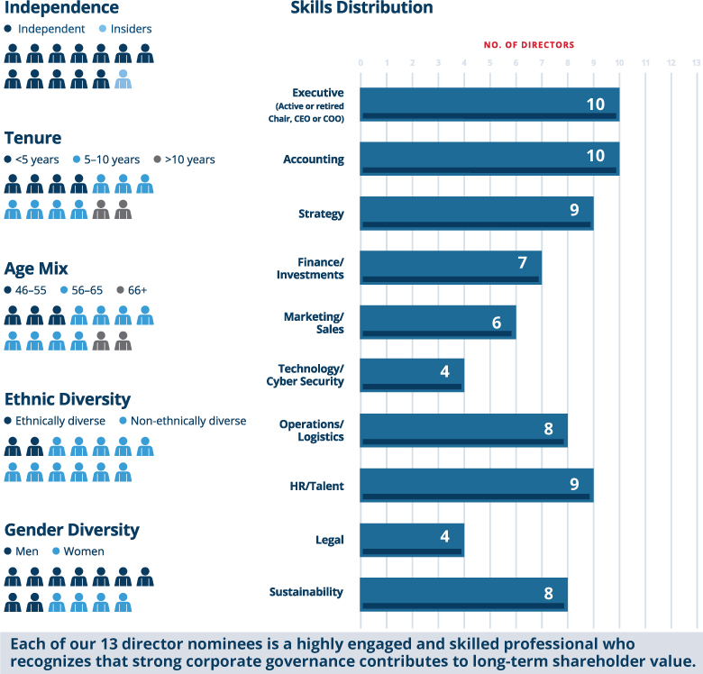

16 |  |  | | |  |  | Republic Services, Inc. 2026 Proxy Statement

Table of Contents
PROXY SUMMARY |  |  |  | BOARD AND GOVERNANCE |  |  |  | EXECUTIVE COMPENSATION |  |  |  | PROPOSALS |  |  |  | MEETING INFORMATION |  |  |  | ANNEX

Listed below are the core skills and experiences we consider to be beneficial for our Board to possess.

Skills & Experience |  | Application to Republic Services
Executive (Active or retired Chair, CEO or COO) |  | As a leader in the environmental services industry with vertically integrated operations across the U.S. and Canada, the scale and intricacies of Republic’s business make it necessary to have directors who have experience leading their organizations. These directors provide valuable guidance and perspective when analyzing and overseeing complex financial, operational, and strategic decisions, and leading strong corporate governance practices.
Financial Accounting |  | As a publicly traded company with a North American footprint and diversified exposure to franchise, large urban and small to mid-sized markets, financial accounting experience enables Republic directors to advise on and provide oversight into risk management, financial reporting and internal control items.
Strategy |  | A focus on customer needs and sustainability is core to how Republic generates profitable growth. Directors with a background in developing and implementing the strategic direction of a company provide useful insight into operating and growing Republic’s business.
Finance/Investments |  | As a vertically integrated company in an industry where acquisitions often present an opportunity to drive growth and build scale, directors with knowledge of financial markets, financing, funding operations and merger integration bring useful insights to the Board, particularly given the role M&A has in Republic’s strategy. In addition, directors who possess a general understanding of business cycles, capital markets and the investor perspective provide guidance on Republic’s capital allocation strategy and broader strategic positioning.
Marketing/Sales |  | As a customer-facing brand focused on growing new business, driving brand awareness and customer loyalty are important to Republic’s growth strategy. Directors with expertise in amplifying and enhancing effective corporate marketing strategies provide useful insight toward developing customer zeal, brand recognition and top-line revenue growth.
Technology/  Cybersecurity |  | A core aspect of Republic’s long-term strategy is using technology to differentiate our service offerings, improve customer satisfaction and drive operational efficiencies. Directors who are familiar with innovative technological strategies and understand emerging trends bring necessary perspectives to the Board regarding technology’s role in Republic’s strategy. In addition, Republic’s technology and cybersecurity programs are crucial to maintaining secure cybersecurity operations, delivering customer satisfaction and trust, which means directors with knowledge of cybersecurity risks and best practices provide valuable insight into oversight of these risks.
Operations/Logistics |  | Republic’s business is focused on providing a comprehensive set of integrated environmental services to customers as efficiently and safely as possible in a cost-effective manner. This includes planning vehicle routes, operating and maintaining facilities such as recycling processing centers and regenerative landfills, and managing the Company’s resources, such as equipment and personnel. Directors with experience strategizing, controlling and implementing logistics management systems can contribute valuable perspective and guidance to the Board on this essential element of Republic’s business.
HR/Talent |  | As a highly technical organization with employees that possess specialized skills in significant demand, directors that are able to provide guidance on attracting and retaining top talent, have experience managing the compensation of executives and other employees and have experience in succession planning are of immense value to the Board. Maintaining an engaged workforce and investing in employee development are also core to Republic’s talent strategy, an area where directors with human resources experience provide thoughtful insight.
Legal |  | As a publicly traded company and a provider of services in a highly regulated industry, directors with legal knowledge and background are beneficial to the Board in its oversight of Republic’s compliance on legal and regulatory matters.
Sustainability |  | Republic’s strategy is designed to generate profitable growth by partnering with customers to create a more sustainable world. As an environmental services company, directors with expertise in evolving issues around talent, inclusion and diversity, employee retention and development, employee safety, climate leadership and community engagement provide valuable guidance and insight to the Board when providing oversight on Republic’s sustainability efforts.

 |  |  |  | Republic Services, Inc. 2026 Proxy Statement |  |  | | |  |  |  | 17

Table of Contents
PROXY SUMMARY |  |  |  | BOARD AND GOVERNANCE |  |  |  | EXECUTIVE COMPENSATION |  |  |  | PROPOSALS |  |  |  | MEETING INFORMATION |  |  |  | ANNEX

Biographical Information Regarding Director Nominees

NEW THIS YEAR |  | As a part of our commitment to active refreshment, the Board added Ian Criag, CEO of Coca-Cola FEMSA, as a new director in 2026. Mr. Craig, who serves on the Audit Committee and the Sustainability & Corporate Responsibility Committee, brings a depth of operations and leadership experience and expertise in logistics, strategy, and digital transformation.
BOARD REFRESHMENT



Manny Kadre  CHAIRMAN OF THE BOARD SINCE MAR. 2017  DIRECTOR SINCE JUNE 2014  AGE: 60 |  | Committees  None

EXPERIENCES AND SKILL SETS ALIGNED WITH BOARD CONTRIBUTIONS AND REPUBLIC’S STRATEGY:
Mr. Kadre is currently the Chief Executive Officer of Kollective Auto Group, a premium luxury retail automotive group, and previously was Chief Executive Officer of a number of beverage, automotive, healthcare and real estate companies.
Mr. Kadre has gained significant management and leadership experience from serving as Chief Executive Officer of these companies for over two decades. He brings to the Board valuable perspective on managing the strategic direction of organizations, particularly useful given Republic operates in a highly technical, regulated and competitive industry.
Throughout his career, Mr. Kadre has held leadership roles in acquiring, managing, and running several businesses, gaining valuable financial and strategy experience. These experiences enable him to provide guidance regarding Republic’s M&A opportunities, which is important given the role M&A plays in Republic’s strategy and Republic’s position in an industry where acquisitions present an opportunity to drive growth and build scale.
Mr. Kadre has extensive experience strategically positioning well-known, customer-facing brands to drive customer awareness and loyalty. His focus on using marketing efforts to heighten brand recognition, particularly for businesses in highly regulated industries, augments the Board’s ability to oversee and provide input on marketing and sales topics.
Through Mr. Kadre’s leadership roles at companies in highly regulated industries, including serving as General Counsel of beverage product distributor CC1 Companies, he offers the Board valuable expertise when assessing legal and regulatory matters. In addition, he has extensive public company experience having served on four public company boards; Republic, NeueHealth, The Home Depot, and Mednax.
CAREER HIGHLIGHTS
Kollective Auto Group, 2012 - Present
Chief Executive Officer
Gold Coast Caribbean Importers, 2005 - 2014
Chief Executive Officer
CC1 Companies, 1995 - 2009
President, Vice President, General Counsel and Secretary
OTHER PUBLIC COMPANY DIRECTORSHIPS
(WITHIN THE LAST 5 YEARS)
The Home Depot, Inc., 2018 - Present
(Member of the Audit Committee and the Finance Committee)
NeueHealth, 2021 - 2025
(NeueHealth was taken private in 2025; Mr. Kadre remains on the Board of Directors of the private company)
Mednax, Inc., 2007 - 2022
ADDITIONAL EXPERIENCE & SERVICE
Board of Trustees, University of Miami
Board of Directors, University of Miami Health System

18 |  |  | | |  |  | Republic Services, Inc. 2026 Proxy Statement

Table of Contents
PROXY SUMMARY |  |  |  | BOARD AND GOVERNANCE |  |  |  | EXECUTIVE COMPENSATION |  |  |  | PROPOSALS |  |  |  | MEETING INFORMATION |  |  |  | ANNEX



Ian Craig  DIRECTOR SINCE FEB. 2026  AGE: 53 |  | Committees  Audit, Sustainability & Corporate Responsibility

EXPERIENCES AND SKILL SETS ALIGNED WITH BOARD CONTRIBUTIONS AND REPUBLIC’S STRATEGY:
Mr. Craig is the Chief Executive Officer of Coca-Cola FEMSA, Latin America’s largest bottling company with a market capitalization of $23 billion.
With more than 20 years of experience at Coca-Cola FEMSA in numerous leadership positions, Mr. Craig has cultivated extensive leadership and management experience.
Mr. Craig possesses a strong track record of driving strategic expansion, having led more than $7 billion in mergers and acquisitions across Latin America, enhancing the Board’s perspective on capital allocation, merger integration, and value creation.
Mr. Craig’s background in building digital platforms and implementing AI-enabled commercial and logistics capabilities equips the Board with differentiated insight into how Republic can leverage new technologies to achieve its business goals and priorities.
Through his oversight of Coca-Cola FEMSA’s sustainability initiatives and in his position as President of Coca-Cola FEMSA’s Sustainability Committee, Mr. Craig brings valuable expertise in sustainability matters, strengthening the Board’s oversight as Republic continues to advance its commitments to environmental stewardship and innovation.
CAREER HIGHLIGHTS
Coca-Cola FEMSA, 2003 – Present
Chief Executive Officer
Chief Operating Officer, KOF Brazil
Chief Operating Officer, KOF Argentina
CFO and Strategic Planning Director, KOF South America
CFO, Planning and Corporate Affairs Director, KOF Mercosur
Corporate Finance and Treasury Director
FEMSA, 1994 – 2003
Corporate Finance
Beer Division Operations Planning
Hylsamex, 1993 – 1993
Strategic Planning
ADDITIONAL EXPERIENCE & SERVICE
Former Advisory Board Member, Bimbo Brazil

 |  |  |  | Republic Services, Inc. 2026 Proxy Statement |  |  | | |  |  |  | 19

Table of Contents
PROXY SUMMARY |  |  |  | BOARD AND GOVERNANCE |  |  |  | EXECUTIVE COMPENSATION |  |  |  | PROPOSALS |  |  |  | MEETING INFORMATION |  |  |  | ANNEX


Michael A. Duffy  DIRECTOR SINCE JULY 2020  AGE: 56 |  | Committees  Audit, Sustainability & Corporate Responsibility

EXPERIENCES AND SKILLSETS ALIGNED WITH BOARD CONTRIBUTIONS AND REPUBLIC’S STRATEGY:
Mr. Duffy is a seasoned distribution, supply chain and retail executive with over 25 years of experience. Mr. Duffy was recently appointed as Chief Executive Officer of Rentokil Initial plc, a global leader in pest control and hygiene and wellbeing services. Prior to his current role, Mr. Duffy served as the Chief Executive Officer of OnTrac, the largest regional e-commerce parcel carrier in the U.S.
Mr. Duffy has extensive leadership and chief executive experience from his roles at Rentokil Initial, OnTrac, FleetPride, and C&S Wholesale Grocers.
In his roles as Chief Executive Officer of FleetPride and C&S Wholesale Grocers, Mr. Duffy developed and implemented strategic initiatives to drive the growth of these organizations.
Mr. Duffy managed complex supply chains for Cardinal Health and The Procter & Gamble Company through his roles as Global President of Supply Chain and Vice President of Global Supply Chain, respectively.
Through his chief executive experience at Rentokil Initial, On Trac, FleetPride, and C&S Wholesale Grocers, Mr. Duffy has gained important perspective on human resources, talent, and labor topics.
CAREER HIGHLIGHTS
Rentokil Initial plc, February 2026 – Present
Chief Executive Officer
OnTrac, 2023 – January 2026
Chief Executive Officer
FleetPride, Inc., 2021 – 2023
Chief Executive Officer
C&S Wholesale Grocers, Inc., 2017 – 2020
Chief Executive Officer
Cardinal Health, Inc., 2006 – 2017
President, Hospital Solutions and Global Supply Chain President, Medical Products
Various executive positions with increasing responsibility
The Procter & Gamble Company, 2005 – 2006
Vice President, Global Supply Chain
Gillette Company, 2001 – 2005 (Acquired by P&G in 2005)
Vice President, North America Value Chain
New York Consulting Partners, 1997 –1999, 2000 – 2001
Partner
OTHER PUBLIC COMPANY DIRECTORSHIPS
(WITHIN THE LAST 5 YEARS)
Rentokil Initial plc, March 2026 – Present
(Executive Director)

20 |  |  | | |  |  | Republic Services, Inc. 2026 Proxy Statement

Table of Contents
PROXY SUMMARY |  |  |  | BOARD AND GOVERNANCE |  |  |  | EXECUTIVE COMPENSATION |  |  |  | PROPOSALS |  |  |  | MEETING INFORMATION |  |  |  | ANNEX


Thomas W. Handley  DIRECTOR SINCE JULY 2016  AGE: 71 |  | Committees  Talent & Compensation (Chair), Nominating & Corporate Governance

EXPERIENCES AND SKILL SETS ALIGNED WITH BOARD CONTRIBUTIONS AND REPUBLIC’S STRATEGY:
Mr. Handley is a senior advisor and former Chief Operating Officer of Cascade Asset Management Company, the investment office for William H. Gates III, and the Gates Foundation Trust.
Mr. Handley’s experience as the former President and Chief Operating Officer of Ecolab, a hygiene and infection prevention solutions and services company, benefits the Board and management as they implement strategies for growth while operating in a safe, responsible and cost-effective manner.
Mr. Handley’s understanding of corporate strategic planning, business operations, sales and marketing gained during two decades in senior executive roles at The Procter & Gamble Company helps the Board oversee Republic’s brand and customer experience.
Mr. Handley’s expertise in business operations and information technology provides the Board governance skills with respect to field operations and cybersecurity which assists Republic in maintaining a strong digital capability.
Mr. Handley’s combined experience in corporate operations and investment management also supports the Board as it considers matters relating to corporate governance, investor relations, compensation, operational safety and sustainability.
CAREER HIGHLIGHTS
William H. Gates III, 2019 – Present
Senior Advisor and former Chief Operating Officer of Cascade Asset Management Company, the investment office for William H. Gates III, and the Gates Foundation Trust
Ecolab Inc., 2003 – 2019
President and Chief Operating Officer
Various other senior executive positions with increasing responsibility
The Procter & Gamble Company, 1981 – 2003
Vice President, Global Planning, Marketing and Always Global Franchise
Various positions in general and brand management both in the United States and internationally
OTHER PUBLIC COMPANY DIRECTORSHIPS
(WITHIN THE LAST 5 YEARS)
HB Fuller Company, 2010 – Present
(Member of the Corporate Governance and Nominating Committee and Chair of the Audit Committee)
ADDITIONAL EXPERIENCE & SERVICE
Director and former director of various other private company and non-profit organizations

 |  |  |  | Republic Services, Inc. 2026 Proxy Statement |  |  | | |  |  |  | 21

Table of Contents
PROXY SUMMARY |  |  |  | BOARD AND GOVERNANCE |  |  |  | EXECUTIVE COMPENSATION |  |  |  | PROPOSALS |  |  |  | MEETING INFORMATION |  |  |  | ANNEX


Jennifer M. Kirk  DIRECTOR SINCE JULY 2016  AGE: 51 |  | Committees  Audit (Chair), Nominating & Corporate Governance

EXPERIENCES AND SKILL SETS ALIGNED WITH BOARD CONTRIBUTIONS AND REPUBLIC’S STRATEGY:
Ms. Kirk serves as the Chief Executive Officer of Exubrion Therapeutics, a company focused on advancing nuclear medicine therapies in the veterinary market. In her prior role, Ms. Kirk served as Senior Vice President, Global Controller and Chief Accounting Officer at Medtronic plc, a medical device company, for nearly five years.
With more than 25 years in finance and accounting roles, Ms. Kirk has deep experience in financial accounting and experience managing the financial activities and reporting of a multinational corporation. Ms. Kirk’s experience includes overseeing financial reporting across global locations, managing budgeting and forecasting processes, ensuring financial compliance with regulations and internal policies, conducting financial analysis for strategic decision-making, coordinating audits, and contributing to strategic planning and business growth initiatives. At Medtronic, she was responsible for maintaining financial integrity, transparency, and strategic financial leadership to support Medtronic’s global operations and long-term success.
During her over 20 years at Occidental Petroleum, Ms. Kirk held various positions, including Senior Vice President of Integration and Value Capture, where she led initiatives focused on technological innovation and cybersecurity.
Ms. Kirk has experience leading companies’ financial departments, particularly their financial support and financial business processes, providing useful perspectives on financial positioning and capital allocation.
Through Ms. Kirk’s time at Medtronic and Occidental Petroleum, she has extensive experience in overseeing compliance for organizations that operate in highly regulated industries.
CAREER HIGHLIGHTS
Exubrion Therapeutics, May 2025 – Present
Chief Executive Officer
Medtronic plc, 2021 – April 2025
Senior Vice President, Global Controller and Chief Accounting Officer
Occidental Petroleum Corporation, 1999 – 2020
Senior Vice President, Integration and Value Capture
Vice President, Controller and Chief Accounting Officer Various operational and HQ positions with increasing responsibility
Arthur Andersen LLP, 1996 – 1999
Responsibilities encompassed all areas of financial statement audits including planning, supervision and financial statement reporting at both a staff and senior level
OTHER PUBLIC COMPANY DIRECTORSHIPS
(WITHIN THE LAST 5 YEARS)
Sempra, 2024 – Present
(Member of the Audit Committee and Safety, Sustainability and Technology Committee)
ADDITIONAL EXPERIENCE & SERVICE
Board Member, Exubrion Therapeutics
Member, Chief Accounting Officer Network and the American Institute of Certified Public Accountants
Member, Healing with Horseplay

22 |  |  | | |  |  | Republic Services, Inc. 2026 Proxy Statement

Table of Contents
PROXY SUMMARY |  |  |  | BOARD AND GOVERNANCE |  |  |  | EXECUTIVE COMPENSATION |  |  |  | PROPOSALS |  |  |  | MEETING INFORMATION |  |  |  | ANNEX


Michael Larson  DIRECTOR SINCE OCT. 2009  AGE: 66 |  | Committees  Nominating & Corporate Governance (Chair), Finance,  Talent & Compensation

EXPERIENCES AND SKILL SETS ALIGNED WITH BOARD CONTRIBUTIONS AND REPUBLIC’S STRATEGY:
Mr. Larson is the Chief Investment Officer of both Cascade Asset Management Company, the investment office for William H. Gates III, and the Gates Foundation Trust.
Over the course of his successful 40-year career as an investor, Mr. Larson has developed a deep understanding of global capital markets, business cycles and capital allocation. These experiences prove invaluable as the Board and management seek to drive growth and build scale.
Mr. Larson’s commitment to sound corporate governance enhances the Board’s ability to align the interests of Republic’s management, investors, shareholders and stakeholders.
Mr. Larson’s insight into sustainability issues also offers the Board unique perspective concerning matters vital to Republic’s business model including talent management, employee safety and climate leadership.
Mr. Larson brings to the Board a special appreciation of the interests of long-term shareholders, including the perspective of Republic’s largest shareholder, Cascade Investment, L.L.C.
CAREER HIGHLIGHTS
William H. Gates III, 1994 – present
Chief Investment Officer for William H. Gates III and the Gates Foundation Trust
OTHER PUBLIC COMPANY DIRECTORSHIPS
(WITHIN THE LAST 5 YEARS)
Ecolab Inc., 2012 – Present
(Chair of the Finance Committee and Member of the Safety, Health and Environment Committee)
Fomento Económico Mexicano, S.A.B.de C.V., 2011 – Present
ADDITIONAL EXPERIENCE & SERVICE
Member of the Western Asset Funds Board of Directors, Member of the Audit, Governance and Nominating, Executive and Contracts, and Investment and Performance Committees. Formerly served on the Board of Directors of AutoNation, Inc., Grupo Televisa, S.A.B., Hamilton Lane and Pan American Silver Corp.
Additional Experience, Prior to 1994
Harris Investment Management
Putnam Management Company
ARCO

 |  |  |  | Republic Services, Inc. 2026 Proxy Statement |  |  | | |  |  |  | 23

Table of Contents
PROXY SUMMARY |  |  |  | BOARD AND GOVERNANCE |  |  |  | EXECUTIVE COMPENSATION |  |  |  | PROPOSALS |  |  |  | MEETING INFORMATION |  |  |  | ANNEX


Norman Thomas Linebarger  DIRECTOR SINCE FEB. 2024  AGE: 63 |  | Committees  Audit, Sustainability & Corporate Responsibility

EXPERIENCES AND SKILL SETS ALIGNED WITH BOARD CONTRIBUTIONS AND REPUBLIC’S STRATEGY:
Mr. Linebarger is the Chief Executive Officer, Energy Transformation for General Catalyst. Prior to that role, Mr. Linebarger served as Chairman and Chief Executive Officer of Cummins Inc., a publicly traded manufacturer of engines, generators, and electrified power solutions.
Mr. Linebarger’s tenure and senior leadership roles at Cummins have afforded him extensive leadership and management experience, enabling him to offer the Board valuable insight into Republic’s strategic direction and growth.
With 30 years of experience at a leading manufacturing company, Mr. Linebarger has developed indispensable logistics, manufacturing and operations expertise, allowing him to drive continued innovation and efficiency.
While overseeing Cummins’ evolution into a global leader with strong environmental stewardship and customer-focused solutions, Mr. Linebarger developed a deep understanding of sustainable technologies in highly regulated industries, which is critical to the Board as Republic strives to be a leader in environmental services.
As the former Vice President of Supply Chain Management at Cummins, Mr. Linebarger is adept at managing complex supply chains, which is beneficial as the Board oversees Republic’s national, vertically integrated operations.

CAREER HIGHLIGHTS
General Catalyst, 2025 – Present
Chief Executive Officer, Energy Transformation
Cummins Inc., 1993 – 2023
Chairman and Chief Executive Officer
President and Chief Operating Officer
Executive Vice President and President, Power Generation Business
Vice President and Chief Financial Officer
Vice President, Supply Chain Management
OTHER PUBLIC COMPANY DIRECTORSHIPS
(WITHIN THE LAST 5 YEARS)
Harley Davidson Inc., 2008 – 2025
Cummins Inc., 2012 – 2023
ADDITIONAL EXPERIENCE & SERVICE
Board Member, Mainspring Energy, Inc.
Board Member, Capture6
Board Member, RiseUpTogether
Former Member and Chair, U.S.-China Business Council

24 |  |  | | |  |  | Republic Services, Inc. 2026 Proxy Statement

Table of Contents
PROXY SUMMARY |  |  |  | BOARD AND GOVERNANCE |  |  |  | EXECUTIVE COMPENSATION |  |  |  | PROPOSALS |  |  |  | MEETING INFORMATION |  |  |  | ANNEX


Meg Reynolds  DIRECTOR SINCE JULY 2023  AGE: 61 |  | Committees  Audit, Sustainability & Corporate Responsibility

EXPERIENCES AND SKILL SETS ALIGNED WITH BOARD CONTRIBUTIONS AND REPUBLIC’S STRATEGY:
Ms. Reynolds is Co-Founder, Principal and Portfolio Manager at Westwood Global Investments, an international and emerging markets investment management firm with $13 billion in assets under management.
Ms. Reynolds’ extensive investment background from her experience at Westwood Global Investments, Fidelity Investments and Putnam Investor Services gives her valuable insights into capital markets and the global macroeconomic environment. As a portfolio manager for over 30 years, Ms. Reynolds has both depth and breadth of experience that enables her to provide valuable oversight with respect to risk management, financial reporting, and internal controls.
Her investment background brings a wealth of experience examining and assessing companies’ capital allocation strategies, which is important as Republic generates consistent earnings and free cash flow growth.
With nearly 35 years of broad investment experience, Ms. Reynolds brings to the Board a strong understanding of sustainability topics, which is critical as Republic focuses on sustainability as a platform for growth.
Ms. Reynolds’ robust not-for-profit board experience and passion for both her clients and communities gives her strong experience engaging with multiple stakeholders and understanding competing stakeholder priorities. This is important as community engagement and relations is central to Republic’s daily operations and success.
CAREER HIGHLIGHTS
Westwood Global Investments, 2003 – Present
Co-Founder, Principal and Portfolio Manager
Fidelity Investments, 1995 – 2003
Portfolio Manager, Latin America
Various Analyst & Associate Portfolio Manager Roles
Putnam Investor Services, 1986 – 1995
Various Analyst & Associate Roles
ADDITIONAL EXPERIENCE & SERVICE
Board Member, Member of Investment Committee, Catholic Schools Foundation
Board Member, Chair of Finance Committee, Member of Grant Committee, Kelly Brush Foundation
Board Member and Member of Finance Committee, Dana Farber Cancer Institute
Board Member, Member of Investment Committee, Member of Allocations Committee, Women’s Foundation of Boston

 |  |  |  | Republic Services, Inc. 2026 Proxy Statement |  |  | | |  |  |  | 25

Table of Contents
PROXY SUMMARY |  |  |  | BOARD AND GOVERNANCE |  |  |  | EXECUTIVE COMPENSATION |  |  |  | PROPOSALS |  |  |  | MEETING INFORMATION |  |  |  | ANNEX


James P. Snee  DIRECTOR SINCE JULY 2018  AGE: 59 |  | Committees  Finance (Chair), Nominating & Corporate Governance,  Talent & Compensation

EXPERIENCES AND SKILL SETS ALIGNED WITH BOARD CONTRIBUTIONS AND REPUBLIC’S STRATEGY:
Mr. Snee is the former Chairman, President and Chief Executive Officer of Hormel Foods Corp., a global manufacturer and marketer of consumer-branded food, where he worked for over 30 years in a variety of executive management roles.
Mr. Snee has extensive executive experience through the multiple leadership roles he held at Hormel Foods Corp., a publicly traded Fortune 500 company.
While overseeing the expanding global portfolio for Hormel Foods, Mr. Snee gained a depth of marketing experience helping customer-facing brands develop customer loyalty and brand awareness.
Mr. Snee held multiple senior operational roles at Hormel Foods, a company that derives revenue from over 80 countries. In these roles, he gained experience with logistics and operating large-scale organizations efficiently.
While leading Hormel Foods, Mr. Snee developed a keen awareness of numerous sustainability factors, especially talent attraction and retention.
At Hormel Foods, Mr. Snee led the modernization of its technology and e-commerce capabilities.

CAREER HIGHLIGHTS
Hormel Foods Corporation, 1989 – 2025
Chairman, President and Chief Executive Officer
President and Chief Operating Officer
Group Vice President and President, Hormel Foods International Corporation
Vice President and Senior Vice President, Hormel Foods International Corporation
Vice President, Affiliated Business Units
OTHER PUBLIC COMPANY DIRECTORSHIPS
(WITHIN THE LAST 5 YEARS)
Hormel Foods Corporation, 2015 – 2025
(Chairman of the Board)
ADDITIONAL EXPERIENCE & SERVICE
External Observing Board Member, PwC USA Board of Partners and Principals
Former Board and Executive Committee Member, Consumer Brands Association
Former Executive Board Member, North American Meat Institute
Former Board Member, The Hormel Foundation

26 |  |  | | |  |  | Republic Services, Inc. 2026 Proxy Statement

Table of Contents
PROXY SUMMARY |  |  |  | BOARD AND GOVERNANCE |  |  |  | EXECUTIVE COMPENSATION |  |  |  | PROPOSALS |  |  |  | MEETING INFORMATION |  |  |  | ANNEX


Brian S. Tyler  DIRECTOR SINCE APR. 2021  AGE: 59 |  | Committees  Finance, Sustainability & Corporate Responsibility,  Talent & Compensation

EXPERIENCES AND SKILL SETS ALIGNED WITH BOARD CONTRIBUTIONS AND REPUBLIC’S STRATEGY:
Mr. Tyler is the Chief Executive Officer of McKesson Corporation, a publicly traded $360 billion healthcare distribution and services firm.
Through his experiences at McKesson, Mr. Tyler has gained leadership experience, helping design, analyze, and execute on the company’s strategy.
With more than twenty-five years at McKesson, Mr. Tyler has developed valuable operations and logistics experience. This helps him oversee Republic’s ability to provide integrated environmental services to customers in an efficient and safe manner.
At McKesson, Mr. Tyler has assessed numerous potential transactions, including financing and funding options, and led the integration of acquired assets.
As the Chief Executive Officer of the leading healthcare distribution and services firm, Mr. Tyler understands the importance of making sustainability a core aspect of a company’s strategy.
In Mr. Tyler’s roles at McKesson, he has been focused on improving patient care and customer value. These efforts have provided him with experience in enhancing customer relationships, brand awareness, and customer loyalty.
CAREER HIGHLIGHTS
McKesson Corporation, 1997 – Present
Chief Executive Officer and President, McKesson Corporation
Chairman, McKesson Europe AG
President and Chief Operating Officer, McKesson Europe AG
President, North America Pharmaceutical Distribution & Services
Various executive positions with increasing responsibility
OTHER PUBLIC COMPANY DIRECTORSHIPS
(WITHIN THE LAST 5 YEARS)
McKesson Corporation, 2019 – Present
ADDITIONAL EXPERIENCE & SERVICE
Board member, International Federation of Pharmaceutical Wholesalers (IFPW)

 |  |  |  | Republic Services, Inc. 2026 Proxy Statement |  |  | | |  |  |  | 27

Table of Contents
PROXY SUMMARY |  |  |  | BOARD AND GOVERNANCE |  |  |  | EXECUTIVE COMPENSATION |  |  |  | PROPOSALS |  |  |  | MEETING INFORMATION |  |  |  | ANNEX


Jon Vander Ark  DIRECTOR SINCE JULY 2021  AGE: 50 |  | Committees  None

RELEVANT EXPERIENCE:
Mr. Vander Ark is President and Chief Executive Officer of Republic Services, Inc. He is responsible for driving its values-based culture and leading the Company’s strategy. He was instrumental in developing Republic’s strategy to partner with customers to create a more sustainable world. By executing this strategy, Republic now has a broad set of environmental services across the United States and Canada.
Mr. Vander Ark has extensive knowledge of the Company’s customer base and growth opportunities that he first developed as the Company’s Chief Marketing Officer. He played a critical role in building the Company’s capabilities in customer zeal, digital, and sustainability.
Mr. Vander Ark also gained extensive knowledge of the Company’s operating assets through a series of operating roles, culminating in his time as the Company’s Chief Operating Officer. He has spent extensive time visiting the Company’s 208 business units. This provides an unrivaled perspective on the Company’s talent, local competitive dynamics and the regulatory environment.
More recently, in Mr. Vander Ark’s time as President and CEO, he has helped develop a strategy to compete more broadly in environmental services while building world-class capabilities in customer zeal, digital, and sustainability.
Prior to joining Republic, Mr. Vander Ark’s role in consulting exposed him to a wide range of industries including automotive, logistics, and consumer durables. He developed deep expertise in marketing and sales serving leading global companies.
CAREER HIGHLIGHTS
Republic Services, Inc., 2013 – Present
President and Chief Executive Officer
Executive Vice President, Chief Operating Officer
Executive Vice President, Operations
Executive Vice President, Chief Marketing Officer
McKinsey & Company, 2000 – 2012
Partner
Associate Principal
Manager
OTHER PUBLIC COMPANY DIRECTORSHIPS
(WITHIN THE LAST 5 YEARS)
Lennox International, 2024 – Present
(Member of the Audit Committee and the Compensation and Human Resources Committee)
ADDITIONAL EXPERIENCE & SERVICE
Board member, Chances for Children

28 |  |  | | |  |  | Republic Services, Inc. 2026 Proxy Statement

Table of Contents
PROXY SUMMARY |  |  |  | BOARD AND GOVERNANCE |  |  |  | EXECUTIVE COMPENSATION |  |  |  | PROPOSALS |  |  |  | MEETING INFORMATION |  |  |  | ANNEX


Sandra M. Volpe  DIRECTOR SINCE DEC. 2016  AGE: 58 |  | Committees  Sustainability & Corporate Responsibility (Chair), Finance,  Nominating & Corporate Governance

EXPERIENCES AND SKILL SETS ALIGNED WITH BOARD CONTRIBUTIONS AND REPUBLIC’S STRATEGY:
Ms. Volpe is the former Senior Vice President of Strategic Planning, Communications and Business Development Solutions at FedEx Ground.
Ms. Volpe led FedEx Ground in finance, strategic planning, communications, and business development for over two decades. This gives her a unique point of view on operations and logistics, including planning vehicle routes and operating and maintaining facilities.
In her roles at FedEx and Lender’s Service, Ms. Volpe developed an understanding of attracting and retaining talent, training and developing employees, and maintaining an engaged workforce.
Ms. Volpe has more than thirty years in financial and strategic planning roles at large global companies. Her knowledge of financial accounting allows her to support Republic with oversight on risk management, financial reporting, and internal control items.
Ms. Volpe’s career in financial and strategic planning brings important perspective to discussions regarding capital allocation and the strategic direction of Republic.
CAREER HIGHLIGHTS
FedEx Ground, 2000 – 2022
Senior Vice President, Strategic Planning, Communications and Business Development Solutions
Senior Vice President, Strategic Planning, Communications and Contractor Relations
Vice President, Strategic Planning
Vice President, Finance
Lender’s Service, Inc., 1993 – 2000
Director of Financial Planning and Analysis
Associate Vice President
ADDITIONAL EXPERIENCE & SERVICE
Board Member, American Heart Association, Greater Pittsburgh Region
Board Member, Go Red for Women
Board Member, American Heart Association, Eastern States
Board Member, National Advisory Board for the Ambassador Crawford College of Business and Entrepreneurship at Kent State University
National Trustee, Kent State University Board of Trustees
FedEx 5 Star Award, FedEx Leadership Award, FedEx Corporation Bravo Zulu Award for Service, and Prudential Principle Player Award
2018 Spirit of Women in Business Award, Kent State University

 |  |  |  | Republic Services, Inc. 2026 Proxy Statement |  |  | | |  |  |  | 29

Table of Contents
PROXY SUMMARY |  |  |  | BOARD AND GOVERNANCE |  |  |  | EXECUTIVE COMPENSATION |  |  |  | PROPOSALS |  |  |  | MEETING INFORMATION |  |  |  | ANNEX


Katharine B. Weymouth  DIRECTOR SINCE OCT. 2018  AGE: 59 |  | Committees  Audit, Finance, Talent & Compensation

EXPERIENCES AND SKILL SETS ALIGNED WITH BOARD CONTRIBUTIONS AND REPUBLIC’S STRATEGY:
Ms. Weymouth is currently a Venture Partner with Blu Venture Investors, a venture fund focused on investing in cybersecurity, healthtech, and B2B SaaS startups. Prior to her current role, Ms. Weymouth was the Chief Operating Officer at FamilyCare, a start-up in the mental health space.
Ms. Weymouth has executive leadership and strategy experience through numerous leadership positions at The Washington Post, including Publisher and Chief Executive Officer.
In her current role, Ms. Weymouth works with start-ups to develop effective growth strategies and operationalize innovative solutions. Additionally, Ms. Weymouth has held leadership roles at two start-ups, which has given her unique insight into building businesses, developing talent, and managing sustainability issues.
In her roles at the Washington Post, Ms. Weymouth led initiatives to modernize the newspaper’s digital platform to improve customer experience. She brings valuable points of view on how Republic can use technology to differentiate its service offering.
Ms. Weymouth’s legal experience from her time as the Assistant General Counsel at The Washington Post gives her a strong understanding of legal and regulatory considerations for high-profile industries.
CAREER HIGHLIGHTS
Blu Venture Investors, 2025 – Present
Venture Partner
FamilyCare, 2021 – 2025
Chief Operating Officer
The Chef Market (formerly dineXpert), 2017 – 2022
Senior Advisor
Chief Operating Officer
Chief Executive Officer
The Washington Post, 1996 – 2014
Chief Executive Officer and Publisher
Director of Advertising Sales
Vice President of Advertising
Assistant General Counsel
Various other legal and advertising positions with increasing responsibility
OTHER PUBLIC COMPANY DIRECTORSHIPS
(WITHIN THE LAST 5 YEARS)
Xometry, Inc., 2020 – Present
(Chair of the Nominating and Corporate Governance Committee and Member of the Audit Committee)
Sequoia Fund, Inc., 2020 – Present
(Member of the Audit Committee and the Nominating Committee)
Cable One, Inc., 2015 – Present
(Chair of the Compensation and Talent Management Committee and Member of the Nominating and Governance Committee)
Graham Holdings Company, 2010 – Present
(Member of the Finance Committee and the Compensation Committee)
ADDITIONAL EXPERIENCE & SERVICE
Trustee, Philip L. Graham Fund
Trustee, Greater Washington Community Foundation

30 |  |  | | |  |  | Republic Services, Inc. 2026 Proxy Statement

Table of Contents
PROXY SUMMARY |  |  |  | BOARD AND GOVERNANCE |  |  |  | EXECUTIVE COMPENSATION |  |  |  | PROPOSALS |  |  |  | MEETING INFORMATION |  |  |  | ANNEX

Board of Directors and Corporate Governance Matters
We operate within a comprehensive corporate governance framework that defines responsibilities, sets high ethical standards of professional and personal conduct, and helps ensure compliance with these responsibilities and standards. The Board’s Corporate Governance Guidelines provide the framework for effective governance and are amended by the Board from time to time in response to changing laws, evolving best practices, and shareholder feedback.
BOARD LEADERSHIP STRUCTURE
We have a non-executive Chairman of the Board. The Board believes that having a non-executive, independent director serving as the Chairman of the Board is in the best interests of Republic and our shareholders because it strengthens the Board’s independence and allows the CEO to focus his talents and attention on managing our business. The Chairman of the Board is also a valuable bridge between the Board and management and provides independent leadership to the Board. Responsibilities of the Chairman role include:
 | • |  | setting the agenda and procedures for Board meetings in collaboration with the CEO;
 | • |  | presiding over all Board meetings;
 | • |  | supervising the circulation of information to the directors;
 | • |  | after consulting with the CEO and other directors, providing input to the Governance Committee regarding revisions to our Corporate Governance Guidelines and the appointment of chairs and members of the Board’s committees;
 | • |  | coordinating periodic reviews of senior management’s strategic plan;
 | • |  | shareholder engagement;
 | • |  | consulting with committee chairs about the retention of advisors and experts; and
 | • |  | performing such other duties and services as the Board may require.
The Chairman of the Board also has the authority to request access to any of our employees at any time.
Our Board has five standing committees — the Audit Committee, the Talent & Compensation Committee, the Governance Committee, the Finance Committee and the Sustainability & Corporate Responsibility Committee. Each committee consists solely of independent directors and has its own chair who is responsible for directing the committee’s work in fulfilling its responsibilities.

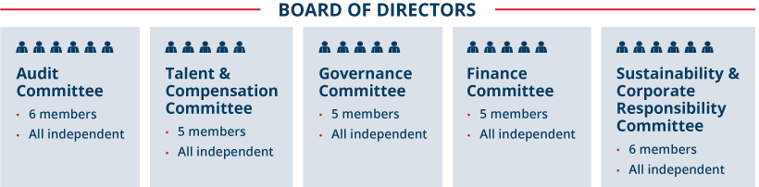
Board Meetings and Committees

NEW THIS YEAR
ENHANCED DISCLOSURES ON BOARD REFRESHMENT |  | We regularly update our disclosures to provide clarity on certain protocols, to reflect shareholder feedback, or to provide shareholders with a perspective into how certain policies are put into action. This year, we’ve expanded our Board refreshment disclosure to provide more detail on our process and a timeline of our Board refreshment efforts.
MEETING PARTICIPATION
The Board held five meetings during 2025. Each director attended at least 75% of the total number of Board meetings during the time he or she served as well as at least 75% of the total number of meetings of all Board committees on which he or she served. The non-employee directors met regularly in executive sessions during 2025.
COMMITTEE COMPOSITION
Each of the five standing committees operates under a written charter adopted by the Board and reviews its charter at least annually. Messrs. Kadre and Vander Ark are not members of any of our standing committees, but attend all committee meetings. Information regarding each of the current standing committees as of the mailing date of this Proxy Statement appears in the chart on page 34.

 |  |  |  | Republic Services, Inc. 2026 Proxy Statement |  |  | | |  |  |  | 31

Table of Contents
PROXY SUMMARY |  |  |  | BOARD AND GOVERNANCE |  |  |  | EXECUTIVE COMPENSATION |  |  |  | PROPOSALS |  |  |  | MEETING INFORMATION |  |  |  | ANNEX

BOARD REFRESHMENT AND DIRECTOR SUCCESSION PLANNING
We are committed to maintaining a Board that has a balanced mix of relevant skills and attributes, and we accomplish this through our active refreshment and director succession planning process. We evaluate our evolving operating environment and feedback received during our Board and committee evaluation process to ensure that the skills and attributes we seek in our Board members reflect the needs of our Company.

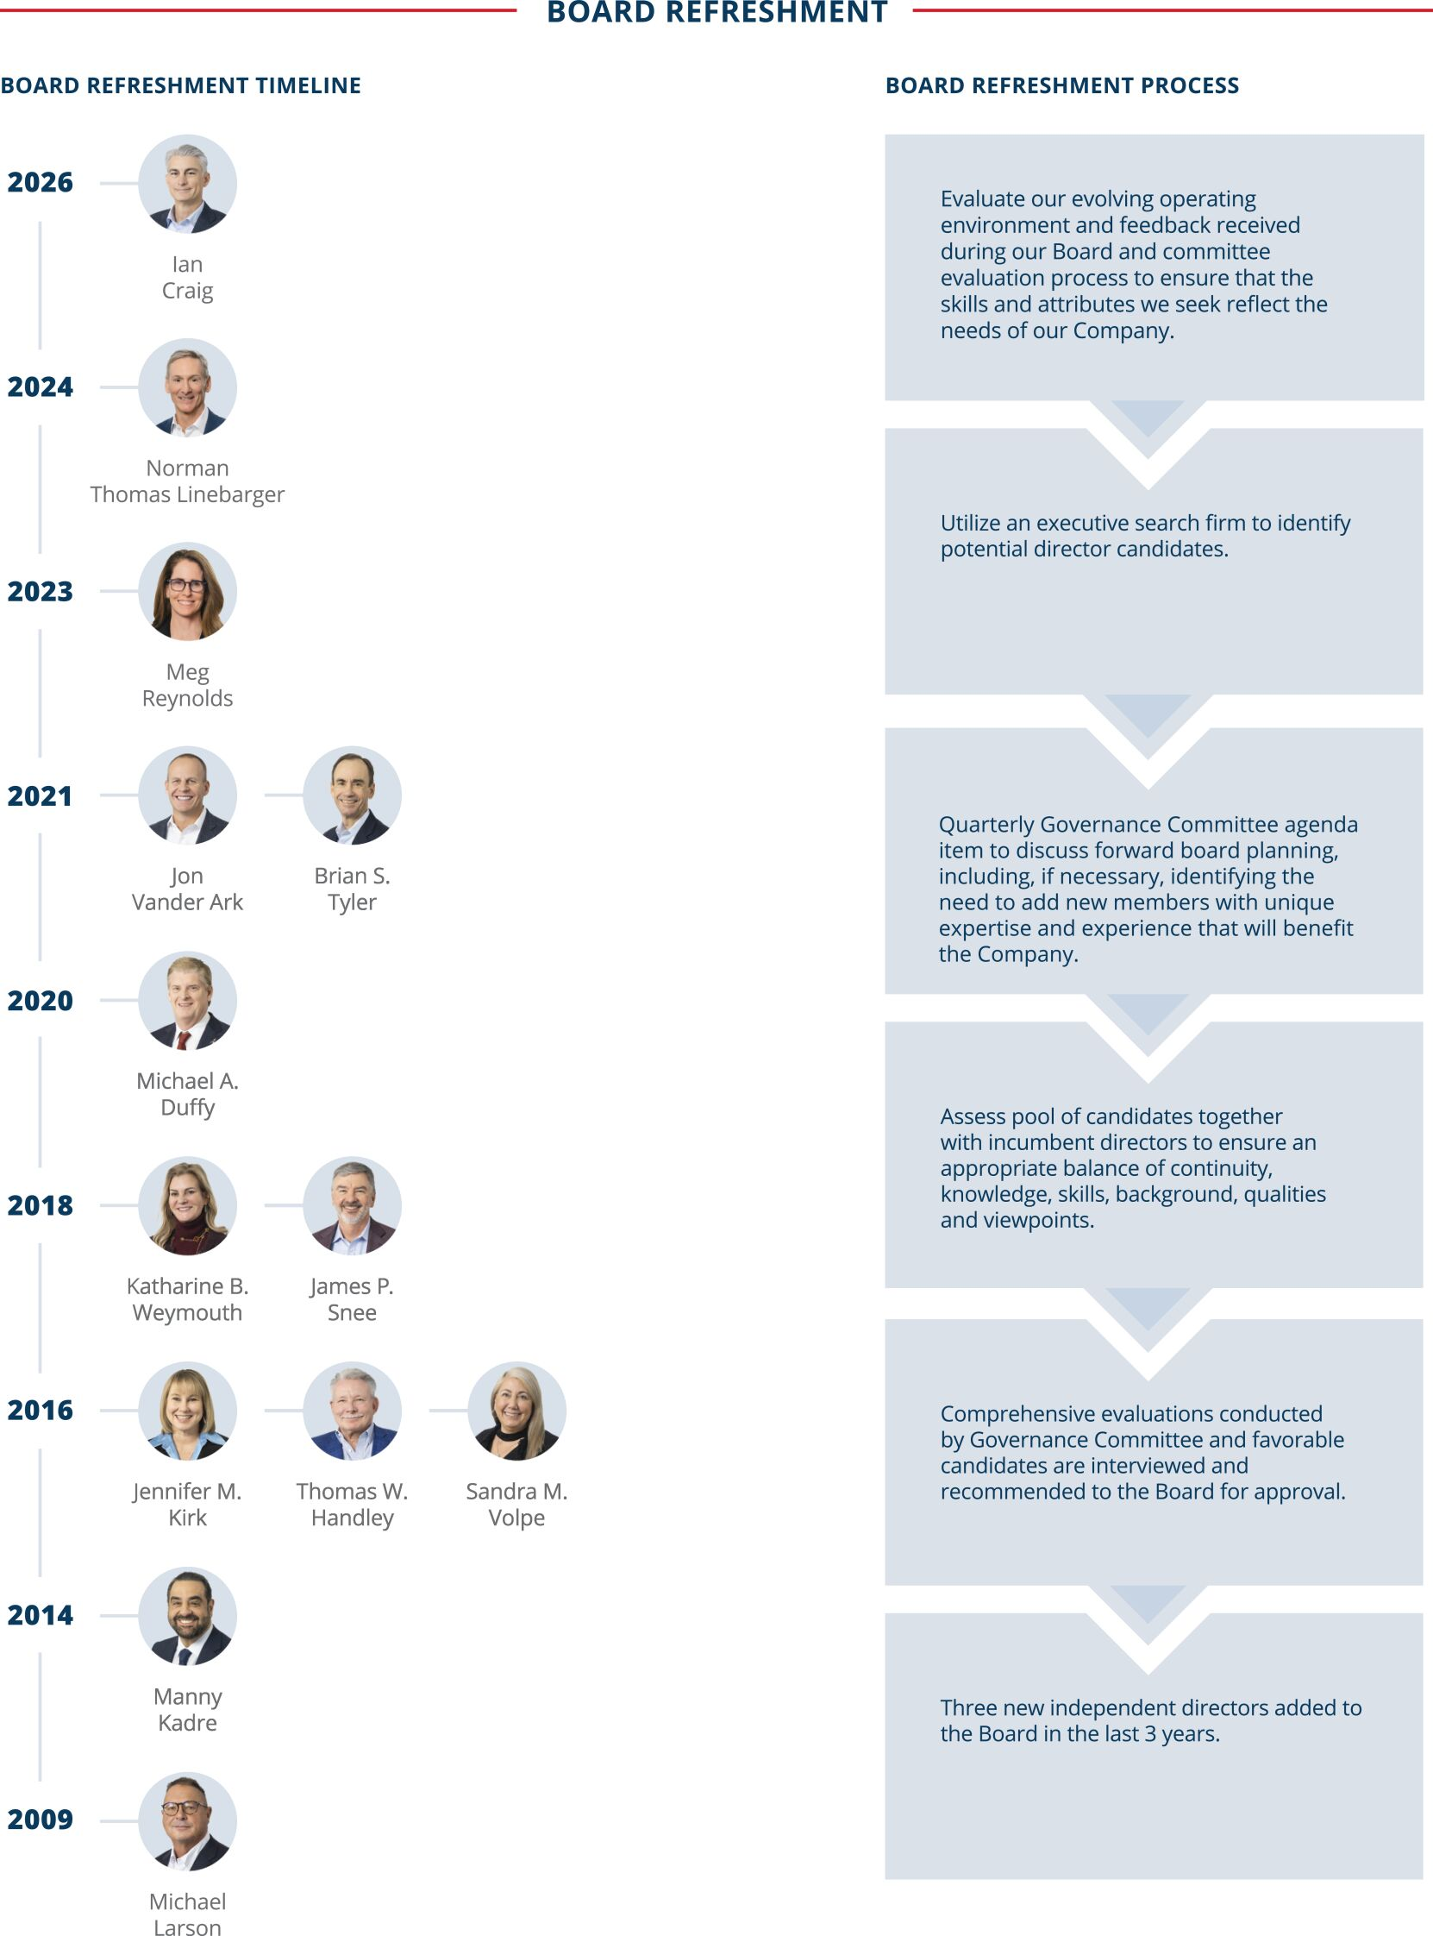
The Board, through the Governance Committee, engages in formal director succession planning discussions at regular intervals throughout the year, in which it considers and evaluates director tenure as well as the skill sets of current directors. These discussions are supported by the formal evaluation process that identifies areas for improvement, including the need

32 |  |  | | |  |  | Republic Services, Inc. 2026 Proxy Statement

Table of Contents
PROXY SUMMARY |  |  |  | BOARD AND GOVERNANCE |  |  |  | EXECUTIVE COMPENSATION |  |  |  | PROPOSALS |  |  |  | MEETING INFORMATION |  |  |  | ANNEX

to add new members with unique expertise and experience that it believes will benefit our Company. These discussion topics are included as quarterly agenda items for the Governance Committee. The Governance Committee utilizes an executive search firm to identify potential director candidates and conducts interviews on an ongoing basis. The Board has implemented a mandatory director retirement age of 75 to ensure we maintain the right mix of tenure and new perspectives, while promoting continual refreshment and the addition of varied skill sets and backgrounds.
DIRECTOR NOMINATION PROCEDURES RELATING TO BOARD CANDIDACY
The Governance Committee is responsible for soliciting recommendations for candidates for the Board, reviewing background information for such candidates, and making recommendations to the Board with respect to such candidates. In evaluating candidates, the Governance Committee considers, among other things, the following attributes:
 | • |  | independence (if required);
 | • |  | personal and professional integrity;
 | • |  | sound business judgment;
 | • |  | relevant business and industry experience;
 | • |  | proper mix of education and skills; and
 | • |  | potential effectiveness as a director in serving the long-term interests of our shareholders.
Our Corporate Governance Guidelines state that directors will be selected in the context of assessing the Board’s needs at the time and with the objective of ensuring a variety of backgrounds, experiences, and viewpoints of Board members. The Board and Governance Committee will continue to assess the need to expand the breadth of experience, expertise, and viewpoints represented collectively by our directors and continue to seek top-quality candidates to fill any identified gaps.
Please also see “Shareholder Director Recommendation Policy” on page 37 for information regarding our policies for director candidates identified by shareholders.
DIRECTOR ONBOARDING PROCESS
Upon joining our Board, new directors participate in a comprehensive formal onboarding process to facilitate their transition onto our Board. Our onboarding process familiarizes new directors with the Company’s business, strategic plans, governance program, Board policies, fiduciary responsibilities and the director’s responsibilities on assigned committees. New directors meet with Republic’s senior leadership and key management representatives to learn about the Company. They also participate in site visits. Directors joining our Talent & Compensation Committee also participate in onboarding meetings with the committee chair, the Company’s outside compensation consultant and members of management to receive information on the Company’s compensation philosophy, compensation and benefit plans and additional information in advance of service on the committee. Based on feedback received, we believe our onboarding programs, coupled with participation in regular Board and committee meetings, provides new directors with a strong foundation in our Company’s business, and accelerates their ability to fully engage in Board discussions and decision-making. Additional training is also encouraged when a director assumes a leadership role as either our Chairman or as a committee chair.
In February 2026, Ian Craig joined the Board and participated in a thorough onboarding process which included, among other items:
 | • |  | Participating in tours of several types of operating sites with our COO and SVP, Operations;
 | • |  | Attending one-on-one meetings with our Executive Vice Presidents to learn about each of their functional areas and go-forward priorities; and
 | • |  | Reviewing comprehensive onboarding materials that detail Republic’s business, strategic plans, governance program, and Board policies, among other topics.
CONTINUING DIRECTOR EDUCATION
Our directors attend seminars and continuing education programs relating to corporate governance, audit, compensation and other matters. In addition, site visits and external and in-house presentations are scheduled as part of the directors’ continuing education. In 2025, our Board conducted a site visit to one of our environmental solutions’ customer locations where we provide on-site services. Examples of continuing education programs attended by some of our directors in 2025 include Harvard Business School’s Advanced Corporate Director Seminar and McKinsey & Co’s AI Board Education Session.
Additionally, in early 2026, our Board of Directors participated in an on-site artificial intelligence (“AI”) “deep dive” session that covered AI governance, risks and opportunities, and included perspectives from outside speakers and Republic leaders. Please see the “Spotlight on Artificial Intelligence” on page 41 for additional information.
BOARD EVALUATION PROCESS
We recognize that Board and committee evaluations play an important role in ensuring the effective functioning of our Board. Therefore, the Board and each of its committees conduct annual self-assessments, which are overseen by the Governance Committee and include written evaluation forms to assess their effectiveness. Periodically, we will employ the services of an external advisor to assist with the evaluation process. Regardless of whether an external advisor is involved in the evaluation process, the results of these assessments are compiled without attribution and sent to the directors for a full Board assessment and to each committee member, for those committees on which they serve, to identify areas for future improvement. This feedback is also considered by the Governance Committee when searching for and evaluating potential future Board nominees to help ensure we are adding new directors with the proper mix of subject matter expertise and perspective consistent with the needs of our growing Company.

 |  |  |  | Republic Services, Inc. 2026 Proxy Statement |  |  | | |  |  |  | 33

Table of Contents
PROXY SUMMARY |  |  |  | BOARD AND GOVERNANCE |  |  |  | EXECUTIVE COMPENSATION |  |  |  | PROPOSALS |  |  |  | MEETING INFORMATION |  |  |  | ANNEX

Audit  Committee |  | Key Responsibilities  • Assists the Board in monitoring the integrity of financial statements, our compliance with legal and regulatory requirements, political contributions, our ethics and compliance program and the independence and performance of our internal and external auditors on an annual basis  • Meets with management and the independent auditor to review the Company’s major financial and cybersecurity risk exposures and the steps management has taken to monitor and control such exposures including a review of information and security policies, data protection strategies and internal controls  • Reviews issues regarding accounting principles, financial statement presentations, internal controls and the effect of regulatory and accounting initiatives on Company financial statements  • Has the ultimate authority and responsibility to select, evaluate, terminate and replace our independent registered public accounting firm  • Approves the Audit Committee Report in this Proxy Statement  * Our Board has determined that each of Mses. Kirk and Reynolds and Mr. Linebarger qualify as an “audit committee financial expert” within the meaning of Item 407 of Regulation S-K. |  | The committee held FIVE meetings and met regularly in executive sessions during 2025
Jennifer M. Kirk*, Chair
Ian Craig
Michael A. Duffy
Norman Thomas Linebarger*
Meg Reynolds*
Katharine B. Weymouth

Talent & Compensation Committee |  | Key Responsibilities  •  Establishes and regularly reviews our compensation and benefits philosophy and program consistent with corporate financial goals and objectives, including sustainability metrics  •  Determines the salaries and incentive compensation payable to executive officers, including annual and long-term incentive compensation under our shareholder-approved pay-for performance program  •  Administers our executive incentive plans, including our stock incentive plan and oversees our Clawback Policy  •  Evaluates our CEO’s performance, sets his compensation and reviews the executive succession plan overseen by the Governance Committee  •  Reviews and oversees our talent strategy and execution including talent acquisition and retention, learning and development, inclusion and diversity, employee engagement and employee wellbeing  •  Engages with management each quarter on critical elements of our talent program  •  Oversees the annual risk assessment of our compensation policies and practices  •  Oversees the scope and engagement of the external compensation consultant’s services  The Committee retained Pearl Meyer & Partners (“Pearl Meyer”) as its compensation consultant, as further discussed on page 77. |  | The committee held FIVE meetings and met regularly in executive sessions during 2025
Thomas W. Handley, Chair
Michael Larson
James P. Snee
Brian S. Tyler
Katharine B. Weymouth

Nominating & Corporate Governance Committee |  | Key Responsibilities  • Identifies director candidates to recommend to our Board for selection as the director nominees for the next annual meeting or to fill vacancies. Additionally, identifies candidates that it recommends to our Board for selection as the Chairman of the Board  • Develops and provides recommendations for our corporate governance principles and reviews and provides oversight of the effectiveness of these practices  • Oversees the annual evaluation of the Board and its committees  • Makes recommendations to the Board related to the compensation of non-employee directors, and monitors the talent management and succession planning program for executive management to ensure appropriate focus on maintaining a diverse team of current and future executives  • Considers nominations for the Board from shareholders that are entitled to vote for the election of directors, as described under “Shareholder Director Recommendation Policy” |  | The committee held FOUR meetings and met regularly in executive sessions during 2025
Michael Larson, Chair
Thomas W. Handley
Jennifer M. Kirk
James P. Snee
Sandra M. Volpe

Sustainability & Corporate Responsibility Committee |  | Key Responsibilities  •  Reviews the Company’s sustainability performance and progress toward sustainability goals and objectives, including appropriate sustainability scorecards and rankings and the Company’s climate change initiatives  •  Reviews and provides oversight on sustainability and corporate responsibility topics including safety, community engagement, charitable giving, sustainability performance and innovation, climate change, environmental management and security for the Company’s people and assets  •  Reviews the annual sustainability report and charitable giving policies  •  Engages with shareholders and proxy advisory firms on sustainability, business conduct, environmental topics, safety and other matters relating to social, political and public policy issues, including the review and evaluation of shareholder proposals on these topics |  | The committee held FOUR meetings and met regularly in executive sessions during 2025
Sandra M. Volpe, Chair
Ian Craig
Michael A. Duffy
Norman Thomas Linebarger
Meg Reynolds
Brian S. Tyler

Finance  Committee |  | Key Responsibilities  • Reviews the financial condition of the Company including the annual finance plan, long-term financial objectives, capital allocation and financial management principles  • Reviews and makes recommendations on management proposals for financing requirements, dividends, proposed capital budget, certain capital expenditures and the repurchase of Company stock  • Evaluates the financial impact of certain acquisitions and divestitures and conducts post-acquisition reviews  • Annually reviews the Company’s insurable risk management strategy  • Reviews and reports to the Board on the significant financial impact of benefit plans, including retirement plans |  | The committee held FIVE meetings and met regularly in executive sessions during 2025
James P. Snee, Chair
Michael Larson
Brian S. Tyler
Sandra M. Volpe
Katharine B. Weymouth

34 |  |  | | |  |  | Republic Services, Inc. 2026 Proxy Statement

Table of Contents
PROXY SUMMARY |  |  |  | BOARD AND GOVERNANCE |  |  |  | EXECUTIVE COMPENSATION |  |  |  | PROPOSALS |  |  |  | MEETING INFORMATION |  |  |  | ANNEX

EXECUTIVE SUCCESSION PLANNING AND LEADERSHIP DEVELOPMENT
The Board believes that planning for CEO succession is one of its most important responsibilities. The Governance Committee discusses potential successor candidates and their qualifications, experience and preparedness. The Governance Committee also maintains and reviews annually an emergency CEO succession plan for the timely and efficient transfer of the CEO’s responsibilities in the event of an emergency or his sudden incapacitation or departure, which includes a periodic external market scan of potential candidates to replace the CEO.
The Board, through the Governance Committee, also regularly reviews the Company’s executive management succession plan to help ensure business continuity in the event a key executive departs from the Company. This evaluation includes a thorough discussion on the Company’s senior leadership structure with a focus on key executive positions and maintaining a diverse and skilled team of current and future executives. Every year, our CEO and Chief Human Resources Officer review with the Governance Committee succession plans for executive officers and other key positions in the organization. The review includes a discussion of potential successors, an evaluation of their readiness for the role and a discussion of development or other opportunities to prepare them for the role. In addition, the Talent & Compensation Committee reviews succession planning for HQ and field leadership roles below the executive officer level. The Company maintains development plans for potential successors identifying specific skills, training, or other development opportunities to help them prepare for the role. The Board’s committees also frequently discuss the talent pipeline, and individuals identified as potential future leaders are given exposure to Board members through formal presentations and informal meetings or events. More broadly, the Board, through the Talent & Compensation Committee, is regularly updated on key talent indicators for the overall workforce and recruiting and development programs. Republic is also cognizant of the impact our overall compensation program has on our succession planning process and has designed our program accordingly.
STOCK OWNERSHIP GUIDELINES AND ANTI-HEDGING AND ANTI-PLEDGING POLICIES
Our Board believes that ownership of our stock by directors, executive officers, and certain other members of management is important to align their interests with our shareholders’ interests and to demonstrate their commitment to the investing public and our employees.
Our Corporate Governance Guidelines reflect the Board’s belief that directors should be shareholders and have a financial stake in Republic. To support that philosophy, we pay our non-employee directors a significant portion of their compensation in the form of RSUs. Our non-employee directors receive RSUs that either (1) do not distribute until the director’s termination of service on the Board or (2) distribute three years after their grant date, unless deferred by the director into the Deferred Compensation Plan (“DCP”). To further demonstrate the Board’s commitment to align itself with our shareholders, our Board’s equity ownership guideline requires each independent director to hold Republic stock or vested RSUs, or both, having a total value of $750,000 within five years from the date of the director’s first full annual grant. All of our independent directors who have been on the Board for at least five years meet this guideline.
We also maintain stock ownership guidelines for our executive officers and other members of management, which were updated in 2024. The stock ownership guidelines for senior leaders are: (1) CEO — eight times salary; (2) other Executive Officers — five times salary; (3) Senior Vice President and Area President — two times salary; and (4) Vice President, Area Vice President and Market Vice President – one times salary. Each member of management has a five-year period from the time of promotion or hire into a covered position to meet the applicable guideline, and interim progress is expected. Members of management may meet their requirement by holding Republic stock or vested Republic stock equivalents in the DCP, or both, having the requisite value, and by holding shares in the 401(k) plan. As discussed further in the CD&A on page 74, all of our named executive officers either meet or are on track to meet their stock ownership guidelines.
As further discussed in the CD&A on page 74, our Insider Trading Policy prohibits all directors, officers and employees, and their immediate family members, from engaging in the following transactions relating to Republic securities or derivatives thereof: purchasing or selling puts or calls, short sales, placing standing orders (other than under approved 10b5-1 plans), engaging in short-term or “in-and-out” trading, and holding Republic securities or derivatives thereof in a margin account or pledging them.
DIRECTOR INDEPENDENCE
Our common stock is listed on the New York Stock Exchange (“NYSE”), which requires that a majority of our Board be comprised of “independent directors” according to the NYSE’s independence standards. The Governance Committee considers the “per se” disqualifications from director independence under NYSE rules when assessing the independence of a current director or a nominee for director. In addition, our Board has adopted categorical standards that provide that certain relationships are not material relationships that would prevent a director’s independence. The Board reviews director independence and considers relationships between each of the directors and their immediate family members and Republic and its subsidiaries, both in the aggregate and individually. Mr. Vander Ark is not an “independent director” under the NYSE listing standards because he is an employee of Republic. The Board determined that the other 12 directors meet the NYSE standards for independence and the categorical standards adopted by our Board, and have no material relationships with us that impair their independence. In making its determination, the Board considered, in the case of Messrs. Larson and Handley, their status as chief investment officer and special advisor, respectively, to William H. Gates III, who is the beneficial owner of Cascade Investment, L.L.C., our largest shareholder. The Board also considered that the Gates Foundation Trust is a current client of Westwood Global Investments, LLC, the investment management firm at which Ms. Reynolds is a co-founder and principal.

 |  |  |  | Republic Services, Inc. 2026 Proxy Statement |  |  | | |  |  |  | 35

Table of Contents
PROXY SUMMARY |  |  |  | BOARD AND GOVERNANCE |  |  |  | EXECUTIVE COMPENSATION |  |  |  | PROPOSALS |  |  |  | MEETING INFORMATION |  |  |  | ANNEX

SERVICE ON OTHER PUBLIC COMPANY BOARDS
To ensure engagement from our directors and effective functioning of our Board, we have a policy limiting the number of other public company boards on which our directors may serve. Under this policy, which can be found in the Company’s Corporate Governance Guidelines:

 | • |  | Our independent directors may not serve on the boards of directors of more than four public companies (including the Company);

 | • |  | If the independent director is an active public company executive, then he or she may serve on no more than two public company boards (including the Company); and

 | • |  | Any exception requires a determination by the Board that such service does not impair the ability of the director to effectively serve on the Company’s Board.
Additionally, the simultaneous service on the audit committees of more than three other public companies requires a determination by the Board that such simultaneous service does not impair the ability of the director to effectively serve on the Company’s Audit Committee.
In the case of Ms. Weymouth, the Board determined that her other public company directorships do not impair her ability to effectively serve on the Company’s Board. Ms. Weymouth is an active and engaged member of the Board and the committees on which she serves, and her other directorships have not interfered with her meeting attendance or participation.
SHAREHOLDER ENGAGEMENT
We have a well-developed shareholder engagement program that emphasizes year-round shareholder engagement and direct communication with our Board. The ways in which we communicate with our investors throughout the year include quarterly earnings releases and earnings conference calls, SEC filings, sustainability reports, investor conferences, press releases, bi-annual or annual investor meetings, and our website.
HIGHLIGHTS OF 2025 SHAREHOLDER ENGAGEMENT
Our individual engagements with our shareholders allow us insight into their views on our corporate governance practices, our sustainability journey, our differentiated operating model, and our compensation program, among other topics. Overall, shareholders were positive in their feedback, specifically regarding:

 | • |  | Sustainability – Shareholders appreciate the progress we have made in our sustainability strategy, including advancements in our investment and operation of our Polymer Centers, where we are transforming plastics recycling and enabling true bottle-to-bottle circularity, and the progress we have made with our partners in further developing our portfolio of landfill gas-to-energy projects, where we are beneficially reusing a natural byproduct from our landfills to create a renewable fuel source for our communities. Shareholders are also encouraged by our progress toward our ambitious 2030 Sustainability Goals. Please see the Compensation Discussion & Analysis section for more information on this topic.

 | • |  | Executive Compensation – Shareholders expressed an appreciation for the inclusion of important non-financial metrics in the annual incentive plan. Shareholders noted the continued enhancement of disclosures in our Proxy Statement regarding how our Sustainability and Performance Modifier aligns to our key sustainability priorities and how the Talent & Compensation Committee elects to exercise its discretion to ensure incentives are aligned with Company goals. Please see the Compensation Discussion & Analysis section for more information on this topic.

 | • |  | Enhanced Disclosure – Many shareholders noted that they are pleased with the enhanced disclosures in our Proxy Statement related to emerging and evolving governance and risk topics. In particular, shareholders appreciate the disclosures on AI governance and our Board oversight of joint ventures. Please see the Risk Oversight section for more information on this topic.

36 |  |  | | |  |  | Republic Services, Inc. 2026 Proxy Statement

Table of Contents
PROXY SUMMARY |  |  |  | BOARD AND GOVERNANCE |  |  |  | EXECUTIVE COMPENSATION |  |  |  | PROPOSALS |  |  |  | MEETING INFORMATION |  |  |  | ANNEX

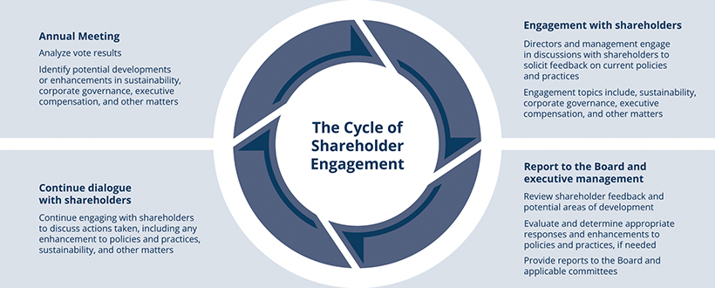
Additional Board Policies
SHAREHOLDER DIRECTOR RECOMMENDATION POLICY
The Governance Committee will consider director candidates recommended by our shareholders unrelated to a recommendation under our proxy access bylaw provision, described below. A shareholder may propose a nominee to serve as a director before a meeting of shareholders by giving timely written notice and meeting the other requirements set forth in Section 2.12 of our Amended and Restated Bylaws (“Bylaws”) and complying with applicable SEC regulations.
The Governance Committee determines the eligibility of a proposed nominee to serve as a director, and may require additional information to determine such eligibility. Director candidates proposed by shareholders are evaluated on the same basis as all other director candidates. See “Director Nomination Procedures Relating to Board Candidacy” on page 33. The Governance Committee may, in its discretion, interview any director candidate proposed by a shareholder.
Shareholders wishing to recommend director candidates for consideration by the Governance Committee may do so by sending the required information in writing to: Attention: Office of the Corporate Secretary, Republic Services, Inc., 5353 E. City North Drive, Phoenix, Arizona 85054. To consider a candidate for nomination at the 2027 annual meeting of shareholders, we must receive the shareholder’s written notice no earlier than January 7, 2027 and no later than February 6, 2027. Refer to our Bylaws for additional information and notice requirements.
In addition to satisfying the requirements of our Bylaws, to comply with the universal proxy rules, shareholders who intend to solicit proxies in support of director nominees other than the Board’s nominees must also provide notice that sets forth the information required by Rule 14a-19 under Securities Exchange Act of 1934, as amended (the “Exchange Act”), and comply with the additional requirements of Rule 14a-19 under the Exchange Act.
PROXY ACCESS DIRECTOR NOMINATIONS
In addition to the right to recommend directors to the Governance Committee, qualifying shareholders also have the right to nominate and include director candidates in our proxy materials by giving adequate and timely notice to the Corporate Secretary pursuant to the procedures and requirements contained in our proxy access bylaw. Any shareholder or group of up to 20 shareholders who have maintained continuous qualifying ownership of at least 3% of the shares of our outstanding common stock for at least the previous three years are permitted to include up to 25% of the number of director nominees in our proxy materials for our annual meeting of shareholders, provided that the shareholders and nominees satisfy the requirements specified in our Bylaws. In order for such nominees to be included in our proxy statement and form of proxy, shareholders and nominees must submit a notice of proxy access nomination together with certain related information required by our Bylaws.
Shareholders wishing to recommend director candidates using our proxy access bylaw may do so by sending the required information in writing to: Attention: Office of the Corporate Secretary, Republic Services, Inc., 5353 E. City North Drive, Phoenix, Arizona 85054. To provide adequate time to assess shareholder-nominated candidates, requests to include these candidates in our proxy materials for our 2027 annual meeting of shareholders must be delivered or mailed and received at our principal executive offices no earlier than October 25, 2026 and no later than November 24, 2026.

 |  |  |  | Republic Services, Inc. 2026 Proxy Statement |  |  | | |  |  |  | 37

Table of Contents
PROXY SUMMARY |  |  |  | BOARD AND GOVERNANCE |  |  |  | EXECUTIVE COMPENSATION |  |  |  | PROPOSALS |  |  |  | MEETING INFORMATION |  |  |  | ANNEX

DIRECTOR RESIGNATION POLICY
Republic is a Delaware corporation. The affirmative vote of the majority of votes cast with respect to that director’s election at a stockholder meeting is required for the election of each director. Under Delaware law, if an incumbent director is not elected, that director remains in office until the director’s successor is duly elected and qualified or until the director’s death, resignation or retirement. To address this potential outcome, we have a director resignation policy in our Bylaws. Under this policy, the Board will nominate for further service on the Board only those incumbent candidates who tender, in advance, irrevocable resignations. Each irrevocable resignation is contingent on the failure to receive the required vote at any annual meeting at which the nominee is nominated for re-election and on Board acceptance of the resignation. The Governance Committee will recommend to the Board whether to accept or reject the tendered resignation. The Board will publicly disclose its decision within 90 days after certification of the election results. If the Board does not accept the resignation, the director will continue to serve until the next annual meeting and until his or her successor is duly elected, or until his or her earlier resignation or removal. If the Board accepts the resignation, then the Board, in its sole discretion, may fill any resulting vacancy or reduce the size of the Board.
COMMUNICATIONS WITH THE BOARD OF DIRECTORS
Any shareholder or other interested party who wishes to communicate with the Board, a Board committee, the Chairman of the Board or the non-management directors (as a group or individually) may send correspondence to: Attention: Office of the Corporate Secretary, Republic Services, Inc., 5353 E. City North Drive, Phoenix, Arizona 85054. The Corporate Secretary will compile and submit such correspondence on a periodic basis to the entire Board or, if designated in the communication, to the appropriate Board committee, the Chairman of the Board or the non-management directors (as a group or the appropriate individual member(s)). The independent directors have approved this process.
ATTENDANCE AT ANNUAL MEETINGS POLICY
We do not have a formal policy requiring our directors to attend the Annual Meeting. Mr. Vander Ark attended and chaired our 2025 annual meeting of shareholders.
ADDITIONAL INFORMATION REGARDING CORPORATE GOVERNANCE
Shareholders may obtain, free of charge, the current charters for the Audit Committee, Finance Committee, Talent & Compensation Committee, Governance Committee, and Sustainability & Corporate Responsibility Committee, as well as our Certificate of Incorporation, Bylaws, Corporate Governance Guidelines, Code of Ethics, Political Contributions Policy and Clawback Policy by written request to: Attention: Office of the Corporate Secretary, Republic Services, Inc., 5353 E. City North Drive, Phoenix, Arizona 85054. These documents also are available on the “Investors” section of our website at www.RepublicServices.com.



38 |  |  | | |  |  | Republic Services, Inc. 2026 Proxy Statement

Table of Contents
PROXY SUMMARY |  |  |  | BOARD AND GOVERNANCE |  |  |  | EXECUTIVE COMPENSATION |  |  |  | PROPOSALS |  |  |  | MEETING INFORMATION |  |  |  | ANNEX

Risk Oversight

 |  | NEW THIS YEAR
 |  | ENHANCED  DISCLOSURE ON AI  OVERSIGHT |  | We regularly update our disclosures to improve clarity, reflect new procedures and policies, and respond to shareholder feedback. This year, we enhanced our disclosure on artificial intelligence (“AI”) oversight to include how it is addressed within our Company. We also added new disclosure around AI training procedures and policies for both directors and employees.
We face a variety of risks, including credit and liquidity, operational, environmental, litigation, compliance, compensation and cyber security risks. Management, the Board and its committees work together to manage these and other significant risks and the opportunities they create. Our management annually reports to the Board on the results of its internal survey and analysis of enterprise risk management, and regularly discusses with the Board, and its committees, various operational and compliance risks, including pricing, recycled commodity prices, safety, talent, environmental, fleet and cyber risks.
While management is responsible for the day-to-day risk management processes, the role of the Board, either acting as the full Board or through its committees, is to ensure that:

FULL BOARD
• The risk management processes designed and implemented by management are adapted to the overall corporate strategy;
• Those processes are functioning effectively;
• Management communicates material risks to the Board or the appropriate committee; and
• Actions are being taken to continue to foster a strong culture of compliance and risk-adjusted decision-making throughout Republic.

 |  | NOMINATING & CORPORATE GOVERNANCE COMMITTEE |  |  |  |  |  |  |  |  |  | AUDIT  COMMITTEE |  |  |  |  |  |  |  |  |  | TALENT &  COMPENSATION  COMMITTEE |  |  |  |  |  |  |  |  |  | SUSTAINABILITY & CORPORATE RESPONSIBILITY  COMMITTEE |  |  |  |  |  |  |  |  |  | FINANCE  COMMITTEE
 |  | • Talent management and succession planning for executives  • Effectiveness of governance practices  • Evaluation of Board and its committees |  |  |  |  |  |  |  |  |  | • Accounting, controls, and financial disclosure  • Cybersecurity  • Internal audit matters  • Field audits  • Employee hotline, the AWARE line  • Oversight of political contribution activity |  |  |  |  |  |  |  |  |  | • Annual risk assessment of compensation policies and practices  • Sets performance criteria under compensation program  • Recruitment and retention |  |  |  |  |  |  |  |  |  | • Sustainability performance and progress toward goals  • Sustainability risks and opportunities, including climate change, safety, environmental and reputational risks  • Practices by which sustainability risks are managed and mitigated |  |  |  |  |  |  |  |  |  | • Financial, credit and liquidity risk, including hedging programs  • Insurance coverage programs and related risks

FINANCIAL AND OPERATIONAL RISK OVERSIGHT

In accordance with NYSE requirements, our Audit Committee charter requires the Audit Committee to, among other things:

 | • |  | Meet periodically with management and our independent registered public accounting firm to review our major financial risk exposures and the steps management has taken to monitor and control them;

 | • |  | Discuss guidelines and policies with respect to financial risk assessment and financial risk management;

 | • |  | Advise the Board with respect to our policies and procedures regarding compliance with applicable laws and regulations and with our Code of Business Ethics and Conduct (“Code of Ethics”);

 | • |  | Review with our Chief Legal Officer legal matters that may have a material impact on our financial statements, our compliance policies, and any material reports or inquiries received from regulators or governmental agencies; and

 | • |  | At least annually, and otherwise as necessary, provide new and existing Audit Committee members an overview of our key financial risks and our legal and regulatory requirements.

 |  |  |  | Republic Services, Inc. 2026 Proxy Statement |  |  | | |  |  |  | 39

Table of Contents
PROXY SUMMARY |  |  |  | BOARD AND GOVERNANCE |  |  |  | EXECUTIVE COMPENSATION |  |  |  | PROPOSALS |  |  |  | MEETING INFORMATION |  |  |  | ANNEX

SPOTLIGHT ON CYBERSECURITY

Our Audit Committee oversees the Company’s management of cybersecurity risk. The Company has taken a number of steps to manage and mitigate our cybersecurity risk, including establishing a formal enterprise-wide cybersecurity policy and related standards, providing cybersecurity training to employees, and entering into an information security risk insurance policy. Our cybersecurity program is designed based on the concepts of control maturity and control efficacy:

 | • | Control Maturity: Our cybersecurity program is aligned to the National Institute of Standards and Technology (NIST) Cybersecurity Framework (CSF) and is assessed annually by an independent third party against our yearly control maturity targets in the context of current cyber threat and industry trends. The NIST CSF assessment results are used to validate the progress made against the current year maturity targets, inform the program’s strategic priorities and establish maturity targets for the following year. These assessment results are provided to our Audit Committee and our Board of Directors on an annual basis.

 | • | Control Efficacy: Our cybersecurity program monitors control efficacy via key metrics in accordance with our cybersecurity policy, standards, risk tolerances, and enterprise risk management program.
At each quarterly meeting, the Audit Committee receives an update from our Chief Information Security Officer and other members of management on cybersecurity program maturity progress, new capabilities implemented, penetration testing results, key cyber metrics (e.g., simulated phishing testing and vulnerability management) and notable incidents or events should they occur.
Another dimension of cybersecurity risk includes the possibility of a data breach affecting employee and customer sensitive data during a cyber incident. Legal and Information Security functions partner to establish effective preventative, detective, and reactive data protection control capabilities in concert with our data minimization program to reduce redundant, obsolete, and trivial data. Additionally, the legal team proactively monitors the evolving data privacy landscape and takes action to implement and execute standard processes in support of data privacy and deletion requests.
BOARD OVERSIGHT OF SUSTAINABILITY
Our Sustainability & Corporate Responsibility Committee meets at least quarterly and takes various steps to assist the Board in fulfilling its oversight responsibility with respect to risks and opportunities, including climate change, safety, environmental and reputational risks, and the practices by which these risks are managed and mitigated.
Our Board is directly involved in the oversight of Republic’s environmental and sustainability initiatives and conducts a comprehensive review of the Company’s sustainability performance on an annual basis. The Sustainability & Corporate Responsibility Committee, which the Board established in 2015, has oversight responsibility with respect to our sustainability performance, our corporate responsibilities, our role as a socially responsible organization, and risks and opportunities related to climate change, safety, community engagement, the environment, and our reputation. The Sustainability & Corporate Responsibility Committee is focused on reviewing the Company’s sustainability performance and progress toward sustainability strategic goals and objectives, including innovation opportunities as well as providing guidance to management with respect to significant sustainability and corporate responsibility initiatives.
BOARD OVERSIGHT OF JOINT VENTURES
As part of our strategy to achieve our 2030 Sustainability Goals, we have invested in two joint ventures (“JVs”), Lightning Renewables and Blue Polymers:

 | • |  | Lightning Renewables is a JV with Archaea Energy, a bp company, focused on developing a portfolio of projects to beneficially reuse landfill gas to develop low-carbon solutions at scale.
 | • |  | Blue Polymers is a joint venture with Ravago, focused on advancing plastic circularity by acquiring the polyolefins processed by our Polymer Centers to create custom blended post-consumer recycled food-grade and non-food-grade packaging. The Blue Polymers production facility in Indianapolis, Indiana began operation in 2025. The second Blue Polymer facility is currently being constructed in Buckeye, Arizona.
Republic has a non-controlling equity interest in each of these JVs, but actively participates in JV oversight and strategic decision-making. Each of these joint ventures is overseen by a board of directors comprised of members of Republic’s senior management team and senior leaders from the respective JV partner. These boards meet on a regular basis to ensure that the joint venture is operating smoothly and efficiently. Members of Republic’s management and legal teams are involved in JV project work as needed.
On a quarterly basis, the Sustainability & Corporate Responsibility Committee receives an update on the progress of the JV projects, including topics such as status, market perspectives, and growth plans, among others. The full Board receives an update on an annual basis.

40 |  |  | | |  |  | Republic Services, Inc. 2026 Proxy Statement

Table of Contents
PROXY SUMMARY |  |  |  | BOARD AND GOVERNANCE |  |  |  | EXECUTIVE COMPENSATION |  |  |  | PROPOSALS |  |  |  | MEETING INFORMATION |  |  |  | ANNEX

SPOTLIGHT ON ARTIFICIAL INTELLIGENCE

As Republic explores new technologies like AI to help us achieve our business goals, we are also committed to ensuring that we are leveraging this technology in a way that is responsible, ethical, and in compliance with laws and regulations. Given how quickly AI technologies continue to evolve, we regularly evaluate how AI is being used across the Company and how those uses may change over time.
As such, in 2026, the Company facilitated a comprehensive AI “deep dive” for our Board, which was designed to ensure directors are informed on how AI is being deployed across the Company, emerging developments in the technology, and Republic’s AI governance structure. We brought in guest speakers to highlight new and efficient AI tools, and facilitated discussions with our senior IT and AI leaders.
Republic’s companywide Acceptable Use of Gen AI Technologies Policy and Procedures, implemented in 2024, establishes controls, safeguards and other measures for the development, procurement and use of Generative AI (“Gen AI”) applications. The Policy and Procedures outline:

 | • | The Company’s expectation that all employees will use Gen AI technology in a responsible and ethical manner;

 | • | The requirement that employees are prohibited from inputting Company confidential information or personal information into a Gen AI application (unless previously approved by the Steering Committee); and

 | • | A process for vetting and implementing Gen AI tools at Republic.
A detailed look at AI governance as outlined in the Policy and Procedures is below:

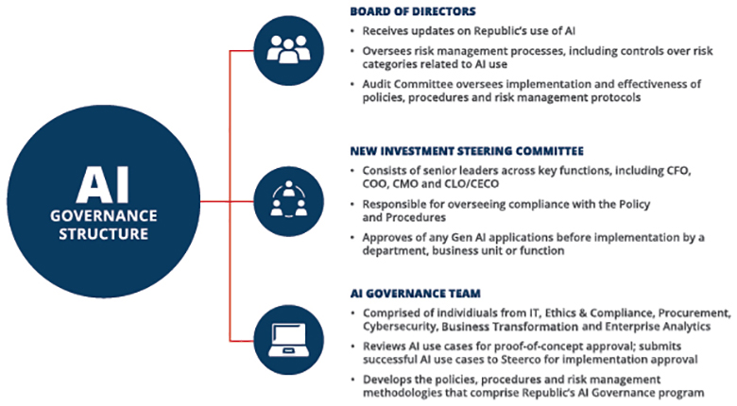
The Board and management team believe that effective oversight and use of AI begins with an understanding of where it is being used in the business and assessing the potential risks and benefits of integrating AI into specific parts of the business. Consistent with this approach, the Company will continue to educate directors on AI as part of our ongoing assessment of existing oversight mechanisms. We will also continue to explore new ways to enhance our operations with AI as the technology continues to evolve while also regularly assessing our oversight and governance.
In 2026, Republic introduced AI compliance training for select employees as part of our ongoing commitment to responsible, ethical, and compliant use of new technologies. This training equips team members with the knowledge and tools needed to navigate the evolving landscape of AI, reinforcing our companywide standards for the development and deployment of AI solutions. By investing in education and awareness, we continue to strengthen our governance framework and ensure that all employees are prepared to uphold Republic’s values as we strategically implement AI tools across our business.

 |  |  |  | Republic Services, Inc. 2026 Proxy Statement |  |  | | |  |  |  | 41

Table of Contents
PROXY SUMMARY |  |  |  | BOARD AND GOVERNANCE |  |  |  | EXECUTIVE COMPENSATION |  |  |  | PROPOSALS |  |  |  | MEETING INFORMATION |  |  |  | ANNEX

BOARD OVERSIGHT OF TALENT
We believe our comprehensive talent program adds long-term value to our business, differentiates us from our peers, and ensures an inclusive and welcoming culture for our employees. Maintaining an engaged workforce starts at the top, with our Board, our Talent & Compensation Committee, and other committees demonstrating a commitment to recruiting and retaining top talent through active oversight of the Company’s talent program.
This is accomplished by focusing on eight key areas: safety, employee engagement, talent development, employee well-being, talent acquisition and onboarding, inclusion and diversity, ethics and compliance, and compensation and benefits.

 | • |  | Our Board receives annual updates and provides guidance on the Company’s talent programs.
 | • |  | Our Talent & Compensation Committee engages with management each quarter on critical elements of our talent program, including talent acquisition, onboarding and retention, inclusion and diversity, employee engagement, employee compensation and benefits, employee well-being, talent development and assessment and diverse pipelines for management.
 | • |  | Our Sustainability & Corporate Responsibility Committee engages in quarterly deep dives related to safety and security, and community engagement.
 | • |  | Our Audit Committee receives quarterly updates on our ethics and compliance programs.
 | • |  | Our Nominating & Corporate Governance Committee ensures that we are seeking director candidates who will bring a diversity of background, experience and viewpoints to our Board and reviews the composition of the current executive officers and potential successors to ensure that there is appropriate focus on maintaining a skilled and diverse team.
 | • |  | Our Finance Committee receives an annual update on the financial condition of the Company’s retirement benefit programs.

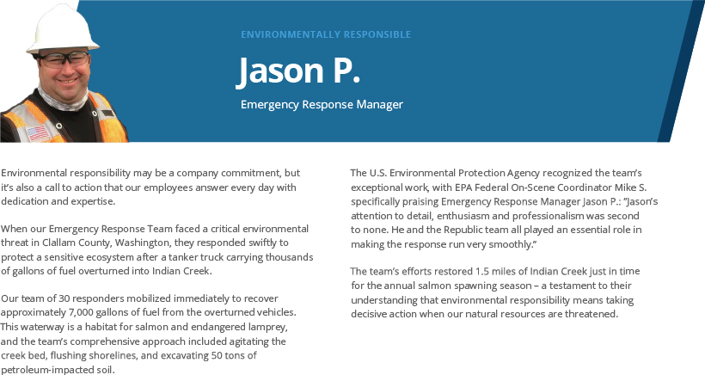

42 |  |  | | |  |  | Republic Services, Inc. 2026 Proxy Statement

Table of Contents
PROXY SUMMARY |  |  |  | BOARD AND GOVERNANCE |  |  |  | EXECUTIVE COMPENSATION |  |  |  | PROPOSALS |  |  |  | MEETING INFORMATION |  |  |  | ANNEX

TALENT FOCUS AREAS:

 |  | SAFETY  Safety is integrated into every aspect of our operations, ensuring we have industry-leading training, tools, and resources to protect our employees and communities. The Board, through the Sustainability & Corporate Responsibility Committee, regularly engages with leadership and closely monitors our safety performance to ensure we uphold rigorous safety standards across all facets of our business.
 |  | EMPLOYEE ENGAGEMENT  Employee engagement is a measure of the connection employees feel toward their company, their team, and the work they do. We prioritize respect, dignity, and recognizing the unique potential of every person to create a motivated workforce and improve retention. The Board evaluates key engagement metrics on a bi-annual basis based on third-party surveys and takes action to strengthen company-wide morale.
 |  | TALENT DEVELOPMENT  We’re committed to ensuring that our employees have the right tools, programs and learning opportunities to develop and grow their careers. We offer a variety of internal and externally sourced development programs to support critical operational roles and leadership training. The Board, through the Talent & Compensation Committee, oversees these programs to align with business needs and long-term workforce planning.
 |  | EMPLOYEE WELL-BEING  The well-being of our employees is a strategic priority, overseen by the Board, to ensure a comprehensive approach to physical, emotional, and financial wellness. Not only is ensuring our workforce is happy and healthy the right thing to do, but it is an important component of facilitating employee productivity, ultimately enabling us to reach our full potential.
 |  | TALENT ACQUISITION AND ONBOARDING  We attract and onboard top talent through targeted hiring, training, and career development programs. The Board, through the Talent & Compensation Committee, oversees the Company’s talent management strategy and execution, including talent acquisition and retention, in order to ensure we maintain a best-in-class recruitment strategy that aligns with our values and long-term business objectives.
 |  | INCLUSION AND DIVERSITY  We foster an inclusive environment where all employees feel valued, respected, and heard. Through direct oversight, the Board ensures the Company is maintaining a supportive workplace where employees of all backgrounds have access to opportunities for growth and development.
 |  | ETHICS AND COMPLIANCE  Our Code of Ethics is the cornerstone of our commitment to conduct business with the highest ethical and legal standards. Through direct oversight of our ethics and compliance practices, the Audit Committee and full Board ensure that the Company upholds ethical business practices at every level.
 |  | COMPENSATION AND BENEFITS  As part of our commitment to meaningful employment practices that make us an employer of choice, we provide a total rewards package to all employees. The Board, through the Talent & Compensation Committee, establishes, and updates as necessary, a compensation philosophy as well as regularly reviews competitive practices and trends to determine the adequacy and competitive nature of our practices.

We believe that the Board and committee leadership structure we have implemented and the division of responsibilities among the Board, committees and management as described in this Proxy Statement constitute the most effective approach to address the risks we face.

 |  |  |  | Republic Services, Inc. 2026 Proxy Statement |  |  | | |  |  |  | 43

Table of Contents
PROXY SUMMARY |  |  |  | BOARD AND GOVERNANCE |  |  |  | EXECUTIVE COMPENSATION |  |  |  | PROPOSALS |  |  |  | MEETING INFORMATION |  |  |  | ANNEX

Ethics and Compliance
At Republic, it is our responsibility to deliver results in the right way. This means every employee is expected to act with integrity and make the right choice in every situation. We lead by example and hold ourselves to the highest ethical standards and practices in all that we do. Our Code of Ethics applies to all of our directors, officers and employees and is an integral part of Republic’s ethics and compliance program. It serves as the cornerstone of our commitment to conduct business with the highest ethical and legal standards.
Our commitment to a strong ethical and compliant culture was recently acknowledged by being named to the 2026 World’s Most Ethical Companies® List by Ethisphere, a global leader in defining and advancing the standards of ethical business practices. This is the eighth time that Republic Services has received this honor. The World’s Most Ethical Companies’ assessment is based upon the Ethisphere Institute’s Ethics Quotient (EQ) framework which offers a quantitative way to assess a company’s performance in an objective, consistent, and standardized manner. Scores are generated in five key categories: ethics and compliance program (35%), culture of ethics (20%), environmental and societal impact (15%), governance (20%), and third-party management (10%).
If we make any substantive amendments to the Code of Ethics or grant any waiver from a provision of the Code of Ethics that applies to our CEO, Chief Financial Officer, Controller or Chief Accounting Officer, we will disclose the nature of such amendment or waiver in a Current Report on Form 8-K filed with the SEC. The Code of Ethics can be viewed on the “Investors” section of our website at www.RepublicServices.com. The information contained on our website, and in all references to our website within this Proxy Statement, shall not be deemed incorporated by reference in this Proxy Statement or in any other filing we make under Exchange Act.
We also have a standalone Supplier Code of Business Ethics and Conduct (“Supplier Code”), which is applicable to our vendors, contractors, consultants, agents, representatives, brokers, and any other third party that provides us with goods and services. Our Supplier Code outlines our expectations with respect to our suppliers’ conduct when they are doing business with, or on behalf of, Republic, with an emphasis on ethical, lawful conduct in every circumstance. Our Supplier Code underscores our commitment to conducting business ethically and lawfully across our entire supply chain.
Sustainability and Corporate Responsibility
In addition to being committed to our customers, employees, and shareholders, we are committed to the communities we serve and to the environment. We are partnering with our customers to create a more sustainable world.
Our Board and committees are actively engaged in the development and oversight of our environmental and sustainability initiatives and strategy:

ACTIVE BOARD OVERSIGHT

 | • |  | Our Board is directly involved in the oversight of Republic’s environmental and sustainability initiatives and conducts a comprehensive review of the Company’s sustainability performance on an annual basis.

 | • |  | Our Board formed a dedicated Sustainability & Corporate Responsibility Committee in 2015. This committee has oversight responsibility with respect to our sustainability performance, our corporate responsibilities, our role as a socially responsible organization, and risks and opportunities related to climate change, safety, community engagement, the environment, and our reputation.

 | • |  | The Sustainability & Corporate Responsibility Committee:

 | • |  | Reviews the Company’s sustainability performance and progress toward our sustainability strategic goals and objectives on a quarterly basis;

 | • |  | Receives quarterly updates on key sustainability initiatives, including fleet electrification, circularity and decarbonization; and

 | • |  | Receives updates on other critical sustainability and environmental priorities on an annual basis, including safety, community engagement, and other sustainability innovation initiatives.

44 |  |  | | |  |  | Republic Services, Inc. 2026 Proxy Statement

Table of Contents
PROXY SUMMARY |  |  |  | BOARD AND GOVERNANCE |  |  |  | EXECUTIVE COMPENSATION |  |  |  | PROPOSALS |  |  |  | MEETING INFORMATION |  |  |  | ANNEX

OUR 2030 SUSTAINABILITY GOALS
We developed our 2030 Sustainability Goals through a comprehensive assessment that included an analysis of global trends, identification of business model dependencies and engagement with key stakeholders, including employees, customers, shareholders and the communities in which we operate. These goals reflect the most critical elements of our sustainability platform and demonstrate how stakeholder feedback directly informs our strategy.

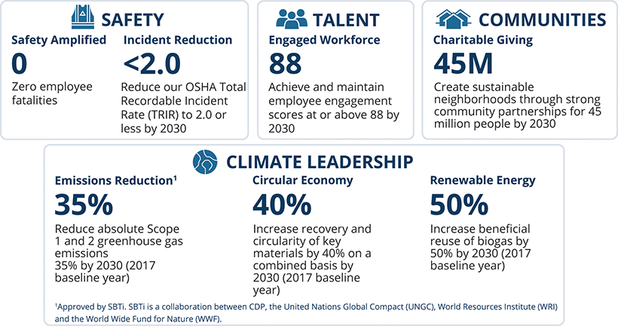
Our Sustainability Highlights

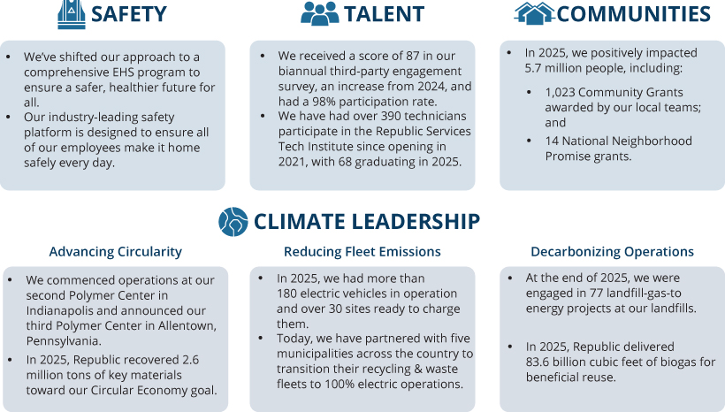

 |  |  |  | Republic Services, Inc. 2026 Proxy Statement |  |  | | |  |  |  | 45

Table of Contents
PROXY SUMMARY |  |  |  | BOARD AND GOVERNANCE |  |  |  | EXECUTIVE COMPENSATION |  |  |  | PROPOSALS |  |  |  | MEETING INFORMATION |  |  |  | ANNEX

OUR COMMITMENT TO ENVIRONMENT, HEALTH & SAFETY
As Republic Services has transformed into a full-scale environmental services provider, we maintain our commitment to safety as we work to encompass the new challenges and responsibilities that come with our enhanced service offerings. As our service offerings expand and we have more complex work streams, we must operate in a way that keeps our employees, customers and communities safe. We have adapted our approach to a comprehensive Environment, Health & Safety (“EHS”) program to ensure a safer, healthier future for all. Our disciplined EHS framework is woven into our culture, guides our decisions and is foundational to how we operate, with a particular focus on the following pillars:

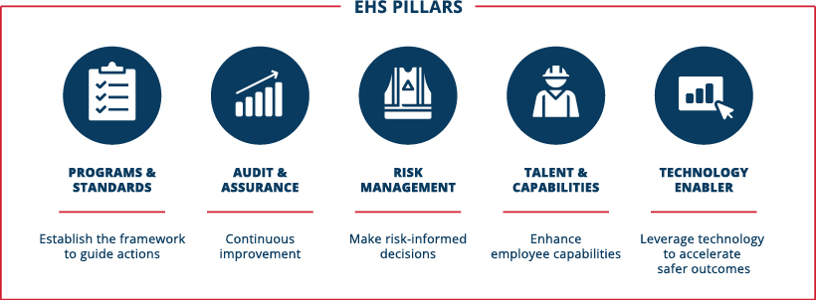
EHS is embedded in how we operate at Republic Services, and “Safe” is our top Company value. We embed safety through leadership engagement, workforce capability development, collaborations across operations, and the use of data and technology to inform decision-making.
Our standards are designed to support safe, consistent operations across facilities through engineering controls, clear expectations, and operational discipline.
In addition to employee safety, our EHS framework supports environmental compliance and responsible operations across our facilities. We work collaboratively with internal stakeholders and regulatory authorities to maintain permit compliance and uphold our environmental stewardship responsibilities.
To solidify our commitment to the safety of our employees and communities, we have two related 2030 Sustainability Goals, “Safety Amplified” and “Incident Reduction.” For more information on these goals and our plans for how we will achieve them, please see our sustainability reporting available at RepublicServices.com/Sustainability. Our sustainability reporting shall not be deemed incorporated by reference into any filing under the Securities Act of 1933, as amended (the “Securities Act”) or the Exchange Act, including this Proxy Statement, unless expressly incorporated by reference.
REDUCING FLEET EMISSIONS
To further our progress toward our climate leadership goals, we have continued our focus on electric propulsion technology innovation for our fleet. We believe that our business is uniquely suited for electrification, with recycling and waste trucks running consistent routes and returning to base nightly for off-peak charging. In 2023, we introduced the industry’s first fully integrated electric collection truck, manufactured by McNeilus and Oshkosh Corp. Our team provided insights to Oshkosh engineers regarding operational, safety and ergonomic features. We have been operating electric vehicles for several years from multiple manufacturers, including Mack and Peterbilt, and by the end of 2025, we had more than 180 electric vehicles in operation and over 30 sites ready to charge them.
ADVANCING CIRCULARITY
Republic is also advancing circularity for plastics. In 2025, we continued to ramp production at our Polymer Center in Las Vegas, Nevada, commenced operations at our second Polymer Center in Indianapolis, Indiana, and announced our third Polymer Center location in Allentown, Pennsylvania. Our Polymer Centers are the nation’s first integrated plastics recycling facilities, which enable us to manage the plastics stream from curbside collection to delivery of high-quality recycled content for consumer packaging. Rigid plastics collected from residential and commercial customers and sorted at local recycling facilities are delivered to a Polymer Center for processing, including shredding and hot washing or sorting by color for processing. Polyethylene terephthalate (“PET”) is shredded, washed and eventually turned back into new PET bottles. Our Blue Polymers JV will take the color-sorted recycled polyethylene and polypropylene from the Polymer Centers to create high-quality, recycled resin for consumer packaging and other applications. In 2025, the first Blue Polymers facility opened in

46 |  |  | | |  |  | Republic Services, Inc. 2026 Proxy Statement

Table of Contents
PROXY SUMMARY |  |  |  | BOARD AND GOVERNANCE |  |  |  | EXECUTIVE COMPENSATION |  |  |  | PROPOSALS |  |  |  | MEETING INFORMATION |  |  |  | ANNEX

Indianapolis, Indiana and construction has commenced at the second facility in Buckeye, Arizona. We are developing a nationwide network of Polymer Centers and Blue Polymers facilities designed to produce 100% post-consumer recycled products to supply plastic manufacturers’ growing demand for sustainable solutions.
DECARBONIZING OPERATIONS
Our customers are increasingly looking for decarbonization solutions, and we are leveraging our network of landfills to meet that need. Republic is committed to harnessing landfill gas, a natural byproduct of decomposing waste, and converting it to energy. More than 89% of our landfill acreage is covered by gas collection systems. Additionally, Republic’s joint venture with Archaea Energy, a bp company, is a key initiative to expand our renewable natural gas (“RNG”) facilities beyond the 77 projects we currently have. In addition to our partnership with Archaea Energy, Republic has partnered with other renewable gas developers to construct RNG plants at our landfills. These initiatives are expected to generate substantial progress toward Republic’s long-term sustainability goal to beneficially reuse 50% more biogas by 2030 (2017 baseline year).
INDUSTRY LEADERSHIP
We regularly review our environmental and social progress and performance to continue advancing our work. We have been named to the North American Dow Jones Sustainability Index, now known as the Dow Jones Best in Class, for nine consecutive years, most recently ranking first in our industry on the North America Index and as the only North American company in our industry included on the World Index. In addition, we were the first industry peer to advance to an “A” rating under MSCI, and we continued to maintain that rating on our recent reassessment. Our performance on these sustainability ratings is in recognition of the Company’s commitment to sustainability, including our 2030 Sustainability Goals, increased disclosures and achievements. These achievements demonstrate our ability to connect financial performance with environmental and social performance, including addressing various risks and opportunities posed by climate change. Our sustainability rankings also highlight Republic’s leadership in corporate governance, environmental, social and financial aspects of sustainability.
All of our latest reports are available on our website at RepublicServices.com/sustainability/reporting.
Talent
Our employees play an essential role in our mission to create a more sustainable world. Our employees are in our communities safely making five million pickups a day, working in our facilities, consulting with customers, engineering solutions, and leading teams. Their work helps our customers achieve their sustainability goals, keeps communities safe and contributes to a healthier environment. We aim to create a workplace where our employees are supported, engaged and empowered.
ENGAGEMENT AND RETENTION PROGRAMS
We believe an engaged workforce is key to our success. We measure employee engagement through third-party surveys, assessing employee sentiment on a variety of topics such as pride for the Company, job satisfaction and intention to stay. These surveys enable employees to provide constructive suggestions and to rate Republic’s receptiveness and action on past suggestions. Our employees completed two surveys in 2025, with our average engagement score increasing to 87 for the year. Approximately 99% of our employees participated in the engagement survey process in March 2025, and 97% in September 2025, reinforcing our commitment to ensuring every voice is heard.

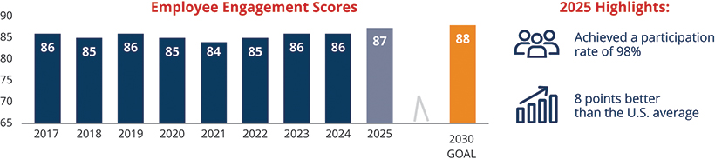

 |  |  |  | Republic Services, Inc. 2026 Proxy Statement |  |  | | |  |  |  | 47

Table of Contents
PROXY SUMMARY |  |  |  | BOARD AND GOVERNANCE |  |  |  | EXECUTIVE COMPENSATION |  |  |  | PROPOSALS |  |  |  | MEETING INFORMATION |  |  |  | ANNEX

TALENT DEVELOPMENT
Training and development are vital components of our culture. We’re committed to ensuring that our current employees have the right tools, programs and learning opportunities to develop and grow their careers. We have a proud history of fostering employee engagement, keeping the lines of employee communication open for constructive feedback and ensuring that employees feel supported at all levels. We offer a variety of dedicated development programs for critical operational roles to support business objectives, sourcing key talent externally and internally through high-potential talent development programs. We deploy dedicated training for all leaders, whether newly promoted or new to role, through our Leadership Fundamentals program.
In 2025, we launched a suite of leadership development courses that build on the skills established in our Leadership Fundamentals program. These courses are available to all leaders, and are offered in a hybrid and virtual format in a self-paced progression. Course topics include Leading with Agility and Resilience, Engaging Our Teams, and Difficult Conversation workshops, among others. These training opportunities are one of the ways we ensure our leaders are equipped to live our values and lead with confidence.
Our Business Resource Groups (BRGs) are employee-led organizations that come together to work on community and Company initiatives, and foster greater employee engagement.

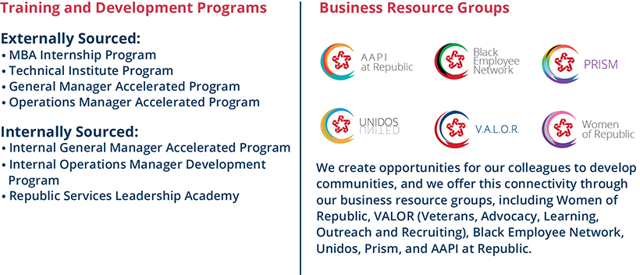

48 |  |  | | |  |  | Republic Services, Inc. 2026 Proxy Statement

Table of Contents
PROXY SUMMARY |  |  |  | BOARD AND GOVERNANCE |  |  |  | EXECUTIVE COMPENSATION |  |  |  | PROPOSALS |  |  |  | MEETING INFORMATION |  |  |  | ANNEX

Audit Committee Matters
AUDIT COMMITTEE REPORT
The following statement made by the Audit Committee shall not be deemed incorporated by reference into any filing under the Securities Act or the Exchange Act and shall not otherwise be deemed filed under either of these Acts.
Management is responsible for our internal controls, financial reporting processes, and compliance with laws and regulations and ethical business standards. Our independent registered public accounting firm is responsible for expressing an opinion as to the conformity of the consolidated financial statements with accounting principles generally accepted in the United States of America and for issuing its opinion on the effectiveness of our internal controls over financial reporting. The Audit Committee’s responsibility is to monitor and oversee these processes on the Board’s behalf.
In this context, the Audit Committee has reviewed and discussed the audited financial statements with management and our independent registered public accounting firm (Ernst & Young LLP). The Audit Committee has discussed with Ernst & Young LLP the matters required to be discussed by the rules of the Securities and Exchange Commission, and by Auditing Standard No. 16, Communications with Audit Committees, as adopted by the Public Company Accounting Oversight Board.
In addition, the Audit Committee has received from Ernst & Young LLP the written disclosures required by the Public Company Accounting Oversight Board Ethics and Independence Rule 3526, Communication with Audit Committees Concerning Independence, regarding the Company’s independent registered public accounting firm’s independence, and discussed with them their independence from the Company and management. The Audit Committee has also discussed with Ernst & Young LLP the matters required to be discussed by Statement on Auditing Standards No. 61, as amended (AICPA, Professional Standards, Vol. 1, AU section 380), as adopted by the Public Company Accounting Oversight Board in Rule 3200T.
Based on the Audit Committee’s review of the matters noted above and its discussions with Ernst & Young LLP and our management, the Audit Committee recommended to the Board that the audited financial statements be included in our Annual Report on Form 10-K for the year ended December 31, 2025 for filing with the SEC.
Submitted by the Audit Committee as of March 3, 2026:
Jennifer M. Kirk (Chair)
Ian Craig
Michael A. Duffy
Norman Thomas Linebarger
Meg Reynolds
Katharine B. Weymouth

 |  |  |  | Republic Services, Inc. 2026 Proxy Statement |  |  | | |  |  |  | 49

Table of Contents
PROXY SUMMARY |  |  |  | BOARD AND GOVERNANCE |  |  |  | EXECUTIVE COMPENSATION |  |  |  | PROPOSALS |  |  |  | MEETING INFORMATION |  |  |  | ANNEX

Audit and Related Fees
INDEPENDENT REGISTERED PUBLIC ACCOUNTING FIRM FEE INFORMATION
The following table discloses the fees for professional services provided by Ernst & Young LLP for the fiscal years ended December 31, 2025 and 2024:

 |  | 2025 |  |  |  | 2024
Audit Fees(1) |  | $ | 6,649,090 |  |  | $ | 5,893,596
Audit-Related Fees(2) |  | $ | 196,000 |  |  | $ | 678,778
Tax Fees(3) |  | $ | 264,692 |  |  | $ | 400,783
All Other Fees |  |  | — |  |  |  | —
Total Fees |  | $ | 7,109,782 |  |  | $ | 6,973,157

(1) | Audit Fees were primarily for professional services rendered for the audits of the consolidated financial statements and internal controls over financial reporting in compliance with Section 404 of the Sarbanes-Oxley Act of 2002, the review of documents filed with the SEC, consents, comfort letters and financial accounting and reporting consultations.
(2) | Audit-related fees were primarily related to pre-implementation services around the redesign of certain back-office software systems.
(3) | Tax Fees were for professional services related to general tax consultation, federal and state tax planning, and state and local tax matters.
PRE-APPROVAL POLICIES AND PROCEDURES
The Audit Committee’s policy is to pre-approve all audit services, audit-related services and other services permitted by law provided by our independent registered public accounting firm. In accordance with that policy, the Audit Committee annually pre-approves a list of specific services and categories of services, including audit, audit-related and other services, for the upcoming or current fiscal year, subject to specified cost levels. Any service that is not included in the pre-approved list of services must be separately approved by the Audit Committee. In addition, if fees for any service exceed the amount that has been pre-approved, then payment of additional fees for such service must be specifically approved by the Audit Committee before the performance of the service. From time to time, the Audit Committee may delegate fee approval authority to the Audit Committee chair. All of the services performed by Ernst & Young LLP in 2025 were pre-approved in accordance with the pre-approval policy adopted by the Audit Committee.
At each regularly scheduled Audit Committee meeting, management updates the Committee on the scope and anticipated cost of (1) any service pre-approved by the chair since the last committee meeting and (2) the projected fees for each service or group of services being provided by our independent registered public accounting firm that exceed the amount that has been pre-approved.

50 |  |  | | |  |  | Republic Services, Inc. 2026 Proxy Statement

Table of Contents
PROXY SUMMARY |  |  |  | BOARD AND GOVERNANCE |  |  |  | EXECUTIVE COMPENSATION |  |  |  | PROPOSALS |  |  |  | MEETING INFORMATION |  |  |  | ANNEX

Director Compensation
When establishing and reviewing our directors’ compensation, we consider the level of work and involvement the directors have with our business. We also consider compensation paid to directors in the marketplace generally and at our peer group companies (“Peer Group”). In 2025, we compensated our directors as follows:

 | • |  | we paid each non-employee director an annual retainer of $100,000, plus an additional $180,000 in the case of our Chairman of the Board;

 | • |  | effective October 2025, we increased the annual retainer for each committee chair by $5,000, resulting in an annual chair retainer of $25,000 for each of the Talent & Compensation Committee, the Governance Committee, the Sustainability & Corporate Responsibility Committee and the Finance Committee, and an annual chair retainer of $30,000 for the Audit Committee. These updated retainers were prorated for the remainder of the year; and

 | • |  | we granted each non-employee director RSUs based on a fair market value of $230,000 as of the date of grant.
Cash retainers are prorated if a director serves less than a full year in the applicable position. The annual grant of RSUs to a newly appointed, non-employee director is prorated to the number of days remaining in the year. We do not pay meeting fees for our Board or committee meetings but we reimburse our non-employee directors for their reasonable out-of-pocket costs and travel expenses in connection with their attendance at Board and committee meetings.
Annual RSUs granted to non-employee directors are fully vested upon grant. RSUs granted before 2012 will be settled upon the director’s termination of service from the Board. Beginning with grants in 2012, the RSUs are settled upon the earlier of the director’s termination of service from the Board or three years after the RSUs are granted, unless they are deferred into our DCP. RSUs are settled through the issuance of shares of our common stock. After any quarter in which dividends are distributed to shareholders, the non-employee directors receive additional RSUs with a value equal to the value of dividends they would have received had they owned the shares of stock underlying the RSUs on the dividend record date. The number of additional RSUs to be received by directors due to the declaration of dividends is based on the closing price of our stock on the dividend payment date.
All compensation paid by us during 2025 to our non-employee directors is detailed below. Mr. Vander Ark’s compensation is reflected in the executive compensation tables contained in this Proxy Statement, and he did not receive any additional compensation from us for his duties as a director.
DIRECTOR COMPENSATION IN 2025

DIRECTOR NAME |  | FEES EARNED OR PAID  IN CASH ($)(1) |  |  |  |  | STOCK AWARDS  ($)(2) |  |  |  |  | TOTAL ($)
Tomago Collins(3) |  |  |  | 43,462 |  |  |  |  | 230,104 |  |  |  |  | 273,566
Michael A. Duffy |  |  |  | 100,000 |  |  |  |  | 230,104 |  |  |  |  | 330,104
Thomas W. Handley |  |  |  | 121,250 |  |  |  |  | 230,104 |  |  |  |  | 351,354
Manny Kadre (Chairman) |  |  |  | 280,000 | (4) |  |  |  | 230,104 |  |  |  |  | 510,104
Jennifer M. Kirk |  |  |  | 126,250 |  |  |  |  | 230,104 |  |  |  |  | 356,354
Michael Larson |  |  |  | 121,250 |  |  |  |  | 230,104 |  |  |  |  | 351,354
Norman Thomas Linebarger |  |  |  | 100,000 |  |  |  |  | 230,104 |  |  |  |  | 330,104
Meg Reynolds |  |  |  | 100,000 |  |  |  |  | 230,104 |  |  |  |  | 330,104
James P. Snee |  |  |  | 121,250 |  |  |  |  | 230,104 |  |  |  |  | 351,354
Brian S. Tyler |  |  |  | 100,000 |  |  |  |  | 230,104 |  |  |  |  | 330,104
Sandra M. Volpe(5) |  |  |  | 119,361 |  |  |  |  | 230,104 |  |  |  |  | 349,465
Katharine B. Weymouth |  |  |  | 100,000 |  |  |  |  | 230,104 |  |  |  |  | 330,104
(1) | Includes annual cash retainers and Board and committee chair retainers.
(2) | The amounts shown in this column represent the grant-date fair value of RSUs granted in 2025 calculated in accordance with FASB ASC Topic 718. See Note 12 to our Consolidated Financial Statements included in our Form 10-K for the year ended December 31, 2025 for a discussion of the relevant assumptions used in making such calculations. This does not include the value of additional RSUs received in lieu of dividends. Each non-employee director received an annual grant of 1,150 RSUs on January 2, 2025 with a grant date fair value of $200.09 per share, which was the closing price of our stock on the date of grant.
(3) | Mr. Collins served as a director until our 2025 Annual Meeting. The Fees Earned or Paid in Cash column represents fees for services while he was still a director.
(4) | Mr. Kadre elected to defer a portion of his cash compensation in accordance with the DCP.
(5) | Ms. Volpe was appointed as Chair of the Sustainability & Corporate Responsibility Committee effective February 4, 2025. Her annual chair retainer was prorated as of her appointment date.

 |  |  |  | Republic Services, Inc. 2026 Proxy Statement |  |  | | |  |  |  | 51

Table of Contents
PROXY SUMMARY |  |  |  | BOARD AND GOVERNANCE |  |  |  | EXECUTIVE COMPENSATION |  |  |  | PROPOSALS |  |  |  | MEETING INFORMATION |  |  |  | ANNEX

Certain Relationships and Related Party Transactions
Our Related Party Transactions Policy stipulates that any transaction for which disclosure is required under Item 404 of Regulation S-K (an “S-K Transaction”) be approved by both our CEO and the Audit Committee. Generally speaking, an S-K Transaction is any transaction, arrangement or relationship (including any indebtedness or guarantee of indebtedness) in which Republic is a participant, the amount involved exceeds $120,000 in the aggregate, and a director, director nominee, executive officer, 5% shareholder, or immediate family member of any of the foregoing has a material interest in the transaction. The related party must disclose in writing to the Chief Legal Officer the material facts of the proposed S-K Transaction and the Chief Legal Officer (or designee) will then submit the written disclosure to the CEO and the Audit Committee for approval. If the proposed S-K Transaction involves the Chief Legal Officer, the written disclosure must be provided to the CEO. As part of its due diligence, the Audit Committee will review and determine, with the advice and assistance of such advisors as it deems appropriate, whether the S-K Transaction would present an improper conflict of interest. In making this determination, the Audit Committee may consider the following factors, among others: (1) whether the transaction terms are at least as favorable to us as those that could be obtained in a transaction between us and an unrelated party; (2) whether there are any compelling business reasons for us to enter into the transaction; and (3) whether the transaction would impair the independence of an otherwise independent director. Except for the compensation arrangements with directors and executive officers described elsewhere in this Proxy Statement, there were no S-K Transactions since January 1, 2025.

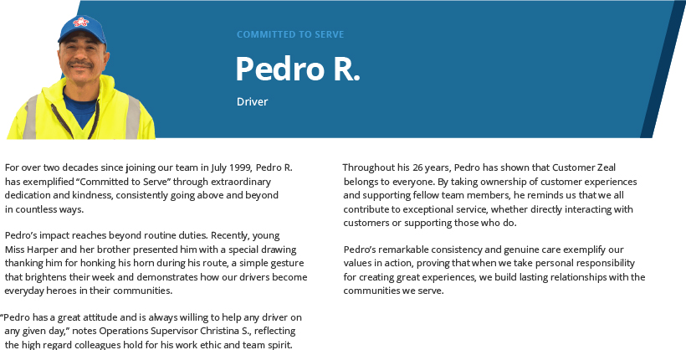

52 |  |  | | |  |  | Republic Services, Inc. 2026 Proxy Statement

Table of Contents
PROXY SUMMARY |  |  |  | BOARD AND GOVERNANCE |  |  |  | EXECUTIVE COMPENSATION |  |  |  | PROPOSALS |  |  |  | MEETING INFORMATION |  |  |  | ANNEX

Security Ownership of the Board of Directors and Management
The following table shows certain information as of March 9, 2026, with respect to the beneficial ownership of common stock and RSUs by (1) our current directors, (2) each of the named executive officers, and (3) all of our current directors and all executive officers as a group. We have adjusted share amounts and percentages shown for each individual in the table to give effect to shares of common stock that are not outstanding but which the individual may acquire upon exercise of options exercisable within 60 days after March 9, 2026, or settlement of RSUs or PSUs within 60 days after March 9, 2026. However, we do not deem these shares to be outstanding for the purpose of computing the percentage of outstanding shares beneficially owned by any other individual listed on the table. As of March 9, 2026, there were no stock options outstanding and held by our directors, named executive officers or the group comprised of our current directors and executive officers.
RSUs and PSUs that will be settled more than 60 days after March 9, 2026 are not considered common stock that is beneficially owned for SEC disclosure purposes. We have included RSUs in this table because they are similar to or track our common stock, they represent an investment risk in the performance of our common stock, they are settled through the issuance of shares of our common stock, and they receive dividend equivalents in the form of additional RSUs each time a dividend is paid on our common stock. The Board has considered the use of RSUs as opposed to common stock for directors and believes that RSUs align the directors with our shareholders’ long-term interests as much as common stock would.

 |  | SHARES BENEFICIALLY OWNED(a)
NAME OF BENEFICIAL OWNER |  | NUMBER(b) |  |  |  |  | PERCENT(c) |  |  |  |  | RESTRICTED STOCK UNITS(d)(e)
Manuel Kadre |  |  |  | 4,245 |  |  |  |  | * |  |  |  |  | 40,031
Ian Craig |  |  |  | — |  |  |  |  | * |  |  |  |  | 919
Michael A. Duffy |  |  |  | 1,598 |  |  |  |  | * |  |  |  |  | 9,983
Thomas W. Handley |  |  |  | 2,057 |  |  |  |  | * |  |  |  |  | 24,778
Jennifer M. Kirk |  |  |  | 4,449 |  |  |  |  | * |  |  |  |  | 24,778
Michael Larson |  |  |  | 59,189 |  |  |  |  | * |  |  |  |  | 39,931
Norman Thomas Linebarger |  |  |  | — |  |  |  |  | * |  |  |  |  | 3,483
Meg Reynolds |  |  |  | 37 |  |  |  |  | * |  |  |  |  | 4,369
James P. Snee |  |  |  | 13,939 |  |  |  |  | * |  |  |  |  | 3,693
Brian S. Tyler |  |  |  | 5,457 | (1) |  |  |  | * |  |  |  |  | 3,693
Sandra M. Volpe |  |  |  | 2,037 | (2) |  |  |  | * |  |  |  |  | 22,918
Katharine B. Weymouth |  |  |  | 8,138 | (3) |  |  |  | * |  |  |  |  | 3,693
Jon Vander Ark |  |  |  | 126,125 |  |  |  |  | * |  |  |  |  | 45,049
Brian A. Bales |  |  |  | 21,016 | (4) |  |  |  | * |  |  |  |  | 106,826
Gregg K. Brummer |  |  |  | 7,448 |  |  |  |  | * |  |  |  |  | 18,162
Brian M. DelGhiaccio |  |  |  | 21,147 |  |  |  |  | * |  |  |  |  | 39,989
Catharine D. Ellingsen |  |  |  | 51,216 |  |  |  |  | * |  |  |  |  | 9,835
All current directors and all current executive officers as a group (22 persons) |  |  |  | 366,730 | (5) |  |  |  | * |  |  |  |  | 434,245
(a) | Excludes the units in the last column of this table. Unless otherwise noted, each of our directors and executive officers has sole voting power and sole dispositive power with respect to the shares listed.
(b) | All share numbers have been rounded to the nearest whole share number and include any restricted shares.
(c) | Calculated in accordance with Rule 13d-3 under the Exchange Act, and based on 308,956,192 shares of common stock issued and outstanding at the close of business on March 9, 2026. * indicates beneficial ownership of less than 1% of our outstanding common stock.
(d) | The numbers in this column represent outstanding RSUs, both vested and unvested, including RSUs represented as units in the DCP’s Stock Unit Fund, and earned PSUs held in the DCP. For further discussion of RSUs and PSUs refer to “Director Compensation” and “Executive Compensation — Components of Executive Compensation.”
(e) | Excluded from this column are units in the DCP’s stock investment fund, a measurement fund under which units are equal in value to shares of the Company’s common stock and are settled in cash. These units apply for purposes of our stock ownership guidelines, and Ms. Ellingsen and Mr. Bales hold 20,888 units and 28,027 units, respectively.
(1) | The aggregate amount of common stock beneficially owned by Mr. Tyler consists of 5,452 shares held indirectly in a revocable trust and 5 shares owned directly by him.
(2) | The aggregate amount of common stock beneficially owned by Ms. Volpe consists of 1,858 shares held indirectly in a revocable trust and 179 shares owned directly by her.
(3) | The aggregate amount of common stock beneficially owned by Ms. Weymouth consists of 540 shares held indirectly in an irrevocable trust and 7,598 shares owned directly by her.
(4) | Mr. Bales holds these shares indirectly in a revocable trust.
(5) | The aggregate amount of common stock beneficially owned by all current directors and all executive officers as a group consists of (a) 365,793 shares, and (b) 937 shares that may be acquired upon settlement of RSUs within 60 days after March 9, 2026.

 |  |  |  | Republic Services, Inc. 2026 Proxy Statement |  |  | | |  |  |  | 53

Table of Contents
PROXY SUMMARY |  |  |  | BOARD AND GOVERNANCE |  |  |  | EXECUTIVE COMPENSATION |  |  |  | PROPOSALS |  |  |  | MEETING INFORMATION |  |  |  | ANNEX

Security Ownership of Five Percent Shareholders
The following table shows certain information as of March 9, 2026, with respect to the beneficial ownership of common stock by each of our shareholders who we know is a beneficial owner of more than 5% of our outstanding common stock.

 |  | SHARES BENEFICIALLY OWNED
NAME OF BENEFICIAL OWNER |  | NUMBER |  |  |  |  | PERCENT(1)
William H. Gates III  Cascade Investment, L.L.C.  2365 Carillon Point, Kirkland, WA 98033 (2) |  |  |  | 109,816,832 |  |  |  |  | 35.5
The Vanguard Group  100 Vanguard Boulevard, Malvern, PA 19355 (3) |  |  |  | 18,153,236 |  |  |  |  | 5.9
BlackRock, Inc.  50 Hudson Yards, New York, NY 10001 (4) |  |  |  | 15,767,490 |  |  |  |  | 5.1
(1) | Calculated in accordance with Rule 13d-3 under the Exchange Act, based on 308,956,192 shares of common stock outstanding at the close of business on March 9, 2026.
(2) | Based on a Schedule 13D/A filed with the SEC by Mr. Gates and Cascade Investment, L.L.C. (“Cascade”) on February 20, 2026, all shares of our common stock held by Cascade may be deemed to be beneficially owned by Mr. Gates as the sole member of Cascade. Mr. Gates’ address is 500 Fifth Avenue North, Seattle, WA 98109. The Schedule 13D/A also discloses that, as the sole member of Cascade, Mr. Gates has sole voting power and sole dispositive power with respect to 109,816,832 shares.
(3) | Based on a Schedule 13G/A filed with the SEC on February 13, 2024, The Vanguard Group, 100 Vanguard Boulevard, Malvern, PA 19355, is the beneficial owner of 18,153,236 shares. The Vanguard Group reports that it has sole voting power with respect to 0 shares, shared voting power with respect to 268,437 shares, sole dispositive power with respect to 17,272,493 shares and shared dispositive power with respect to 880,743 shares, as of December 29, 2023.
(4) | Based on a Schedule 13G/A filed with the SEC on April 24, 2025, BlackRock, Inc. (“BlackRock”), 50 Hudson Yards, New York, NY 10001, is the beneficial owner of 15,767,490 shares. BlackRock reports that it has sole voting power with respect to 14,397,893 shares, shared voting power with respect to 0 shares, sole dispositive power with respect to 15,767,490 shares and shared dispositive power with respect to 0 shares, as of March 31, 2025.
Delinquent Section 16(a) Reports
Based solely upon a review of (1) Forms 3 and 4 and amendments to each form furnished to us pursuant to Rule 16a-3(e) under the Exchange Act, during our fiscal year ended December 31, 2025, (2) any Form 5’s and amendments to each form furnished to us with respect to such fiscal year, and (3) any written representations referred to us under subparagraph (b)(1) of Item 405 of Regulation S-K under the Exchange Act with respect to such fiscal year, no person who at any time during such fiscal year was a director, Section 16(a) officer or, to our knowledge, a beneficial owner of more than 10% of our common stock failed to file on a timely basis reports required by Section 16(a) of the Exchange Act during such fiscal year, except that, Julia Arambula had 390 PSUs distributed out of the Company’s Deferred Compensation Plan on December 22, 2025, but these PSUs were not timely reported due to an administrative tracking error. This transaction was reported in a subsequent Form 4 promptly after discovery of the error.

54 |  |  | | |  |  | Republic Services, Inc. 2026 Proxy Statement

Table of Contents


Table of Contents
PROXY SUMMARY |  |  |  | BOARD AND GOVERNANCE |  |  |  | EXECUTIVE COMPENSATION |  |  |  | PROPOSALS |  |  |  | MEETING INFORMATION |  |  |  | ANNEX

CD&A Table of Contents

Message from the Talent & Compensation Committee |  |  | 57
Executive Officers |  |  | 58
Executive Summary |  |  | 60
Vision and Strategy |  |  | 60
2025 Performance Highlights |  |  | 60
Executive Compensation Philosophy & Goals |  |  | 61
Key Compensation Governance Practices |  |  | 62
Shareholder Engagement |  |  | 62
Performance Metrics |  |  | 62
Components of Executive Compensation
How We Pay |  |  | 65
Other Benefits |  |  | 73
Other Compensation Policies |  |  | 74
Compensation Process |  |  | 76
Comparator Group |  |  | 76
Evaluating Company and Executive Performance |  |  | 77
Role of the Independent Compensation Consultant and Other Advisors |  |  | 77
Other Considerations |  |  | 78
Employment Agreements and Executive Separation Policy |  |  | 78
Annual Risk Assessment |  |  | 78
Equity Usage (Burn Rate and Dilution) |  |  | 78
Talent & Compensation Committee Interlocks and Insider Participation |  |  | 78
Talent & Compensation Committee Report |  |  | 79

56 |  |  | | |  |  | Republic Services, Inc. 2026 Proxy Statement

Table of Contents
PROXY SUMMARY |  |  |  | BOARD AND GOVERNANCE |  |  |  | EXECUTIVE COMPENSATION |  |  |  | PROPOSALS |  |  |  | MEETING INFORMATION |  |  |  | ANNEX

Message from the Talent & Compensation Committee
Dear Fellow Shareholders,
On behalf of the entire Board of Directors, thank you for your continued investment in Republic. As members of the Board, and specifically the Talent & Compensation Committee, we regularly review and refine our executive compensation program to ensure incentives attract, retain and motivate top talent as well as align the focus of executives with Republic’s most important financial and strategic goals to create long-term value.
In structuring the 2025 executive compensation program, the Committee saw the opportunity for several small but meaningful changes which would better position our incentive program to continue encouraging value-creating actions by management. While our overarching goals remain the same, we regularly finetune our program and make changes that we believe align the interests of our executives with our shareholders. Our program continues to prioritize rewarding executives for delivering shareholder value in alignment with our strategy, which focuses on meeting the needs of our customers through differentiated service offerings across our business.
After carefully reviewing our program and priorities, and incorporating shareholder feedback, we made the following changes for 2025:

 | • |  | LTI Mix: We updated our overall long-term incentive mix to have a higher percentage of performance share units (“PSUs”) (relative to non-performance-based restricted stock units (“RSUs”)) and we standardized this weighting across all executives. With this update, the LTI mix is comprised of 80% PSUs and 20% RSUs. This change better aligns us with our peer companies and creates upside for long-term strategic execution and reduced compensation if the Company underperforms.

 | • |  | PSU Measures: We changed the weighting of metrics used for performance share units. Previously, we included a weighting of 40% Cash Flow Value Creation (CFVC), 40% Return on Invested Capital (ROIC) and 20% TSR vs. the S&P 500 (“RTSR”). For PSUs granted during the 2025 to 2027 performance period, both ROIC and CFVC are weighted at 50% if ROIC remains below target. If ROIC is above target, CFVC will be the only metric weighted. The ROIC “gate” balances the importance of meeting ROIC expectations while recognizing improving ROIC in perpetuity can be difficult and may lead to misaligned management incentives. Whether the ROIC gate is met, a relative total shareholder return (“RTSR”) modifier can impact total pay, positively or negatively, by up to 10 percentage points.

 | • |  | Sustainability and Performance Modifier: The annual incentive plan includes a Sustainability and Performance Modifier that adjusts the annual incentives for senior executives up to 10 percentage points, positively or negatively, depending upon the Company’s interim performance on safety, talent, climate leadership and customer zeal goals. In 2025, we updated these pillars to include customer zeal to ensure alignment with the Company’s overall performance and long-term strategy. We also changed the metrics used for talent to focus on employee engagement to ensure alignment with our business strategy.

 | • |  | Comparator Group: We updated our compensation comparator group to better align with companies of similar size to Republic, as well as include industrials companies with a sustainability-focused business strategy like ours. This resulted in the addition of four new companies and the removal of four that were no longer adequate comparators to Republic due to their business model or size.
We believe this structure, as a whole, helps attract, retain, and motivate top talent while incentivizing long-term shareholder value creation. Importantly, we also believe this structure and the disclosures in this Proxy Statement are reflective of shareholder feedback. As we look ahead, we value your feedback and your continued investment in Republic Services.
We remain committed to continuing to drive the ongoing success of our business, while building sustained, long-term value for our shareholders. Our senior leadership team is motivated and appropriately incentivized to ensure the Company is a market leader in each of our operating areas. Together, we look forward to continuing to support Republic’s teams as they partner with customers to create a more sustainable world.
Sincerely,
The Talent & Compensation Committee
Thomas W. Handley (Chair)
Michael Larson
James P. Snee
Brian S. Tyler
Katharine B. Weymouth

 |  |  |  | Republic Services, Inc. 2026 Proxy Statement |  |  | | |  |  |  | 57

Table of Contents
PROXY SUMMARY |  |  |  | BOARD AND GOVERNANCE |  |  |  | EXECUTIVE COMPENSATION |  |  |  | PROPOSALS |  |  |  | MEETING INFORMATION |  |  |  | ANNEX

Compensation Discussion & Analysis
This Compensation Discussion & Analysis (“CD&A”) provides a detailed description of our executive compensation program for 2025. This CD&A focuses on the compensation of the named executive officers listed in the Summary Compensation Table.
Executive Officers
Our executive officers serve at the Board’s pleasure and are subject to annual appointment by the Board. Our current executive officers are as follows:

EXECUTIVE NAME |  | AGE |  | POSITION
Jon Vander Ark |  | 50 |  | President and Chief Executive Officer
Brian M. DelGhiaccio |  | 52 |  | Executive Vice President, Chief Financial Officer
Brian A. Bales |  | 63 |  | Executive Vice President, Chief Development Officer
Jeni Bell |  | 49 |  | Executive Vice President, Chief Marketing Officer
Gregg K. Brummer |  | 60 |  | Executive Vice President, Chief Operating Officer
Catharine D. Ellingsen |  | 61 |  | Executive Vice President, Chief Legal Officer,  Chief Ethics & Compliance Officer, and Corporate Secretary
Amanda Hodges |  | 53 |  | Executive Vice President, Chief Commercial Officer
Courtney Rodriguez |  | 52 |  | Executive Vice President, Chief Human Resources Officer
Julia Arambula |  | 48 |  | Senior Vice President, Operations
Larson Richardson |  | 46 |  | Senior Vice President, Operations

 |  | Jon Vander Ark  For biographical information about Mr. Vander Ark, see “Board of Directors and Corporate Governance — Biographical Information Regarding Director Nominees.”
 |  | Brian M. DelGhiaccio  Mr. DelGhiaccio was named Executive Vice President, Chief Financial Officer in June 2020. Mr. DelGhiaccio has over 25 years of experience with Republic in a variety of roles of increasing responsibility. He was named Executive Vice President and Chief Transformation Officer in June 2019. Before that, Mr. DelGhiaccio served as Vice President, Investor Relations from 2012 to 2014, progressed to Senior Vice President, Finance from 2014 to 2017 and then to Senior Vice President, Business Transformation in 2017. Prior to his time at Republic, Mr. DelGhiaccio worked in the audit practice of Arthur Andersen. Mr. DelGhiaccio serves on the Board of Directors of Aramark.
 |  | Brian A. Bales  Mr. Bales was named Executive Vice President, Chief Development Officer in February 2015. Mr. Bales has been with Republic for over 25 years, serving as Executive Vice President, Business Development from December 2008 to February 2015, and Vice President, Corporate Development from 1998 to December 2008. Prior to his time at Republic, Mr. Bales held roles of increasing responsibility in finance and business development for Ryder System, Inc. from 1993 to 1998, and served as chief financial officer for EDIFEX & VTA Communications from 1988 through 1993. Prior to that, Mr. Bales was an accountant for PwC (formerly Price Waterhouse) from 1986 to 1988. Mr. Bales serves on the Board of Directors of RB Global, Inc.
 |  | Jeni Bell  Ms. Bell was named Executive Vice President, Chief Marketing Officer in April 2025. In this role, Ms. Bell oversees marketing, communications, product development, customer engagement, and revenue management for the Company. Prior to joining Republic, Ms. Bell held leadership roles at AT&T, serving as senior vice president of performance marketing & platforms from November 2023 to March 2025, and senior vice president of product marketing & sales from December 2020 to November 2023. Prior to her time at AT&T, Ms. Bell was senior vice president, corporate synergy at WarnerMedia.

58 |  |  | | |  |  | Republic Services, Inc. 2026 Proxy Statement

Table of Contents
PROXY SUMMARY |  |  |  | BOARD AND GOVERNANCE |  |  |  | EXECUTIVE COMPENSATION |  |  |  | PROPOSALS |  |  |  | MEETING INFORMATION |  |  |  | ANNEX

 |  | Gregg K. Brummer  Mr. Brummer was named Executive Vice President, Chief Operating Officer in August 2023. Prior to his current role, Mr. Brummer served as Senior Vice President, Operations from June 2019 to August 2023 where he was responsible for maximizing field performance, ensuring superior service delivery, executing the operating plan, and achieving financial and operational results across the Company. Mr. Brummer joined the Company in January 2014 as Area President, a role he held until June 2019. Prior to joining the Company, Mr. Brummer was a Regional Vice President as well as General Manager at BlueLinx Corporation and held various leadership positions at Georgia Pacific Corporation.
 |  | Catharine D. Ellingsen  Ms. Ellingsen was named Executive Vice President, Chief Legal Officer, Chief Ethics & Compliance Officer, and Corporate Secretary in June 2016. Ms. Ellingsen has been with the Company for over 25 years in a variety of roles of increasing responsibility. Prior to her current role, Ms. Ellingsen was Senior Vice President, Human Resources from August 2011 to June 2016. Prior to that, Ms. Ellingsen held the position of Vice President and Deputy General Counsel from June 2007 to August 2011. Before joining the Company, Ms. Ellingsen was an attorney at Steptoe & Johnson LLP from 1996 to 2001 and at Bryan Cave LLP from 1993 to 1996.
 |  | Amanda Hodges  Ms. Hodges was named Executive Vice President, Chief Commercial Officer in August 2024. In this role, Ms. Hodges leads the Company’s sales organization and customer service team to drive profitable growth and customer loyalty. Prior to her current role, Ms. Hodges served as Executive Vice President, Chief Marketing Officer from November 2020 to August 2024. Prior to joining Republic, Ms. Hodges spent 15 years in leadership roles for Dell Technologies, most recently serving as Senior Vice President of North America Marketing and the Global Customer Briefing Program. Before joining Dell, Ms. Hodges worked as a consultant for McKinsey & Company and a chemical engineer at GE Plastics. Ms. Hodges serves on the Board of Directors of Alliance Laundry Holdings.
 |  | Courtney Rodriguez  Ms. Rodriguez was named Executive Vice President, Chief Human Resources Officer in March 2023. In this role, she is responsible for all aspects of the Company’s talent strategy, including talent acquisition and retention, learning and development, and total rewards. Prior to joining Republic, Ms. Rodriguez served as Senior Vice President, Global HR, for Dell Technologies from 2021 to 2023. She has over 20 years of HR experience, including frontline, customer operations, culture transformation and M&A support. Ms. Rodriguez started her career in finance as a senior auditor for Arthur Andersen before moving to Dell as a financial analyst.
 |  | Julia Arambula  Ms. Arambula was named Senior Vice President, Operations, Environmental Solutions in August 2024. Ms. Arambula joined the Company in 2002 and has held a variety of roles of increasing responsibility. In her current role, Ms. Arambula is responsible for maximizing field performance, ensuring superior service delivery, executing the operating plan, and achieving financial and operational results for our environmental solutions field operations. Prior to her current role, Ms. Arambula was Senior Vice President, Operations in our recycling and waste field operations from November 2021 to August 2024. Prior to that, Ms. Arambula served as Senior Vice President, Operations Support from March 2020 to November 2021. Prior to that, Ms. Arambula held a variety of finance and accounting roles of increasing responsibility. Prior to Republic, Ms. Arambula was a senior auditor with Arthur Andersen.
 |  | Larson Richardson  Mr. Richardson was named Senior Vice President, Operations in December 2023. In his current role, Mr. Richardson is responsible for maximizing field performance, ensuring superior service delivery, executing the operating plan, and achieving financial and operational results for Republic’s recycling and waste field operations in the western portion of the United States and Canada. Prior to his current role, Mr. Richardson was Area President over the Company’s Heartland Area from June 2019 to December 2023. Prior to that, Mr. Richardson was Area Vice President for the Southeast Area from September 2017 to June 2019. Mr. Richardson started with Republic in 2012 as a General Manager in the Southeast Area. Prior to Republic, Mr. Richardson was an Area General Manager at Waste Industries USA.

 |  |  |  | Republic Services, Inc. 2026 Proxy Statement |  |  | | |  |  |  | 59

Table of Contents
PROXY SUMMARY |  |  |  | BOARD AND GOVERNANCE |  |  |  | EXECUTIVE COMPENSATION |  |  |  | PROPOSALS |  |  |  | MEETING INFORMATION |  |  |  | ANNEX

Executive Summary
VISION AND STRATEGY

Our purpose-driven vision is to partner with customers to create a more sustainable world. We work towards this vision by effectively executing our integrated growth strategy, which focuses on three key areas: recycling and waste, environmental solutions, and sustainability innovation.

Through this integrated approach, strengthening our position in any one of these areas advances other areas of our business. Our integrated growth strategy is supported by our differentiating capabilities:

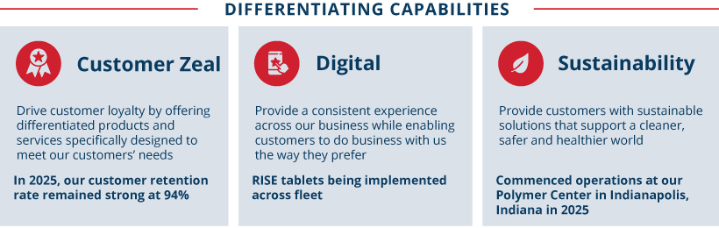
FOCUSED CAPITAL ALLOCATION STRATEGY TO INCREASE SHAREHOLDER VALUE CREATION
Our balanced capital allocation practices prioritize reinvesting into the business and then returning cash to shareholders while maintaining an investment-grade credit rating.

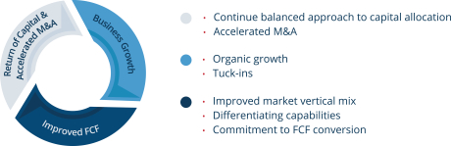
2025 PERFORMANCE HIGHLIGHTS
During 2025, we continued to create value for our shareholders. Our performance reflects the success of our strategic priorities. We remain focused on generating profitable growth by sustainably responding to our customers’ needs, managing our cost structure, generating consistent earnings and free cash flow growth, improving return on invested capital, and increasing cash returns to our shareholders.

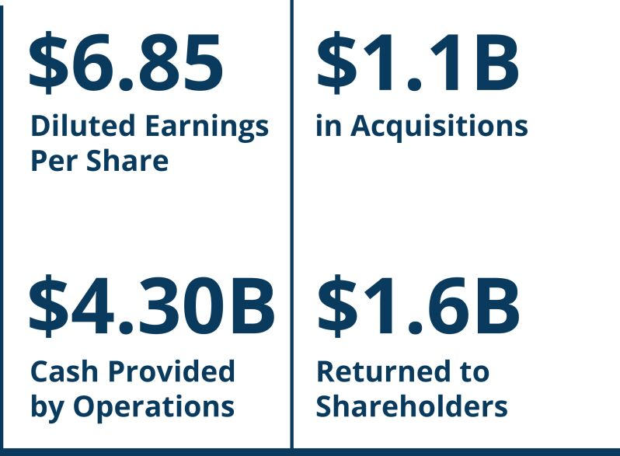

60 |  |  | | |  |  | Republic Services, Inc. 2026 Proxy Statement

Table of Contents
PROXY SUMMARY |  |  |  | BOARD AND GOVERNANCE |  |  |  | EXECUTIVE COMPENSATION |  |  |  | PROPOSALS |  |  |  | MEETING INFORMATION |  |  |  | ANNEX

Highlights of the year include:

 | • |  | Full-year diluted EPS was $6.85 per share and full-year adjusted EPS(1) was $7.02 per share. Adjusted EPS increased 8.7 percent over the prior year;
 | • |  | Full-year cash provided by operating activities was $4.30 billion and adjusted free cash flow (“FCF”)(1) was $2.43 billion;
 | • |  | Invested over $1.1 billion in acquisitions during 2025;
 | • |  | Returned $1.6 billion to shareholders in 2025 through dividends and share repurchases; and
 | • |  | Received many notable awards for our continued leadership in in several key areas including employee engagement, ethics, innovation and climate change management and resiliency.

(1) | Adjusted EPS and adjusted FCF are non-GAAP financial measures. For a reconciliation of these non-GAAP measures to the comparable measures in accordance with GAAP, see “Reconciliation of GAAP to Non-GAAP Financial Measures” in the Annex on page 105.

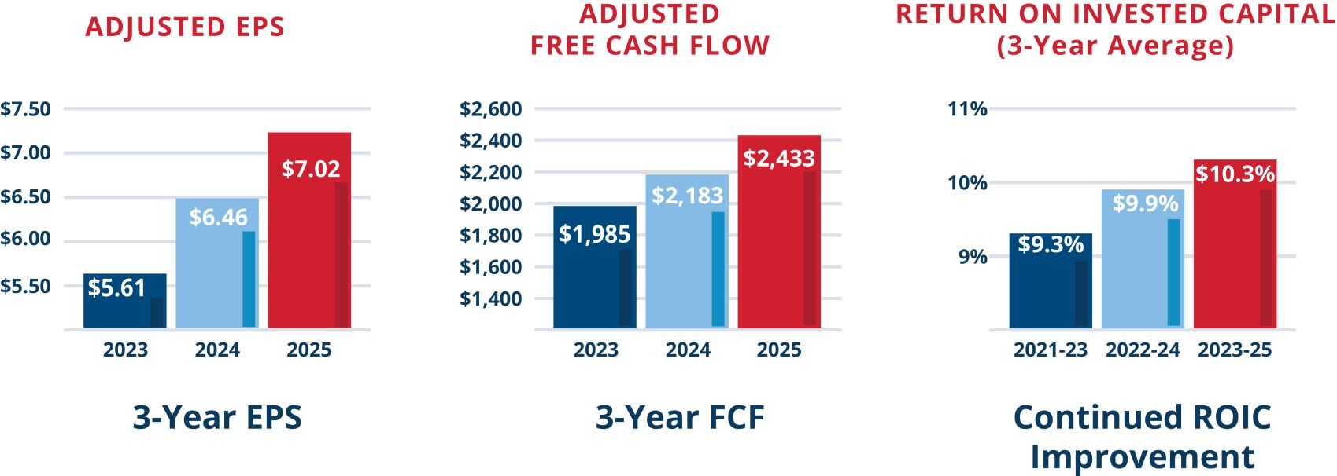
Executive Compensation Philosophy & Goals
Our executive compensation philosophy and practices reflect our strong commitment to paying for performance — both short-term and long-term. A primary component of our people and talent agenda is to identify, recruit, place, develop and retain key management talent to help ensure that we have the highest caliber leadership. The Talent & Compensation Committee and the executive management team believe that a critical aspect of being able to successfully execute this strategy is maintaining a comprehensive, integrated and well-balanced executive compensation program. We believe such a program provides competitive and differentiated levels of pay based on corporate performance and aligns executives’ interests with shareholders’ interests.

ATTRACT AND RETAIN EXECUTIVES |  |  |  | We define performance as the achievement of results against our challenging internal financial targets and sustainability goals, which take into account industry and market conditions.
Attract and retain the highest caliber executives by providing compensation opportunities comparable to those offered by other companies with which we compete for business and talent
ACHIEVE BUSINESS GOALS

Communicate, support and drive achievement of our business strategy, including sustainability goals |  |  |  | Our executive compensation program has an integrated focus on short- and long-term financial metrics and provides an effective framework by which progress against strategic goals may be appropriately measured and rewarded. The Talent & Compensation Committee continues to place great emphasis on performance indicators that executive management can influence or control, including profitability and sound financial management of our capital, to drive sustained shareholder value creation and reward executives when they are successful.
MOTIVATE PERFORMANCE

Motivate strong performance from executive management in an incentive-driven culture by delivering greater rewards for superior performance and reduced rewards for underperformance

ALIGN INTERESTS |  | 
Closely align executives’ interests with our shareholders’ interests and foster an equity-based ownership environment

REWARD ACHIEVEMENT

Reward achievement of both short-term results and long-term shareholder value creation

 |  |  |  | Republic Services, Inc. 2026 Proxy Statement |  |  | | |  |  |  | 61

Table of Contents
PROXY SUMMARY |  |  |  | BOARD AND GOVERNANCE |  |  |  | EXECUTIVE COMPENSATION |  |  |  | PROPOSALS |  |  |  | MEETING INFORMATION |  |  |  | ANNEX

Key Compensation Governance Practices
The Talent & Compensation Committee independently governs the executive compensation program with the support of an independent compensation consultant and management. Our compensation program demonstrates strong governance through the following key practices:

•  Maintain a clawback policy covering incentive compensation that’s more robust than SEC and NYSE requirements  •  Require double trigger provisions for all severance and equity awards following a change in control  •  Consider dilution and burn rates in determining equity awards to manage the impact of dilution on shareholders  •  Base a significant percentage of both the target total direct compensation opportunity and the LTI opportunity on performance  •  Cap annual incentive awards and LTI awards and base them on value-driving financial metrics |  | •  Use a well-structured Peer Group, consisting of companies with which Republic competes for business or executive talent  •  Maintain stock ownership guidelines of 8x salary for our CEO and 5x salary for other Executive Officers  •  Say-on-Pay Vote seeking annual non-binding advisory votes from shareholders of the NEO compensation program disclosed in our CD&A  •  Annual Talent & Compensation Committee review of our compensation program including incentive program, to ensure no excessive or inappropriate risk taking |  |  |  | •  No gross-ups for excise tax payments made in the event of a change in control  •  No payment of dividends on unearned PSU awards  •  No excessive change in control provisions in executive severance agreements  •  No executive termination for “good reason” absent a change in control  •  No repricing or exchange of underwater options allowed without shareholder approval  •  No significant perquisites – our NEOs and other executives generally receive the same benefits as other employees  •  No hedging, pledging, or short selling of our Company stock by directors, officers, employees or their immediate family members
Shareholder Engagement
Republic has an active shareholder outreach program and regularly engages with shareholders on a number of matters, including executive compensation, governance and sustainability. The Board continues to consider feedback received from shareholders on executive compensation when designing and reviewing our compensation program. The Board was pleased that our 2025 say-on-pay vote received support from 96.6% of the shares voted. Our shareholders, both via the say-on-pay vote and in our engagement sessions, spoke favorably of our overall compensation program.
Performance Metrics
We believe the performance metrics we use for our executive compensation program are strongly aligned with shareholder interests and support our business strategy. For our annual cash incentive plan, we use an earnings per share measure (“EPS Measure”) and a free cash flow measure (“FCF Measure”). For the PSUs awarded under our long-term incentive (“LTI”) plan, we use return on invested capital (“ROIC”), cash flow value creation (“CFVC”), and relative total shareholder return (“RTSR”).
For the 2025 – 2027 performance period, we updated the weighting of our PSU metrics. Both ROIC and CFVC are weighted at 50%. If CFVC is above target, outperformance will be based on the CFVC metric only provided that the ROIC metric is met. This structure aims to recognize that meeting expectations on ROIC is important both externally and internally, while acknowledging improving ROIC in perpetuity is difficult and may result in misaligned management incentives. Additionally, we added an RTSR multiplier to the PSUs in lieu of RTSR weighting. This modifier adjusts the incentives paid to our senior executives within a range of 90% to 110% based on performance. Our shareholders have told us that these metrics align well with their interests.

62 |  |  | | |  |  | Republic Services, Inc. 2026 Proxy Statement

Table of Contents
PROXY SUMMARY |  |  |  | BOARD AND GOVERNANCE |  |  |  | EXECUTIVE COMPENSATION |  |  |  | PROPOSALS |  |  |  | MEETING INFORMATION |  |  |  | ANNEX

In 2022, we added a Sustainability and Performance Modifier to our annual incentive plan, pursuant to which the annual incentive paid to our senior executives is subject to adjustment up or down by up to 10 percentage points based on the Company’s interim performance on safety, talent, climate leadership and customer zeal goals. The following graphic describes the financial performance metrics applied to both the annual incentive plan and the PSUs awarded under our LTI plan in 2025 as well as how they align with our strategic goals:

Annual Cash Incentive

Our annual incentive metrics are designed to encourage profitable growth and are widely accepted by the investment community as important performance metrics:

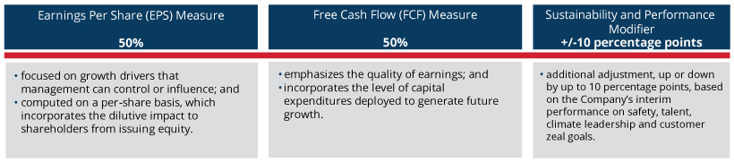

Performance-based Long Term Incentive Award (PSUs)

Our LTI metrics are designed to grow our business with an emphasis on cash flow while maximizing investment returns and aligning interest between our executives and shareholders:

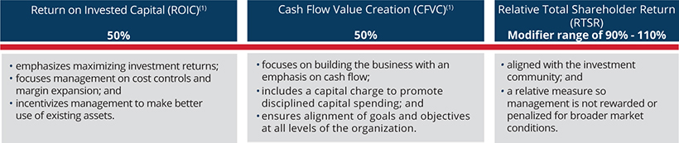

(1) | ROIC and CFVC are adjusted to exclude gains or losses (or related impairments) from divestitures, impairments of goodwill and other costs and impairments resulting from exiting a business, losses recorded on the extinguishment of debt instruments, gains or losses associated with withdrawal from or termination of one or more benefit plans, material changes caused by new accounting rules or new interpretations of previous accounting rules and other similar events or circumstances.
Although the FCF Measure used for our annual incentive and the CFVC used for our PSUs may appear similar, the measures are distinct and support different objectives.

 |  | FREE CASH FLOW MEASURE |  | CASH FLOW VALUE CREATION
Calculation |  | FCF = Cash Flow from Operations – Net Capital Expenditures |  | CFVC = Net Operating Profit After Tax – (Average Net Assets x Capital Charge)
Rationale for Use as  Performance Metric |  | •  Reflects strength of the Company’s cash flow on an annual basis and quality of the Company’s earnings  •  Measures the Company’s ability to generate cash flow in excess of capital expenditures |  | •  Includes a capital charge on net assets to promote business growth through disciplined investments  •  Reflects creation of value over the  long term

 |  |  |  | Republic Services, Inc. 2026 Proxy Statement |  |  | | |  |  |  | 63

Table of Contents
PROXY SUMMARY |  |  |  | BOARD AND GOVERNANCE |  |  |  | EXECUTIVE COMPENSATION |  |  |  | PROPOSALS |  |  |  | MEETING INFORMATION |  |  |  | ANNEX

Please refer to the Annex on pages 105-107 for details regarding the calculation of the EPS Measure, FCF Measure, CFVC, and ROIC for 2023, 2024 and 2025.
Setting Robust Performance Targets
We develop rigorous performance metrics on a bottom-up basis – reflecting both management initiatives and the impact of external factors. To align management incentives, our metrics and performance targets focus on factors that management can impact rather than on external factors not under management’s control or ability to mitigate.
The performance metrics used in the annual incentive plan and the PSUs are either directly tied to management’s ability to increase shareholder value, or use shareholder value as a metric itself (through the use of relative TSR). In setting performance targets for the annual incentive plan and for the three-year PSU performance cycle, the Talent & Compensation Committee considers the macro-economic environment, industry-specific conditions, prior-year actual performance, tax conditions and changes in regulations and laws. The Talent & Compensation Committee confirms that performance targets align with our published earnings guidance, which assures that they are transparent and reward management only if management is successful in achieving financial results that align with the expectations we communicate externally. Based on this due diligence, the Talent & Compensation Committee sets rigorous, but reasonable, performance goals for the business.
Progress toward our sustainability goals is included within each of our management initiatives. As a result, there is a direct line from our sustainability initiatives to our business results, our culture and strategy and thus, to our performance-based executive compensation program. Accordingly, the annual incentives for senior executives including our NEOs are subject to adjustment up or down by up to 10 percentage points based on the Company’s interim performance on safety, talent, climate leadership and customer zeal goals. This Sustainability and Performance Modifier is “universal,” meaning the adjustment is applied consistently for all corporate members of our senior management team, including our named executive officers.
The following table sets forth the components for setting rigorous performance targets that are aligned closely with shareholder value creation.

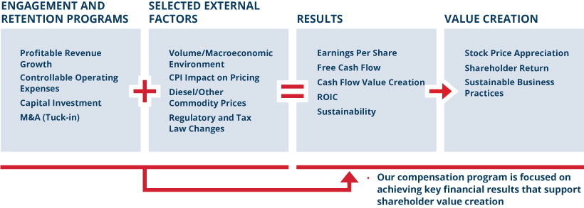
In addition, on a quarterly basis, the chairs of our Audit Committee and our Talent & Compensation Committee meet with the Chairman of the Board, the CEO, and members of management to conduct a quality of earnings review of Company performance and adjustments to performance metrics included in our compensation plans to ensure consistency and conformity with the plans.

64 |  |  | | |  |  | Republic Services, Inc. 2026 Proxy Statement

Table of Contents
PROXY SUMMARY |  |  |  | BOARD AND GOVERNANCE |  |  |  | EXECUTIVE COMPENSATION |  |  |  | PROPOSALS |  |  |  | MEETING INFORMATION |  |  |  | ANNEX

The following table compares financial metrics with actual outcomes for each performance measure in the 2024 and 2025 NEO compensation program.

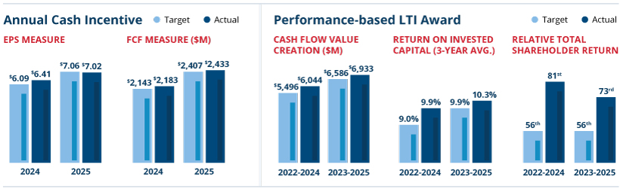
How We Pay
In 2025, we compensated each NEO using three key forms of compensation:

 | • |  | base salary;

 | • |  | annual cash incentive based on achieving target amounts of pre-established performance metrics; and

 | • |  | long-term incentive awards (PSUs and RSUs), with PSUs based on achieving target amounts of pre-established performance metrics.
The forms of compensation, their target weight, method of payment, applicable performance or vesting terms and purpose are summarized in the following chart:

Form of  Compensation |  |  |  | Target Weight |  |  |  | Award  Method |  | Performance  Period |  | Performance  Metrics |  | Vesting  Period |  | Purpose
 |  |  |  | CEO |  | NEO (Avg.)
Base Salary |  |  |  | 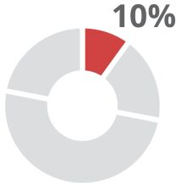 |  | 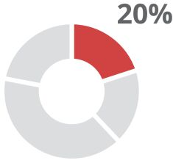 |  | Cash |  | N/A |  | N/A |  | N/A |  | Retention
Annual  Incentive |  |  |  | 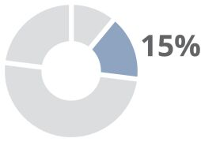 |  | 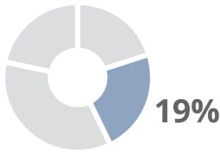 |  | Cash |  | 1 year |  | •  50% EPS  Measure  •  50% FCF  Measure  •  +/-10 percentage points Sustainability and Performance Modifier |  | N/A |  | Incentivize and recognize performance in areas of short-term strategic importance
Long-  Term |  | PSUs |  | 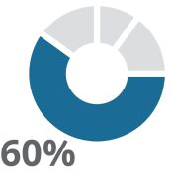 |  | 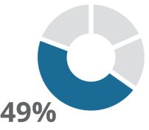 |  | •  50% cash  •  50%  common stock |  | 3 years |  | •  50% ROIC  •  50% Cash Flow Value Creation  •  Relative TSR Multiplier with a range of 90%-110% |  | 3 years |  | Incentivize and recognize performance in areas of long-term strategic importance
Long-  Term |  | RSUs |  | 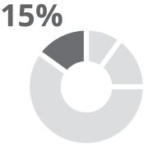 |  | 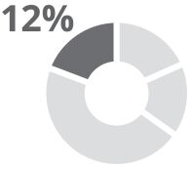 |  | Common stock |  | N/A |  | N/A |  | Vest ratably over 4 years |  | Retention and incentivize long-term performance
The annual and long-term incentives are variable and the amount realized is based on achieving specific performance objectives or on the performance of Republic’s stock.

 |  |  |  | Republic Services, Inc. 2026 Proxy Statement |  |  | | |  |  |  | 65

Table of Contents
PROXY SUMMARY |  |  |  | BOARD AND GOVERNANCE |  |  |  | EXECUTIVE COMPENSATION |  |  |  | PROPOSALS |  |  |  | MEETING INFORMATION |  |  |  | ANNEX

For 2025, the target total direct compensation (“Target TDC”), comprised of annualized base salary, annual incentive and LTI awards (consisting of PSUs and RSUs), exclusive of retirement contributions, for Republic’s current NEOs was as follows:

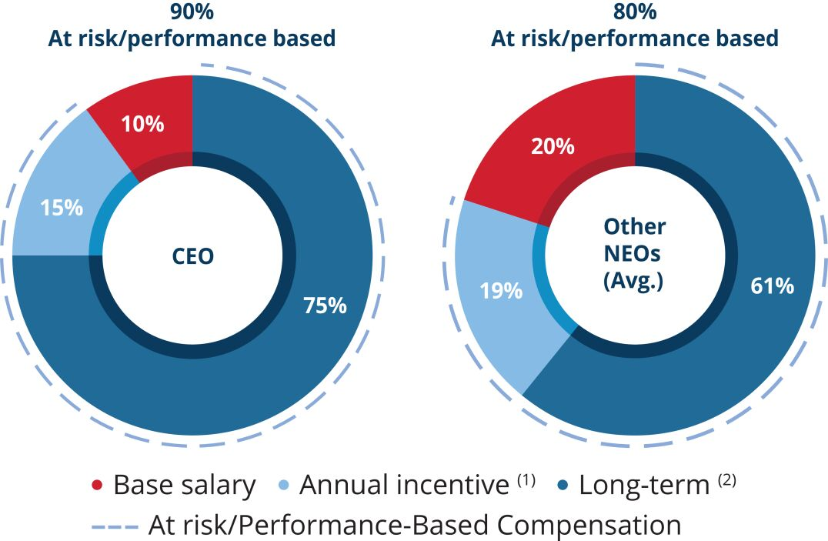 |  | (1) Variable annual incentive target award for 2025  (2) PSU target award for performance cycle beginning in 2025 and target value of RSU awards
Base Salary
We believe a competitive base salary attracts and retains high-caliber executive talent while providing a fixed level of compensation commensurate with the position’s responsibilities and level. The Talent & Compensation Committee annually reviews each NEO’s base salary to determine if any adjustment is warranted. This review consists of a comparison of the compensation paid to incumbents in comparable positions in our Peer Group, taking into account individual qualifications and responsibilities, internal salary levels, and individual and Company performance. Base salary levels may be adjusted when the Talent & Compensation Committee believes there is a competitive need to do so, in light of an individual’s promotion or taking into account an individual’s performance. In 2025, increases to base salaries for each of the NEOs were based on Peer Group benchmarking as well as individual performance. The table below shows the annual base salary for each NEO in 2024 and 2025, as approved by the Talent & Compensation Committee, which may be different from the amounts reflected in the Summary Compensation Table (“SCT”) in the “Salary” column.

NAME |  | 2025  BASE SALARY |  |  |  |  | 2024  BASE SALARY
Jon Vander Ark |  |  | $ | 1,350,000 |  |  |  | $ | 1,200,000
Brian M. DelGhiaccio |  |  | $ | 710,000 |  |  |  | $ | 681,200
Brian A. Bales |  |  | $ | 570,000 |  |  |  | $ | 545,900
Gregg K. Brummer |  |  | $ | 700,000 |  |  |  | $ | 660,000
Catharine D. Ellingsen |  |  | $ | 625,000 |  |  |  | $ | 615,000
Variable and Performance-Based Compensation Overview
The annual incentive and LTI awards link the majority of compensation to management’s performance against the financial metrics set by the Talent & Compensation Committee and the performance of Republic stock over the vesting periods of the equity-based awards. The performance metrics for the annual incentives and the PSUs and the range of opportunity relative to target payouts are consistent for all NEOs, including the CEO. These programs have both minimum performance thresholds below which no payments will be made and capped maximum payments.
Each year, management recommends that the Board approve financial performance targets that are challenging and, if achieved, can deliver superior value to shareholders. Consistent with the setting of ambitious performance targets, Republic looks to have its aggregate total Target TDC for its NEOs near or at the median of our Peer Group, taking into account experience, tenure and overall position responsibility. The Talent & Compensation Committee believes it is appropriate to reward the executive management team with compensation above the target opportunity with respect to performance-based awards if the rigorous financial targets associated with the variable pay programs are exceeded. Conversely, if those targets are not met, awards are paid at levels that result in variable compensation below target. Thus, our NEOs generally may be paid above the median of our Peer Group only if the targets are exceeded.

66 |  |  | | |  |  | Republic Services, Inc. 2026 Proxy Statement

Table of Contents
PROXY SUMMARY |  |  |  | BOARD AND GOVERNANCE |  |  |  | EXECUTIVE COMPENSATION |  |  |  | PROPOSALS |  |  |  | MEETING INFORMATION |  |  |  | ANNEX

Annual Cash Incentive
Republic maintains an annual incentive program for its NEOs and certain other members of management. This reflects our pay-for-performance philosophy by linking a significant portion of NEO compensation to Company performance. Actual annual incentive awards earned are a function of performance relative to Talent & Compensation Committee-approved financial targets. The Talent & Compensation Committee may apply (and in some years has applied) negative discretion to adjust actual performance downward if it believes that actual results reflect the benefit of matters that, although valuable to Republic, are not the type of benefit the annual incentive plan was designed to reward.
ANNUAL INCENTIVE CALCULATION
The annual incentive program rewards the NEOs based on performance relative to targets for the EPS Measure and the FCF Measure as well as a Sustainability and Performance Modifier. A visual of how the incentive program is calculated is below.

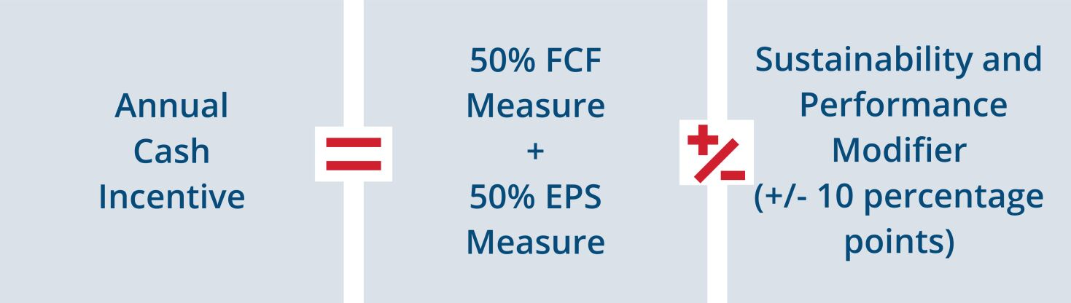
For 2025 compensation purposes, we defined the EPS Measure, which is not a measure determined in accordance with GAAP, as our reported EPS, adjusted to remove the impact of: (a) the loss on extinguishment of debt; (b) gains or losses (or related impairments) from divestitures, impairments of goodwill and other costs and impairments resulting from exiting a business; (c) gains or losses associated with withdrawal from or termination of one or more benefit plans; (d) restructuring charges; and (e) similar events or circumstances. We defined the FCF Measure, which is not a measure determined in accordance with GAAP, as cash provided by operating activities, less property and equipment received in 2025, plus proceeds from sales of property and equipment, adjusted to remove the impact of: (1) cash taxes arising from debt extinguishment; (2) tax payments related to divestitures, impairments of goodwill and other costs and impairments resulting from exiting a business; (3) cash paid or received associated with withdrawal from or termination of one or more benefit plans, net of tax; (4) restructuring payments, net of tax; and (5) similar events or circumstances. For a reconciliation of these non-GAAP measures to the comparable measures in accordance with GAAP, see “Reconciliation of GAAP to Non-GAAP Financial Measures” in the Annex on page 105.
The following tables illustrate our 2025 targets, threshold and maximum awards for the annual incentive. For performance at and below target, the two measures are equally weighted and a participant may earn a percentage of the target award for each measure based on performance for that measure. If the EPS Measure target is exceeded, and the FCF Measure at least meets target, the annual incentive award earned may be increased above target (up to a maximum of 200% of the target amount), based on the extent to which the EPS Measure target is exceeded. No additional amount above target will be earned based on exceeding the FCF Measure target.
2025 PERCENT OF ANNUAL INCENTIVE AWARD EARNED IF EITHER MEASURE IS LESS THAN TARGET

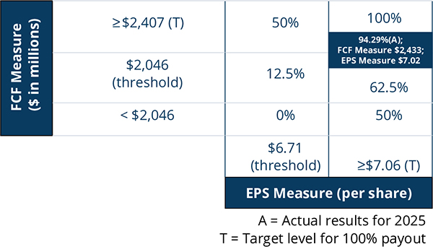

 |  |  |  | Republic Services, Inc. 2026 Proxy Statement |  |  | | |  |  |  | 67

Table of Contents
PROXY SUMMARY |  |  |  | BOARD AND GOVERNANCE |  |  |  | EXECUTIVE COMPENSATION |  |  |  | PROPOSALS |  |  |  | MEETING INFORMATION |  |  |  | ANNEX

2025 PERCENT OF ANNUAL INCENTIVE AWARD EARNED IF BOTH MEASURES ARE ABOVE OR AT TARGET

FCF Measure  ($ in millions) |  | ≥ $2,407 (T) |  | 100% |  | 200%
 |  |  |  | ≥ $7.06 (T) |  | ≥$7.77  (max)
 |  |  |  | EPS Measure (per share)
 |  | T = Target level for 100% payout
 |  | Actual results for EPS Measure below Target and therefore the table above did not determine the payout.
For 2025, the actual EPS Measure performance was $7.02 per share against a target of $7.06 per share. The actual FCF Measure performance for 2025 was $2,433 million against a target of $2,407 million. The below-target performance on the EPS Measure and the above-target performance on the FCF measure resulted in a potential annual incentive payment of 94.29% of target, prior to giving effect to the Sustainability and Performance Modifier.
SUSTAINABILITY AND PERFORMANCE MODIFIER
How It Works:
To ensure our annual short-term incentive compensation aligns with our Company values on sustainability and employee development and safety, we utilize a Sustainability and Performance Modifier as a component of our annual incentive program. The Sustainability and Performance Modifier has four pillars that are directly aligned with our 2030 Sustainability Goals – safety, talent, climate leadership and customer zeal. To the extent these goals are achieved by senior executives, including our NEOs, it can result in an adjustment of up to ten percentage points, either upward or downward.
Each year, the Talent & Compensation Committee evaluates performance under each pillar and assigns a rating to the components within each pillar – with 1 representing “significant underperformance” and 5 representing “significant outperformance.” This rating is determined for each component by an assessment of qualitative factors and progress against a specific quantitative goal. Assessing both quantitative and qualitative factors for each component is important because it allows the Talent & Compensation Committee to consider progress holistically, accounting for all of the Company’s efforts within a given pillar that may not be captured by a single metric. This approach allows the Talent & Compensation Committee to balance the importance of Republic making progress toward its 2030 Sustainability Goals alongside Company initiatives and practices that contribute to broader progress under each pillar.
Once a rating is determined for each component, the Talent & Compensation Committee analyzes all of the ratings and aggregates them to determine the Sustainability and Performance Modifier percentage that senior executives’, including NEOs’, annual bonus should be adjusted up or down. The aggregation of the pillar ratings into one modifier percentage is not a formulaic approach. Rather, the ratings for each pillar serve as a guide for the Talent & Compensation Committee to determine in its discretion overall performance – where lower ratings generally decrease the modifier percentage and higher ratings generally increase the modifier percentage.

68 |  |  | | |  |  | Republic Services, Inc. 2026 Proxy Statement

Table of Contents
PROXY SUMMARY |  |  |  | BOARD AND GOVERNANCE |  |  |  | EXECUTIVE COMPENSATION |  |  |  | PROPOSALS |  |  |  | MEETING INFORMATION |  |  |  | ANNEX

How It Was Applied for 2025 Annual Incentive:
Overall, the Talent & Compensation Committee in its discretion determined that the Sustainability and Performance Modifier should reduce the annual incentive by 2.5 percentage points based on the Company’s performance on the key metrics for 2025. The factors that led to each of these ratings for each pillar are disclosed in the table below.

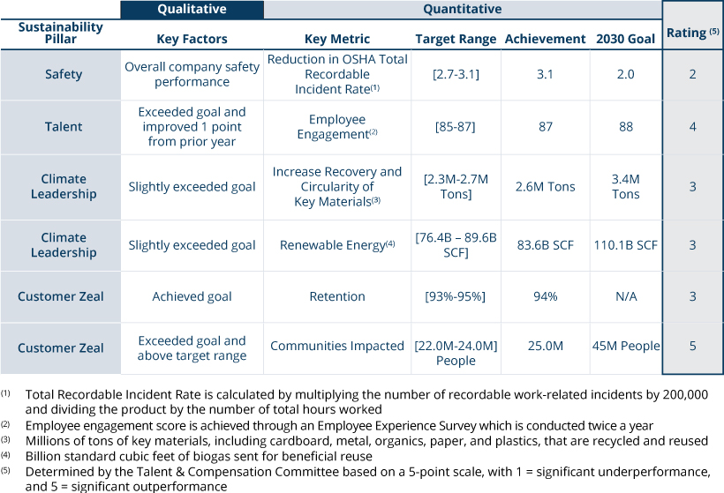
2025 ANNUAL INCENTIVE OPPORTUNITY AS A PERCENTAGE OF SALARY AND ACTUAL PAYOUT AS A PERCENTAGE OF SALARY AND IN DOLLARS
The following table shows the NEOs’ 2025 annual incentive opportunity as a percentage of salary at various performance levels and the actual payout as a percentage of salary and in dollars. The payout amount is also reflected in the Summary Compensation Table under the column titled “Non-Equity Incentive Plan Compensation.” Further, the annual cash incentive payouts that would have been earned if the minimum, target and maximum performance level were achieved are reflected in the “Grants of Plan-Based Awards in 2025” table on page 82 under the column titled “Estimated Future Payouts under Non-Equity Incentive Plan Awards” and associated footnotes.

NAME |  | Below  Threshold  Performance  Level |  |  |  |  | At Threshold  Performance  Level |  |  |  |  | At Target  Performance  Level |  |  |  |  | At Maximum  Performance  Level |  |  |  |  | Actual Annual  Incentive  Payout  as a Percentage  of Salary (1) |  |  |  |  | Actual Annual  Incentive Payout  in $
Jon Vander Ark |  |  |  | 0% |  |  |  |  | 20.00% |  |  |  |  | 160% |  |  |  |  | 320% |  |  |  |  | 91.79% |  |  |  |  | $1,982,664
Brian M. DelGhiaccio |  |  |  | 0% |  |  |  |  | 13.13% |  |  |  |  | 105% |  |  |  |  | 210% |  |  |  |  | 91.79% |  |  |  |  | $ 684,294
Brian A. Bales |  |  |  | 0% |  |  |  |  | 10.63% |  |  |  |  | 85% |  |  |  |  | 170% |  |  |  |  | 91.79% |  |  |  |  | $ 444,723
Gregg K. Brummer |  |  |  | 0% |  |  |  |  | 12.50% |  |  |  |  | 100% |  |  |  |  | 200% |  |  |  |  | 91.79% |  |  |  |  | $ 642,530
Catharine D. Ellingsen |  |  |  | 0% |  |  |  |  | 10.63% |  |  |  |  | 85% |  |  |  |  | 170% |  |  |  |  | 91.79% |  |  |  |  | $ 487,634

(1) | The percentage is calculated utilizing base salary as of the end of the fiscal year.
For 2026, the annual incentive plan design remains very similar to prior years with the measures again consisting of the EPS Measure, the FCF Measure and a Sustainability and Performance Modifier.

 |  |  |  | Republic Services, Inc. 2026 Proxy Statement |  |  | | |  |  |  | 69

Table of Contents
PROXY SUMMARY |  |  |  | BOARD AND GOVERNANCE |  |  |  | EXECUTIVE COMPENSATION |  |  |  | PROPOSALS |  |  |  | MEETING INFORMATION |  |  |  | ANNEX

HISTORICAL TARGETS AND OUTCOMES OF ANNUAL INCENTIVE PLAN
Please refer to the Annex on page 106 for details regarding the calculation of our actual results for 2023, 2024 and 2025 for the EPS Measure and the FCF Measure. The following table shows targets and actual outcomes for the annual incentive in the 2023 through 2025 NEO compensation program.

 |  | 2023 |  |  |  | 2024 |  |  |  | 2025
EPS MEASURE TARGET |  | $ | 5.27 |  |  | $ | 6.09 |  |  | $ | 7.06
EPS MEASURE ACTUAL |  | $ | 5.61 |  |  | $ | 6.41 |  |  | $ | 7.02
FCF MEASURE TARGET |  | $ | 1,915 |  |  | $ | 2,143 |  |  | $ | 2,407
FCF MEASURE ACTUAL |  | $ | 1,985 |  |  | $ | 2,183 |  |  | $ | 2,433
FINANCIAL INCENTIVE PAYOUT |  |  | 164.15% |  |  |  | 152.46% |  |  |  | 94.29%
SUSTAINABILITY AND PERFORMANCE MODIFIER |  |  | -3% |  |  |  | 0% |  |  |  | -2.5%
TOTAL ANNUAL INCENTIVE PAYOUT |  |  | 161.15% |  |  |  | 152.46% |  |  |  | 91.79%
Long-Term Incentive Awards
The Talent & Compensation Committee strongly believes in using LTI compensation to reinforce key objectives that drive financial progress and sustained shareholder value creation:
 | • |  | focus on the importance of shareholder returns;
 | • |  | promote the achievement of long-term performance goals;
 | • |  | encourage executive retention; and
 | • |  | promote meaningful levels of Republic stock ownership by executives.
To determine the overall opportunity and appropriate mix of LTI awards, the Talent & Compensation Committee considers a variety of factors, including competitive market positioning against comparable executives in the Peer Group, Peer Group LTI award practices, potential economic value realized, timing of vesting, and taxation. Our compensation program is highly performance-based, and the mix of LTI awards that are granted aligns with our target pay mix philosophy that indicates 50% or more of long-term incentive awards should be performance based. Taking this into consideration, the Talent & Compensation Committee awarded 80% of our NEO’s total equity in the form of PSUs and 20% in the form of RSUs.
ELEMENTS OF LONG-TERM INCENTIVE AWARDS

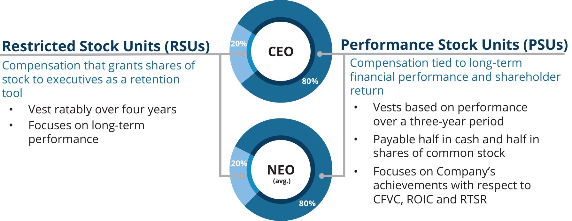

NEW THIS YEAR
REVISED METRICS FOR LTI Mix |  | We updated our overall long-term incentive mix to have a higher percentage of PSU (relative to RSU) and we standardized this weighting across all executives. With this update, the LTI mix is comprised of 80% PSUs and 20% RSUs for all NEOs. This change places more compensation at risk, subject to achievement of long-term performance targets and aligns executives with shareholder interests.
RESTRICTED STOCK UNITS
In February 2025, the Talent & Compensation Committee approved equity awards to our NEOs in the form of RSUs that vest ratably over four years. The full grant date fair value of RSUs granted to each NEO during 2025 is shown in the Summary Compensation Table on page 80. Additional information, including the number of shares subject to each award, is shown in the “Grants of Plan-Based Awards in 2025” table on page 82.

70 |  |  | | |  |  | Republic Services, Inc. 2026 Proxy Statement

Table of Contents
PROXY SUMMARY |  |  |  | BOARD AND GOVERNANCE |  |  |  | EXECUTIVE COMPENSATION |  |  |  | PROPOSALS |  |  |  | MEETING INFORMATION |  |  |  | ANNEX

Generally, our executives and other employees who receive grants of RSUs receive dividend equivalents for any dividends we declare on our common stock following the date on which they are granted RSUs. The dividend equivalents are in the form of additional RSUs with a value equal to the value of dividends they would have received on the shares of the common stock underlying the RSUs they hold on the dividend record date. Dividend equivalents on unvested RSUs granted to the NEOs will vest at the same time as the underlying RSUs. Accordingly, no dividends or dividend equivalents were paid on any unvested RSUs grants to the NEOs.

NEW THIS YEAR
CHANGES TO PSU WEIGHTING AND CALCULATION |  | Periodically, the Talent & Compensation Committee reviews performance metrics for equity awards and will make changes when necessary to better align our long-term goals with sustained shareholder value. For the 2025–2027 performance period, the Committee chose to update the weighting of the PSU metrics. Both ROIC and CFVC are weighted at 50%. If CFVC is above target, outperformance will be based on the CFVC metric only provided that the ROIC metric is met. This structure balances the importance of meeting ROIC expectations while recognizing improving ROIC in perpetuity can be difficult and may result in misaligned management incentives. The RTSR multiplier can impact the PSU payout, positively or negatively, with a range of 90% to 110%. As our business continues to evolve, the Committee will regularly revisit these metrics to ensure alignment with the organization’s broader business goals.
PERFORMANCE SHARE UNITS
PSUs are performance-based because the number of shares of common stock ultimately earned depends on performance against predetermined goals over a three-year period and the value of the PSUs fluctuates based on our stock price. For the 2025-2027 performance period, the opportunity to earn PSUs is based on three key financial metrics — CFVC, ROIC and an RTSR Modifier.
If ROIC target is not met:

FISCAL 2025-2027 PSU METRICS |  | WEIGHTING
Cash Flow Value Creation (CFVC) |  | 50%
Return on Invested Capital (ROIC) |  | 50%
Relative Total Shareholder Return Modifier |  | Range of 90% to 110%
If ROIC target is met:

FISCAL 2025-2027 PSU METRICS |  | WEIGHTING
Cash Flow Value Creation (CFVC) |  | 100%
Relative Total Shareholder Return Modifier |  | Range of 90% to 110%
The Talent & Compensation Committee established the performance and payout targets for the 2025-2027 performance period in February 2025. We believe that the CFVC and ROIC targets for these performance periods are rigorous and appropriately reflect the Talent & Compensation Committee’s consideration of the business, operational and regulatory environment as it existed when the targets were set. Additionally, we believe the RTSR target established by the Talent & Compensation Committee ensures that management is not rewarded or penalized for broader market conditions. Each of the components align all NEOs to performance against the financial metrics and to increasing shareholder value. Additional information, including the threshold, target, and maximum awards payable to each of the NEOs for the 2025-2027 performance period, is shown in the “Grants of Plan-Based Awards in 2025” table on page 82.
Dividends on PSUs are accrued but not earned and granted to the executives until the shares of common stock underlying the PSUs are earned, if at all, based on the achievement of the performance metrics as determined following the end of the three-year performance period. Accordingly, no dividends or dividend equivalents were paid on any unvested PSUs granted to the NEOs.

 |  |  |  | Republic Services, Inc. 2026 Proxy Statement |  |  | | |  |  |  | 71

Table of Contents
PROXY SUMMARY |  |  |  | BOARD AND GOVERNANCE |  |  |  | EXECUTIVE COMPENSATION |  |  |  | PROPOSALS |  |  |  | MEETING INFORMATION |  |  |  | ANNEX

The award value for RSUs and PSUs granted to each NEO in 2025, as approved by the Talent & Compensation Committee, are shown below.

EXECUTIVE NAME |  | RSU AWARDS(1)  VALUE |  |  |  |  | PSU AWARDS(2)  VALUE
Jon Vander Ark |  |  | $ | 2,160,000 |  |  |  | $ | 8,640,000
Brian M. DelGhiaccio |  |  | $ | 510,000 |  |  |  | $ | 2,040,000
Brian A. Bales |  |  | $ | 280,000 |  |  |  | $ | 1,120,000
Gregg K. Brummer |  |  | $ | 420,000 |  |  |  | $ | 1,680,000
Catharine D. Ellingsen |  |  | $ | 380,000 |  |  |  | $ | 1,520,000

(1) | The value of RSUs will differ from the grant date fair value of RSUs shown in the Summary Compensation Table, as we did not grant fractional shares in 2025.
(2) | The value of PSUs will differ from the grant date fair value of PSUs shown in the Summary Compensation Table. A portion of the grant date fair value of PSUs shown in the Summary Compensation Table reflects total shareholder return relative to the S&P 500, and is based on a Monte Carlo valuation model.
The following chart shows the performance targets and the potential payouts for PSUs granted in 2023 with a performance period of 2023–2025, for performance above and below target. It also shows the actual performance of CFVC and ROIC during the performance period of $6,933 million and 10.3%, respectively. Because our actual CFVC and ROIC were above the target, the resulting payout based on CFVC and ROIC was 115.45% of the target payout amount. We will disclose the performance targets, potential payouts, and actual results for the 2024–2026 and 2025–2027 performance periods once the applicable performance period has concluded.
2023-2025 CFVC/ROIC EARNED PERCENTAGE

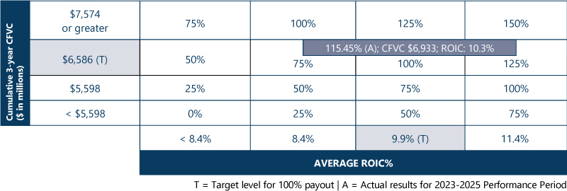

Twenty percent of the PSU payout is based on the RTSR performance to target. In 2023, the Talent & Compensation Committee set the RTSR performance target for the 2023-2025 performance period at the 56th percentile. |  | 2023-2025 RTSR EARNED PERCENTAGE
 |  | RTSR ATTAINED DURING  THE PERFORMANCE PERIOD |  | RTSR EARNING  PERCENTAGE
The chart to the right shows the performance target and the potential payouts for performance above and below target. It also shows the actual performance of RTSR during the performance period at the 73.2nd percentile, which together with the Company’s performance for CFVC and ROIC, resulted in a payout at 119.51% of target. |  | Less than 20th Percentile |  | 0%
 |  | 20th Percentile |  | 25%
 |  | 40th Percentile |  | 67%
 |  | 56th Percentile (T) |  | 100%
 |  | 60th Percentile |  | 108%
 |  | 73.2nd Percentile (A) |  | 136%
 |  | 80th Percentile or higher |  | 150%
T = Target level for 100% payout

A = Actual results for 2023-2025
Performance Period
Taking into consideration the combined performance of CFVC, ROIC and RTSR for the 2023-2025 performance period, the combined PSU payout was 119.51% of target. The actual payout amounts are reflected in the “PSUs and RSUs Vested in 2025” table on page 85.

72 |  |  | | |  |  | Republic Services, Inc. 2026 Proxy Statement

Table of Contents
PROXY SUMMARY |  |  |  | BOARD AND GOVERNANCE |  |  |  | EXECUTIVE COMPENSATION |  |  |  | PROPOSALS |  |  |  | MEETING INFORMATION |  |  |  | ANNEX

Other Benefits
Republic makes available medical, dental and vision insurance, life insurance and short- and long-term disability insurance programs for our employees. The NEOs are eligible to participate in these programs on the same basis and with the same level of financial subsidy as our general employee population (other than those employees who are subject to different terms under a collective bargaining agreement). Like our other employees, our NEOs may participate in our 401(k) plan and may defer a portion of their base salary and annual incentive compensation, to the maximum defined level specified by the IRS, which in 2025 was $23,500 plus an additional $7,500 for those age 50 and above. Republic matches 100% of the first three percent of pay contributed and 50% of the next two percent of pay contributed by an employee. Republic’s matching contributions into the 401(k) plan for the NEOs who participated are reported in the “All Other Compensation for 2025” table on page 81.
DEFERRED COMPENSATION PLAN AND DEFERRED COMPENSATION SAVINGS PROGRAM CONTRIBUTIONS
Eligible employees are limited by federal law as to the amount they may contribute to their 401(k) accounts. Accordingly, we have established a Deferred Compensation Plan (“DCP”) that permits certain participants, including the NEOs, to defer additional amounts of compensation, including RSUs and PSUs, in a tax-efficient manner for retirement savings. Under the DCP, most participants are eligible for matching contributions. The matching contribution under the DCP is equal to the lesser of two percent of the participant’s eligible compensation over the established 401(k) limit ($350,000 in 2025) or 50% of the participant’s annual deferrals, excluding deferred RSUs and stock-settled PSUs.
In addition, we make discretionary retirement contributions to certain of our senior executives’ accounts in the Deferred Compensation Plan (“DCSP Contributions”). The Talent & Compensation Committee reviews the DCSP Contributions annually and may change the amounts or discontinue the contributions at any time. Each DCSP Contribution is a fixed dollar amount that depends on the participant’s position in the organization, among other considerations. Unless otherwise specified, DCSP Contributions vest in one of four ways: (1) upon a participant satisfying the age and service requirements necessary to qualify for retirement; (2) in the event of death or disability, the retirement contributions vest immediately; (3) if a participant’s employment is terminated “without cause,” the retirement contributions vest immediately but are not available to the participant until the earlier of the fifth anniversary of the termination date or the date the participant would have become eligible for retirement; or (4) if we complete a transaction that is deemed a change in control, all retirement contributions vest immediately and may be paid out depending upon the original election of the participant. Mr. Vander Ark received contributions of $100,000 in 2025, 2024 and 2023. Ms. Ellingsen and Messrs. Bales and DelGhiaccio each received a contribution of $65,000 in 2025, 2024 and 2023. Mr. Brummer received a contribution of $65,000 in 2025 and 2024 and $55,000 in 2023.
The individual contributions of the participating NEOs, including earnings on those contributions and total account balances as of the end of 2025, are shown in the “Nonqualified Deferred Compensation in 2025” table on page 86. Republic’s matching contributions and the DCSP Contributions are shown in the “All Other Compensation for 2025” table on page 81.
MODEST PERQUISITES
With the exception of (1) certain gross-up payments pursuant to our relocation policy that are applicable to all eligible employees, (2) membership-based primary care medical services available to vice presidents, senior vice presidents, and executive vice presidents in our corporate office for a nominal charge paid by the Company, and (3) a medical physical exam benefit offered to our executive officers, including our NEOs, Republic generally does not offer perquisites or other personal benefits other than the aircraft usage discussed below. All associated relocation expenses, if any, are reported in the “All Other Compensation for 2025” table on page 81. We also do not provide any additional cash compensation to any of the NEOs to reimburse them for income tax liability as a result of the receipt of any cash or equity compensation, benefit or perquisite. Our CEO may use our airplane for non-business travel. Other NEOs may use our airplane for non-business travel if the CEO is on board and approves the travel. On a quarterly basis, the Audit Committee reviews all use of our airplane by our CEO, and other NEOs as applicable, for reasonableness. The amount reflected in the “All Other Compensation for 2025” table as “Perquisites and Other Personal Benefits” includes the incremental cost of providing aircraft to an NEO for non-business travel.

 |  |  |  | Republic Services, Inc. 2026 Proxy Statement |  |  | | |  |  |  | 73

Table of Contents
PROXY SUMMARY |  |  |  | BOARD AND GOVERNANCE |  |  |  | EXECUTIVE COMPENSATION |  |  |  | PROPOSALS |  |  |  | MEETING INFORMATION |  |  |  | ANNEX

Other Compensation Policies

STOCK OWNERSHIP GUIDELINES
The Board recognizes the importance of equity ownership by our executives to further link their interests with shareholders’ interests. Accordingly, the Board maintains stock ownership guidelines for all senior management employees (defined as President and CEO, Chief Operating Officer, Chief Financial Officer, and Chief Legal Officer, and any Executive Vice President, Senior Vice President, Vice President, Area President, Area Vice President and Market Vice President). The guidelines require that senior management employees achieve compliance with the ownership guidelines within five years of becoming a covered employee and maintain their ownership level thereafter. Shares included in the calculation to assess compliance with the ownership guidelines include shares owned outright and through certain trusts, shares held in the 401(k) plan, and vested stock equivalents held in the DCP.

NAME |  | MULTIPLE OF  SALARY REQUIRED |  |  |  |  | IN COMPLIANCE  OR ON TRACK
Jon Vander Ark |  |  |  | 8x |  |  |  |  | Yes
Brian M. DelGhiaccio |  |  |  | 5x |  |  |  |  | Yes
Brian A. Bales |  |  |  | 5x |  |  |  |  | Yes
Gregg K. Brummer |  |  |  | 5x |  |  |  |  | Yes
Catharine D. Ellingsen |  |  |  | 5x |  |  |  |  | Yes
INSIDER TRADING POLICIES
Executive management and the Board take seriously their responsibilities and obligations to exhibit the highest standards of behavior relative to buying and selling Republic stock. We have adopted an Insider Trading Policy and Procedures (together, our “Insider Trading Policy”) that govern the purchase, sale, and
other
transactions of Republic securities, and applies to all Republic employees, officers, consultants, contractors, and our Board of Directors (collectively, “Company Representatives”), and which we believe are reasonably designed to promote compliance with insider trading laws, rules and regulations and any applicable listing standards. Our Insider Trading Policy prohibits Company Representatives from:

 | • |  | trading in Company securities while in possession of “Material Nonpublic Information”, as such term is defined in the Insider Trading Policy;
 | • |  | trading in the securities of any other company if they are in possession of Material Nonpublic Information about that company that they obtained in the course of their employment with or service to Republic; and
 | • |  | engaging in the following transactions relating to Republic securities or derivatives thereof: purchasing or selling puts or calls, short sales, placing standing orders (other than under approved  10b5-1  plans), engaging in short-term or  “in-and-out”  trading, and holding Republic securities or derivatives thereof in a margin account or pledging them.
Additionally, our Insider Trading Policy implements additional controls and restrictions on the following subsets of Company Representatives:

 | • |  | “Blackout Personnel” (as defined in the Insider Trading Policy to include Company Insiders, defined below, and certain key Company Representatives) are restricted from engaging in transactions involving Republic securities during quarterly blackout periods, which begin on March 15, June 15, September 15, and December 15 each year and continue through the beginning of the second day following the Company’s quarterly earnings announcement. The Company may also impose special event-specific blackout periods during which certain designated Blackout Personnel are restricted from trading in Company securities.
 | • |  | “Insiders” (as defined in the Insider Trading Policy to include the Company’s Board of Directors and officers as defined pursuant to Section 16 of the Exchange Act) must obtain  pre-clearance  from our Chief Legal Officer before transacting in Company securities.
In addition to our Insider Trading Policy, we have also adopted a Share Repurchase Policy to ensure the Company complies with all applicable securities laws when transacting in its own securities. Our Share Repurchase Policy permits the Company to repurchase shares of Company common stock as part of a publicly announced share repurchase program authorized by our Board, including the use of plans designated to comply with Rules
10b5-1
and
10b-18
of the Exchange Act. A copy of our Insider Trading Policy, Insider Trading Procedures, and our Share Repurchase Policy can be found as Exhibits 19.1, 19.2 and 19.3, respectively, to our Annual Report on Form
10-K
for the fiscal year ended December 31, 2025.
COMPENSATION RECOUPMENT (CLAWBACK) POLICY
Our Board established a Clawback Policy to encourage sound
financial
reporting and increase individual accountability and updated it in 2022 and 2023 to expand the triggering events to include additional Covered Events, as defined below, and conform to SEC rules and NYSE listing standard changes. As more fully described in our revised Clawback Policy, which is available on our website on the Investors page under Corporate Governance and filed as an exhibit to our Form
10-K:

 | • |  | the policy applies to Republic’s officers as defined by Rule  16(a)-1(f)  under the Exchange Act and other members of the Company’s senior leadership team (“Covered Officers”);

74 |  |  | | |  |  | Republic Services, Inc. 2026 Proxy Statement

Table of Contents
PROXY SUMMARY |  |  |  | BOARD AND GOVERNANCE |  |  |  | EXECUTIVE COMPENSATION |  |  |  | PROPOSALS |  |  |  | MEETING INFORMATION |  |  |  | ANNEX

 | • |  | the policy applies to all short- and long-term incentives and bonuses, stock options, PSUs, RSUs and other stock and stock-based awards (“Incentive Compensation”);
 | • |  | the policy is triggered by an accounting restatement we must make due to material noncompliance with any financial reporting requirement under the securities laws, including any required accounting restatement to correct an error in previously issued financial statements that is material to the previously issued financial statements or that would result in a material misstatement if the error were corrected in the current period or left uncorrected in the current period (a “Restatement”) or another defined “Covered Event”, which includes conviction of certain crimes, a material violation of Company policies, rules, or guidelines, a breach of fiduciary duty or violation of a restrictive covenant and other conduct by a Covered Officer that exposes Republic to serious actual or potential injury;
 | • |  | if a Restatement occurs, the Talent & Compensation Committee generally must seek to claw back vested and unvested Incentive Compensation, including gains on equity, during the  3-year  period preceding the Restatement date to the extent such Incentive Compensation exceeds what would have been paid to the Covered Officer under the restated financial statements; and
 | • |  | If a Covered Event occurs, the Talent & Compensation Committee may review all Incentive Compensation, and seek to require the forfeiture or repayment of the award, vesting or amount of Incentive Compensation, in whole or in part, vested or unvested and including gains on equity,  during  the  3-year  period preceding the Covered Event.
POLICIES AND PRACTICES RELATED TO THE GRANT OF CERTAIN EQUITY AWARDS CLOSE IN TIME TO THE RELEASE OF INFORMATION
Our annual long-term equity awards are approved at a meeting of the Talent & Compensation Committee held in early February of each year and are granted following the release of our Form
10-K
for the prior year, typically several business days later and aligned with the end of the blackout period under our Insider Trading Policy. The dates for these grants are typically predetermined a year or more in advance on a fairly consistent cadence year-over-year. For
mid-year
new hires and promotions, we grant equity awards after the release of the applicable quarterly report on Form
10-Q,
typically several business days later and aligned with the end of the blackout period under our Insider Trading Policy.
For our nonemployee directors, annual RSU awards are granted on first business day after January 1 of each year. The prorated annual grant of RSUs to a newly appointed
non-employee
director is made on the date of such
non-employee
director’s appointment.
In all cases, the timing of grants of equity awards occurs independent of the release of any material nonpublic information, and we do not backdate grants of awards and do not have any program, plan, or practice to select equity award grant dates for executive officers in coordination with the release of material nonpublic information for the purpose of affecting the value of executive compensation.
We have not granted stock options to our executive officers since 2014 and accordingly, in 2025, no stock options were granted to
any
NEO within four business days prior to or one business day following the filing of a Form
10-Q,
10-K,
or
8-K
that disclosed material nonpublic information.

 |  |  |  | Republic Services, Inc. 2026 Proxy Statement |  |  | | |  |  |  | 75
PROXY SUMMARY |  |  |  | BOARD AND GOVERNANCE |  |  |  | EXECUTIVE COMPENSATION |  |  |  | PROPOSALS |  |  |  | MEETING INFORMATION |  |  |  | ANNEX

Table of Contents
PROXY SUMMARY |  |  |  | BOARD AND GOVERNANCE |  |  |  | EXECUTIVE COMPENSATION |  |  |  | PROPOSALS |  |  |  | MEETING INFORMATION |  |  |  | ANNEX

Compensation Process

NEW THIS YEAR
UPDATED COMPOSITION OF OUR COMPARATOR GROUP |  | In 2025, we updated the composition of our Comparator Group to include companies of a similar size to Republic and with a sustainability-focused business strategy. This resulted in a recommendation of a 17-company peer group, with the addition of four new companies and the removal of four that are no longer adequate comparators to Republic due to business model and size.
COMPARATOR GROUP
The Talent & Compensation Committee, in consultation with its independent compensation consultant, annually reviews the composition of the Peer Group used as a reference for executive compensation decisions. As shown below, the Talent & Compensation Committee updated the Group’s composition this year to include companies of a similar size to Republic and with a sustainability-focused business strategy.

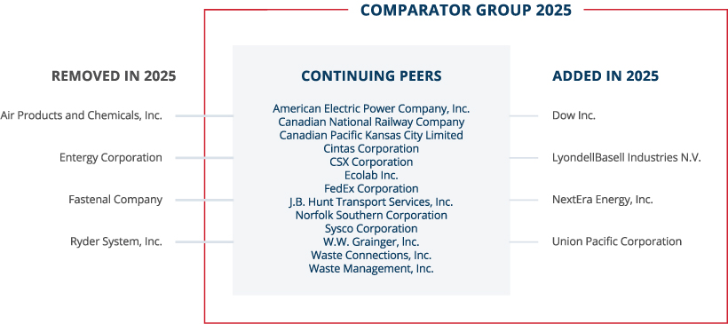

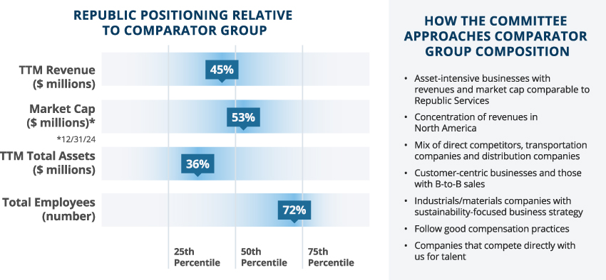

76 |  |  | | |  |  | Republic Services, Inc. 2026 Proxy Statement

Table of Contents
PROXY SUMMARY |  |  |  | BOARD AND GOVERNANCE |  |  |  | EXECUTIVE COMPENSATION |  |  |  | PROPOSALS |  |  |  | MEETING INFORMATION |  |  |  | ANNEX

The Talent & Compensation Committee considers data and analyses prepared by its independent compensation consultant based on our current and prior performance, and the historical NEO pay and the appropriateness of that compensation compared to the NEO compensation in the Peer Group. The Talent & Compensation Committee also considers general compensation surveys compiled by external consulting firms and takes into account recommendations of our CEO for executives other than himself. The Talent & Compensation Committee uses the Peer Group and other surveys as a reference but does not target a specified percentile of compensation to be paid. After taking into account all data, and factors such as Company performance and an individual’s contribution, experience and potential, the Talent & Compensation Committee makes compensation decisions. For 2025, increases in NEO compensation as compared to 2024 primarily reflect the performance of the NEOs and were intended to achieve better alignment to median. Based on the independent consultant’s analysis, our CEO’s 2025 Target TDC was positioned near the 50th percentile of the Peer Group.
EVALUATING COMPANY AND EXECUTIVE PERFORMANCE
The Talent & Compensation Committee, after consulting with the Board and management, has established a process for evaluating Republic’s performance, as well as the performance of each of our executive officers. Each year, the Talent & Compensation Committee approves strategic, financial and sustainability objectives for the executive officers for the upcoming year and for the long term. It also reviews and evaluates the performance against these strategic and financial objectives for the prior year and reviews the interim progress on all open three-year performance periods under the PSUs. Our CEO provides his assessment of the performance against the strategic objectives and on the individual contributions of the executive officers. The Talent & Compensation Committee considers all of these factors in reaching its compensation decisions. The Talent & Compensation Committee routinely meets in executive session without the presence of any management when considering compensation matters.

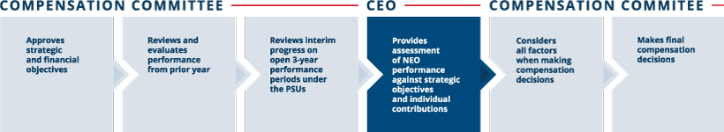
ROLE OF THE INDEPENDENT COMPENSATION CONSULTANT AND OTHER ADVISORS
Since 2003, the Talent & Compensation Committee has retained Pearl Meyer & Partners, LLC (“Pearl Meyer”) to assist with its review of compensation for the NEOs and other related matters. The Talent & Compensation Committee retains Pearl Meyer directly, supervises all work done by Pearl Meyer, and reviews and approves all work invoices. While Pearl Meyer provides data and analyses and makes recommendations on the form and amount of compensation, the Talent & Compensation Committee makes all decisions regarding the compensation of our executive officers, including our NEOs.
During 2025, Pearl Meyer advised the Talent & Compensation Committee on a variety of subjects, including compensation plan design and trends, pay-for-performance analytics, Peer Group benchmarking and other related matters. Pearl Meyer reports directly to the Talent & Compensation Committee, participates in meetings as requested and communicates with the Talent & Compensation Committee chair between meetings, as necessary. Pearl Meyer also provides advice to the Governance Committee and its chair regarding director compensation. Pearl Meyer did not provide any other services during 2025 and is considered independent and free from conflict under the Dodd-Frank Wall Street Reform and Consumer Protection Act and associated standards set forth by the SEC and NYSE.
The Talent & Compensation Committee also may use market data provided by Aon Radford, Mercer and Willis Tower Watson for benchmarking and other purposes. This benchmarking data consists of information that is generally available to other Aon Radford, Mercer, and Willis Tower Watson clients. None of these consulting firms made recommendations to the Talent & Compensation Committee or management on peer group composition or on the form, amount or design of executive or director compensation in 2025.

 |  |  |  | Republic Services, Inc. 2026 Proxy Statement |  |  | | |  |  |  | 77

Table of Contents
PROXY SUMMARY |  |  |  | BOARD AND GOVERNANCE |  |  |  | EXECUTIVE COMPENSATION |  |  |  | PROPOSALS |  |  |  | MEETING INFORMATION |  |  |  | ANNEX

Other Considerations
EMPLOYMENT AGREEMENTS AND EXECUTIVE SEPARATION POLICY
Republic generally does not enter into employment agreements. Our NEOs do not have employment agreements but instead are eligible to participate in the Executive Separation Policy. They also have non-competition and non-solicitation agreements with Republic. For more information regarding the employment agreements and Executive Separation Policy, see “Executive Compensation — Employment Agreements and Post-Employment Compensation.”
ANNUAL RISK ASSESSMENT
Management conducted a risk assessment of Republic’s policies and programs relating to the compensation of employees, including those that apply to our executive officers. In particular, management considered the following factors of our compensation policies, practices and programs: the Talent & Compensation Committee’s robust governance controls; our balanced mix of long-term and short-term programs; our use of objective standards that are applied consistently from year to year; peer group benchmarking for stock performance; caps on PSU awards and annual incentives to limit windfalls; and clawback provisions designed to recoup compensation in circumstances set forth in the Company’s clawback policy.
Management discussed the findings of the risk assessment with the Talent & Compensation Committee. Based on the assessment, we believe that our compensation policies and practices create an appropriate balance between our base salary compensation, short-term incentive compensation and long-term incentive compensation, thereby reducing the possibility of imprudent risk-taking and that our compensation policies and practices do not create risks that are reasonably likely to have a material adverse effect on Republic.
EQUITY USAGE (BURN RATE AND DILUTION)
Under our 2021 Stock Incentive Plan, as approved by our shareholders in May 2020 (the “SIP”), the total number of shares of equity-based awards granted in 2025 was approximately 0.07% of the diluted weighted average number of shares outstanding for the year and within the limitations set by the SIP. As of December 31, 2025, the total number of shares that could be issued under the SIP was approximately 3.3% of the diluted weighted average number of shares outstanding for the year. Republic’s diluted EPS reflects all potentially dilutive shares.
Talent & Compensation Committee Interlocks and Insider Participation
Messrs. Handley, Larson, Snee and Tyler and Ms. Weymouth served as members of the Talent & Compensation Committee during 2025. No member of the Talent & Compensation Committee is, or has ever been, an officer or employee of Republic. During 2025, none of our executive officers served as a member of the Talent & Compensation Committee (or other board committee performing equivalent functions) or as a director of another entity where an executive officer of such entity served either on our Board or on our Talent & Compensation Committee.

78 |  |  | | |  |  | Republic Services, Inc. 2026 Proxy Statement

Table of Contents
PROXY SUMMARY |  |  |  | BOARD AND GOVERNANCE |  |  |  | EXECUTIVE COMPENSATION |  |  |  | PROPOSALS |  |  |  | MEETING INFORMATION |  |  |  | ANNEX

Talent & Compensation Committee Report
The following statement made by the Talent & Compensation Committee shall not be deemed incorporated by reference into any filing under the Securities Act or the Exchange Act and shall not otherwise be deemed filed under either of these Acts.
The Talent & Compensation Committee has reviewed and discussed with management the Compensation Discussion & Analysis required by Item 402(b) of Regulation S-K. Based on such review and discussions, the Talent & Compensation Committee recommended to the Board that this CD&A be included in this Proxy Statement.
Submitted by the Talent & Compensation Committee as of February 26, 2026:
Thomas W. Handley (Chair)
Michael Larson
James P. Snee
Brian S. Tyler
Katharine B. Weymouth



 |  |  |  | Republic Services, Inc. 2026 Proxy Statement |  |  | | |  |  |  | 79

Table of Contents
PROXY SUMMARY |  |  |  | BOARD AND GOVERNANCE |  |  |  | EXECUTIVE COMPENSATION |  |  |  | PROPOSALS |  |  |  | MEETING INFORMATION |  |  |  | ANNEX

2025 Summary Compensation Table
The following Summary Compensation Table shows information about the compensation we paid to our CEO, CFO and other named executive officers during 2025, 2024 and 2023. We refer to the individuals shown in the table below as the named executive officers (“NEOs”).

NAME AND PRINCIPAL  2025 POSITIONS |  | Year |  |  |  |  | Salary  ($)(1) |  |  |  |  | Stock  Awards  ($)(2) |  |  |  |  | Non-Equity  Incentive Plan  Compensation  ($)(3) |  |  |  |  | All Other  Compensation  ($) |  |  |  |  | Total ($)
Jon Vander Ark |  |  |  | 2025 |  |  |  |  | 1,302,692 |  |  |  |  | 11,124,489 |  |  |  |  | 1,982,664 |  |  |  |  | 447,171 |  |  |  |  | 14,857,016
President and Chief Executive  Officer |  |  |  | 2024 |  |  |  |  | 1,161,539 |  |  |  |  | 8,463,766 |  |  |  |  | 2,744,262 |  |  |  |  | 437,355 |  |  |  |  | 12,806,922
President and Chief Executive  Officer |  |  |  | 2023 |  |  |  |  | 1,113,077 |  |  |  |  | 7,343,734 |  |  |  |  | 2,594,515 |  |  |  |  | 285,265 |  |  |  |  | 11,336,591
Brian M. DelGhiaccio |  |  |  | 2025 |  |  |  |  | 687,046 |  |  |  |  | 2,626,746 |  |  |  |  | 684,294 |  |  |  |  | 131,608 |  |  |  |  | 4,129,694
Executive Vice President,  Chief Financial Officer |  |  |  | 2024 |  |  |  |  | 659,434 |  |  |  |  | 2,295,274 |  |  |  |  | 1,038,551 |  |  |  |  | 133,734 |  |  |  |  | 4,126,993
Executive Vice President,  Chief Financial Officer |  |  |  | 2023 |  |  |  |  | 633,923 |  |  |  |  | 2,092,635 |  |  |  |  | 949,979 |  |  |  |  | 112,978 |  |  |  |  | 3,789,515
Brian A. Bales |  |  |  | 2025 |  |  |  |  | 551,535 |  |  |  |  | 1,442,376 |  |  |  |  | 444,723 |  |  |  |  | 113,861 |  |  |  |  | 2,552,495
Executive Vice President,  Chief Development Officer |  |  |  | 2024 |  |  |  |  | 528,614 |  |  |  |  | 1,159,783 |  |  |  |  | 665,819 |  |  |  |  | 113,648 |  |  |  |  | 2,467,864
Executive Vice President,  Chief Development Officer |  |  |  | 2023 |  |  |  |  | 513,385 |  |  |  |  | 1,106,078 |  |  |  |  | 683,276 |  |  |  |  | 104,416 |  |  |  |  | 2,407,155
Gregg K. Brummer (4) |  |  |  | 2025 |  |  |  |  | 676,923 |  |  |  |  | 2,163,218 |  |  |  |  | 642,530 |  |  |  |  | 103,749 |  |  |  |  | 3,586,420
Executive Vice President,  Chief Operating Officer |  |  |  | 2024 |  |  |  |  | 638,769 |  |  |  |  | 1,728,914 |  |  |  |  | 855,295 |  |  |  |  | 99,511 |  |  |  |  | 3,322,489
Executive Vice President,  Chief Operating Officer |  |  |  | 2023 |  |  |  |  | 500,218 |  |  |  |  | 799,079 |  |  |  |  | 685,844 |  |  |  |  | 85,860 |  |  |  |  | 2,071,001
Catharine D. Ellingsen |  |  |  | 2025 |  |  |  |  | 605,385 |  |  |  |  | 1,957,231 |  |  |  |  | 487,634 |  |  |  |  | 124,417 |  |  |  |  | 3,174,667
Executive Vice President, Chief  Legal Officer, Chief Ethics &  Compliance Officer and Corporate  Secretary |  |  |  | 2024 |  |  |  |  | 595,308 |  |  |  |  | 1,658,383 |  |  |  |  | 750,098 |  |  |  |  | 128,203 |  |  |  |  | 3,131,992
 |  |  |  | 2023 |  |  |  |  | 571,231 |  |  |  |  | 1,758,465 |  |  |  |  | 760,628 |  |  |  |  | 112,248 |  |  |  |  | 3,202,572

(1) | Amounts reflect base salary paid in the year.
(2) | Included in the Stock Awards column are the grant date fair values of RSU and PSU awards granted in 2025, 2024 and 2023, determined in accordance with FASB ASC Topic 718. See Note 12 to our Consolidated Financial Statements included in our Form 10-K for the fiscal year ended December 31, 2025 for a discussion of the relevant assumptions used in calculating grant date fair value. The amounts shown in the table above reflect grant date fair value and may not correspond to the actual value that will be realized by the NEOs. For purposes of calculating the grant date fair value of PSU awards, we have assumed that we will achieve target performance levels. The grant date fair values of the PSU awards have been restated from prior year disclosures.
(3) | The amounts shown for each of the years reflect the annual cash incentive earned for the year and, if applicable, the three-year long-term cash incentive earned for the performance cycle that ended in that year.
(4) | Mr. Brummer was named Executive Vice President, Chief Operating Officer effective August 18, 2023.

80 |  |  | | |  |  | Republic Services, Inc. 2026 Proxy Statement

Table of Contents
PROXY SUMMARY |  |  |  | BOARD AND GOVERNANCE |  |  |  | EXECUTIVE COMPENSATION |  |  |  | PROPOSALS |  |  |  | MEETING INFORMATION |  |  |  | ANNEX

All Other Compensation for 2025

NAME |  | Matching  Contribution  to 401(k) Plan ($) |  |  |  |  | Matching  Contribution to  Deferred  Compensation  Plan ($) |  |  |  |  | Retirement  Contribution to  Deferred  Compensation  Plan ($) |  |  |  |  | Value of  Life Insurance  Premiums ($) |  |  |  |  | Perquisites and  Other Personal  Benefits  ($)(1) |  |  |  |  | Total ($)(2)
Jon Vander Ark |  |  |  | 14,000 |  |  |  |  | 182,526 |  |  |  |  | 100,000 |  |  |  |  | 680 |  |  |  |  | 149,965 |  |  |  |  | 447,171
Brian M. DelGhiaccio |  |  |  | 14,000 |  |  |  |  | 51,928 |  |  |  |  | 65,000 |  |  |  |  | 680 |  |  |  |  | — |  |  |  |  | 131,608
Brian A. Bales |  |  |  | 14,000 |  |  |  |  | 34,278 |  |  |  |  | 65,000 |  |  |  |  | 583 |  |  |  |  | — |  |  |  |  | 113,861
Gregg K. Brummer |  |  |  | 14,000 |  |  |  |  | 24,069 |  |  |  |  | 65,000 |  |  |  |  | 680 |  |  |  |  | — |  |  |  |  | 103,749
Catharine D. Ellingsen |  |  |  | 14,000 |  |  |  |  | 44,737 |  |  |  |  | 65,000 |  |  |  |  | 680 |  |  |  |  | — |  |  |  |  | 124,417

(1) | Includes perquisites and personal benefits received by an NEO, to the extent that the total value of such perquisites and personal benefits was at least $10,000. The amounts shown for Mr. Vander Ark reflect the incremental cost of providing Company-owned aircraft for non-business travel. This valuation differs from the valuation under applicable tax guidelines. Aggregate incremental cost includes the cost of in-flight catering, landing and ground handling fees, hangar or parking costs, and fuel costs based on the average annual cost of fuel per hour flown. Fixed costs that do not change based on usage are not included.
(2) | NEOs and other executives are entitled to participate in an executive medical services program at an estimated cost per participant of $162. The cost is paid by the Company on behalf of the participant, and it is not included in the table shown above. Our NEOs and other executive officers also participate in a medical physical exam program. The cost is paid by the Company on behalf of the participant, and is not included in the table shown above.

 |  |  |  | Republic Services, Inc. 2026 Proxy Statement |  |  | | |  |  |  | 81

Table of Contents
PROXY SUMMARY |  |  |  | BOARD AND GOVERNANCE |  |  |  | EXECUTIVE COMPENSATION |  |  |  | PROPOSALS |  |  |  | MEETING INFORMATION |  |  |  | ANNEX

Grants of Plan-Based Awards in 2025
The following table sets forth information concerning each grant of an award to an NEO during the year ended December 31, 2025 under the Executive Incentive Plan or the SIP. Information regarding our awards under these plans also is included in our Compensation Discussion & Analysis.

 |  |  |  |  |  |  |  |  |  |  |  | Estimated Future Payouts  Under Non-Equity  Incentive Plan Awards |  |  |  |  |  |  |  |  |  |  |  |  |  |  | Estimated Future Payouts  Under Equity Incentive  Plan Awards(4) |  |  |  |  |  |  |  |  |  |  |  |  |  |  | All Other  Stock  Awards:  Number of  Shares of  Stock or  Units (#) |  |  |  |  | Grant Date  Fair Value  of Stock  and Option  Awards(5)(6) ($)
NAME |  | Award  Type (1) |  |  |  |  | Grant  Date |  |  |  |  | Threshold  ($)(2) |  |  |  |  | Target  ($) |  |  |  |  | Maximum  ($)(3) |  |  |  |  | Threshold  (#) |  |  |  |  | Target  (#) |  |  |  |  | Maximum  (#)
Jon  Vander Ark |  |  |  | RSUs |  |  |  |  | 2/18/2025 |  |  |  |  |  |  |  |  |  |  |  |  |  |  |  |  |  |  |  |  |  |  |  |  |  |  |  |  |  |  |  |  |  |  | 9,451 |  |  |  |  | 2,160,026
Jon  Vander Ark |  |  |  | PSUs |  |  |  |  | 2/18/2025 |  |  |  |  |  |  |  |  |  |  |  |  |  |  |  |  |  |  |  | 9,451 |  |  |  |  | 37,804 |  |  |  |  | 83,169 |  |  |  |  |  |  |  |  |  | 8,964,463
Jon  Vander Ark |  |  |  | Annual  Cash  Incentive |  |  |  |  |  |  |  |  |  | 270,000 |  |  |  |  | 2,160,000 |  |  |  |  | 4,320,000
Brian M.  DelGhiaccio |  |  |  | RSUs |  |  |  |  | 2/18/2025 |  |  |  |  |  |  |  |  |  |  |  |  |  |  |  |  |  |  |  |  |  |  |  |  |  |  |  |  |  |  |  |  |  |  | 2,232 |  |  |  |  | 510,124
Brian M.  DelGhiaccio |  |  |  | PSUs |  |  |  |  | 2/18/2025 |  |  |  |  |  |  |  |  |  |  |  |  |  |  |  |  |  |  |  | 2,232 |  |  |  |  | 8,926 |  |  |  |  | 19,637 |  |  |  |  |  |  |  |  |  | 2,116,622
Brian M.  DelGhiaccio |  |  |  | Annual  Cash  Incentive |  |  |  |  |  |  |  |  |  | 93,188 |  |  |  |  | 745,500 |  |  |  |  | 1,491,000
Brian A.  Bales |  |  |  | RSUs |  |  |  |  | 2/18/2025 |  |  |  |  |  |  |  |  |  |  |  |  |  |  |  |  |  |  |  |  |  |  |  |  |  |  |  |  |  |  |  |  |  |  | 1,226 |  |  |  |  | 280,202
Brian A.  Bales |  |  |  | PSUs |  |  |  |  | 2/18/2025 |  |  |  |  |  |  |  |  |  |  |  |  |  |  |  |  |  |  |  | 1,225 |  |  |  |  | 4,901 |  |  |  |  | 10,782 |  |  |  |  |  |  |  |  |  | 1,162,174
Brian A.  Bales |  |  |  | Annual  Cash  Incentive |  |  |  |  |  |  |  |  |  | 60,563 |  |  |  |  | 484,500 |  |  |  |  | 969,000
Gregg K.  Brummer |  |  |  | RSUs |  |  |  |  | 2/18/2025 |  |  |  |  |  |  |  |  |  |  |  |  |  |  |  |  |  |  |  |  |  |  |  |  |  |  |  |  |  |  |  |  |  |  | 1,838 |  |  |  |  | 420,075
Gregg K.  Brummer |  |  |  | PSUs |  |  |  |  | 2/18/2025 |  |  |  |  |  |  |  |  |  |  |  |  |  |  |  |  |  |  |  | 1,838 |  |  |  |  | 7,351 |  |  |  |  | 16,172 |  |  |  |  |  |  |  |  |  | 1,743,143
Gregg K.  Brummer |  |  |  | Annual  Cash  Incentive |  |  |  |  |  |  |  |  |  | 87,500 |  |  |  |  | 700,000 |  |  |  |  | 1,400,000
Catharine D.  Ellingsen |  |  |  | RSUs |  |  |  |  | 2/18/2025 |  |  |  |  |  |  |  |  |  |  |  |  |  |  |  |  |  |  |  |  |  |  |  |  |  |  |  |  |  |  |  |  |  |  | 1,663 |  |  |  |  | 380,079
Catharine D.  Ellingsen |  |  |  | PSUs |  |  |  |  | 2/18/2025 |  |  |  |  |  |  |  |  |  |  |  |  |  |  |  |  |  |  |  | 1,663 |  |  |  |  | 6,651 |  |  |  |  | 14,632 |  |  |  |  |  |  |  |  |  | 1,577,152
Catharine D.  Ellingsen |  |  |  | Annual  Cash  Incentive |  |  |  |  |  |  |  |  |  | 66,406 |  |  |  |  | 531,250 |  |  |  |  | 1,062,500
(1) | All equity awards granted in 2025 were granted under the SIP. For all NEOs, the annual cash incentive award was granted under the Executive Incentive Plan. For further details regarding annual compensation, see “Executive Compensation — Components of Executive Compensation.” The RSU awards shown above are scheduled to vest in equal annual installments over four years, beginning on the first anniversary of the grant date. The PSU awards shown above are scheduled to vest at the end of the three-year performance period based on performance for the 2025-2027 period.
(2) | This column shows the annual cash incentive payouts that would be earned if the minimum performance level were achieved. If at least the minimum level of performance is not achieved, no payout is made.
(3) | If the maximum level of performance is achieved under the annual cash incentive plan, the maximum payout would be 200% of target.
(4) | Represents the potential number of shares earned based on achievement of performance criteria for PSU awards granted under the SIP. The earned number of shares is payable half in cash and half in shares for all NEOs. No exercise price or other consideration is paid by the NEOs with respect to PSU awards. The PSU award measurement period is the three-year period beginning January 1, 2025 and ending December 31, 2027. PSUs accrue dividend equivalents, which are paid out based on the number of shares actually earned, if any, at the end of the performance period. If at least the minimum level of performance is not achieved, no payout will be made. See “Executive Compensation — Components of Executive Compensation” for further details regarding PSUs.
(5) | Determined in accordance with FASB ASC Topic 718. See Note 12 to our Consolidated Financial Statements included in our Form 10-K for the fiscal year ended December 31, 2025 for a discussion of the relevant assumptions used in calculating grant date fair value. The amounts shown in the table above reflect grant date fair value and may not correspond to the actual value that will be realized by the NEOs. For purposes of calculating the grant date fair value of PSU awards, we have assumed that we will achieve target performance levels.
(6) | The value of RSUs and PSUs will differ from the grant date fair value. A portion of the grant date fair value of PSUs shown here reflects total shareholder return relative to the S&P 500, and is based on a Monte Carlo valuation model.

82 |  |  | | |  |  | Republic Services, Inc. 2026 Proxy Statement

Table of Contents
PROXY SUMMARY |  |  |  | BOARD AND GOVERNANCE |  |  |  | EXECUTIVE COMPENSATION |  |  |  | PROPOSALS |  |  |  | MEETING INFORMATION |  |  |  | ANNEX

Outstanding Equity Awards at Fiscal Year End
The following table reflects RSU and PSU awards granted to the NEOs that were outstanding as of December 31, 2025.

STOCK AWARDS(1)(2)
NAME |  | Grant Date |  |  |  |  | Number of  Shares or Units  of Stock that  Have Not  Vested |  |  |  |  | Market Value of  Shares or Units of  Stock that Have Not  Vested ($) |  |  |  |  | Equity Incentive  Plan Awards:  Number of  Unearned  Shares, Units or  Other Rights that  Have Not Vested |  |  |  |  | Equity Incentive Plan:  Market or Payout  Value of Unearned  Shares, Units or  Rights that Have Not  Vested ($)
Jon Vander Ark |  |  |  | 2/11/2022 |  |  |  |  | 3,709 |  |  |  |  | 786,048
Jon Vander Ark |  |  |  | 2/17/2023 |  |  |  |  | 9,002 |  |  |  |  | 1,907,794
Jon Vander Ark |  |  |  | 3/1/2024 |  |  |  |  | 10,403 |  |  |  |  | 2,204,708 |  |  |  |  | 32,180 |  |  |  |  | 6,819,907
Jon Vander Ark |  |  |  | 2/18/2025 |  |  |  |  | 9,523 |  |  |  |  | 2,018,197 |  |  |  |  | 38,092 |  |  |  |  | 8,072,791
Brian M.  DelGhiaccio (3) |  |  |  | 2/11/2022 |  |  |  |  | 1,313 |  |  |  |  | 278,264
Brian M.  DelGhiaccio (3) |  |  |  | 2/17/2023 |  |  |  |  | 2,506 |  |  |  |  | 531,097
Brian M.  DelGhiaccio (3) |  |  |  | 3/1/2024 |  |  |  |  | 2,707 |  |  |  |  | 573,695 |  |  |  |  | 8,873 |  |  |  |  | 1,880,455
Brian M.  DelGhiaccio (3) |  |  |  | 2/18/2025 |  |  |  |  | 2,249 |  |  |  |  | 476,628 |  |  |  |  | 8,994 |  |  |  |  | 1,906,090
Brian A. Bales (4) |  |  |  | 2/11/2022 |  |  |  |  | 874 |  |  |  |  | 185,227
Brian A. Bales (4) |  |  |  | 2/17/2023 |  |  |  |  | 1,646 |  |  |  |  | 348,837
Brian A. Bales (4) |  |  |  | 3/1/2024 |  |  |  |  | 1,832 |  |  |  |  | 388,256 |  |  |  |  | 3,882 |  |  |  |  | 822,712
Brian A. Bales (4) |  |  |  | 2/18/2025 |  |  |  |  | 1,235 |  |  |  |  | 261,803 |  |  |  |  | 4,938 |  |  |  |  | 1,046,574
Gregg K. Brummer |  |  |  | 2/11/2022 |  |  |  |  | 436 |  |  |  |  | 92,401
Gregg K. Brummer |  |  |  | 2/17/2023 |  |  |  |  | 783 |  |  |  |  | 165,941
Gregg K. Brummer |  |  |  | 8/25/2023 |  |  |  |  | 1,056 |  |  |  |  | 223,798
Gregg K. Brummer |  |  |  | 3/1/2024 |  |  |  |  | 2,832 |  |  |  |  | 600,186 |  |  |  |  | 5,657 |  |  |  |  | 1,198,888
Gregg K. Brummer |  |  |  | 2/18/2025 |  |  |  |  | 1,852 |  |  |  |  | 392,492 |  |  |  |  | 7,407 |  |  |  |  | 1,569,755
Catharine D. Ellingsen |  |  |  | 2/11/2022 |  |  |  |  | 1,278 |  |  |  |  | 270,847
Catharine D. Ellingsen |  |  |  | 2/17/2023 |  |  |  |  | 3,132 |  |  |  |  | 663,765
Catharine D. Ellingsen |  |  |  | 3/1/2024 |  |  |  |  | 2,623 |  |  |  |  | 555,892 |  |  |  |  | 5,548 |  |  |  |  | 1,175,788
Catharine D. Ellingsen |  |  |  | 2/18/2025 |  |  |  |  | 1,676 |  |  |  |  | 355,123 |  |  |  |  | 6,702 |  |  |  |  | 1,420,274

(1) | The values of the RSUs and PSUs are based on $211.93 per share, which was the closing price of Republic’s stock on December 31, 2025, the last trading day of our fiscal year.
(2) | Includes PSUs for the 2024-2026 and 2025-2027 performance periods. Subsequent to the end of a performance period, PSU payouts are generally made in February or March of the succeeding year after the Talent & Compensation Committee has determined the achievement of performance metrics. The PSUs for 2023-2025 performance period are not included in the table as they are considered vested as of December 31, 2025 for proxy statement disclosure purposes; instead, such PSUs are included in the “Option Exercises and Stock Vested In 2025” table.
(3) | Mr. DelGhiaccio deferred 50% of his RSU awards granted in 2022.
(4) | Mr. Bales deferred 100% of his RSU awards granted in 2023, 2024 and 2025.

 |  |  |  | Republic Services, Inc. 2026 Proxy Statement |  |  | | |  |  |  | 83

Table of Contents
PROXY SUMMARY |  |  |  | BOARD AND GOVERNANCE |  |  |  | EXECUTIVE COMPENSATION |  |  |  | PROPOSALS |  |  |  | MEETING INFORMATION |  |  |  | ANNEX

The vesting dates and number of shares vesting for the RSUs and PSUs are shown in the following table.

 |  | RSUs |  |  |  |  |  |  |  |  |  | PSUs
NAME |  | Vesting Date |  |  |  |  | Shares Vesting |  |  |  |  | Vesting Date |  |  |  |  | Shares Vesting
Jon Vander Ark |  |  |  | 2/11/2026 |  |  |  |  | 3,709 |  |  |  |  | 12/31/2026 |  |  |  |  | 32,180
Jon Vander Ark |  |  |  | 2/17/2026 |  |  |  |  | 4,498 |  |  |  |  | 12/31/2027 |  |  |  |  | 38,092
Jon Vander Ark |  |  |  | 2/18/2026 |  |  |  |  | 2,380
Jon Vander Ark |  |  |  | 3/1/2026 |  |  |  |  | 3,466
Jon Vander Ark |  |  |  | 2/17/2027 |  |  |  |  | 4,504
Jon Vander Ark |  |  |  | 2/18/2027 |  |  |  |  | 2,381
Jon Vander Ark |  |  |  | 3/1/2027 |  |  |  |  | 3,466
Jon Vander Ark |  |  |  | 2/18/2028 |  |  |  |  | 2,381
Jon Vander Ark |  |  |  | 3/1/2028 |  |  |  |  | 3,471
Jon Vander Ark |  |  |  | 2/18/2029 |  |  |  |  | 2,381
 |  |  |  | 2/11/2026 |  |  |  |  | 1,313 |  |  |  |  | 12/31/2026 |  |  |  |  | 8,873
Brian M. DelGhiaccio (1) |  |  |  | 2/17/2026 |  |  |  |  | 1,251 |  |  |  |  | 12/31/2027 |  |  |  |  | 8,994
Brian M. DelGhiaccio (1) |  |  |  | 2/18/2026 |  |  |  |  | 562
Brian M. DelGhiaccio (1) |  |  |  | 3/1/2026 |  |  |  |  | 901
Brian M. DelGhiaccio (1) |  |  |  | 2/17/2027 |  |  |  |  | 1,255
Brian M. DelGhiaccio (1) |  |  |  | 2/18/2027 |  |  |  |  | 562
Brian M. DelGhiaccio (1) |  |  |  | 3/1/2027 |  |  |  |  | 903
Brian M. DelGhiaccio (1) |  |  |  | 2/18/2028 |  |  |  |  | 562
Brian M. DelGhiaccio (1) |  |  |  | 3/1/2028 |  |  |  |  | 903
Brian M. DelGhiaccio (1) |  |  |  | 2/18/2029 |  |  |  |  | 562
 |  |  |  | 2/11/2026 |  |  |  |  | 874 |  |  |  |  | 12/31/2026 |  |  |  |  | 3,882
Brian A. Bales (2) |  |  |  | 2/17/2026 |  |  |  |  | 821 |  |  |  |  | 12/31/2027 |  |  |  |  | 4,938
Brian A. Bales (2) |  |  |  | 2/18/2026 |  |  |  |  | 308
Brian A. Bales (2) |  |  |  | 3/1/2026 |  |  |  |  | 609
Brian A. Bales (2) |  |  |  | 2/17/2027 |  |  |  |  | 825
Brian A. Bales (2) |  |  |  | 2/18/2027 |  |  |  |  | 309
Brian A. Bales (2) |  |  |  | 3/1/2027 |  |  |  |  | 610
Brian A. Bales (2) |  |  |  | 2/18/2028 |  |  |  |  | 308
Brian A. Bales (2) |  |  |  | 3/1/2028 |  |  |  |  | 613
Brian A. Bales (2) |  |  |  | 2/18/2029 |  |  |  |  | 309

(1) | Mr. DelGhiaccio has deferral arrangements for the awards with the following vesting dates: 2/11/26: Deferred 50%.
(2) | Mr. Bales has deferral arrangements for 100% of the RSU awards with the following vesting dates: 2/17/26, 2/18/26, 3/1/26, 2/17/27, 2/18/27, 3/1/27, 2/18/28, 3/1/28, 2/18/29.

84 |  |  | | |  |  | Republic Services, Inc. 2026 Proxy Statement

Table of Contents
PROXY SUMMARY |  |  |  | BOARD AND GOVERNANCE |  |  |  | EXECUTIVE COMPENSATION |  |  |  | PROPOSALS |  |  |  | MEETING INFORMATION |  |  |  | ANNEX

The vesting dates and number of shares vesting for the RSUs and PSUs are shown in the following table (continued from prior page).

 |  | RSUs |  |  |  |  |  |  |  |  |  | PSUs
NAME |  | Vesting Date |  |  |  |  | Shares Vesting |  |  |  |  | Vesting Date |  |  |  |  | Shares Vesting
Gregg K. Brummer |  |  |  | 2/11/2026 |  |  |  |  | 436 |  |  |  |  | 12/31/2026 |  |  |  |  | 5,657
Gregg K. Brummer |  |  |  | 2/17/2026 |  |  |  |  | 391 |  |  |  |  | 12/31/2027 |  |  |  |  | 7,407
Gregg K. Brummer |  |  |  | 2/18/2026 |  |  |  |  | 462
Gregg K. Brummer |  |  |  | 3/1/2026 |  |  |  |  | 942
Gregg K. Brummer |  |  |  | 8/25/2026 |  |  |  |  | 525
Gregg K. Brummer |  |  |  | 2/17/2027 |  |  |  |  | 392
Gregg K. Brummer |  |  |  | 2/18/2027 |  |  |  |  | 464
Gregg K. Brummer |  |  |  | 3/1/2027 |  |  |  |  | 944
Gregg K. Brummer |  |  |  | 8/25/2027 |  |  |  |  | 531
Gregg K. Brummer |  |  |  | 2/18/2028 |  |  |  |  | 462
Gregg K. Brummer |  |  |  | 3/1/2028 |  |  |  |  | 946
Gregg K. Brummer |  |  |  | 2/18/2029 |  |  |  |  | 464
Catharine D. Ellingsen |  |  |  | 2/11/2026 |  |  |  |  | 1,278 |  |  |  |  | 12/31/2026 |  |  |  |  | 5,548
Catharine D. Ellingsen |  |  |  | 2/17/2026 |  |  |  |  | 1,563 |  |  |  |  | 12/31/2027 |  |  |  |  | 6,702
Catharine D. Ellingsen |  |  |  | 2/18/2026 |  |  |  |  | 418
Catharine D. Ellingsen |  |  |  | 3/1/2026 |  |  |  |  | 875
Catharine D. Ellingsen |  |  |  | 2/17/2027 |  |  |  |  | 1,569
Catharine D. Ellingsen |  |  |  | 2/18/2027 |  |  |  |  | 419
Catharine D. Ellingsen |  |  |  | 3/1/2027 |  |  |  |  | 872
Catharine D. Ellingsen |  |  |  | 2/18/2028 |  |  |  |  | 419
Catharine D. Ellingsen |  |  |  | 3/1/2028 |  |  |  |  | 876
Catharine D. Ellingsen |  |  |  | 2/18/2029 |  |  |  |  | 419
PSUs and RSUs Vested in 2025
The following table reflects the vesting of previously granted RSUs and PSUs for each of the NEOs during the year ended December 31, 2025. The value represented by the vesting of the RSUs or PSUs is based on the closing price of our stock on the vesting date.

 |  | STOCK AWARDS(1)
NAME |  | Number of  Shares Acquired  on Vesting |  |  |  |  | Value Realized  on Vesting ($)
Jon Vander Ark |  |  |  | 62,293 |  |  |  | $ | 13,957,458
Brian M. DelGhiaccio |  |  |  | 18,614 |  |  |  | $ | 4,169,017
Brian A. Bales |  |  |  | 9,826 |  |  |  | $ | 2,207,228
Gregg K. Brummer |  |  |  | 14,719 |  |  |  | $ | 3,307,532
Catharine D. Ellingsen |  |  |  | 14,279 |  |  |  | $ | 3,210,888

(1) | Other than for Mr. Brummer, the amounts reflected in this table include the vesting in 2025 of PSUs granted for the 2023-2025 performance period. Upon vesting, 50% of the PSU awards settled in cash and 50% of the PSU awards settled in shares on February 19, 2026. For Mr. Brummer, upon vesting, 100% of the PSU award settled in shares on February 19, 2026.

 |  |  |  | Republic Services, Inc. 2026 Proxy Statement |  |  | | |  |  |  | 85

Table of Contents
PROXY SUMMARY |  |  |  | BOARD AND GOVERNANCE |  |  |  | EXECUTIVE COMPENSATION |  |  |  | PROPOSALS |  |  |  | MEETING INFORMATION |  |  |  | ANNEX

Nonqualified Deferred Compensation in 2025
The following table reflects information concerning the participation of our NEOs in our nonqualified Deferred Compensation Plan. For a description of that plan, see “Executive Compensation — Compensation Discussion & Analysis — Components of Executive Compensation — Deferred Compensation Plan and Deferred Compensation Savings Program Contributions.”

NAME |  | Executive  Contributions  in Last Fiscal  Year ($)(1) |  |  |  |  | Registrant  Contributions  in Last Fiscal  Year ($)(2) |  |  |  |  | Aggregate  Earnings in  Last Fiscal  Year ($)(3) |  |  |  |  | Aggregate  Withdrawals/  Distributions ($) |  |  |  |  | Aggregate  Balance at Last  Fiscal Year End  ($)(4)
Jon Vander Ark |  |  |  | 364,256 |  |  |  |  | 282,526 |  |  |  |  | 846,545 |  |  |  |  | — |  |  |  |  | 7,833,886
Brian M. DelGhiaccio |  |  |  | 445,900 |  |  |  |  | 116,928 |  |  |  |  | 574,383 |  |  |  |  | — |  |  |  |  | 10,615,364
Brian A. Bales |  |  |  | 1,660,677 |  |  |  |  | 99,278 |  |  |  |  | 1,464,829 |  |  |  |  | (89,783) |  |  |  |  | 28,343,098
Gregg K. Brummer |  |  |  | 125,803 |  |  |  |  | 89,069 |  |  |  |  | 386,616 |  |  |  |  | — |  |  |  |  | 5,541,079
Catharine D. Ellingsen |  |  |  | 135,060 |  |  |  |  | 109,737 |  |  |  |  | 478,335 |  |  |  |  | — |  |  |  |  | 7,435,505

(1) | All amounts contributed to the DCP by the NEOs in 2025 have been included in the Summary Compensation Table as Salary, Stock Awards or Non-Equity Incentive Plan Compensation.
(2) | This column includes retirement contributions of $100,000 for Mr. Vander Ark, $65,000 for each of Ms. Ellingsen and Messrs. DelGhiaccio, Bales and Brummer that were made by Republic to the plan on behalf of the executive. These amounts vest in accordance with the terms of the plan described in the CD&A. All other amounts in this column relate to matching contributions made by Republic during 2025 that are attributable to 2025 executive contributions.
(3) | For deferrals of RSUs and stock-settled PSUs, earnings are calculated based on the change in the price of our common stock during 2025. For cash deferrals, earnings are calculated based on the performance of the measurement funds selected by the participants.
(4) | For Ms. Ellingsen and Messrs. Vander Ark, DelGhiaccio and Bales, these amounts include the following amounts reported as compensation in 2023 and 2024 in the Summary Compensation Table: Mr. Vander Ark: $528,036; Mr. DelGhiaccio: $1,490,482; Mr. Bales: $2,491,299; Mr. Brummer: $627,544; and Ms. Ellingsen: $182,861.
Employment Agreements and Post-Employment Compensation
We do not have employment agreements with any of our NEOs.
EXECUTIVE SEPARATION POLICY
The Company maintains an Executive Separation Policy (the “Separation Policy”) to ensure we are able to attract and retain the most qualified and capable professionals to serve in key executive positions to maximize the value of Republic for the benefit of our shareholders. The Separation Policy is in effect for our Executive Officers and each Senior Vice President, Area President and Vice President. The Talent & Compensation Committee may, in its discretion, make the Separation Policy applicable to other members of management.
Each of our current NEOs (collectively, the “Covered Executives”) are covered by our Separation Policy. Severance benefits under the Separation Policy are subject to the following requirements: (1) having an agreement containing non-solicitation, confidentiality and arbitration provisions and, if appropriate, a non-competition provision (which each has done); (2) executing a separation agreement containing a full release of legal claims; (3) refraining from disparaging Republic following their employment with us; and (4) providing reasonable cooperation and assistance concerning legal or business matters as requested by Republic following their employment.
UNDER THE SEPARATION POLICY, TOGETHER WITH THE APPLICABLE PLANS AND AWARD AGREEMENTS, THE COVERED EXECUTIVE WILL RECEIVE THE FOLLOWING COMPENSATION FOR EACH RESPECTIVE SCENARIO:
Death: Upon the Covered Executive’s death:

 | • |  | the Company will pay all base salary earned, but not yet paid;

 | • |  | the Company will pay the employer contributions to the DCP made on the Covered Executive’s behalf and earnings on those amounts;

 | • |  | the Covered Executive’s annual cash incentive awards will vest and be payable at target, except that any awards determined to be earned prior to death will be payable following the end of the applicable performance period at the actual amount to be determined;

 | • |  | the Covered Executive’s outstanding equity awards will immediately vest;

86 |  |  | | |  |  | Republic Services, Inc. 2026 Proxy Statement

Table of Contents
PROXY SUMMARY |  |  |  | BOARD AND GOVERNANCE |  |  |  | EXECUTIVE COMPENSATION |  |  |  | PROPOSALS |  |  |  | MEETING INFORMATION |  |  |  | ANNEX

 | • |  | the Covered Executive’s earned PSUs will vest on a prorated schedule; and

 | • |  | the Covered Executive’s qualified beneficiaries will receive continued coverage under certain welfare plans in accordance with our benefit continuation policy under COBRA.
Disability: If the Covered Executive’s employment is terminated due to disability:

 | • |  | the Company will pay all base salary earned, but not yet paid;

 | • |  | the Company will pay the employer contributions to the DCP made on the Covered Executive’s behalf and earnings on those amounts;

 | • |  | the Covered Executive’s annual cash incentive awards will vest and be payable on a prorated basis in an amount determined by the Talent & Compensation Committee, based on actual Company performance, payable following the end of the performance period, except that any awards determined to be earned prior to any disability will be payable following the end of the applicable performance period at the actual amount to be determined;

 | • |  | the Covered Executive’s outstanding equity awards will immediately vest;

 | • |  | the Covered Executive’s earned PSUs will vest on a prorated schedule; and

 | • |  | the Covered Executive and his or her qualified beneficiaries will receive continued coverage under certain welfare plans in accordance with our benefit continuation policy under COBRA.
Without Cause by the Company: If the Covered Executive’s employment is terminated without cause (as such term is defined in the Separation Policy):

 | • |  | the Company will pay all base salary earned, but not yet paid;

 | • |  | the Company will pay the employer contributions to the DCP made on the Covered Executive’s behalf and earnings on those amounts;

 | • |  | the Covered Executive will receive continued base salary for two years (provided that Mr. Vander Ark would receive continued base salary plus target annual bonus for two years);

 | • |  | except for Mr. Vander Ark, all annual cash incentive awards will vest and be payable on a prorated basis in an amount determined by the Talent & Compensation Committee, based on actual Company performance, payable following the end of the performance period;

 | • |  | the Covered Executive’s outstanding equity awards will continue to vest for up to one year following termination;

 | • |  | the Covered Executive’s earned PSUs will vest on a prorated schedule; and

 | • |  | the Covered Executive and his or her qualified beneficiaries will receive continued coverage under certain welfare plans for up to two years.
Without Cause by the Company or by the Covered Executive for Good Reason – Change in Control: If the Covered Executive’s employment is terminated without cause or by the Covered Executive for good reason (as such terms are defined in the Separation Policy) within one year after a change in control, then:

 | • |  | the Company will pay all base salary earned, but not yet paid;

 | • |  | the Company will pay the employer contributions to the DCP made on the Covered Executive’s behalf and earnings on those amounts;

 | • |  | the Covered Executive will receive a lump sum payment in the amount of two times the sum of the current base salary and the target annual cash incentive award for the year in which termination occurs, payable six months following termination;

 | • |  | all annual cash awards outstanding as of the change in control will vest and become payable at target no later than ten days following the change in control;

 | • |  | all PSUs outstanding as of the termination date will vest and become payable at target and without proration;

 | • |  | the Covered Executive’s outstanding equity, including RSUs outstanding as of the termination date, will immediately vest; and

 | • |  | the Covered Executive and his or her qualified beneficiaries will receive continued coverage under certain welfare plans for up to two years.
For Cause by the Company or if the Covered Employee Resigns Without Good Reason: If the Covered Executive is terminated for cause by Republic or resigns without good reason:

 | • |  | the Covered Executive will receive all base salary earned, but not yet paid;

 | • |  | the Covered Executive will receive the employer contributions to the DCP made on the Covered Executive’s behalf and earnings on those amounts if the Covered Executive meets the definition of “retirement”, as defined by the DCP; and

 |  |  |  | Republic Services, Inc. 2026 Proxy Statement |  |  | | |  |  |  | 87

Table of Contents
PROXY SUMMARY |  |  |  | BOARD AND GOVERNANCE |  |  |  | EXECUTIVE COMPENSATION |  |  |  | PROPOSALS |  |  |  | MEETING INFORMATION |  |  |  | ANNEX

 | • |  | the Covered Executive and his or her qualified beneficiaries will receive continued coverage under certain welfare plans in accordance with our benefit continuation policy under COBRA.
The Talent & Compensation Committee may use its discretion to make post-termination payments to executive officers that may not be required pursuant to the terms of the Separation Policy if such payments are determined to be in Republic’s best interests.
RETIREMENT
Upon satisfying Republic’s definition of “retirement” and providing proper notice to the Company:

 | • |  | the NEO will receive all base salary earned, but not yet paid;

 | • |  | the NEO’s outstanding RSUs will immediately vest;

 | • |  | the NEO’s earned PSUs will vest in full; and

 | • |  | the Covered Executive and his or her qualified beneficiaries will receive continuation coverage under certain welfare plans in accordance with our benefit continuation policy under COBRA.
Additionally, Republic will pay the employer contributions to the DCP made on the executive’s behalf and earnings on those amounts if the executive meets the definition of “retirement”, as defined by the DCP, and will provide continued coverage under certain welfare plans in accordance with our benefit continuation policy under COBRA.
POTENTIAL PAYMENTS UPON TERMINATION
The following pages describe the post-employment consideration payable to Ms. Ellingsen and Messrs. Vander Ark, DelGhiaccio, Bales and Brummer under applicable policies in the event of a covered termination, and assuming the specified events occurred on December 31, 2025. We have not quantified the estimated welfare benefits payable because we do not believe any estimates would be meaningful.
We can terminate an NEO’s employment without cause at any time. Ms. Ellingsen and Messrs. Vander Ark, DelGhiaccio, Bales and Brummer can terminate their employment for good reason during the one-year period following a change in control if we reduce their salary or incentive opportunity or title, or we materially reduce their duties or responsibilities.
For purposes of the calculations in the table on page 90 related to our common stock, the value of RSUs and the value of PSUs for the 2024-2026 and 2025-2027 performance periods is based on a price of $211.93, the closing price of our stock on December 31, 2025, the last trading day of our 2025 fiscal year. Also, because actual payouts for the 2024-2026 and 2025-2027 PSUs performance periods have not yet been determined, calculations based on actual payouts of such performance periods assume that payouts will be at target. The balance of Company contributions to the DCP that were not previously vested will become vested and payable in accordance with the terms of the DCP. The table on page 90 does not include amounts contributed by the executives into their DCP accounts.

88 |  |  | | |  |  | Republic Services, Inc. 2026 Proxy Statement

Table of Contents


Table of Contents
PROXY SUMMARY |  |  |  | BOARD AND GOVERNANCE |  |  |  | EXECUTIVE COMPENSATION |  |  |  | PROPOSALS |  |  |  | MEETING INFORMATION |  |  |  | ANNEX

POTENTIAL PAYMENTS UPON TERMINATION TABLE(1,5)

NAME |  | DEATH |  |  |  | DISABILITY |  |  |  | COMPANY  TERMINATION  W/O CAUSE  OR FOR GOOD  REASON(5) |  |  |  | CHANGE IN  CONTROL(8) |  |  |  | RETIREMENT(12)
Jon Vander Ark
Severance |  |  | — |  |  |  | — |  |  |  | 2,700,000 | (7) |  |  | 2,700,000 | (11) |  |  | —
COBRA |  |  | — |  |  |  | — |  |  |  | 43,807 |  |  |  | 43,807 |  |  |  | —
Stock Awards |  |  | 24,520,268 | (1) |  |  | 24,520,268 | (1) |  |  | 20,582,919 | (6) |  |  | 30,103,326 | (9) |  |  | —
Non Equity Incentive Plan |  |  | 2,160,000 | (2) |  |  | 4,320,000 | (4) |  |  | 4,320,000 | (4) |  |  | 4,320,000 | (10) |  |  | —
Deferred Compensation |  |  | 1,879,172 | (3) |  |  | 1,879,172 | (3) |  |  | 1,879,172 | (3) |  |  | 1,879,172 | (3) |  |  | —
TOTAL COMPENSATION PAYABLE |  |  | 28,559,440 |  |  |  | 30,719,440 |  |  |  | 29,525,898 |  |  |  | 39,046,305 |  |  |  | —
Brian M. DelGhiaccio
Severance |  |  | — |  |  |  | — |  |  |  | 1,420,000 | (7) |  |  | 1,420,000 | (11) |  |  | —
COBRA |  |  | — |  |  |  | — |  |  |  | 39,951 |  |  |  | 39,951 |  |  |  | —
Stock Awards |  |  | 6,734,760 | (1) |  |  | 6,734,761 | (1) |  |  | 5,729,278 | 6) |  |  | 8,035,528 | (9) |  |  | —
Non Equity Incentive Plan |  |  | 745,500 | (2) |  |  | 684,294 | (4) |  |  | 684,294 | (4) |  |  | 1,491,000 | (10) |  |  | —
Deferred Compensation |  |  | 1,167,196 | (3) |  |  | 1,167,196 | (3) |  |  | 1,167,196 | (3) |  |  | 1,167,196 | (3) |  |  | —
TOTAL COMPENSATION PAYABLE |  |  | 8,647,456 |  |  |  | 8,586,251 |  |  |  | 9,040,719 |  |  |  | 12,153,675 |  |  |  | —
Brian A. Bales
Severance |  |  | — |  |  |  | — |  |  |  | 1,140,000 | (7) |  |  | 1,140,000 | (11) |  |  | —
COBRA |  |  | — |  |  |  | — |  |  |  | 32,809 |  |  |  | 32,809 |  |  |  | —
Stock Awards |  |  | 3,490,013 | (1) |  |  | 3,490,013 | (1) |  |  | 2,860,405 | (6) |  |  | 4,180,453 | (9) |  |  | 4,461,988 | (13)
Non Equity Incentive Plan |  |  | 484,500 | (2) |  |  | 444,723 | (4) |  |  | 444,723 | (4) |  |  | 969,000 | (10) |  |  | 444,723 | (14)
Deferred Compensation |  |  | 6,202,324 | (3) |  |  | 6,202,324 | (3) |  |  | 6,202,324 | (3) |  |  | 6,202,324 | (3) |  |  | 6,202,324 | (3)
TOTAL COMPENSATION PAYABLE |  |  | 10,176,837 |  |  |  | 10,137,060 |  |  |  | 10,680,261 |  |  |  | 12,524,586 |  |  |  | 11,109,035
Gregg K. Brummer
Severance |  |  | — |  |  |  | — |  |  |  | 1,400,000 | (7) |  |  | 1,400,000 | (11) |  |  | —
COBRA |  |  | — |  |  |  | — |  |  |  | 46,431 |  |  |  | 46,431 |  |  |  | —
Stock Awards |  |  | 3,860,830 | (1) |  |  | 3,860,830 | (1) |  |  | 2,776,598 | (6) |  |  | 5,172,351 | (9) |  |  | 5,307,030 | (13)
Non Equity Incentive Plan |  |  | 700,000 | (2) |  |  | 642,530 | (4) |  |  | 642,530 | (4) |  |  | 1,400,000 | (10) |  |  | 642,530 | (14)
Deferred Compensation |  |  | 436,024 | (3) |  |  | 436,024 | (3) |  |  | 436,024 | (3) |  |  | 436,024 | (3) |  |  | 436,024 | (3)
TOTAL COMPENSATION PAYABLE |  |  | 4,996,854 |  |  |  | 4,939,384 |  |  |  | 5,301,583 |  |  |  | 8,454,806 |  |  |  | 6,385,584
Catharine D. Ellingsen
Severance |  |  | — |  |  |  | — |  |  |  | 1,250,000 | (7) |  |  | 1,250,000 | (11) |  |  | —
COBRA |  |  | — |  |  |  | — |  |  |  | 34,712 |  |  |  | 34,712
Stock Awards |  |  | 5,072,368 | (1) |  |  | 5,072,368 | (1) |  |  | 4,103,549 | (6) |  |  | 6,017,599 | (9) |  |  | 6,411,262 | (13)
Non Equity Incentive Plan |  |  | 531,250 | (2) |  |  | 487,634 | (4) |  |  | 487,634 | (4) |  |  | 1,062,500 | (10) |  |  | 487,634 | (14)
Deferred Compensation |  |  | 3,204,413 | (3) |  |  | 3,204,413 | (3) |  |  | 3,204,413 | (3) |  |  | 3,204,413 | (3) |  |  | 3,204,413 | (3)
TOTAL COMPENSATION PAYABLE |  |  | 8,808,031 |  |  |  | 8,764,415 |  |  |  | 9,080,308 |  |  |  | 11,569,224 |  |  |  | 10,103,309

(1) | Amounts include the prorated vesting in a portion of earned PSUs for the 2024-2026 and 2025-2027 performance periods (calculated using target for purposes of the table above) and the vesting in the full number of earned PSUs for the 2023-

90 |  |  | | |  |  | Republic Services, Inc. 2026 Proxy Statement

Table of Contents
PROXY SUMMARY |  |  |  | BOARD AND GOVERNANCE |  |  |  | EXECUTIVE COMPENSATION |  |  |  | PROPOSALS |  |  |  | MEETING INFORMATION |  |  |  | ANNEX

2025 performance period (based on the closing price of our stock of $221.63 on February 19, 2026 for PSUs). Amounts also include the immediate vesting of outstanding RSUs.
(2) | The amounts reflect the target 2025 annual cash incentive award.
(3) | This includes the employer contributions to the DCP made on the executive’s behalf and earnings on those amounts. The amount will be paid to the executive’s beneficiary upon the executive’s death. This amount does not include amounts that have been previously earned and deferred by the executive, nor does it include any unvested RSUs or PSUs that the executive has elected to defer (the early vesting of which is reflected in the “Stock Awards” row for each respective executive).
(4) | For Mr. Vander Ark, the amount reflects target annual bonus for two years. For Ms. Ellingsen and Messrs. Bales, Brummer and DelGhiaccio, the amounts reflect the actual 2025 annual cash incentive award.
(5) | Absent a change in control, no NEO may terminate for “good reason”, and the consideration described in this column would only be provided in the event of a termination by the Company without cause.
(6) | For each of the NEOs, the table includes outstanding RSUs that will continue to vest for up to one year following termination. For each of the NEOs, Stock Awards include amounts for the prorated vesting in a portion of earned PSUs for the 2024-2026 and 2025-2027 performance periods (calculated using target for purposes of the table above) and the vesting in the full number of earned PSUs for the 2023-2025 performance period (based on the closing price of our stock of $221.63 on February 19, 2026 for PSUs).
(7) | Amounts reflect continued base salary for two years.
(8) | The payments set forth in this column assume a change in control and a termination without cause or a resignation for good reason occurring on December 31, 2025.
(9) | Amounts reflect target PSU awards for the 2023-2025, 2024-2026 and 2025-2027 performance periods and immediate vesting of outstanding RSU awards.
(10) | The amounts reflect two times target 2025 annual cash incentive award.
(11) | Amounts reflect a lump sum payment in the amount of two times current base salary.
(12) | As of December 31, 2025, Ms. Ellingsen and Messrs. Bales and Brummer have met the age and service requirements to be eligible for retirement, but they have not met the notice requirement to be eligible for retirement. The payments set forth in the table above assume that Ms. Ellingsen and Messrs. Bales and Brummer have met the notice requirement as of December 31, 2025.
(13) | Amounts reflect vesting in the full number of earned PSUs for the 2023-2025 performance period (based on the closing price of our stock of $221.63 on February 19, 2026 for PSUs), vesting in the full number of earned PSUs for the 2024-2026 and 2025-2027 performance periods (calculated using target for purposes of the table above) and the immediate vesting of outstanding RSUs upon retirement.
(14) | Amounts reflect actual 2025 annual cash incentive award for Ms. Ellingsen and Messrs. Bales and Brummer.
CEO Pay Ratio
We determined that the 2025 annual total compensation of the individual identified in 2023 as our median compensated employee was $79,734; our CEO’s 2025 annual total compensation was $14,857,016, and the ratio of these amounts was 1-to-186.
In 2023, we identified our median employee for purposes of the pay ratio analysis, making the following assumptions:

 | • |  | We included all individuals (excluding our CEO) employed on December 31, 2023 who had received a W-2 from the Company during 2023;
 | • |  | We utilized W-2, Box 5 payroll data for 2023 as our consistently applied compensation measure, annualizing pay for those individuals employed less than a full calendar year.
We concluded that there were no significant changes to our employee population or employee compensation arrangements since the median employee was originally identified that we believe would significantly impact our pay ratio disclosure. Accordingly, the previously identified median employee was used for our analysis for 2025. With respect to the annual total compensation of the median employee, we identified and calculated the elements of such employee’s compensation for 2025 in accordance with SEC rules.
The SEC rules for identifying the median compensated employee and calculating the pay ratio based on that employee’s annual total compensation allow companies to adopt a variety of methodologies, to apply certain exclusions, and to make reasonable estimates and assumptions that reflect their compensation practices. As such, the pay ratio reported by other companies may not be comparable to the pay ratio reported above, as other companies may have different employment and compensation practices and may utilize different methodologies, exclusions, estimates and assumptions in calculating their own pay ratios.

 |  |  |  | Republic Services, Inc. 2026 Proxy Statement |  |  | | |  |  |  | 91

Table of Contents

Pay versus Performance

As required by Section 953(a) of the Dodd-Frank Act and Item 402(v) of Regulation
S-K,
we are providing the following pay versus performance (“PVP”) table and related information, including “compensation actually paid” (as defined by the SEC and further described below) or “CAP”. For details about the Company’s
pay-for-performance
philosophy and how the Compensation Committee makes its decisions about executive pay, you should refer to the CD&A.
PVP Table

Value
of Initial Fixed $100
Investment Based On:
Year |  | SCT Total  for PEO  (Slager)  (1) |  |  |  | CAP to PEO  (Slager)  (1)  (2) |  |  |  | SCT total  for PEO  (Vander  Ark)  (3) |  |  |  | CAP to PEO  (Vander  Ark)  (2) (3) |  |  |  | Average  SCT Total  for  Non-PEO  NEOs  (4) |  |  |  | Average  CAP to  Non-PEO  NEOs  (2) (4) |  |  |  | Total  Shareholder  Return |  |  |  | Peer  Group  (5)  Total  Shareholder  Return  (2025 Peer  Group) |  |  |  | Peer  Group  (5)  Total  Shareholder  Return  (2021-2024  Peer Group) |  |  |  | Net  Income |  |  |  | Adjusted  Free Cash  Flow  (6)
2025 |  |  | N/A |  |  |  | N/A |  |  | $ | 14,857,016 |  |  | $ | 14,865,606 |  |  | $ | 3,360,819 |  |  | $ | 3,462,640 |  |  | $ | 234.13 |  |  | $ | 131.58 |  |  | $ | 144.66 |  |  | $ | 2,139 |  |  | $ | 2,433
2024 |  |  | N/A |  |  |  | N/A |  |  | $ | 12,806,922 |  |  | $ | 20,215,828 |  |  | $ | 3,262,335 |  |  | $ | 4,815,156 |  |  | $ | 219.96 |  |  | $ | 123.22 |  |  | $ | 133.81 |  |  | $ | 2,043 |  |  | $ | 2,183
2023 |  |  | N/A |  |  |  | N/A |  |  | $ | 11,336,591 | (7) |  | $ | 18,731,525 | (7) |  | $ | 3,354,729 |  |  | $ | 3,871,169 | (7) |  | $ | 178.80 |  |  | $ | 117.60 |  |  | $ | 123.52 |  |  | $ | 1,731 |  |  | $ | 1,985
2022 |  |  | N/A |  |  |  | N/A |  |  | $ | 9,914,945 | (7) |  | $ | 11,495,079 | (7) |  | $ | 3,405,936 |  |  | $ | 3,591,775 |  |  | $ | 137.95 |  |  | $ | 107.37 |  |  | $ | 108.67 |  |  | $ | 1,488 |  |  | $ | 1,742
2021 |  | $ | 15,027,945 |  |  | $ | 35,683,981 |  |  | $ | 7,873,660 |  |  | $ | 18,049,268 |  |  | $ | 3,365,003 |  |  | $ | 6,844,632 |  |  | $ | 147.01 |  |  | $ | 119.19 |  |  | $ | 118.97 |  |  | $ | 1,290 |  |  | $ | 1,515
(1) | Reflects compensation for our former Chief Executive Officer, Mr. Slager, who served as our Principal Executive Officer (PEO) during a portion of 2021 until his retirement effective June 25, 2021.
(2) | CAP is calculated by making the following adjustments from the SCT totals as follows:
PEOs:

Item and Value Added (Deducted) |  | 2025  Vander  Ark |  |  |  | 2024  Vander  Ark |  |  |  | 2023  Vander  Ark |  |  |  | 2022  Vander  Ark |  |  |  | 2021  Vander  Ark |  |  |  | 2021  Slager
Summary Compensation Table Total |  | $ | 14,857,016 |  |  | $ | 12,806,922 |  |  | $ | 11,336,591 |  |  | $ | 9,914,945 |  |  | $ | 7,873,660 |  |  | $ | 15,027,945
- SCT Stock Awards Column Value |  | ($ | 11,124,489 | ) |  | ($ | 8,463,766 | ) |  | ($ | 7,343,734 | ) |  | ($ | 5,660,534 | ) |  | ($ | 4,613,538 | ) |  | ($ | 10,004,991 | )
+  Year-End  Fair Value of Outstanding Equity Awards Granted in Covered Year |  | $ | 9,661,487 |  |  | $ | 10,058,007 |  |  | $ | 9,643,993 |  |  | $ | 6,862,648 |  |  | $ | 8,543,250 |  |  | $ | 14,959,599
+/- Change in Fair Value of Outstanding Equity Awards Granted in Prior Years |  | $ | 64,009 |  |  | $ | 3,411,151 |  |  | $ | 2,669,353 |  |  | ($ | 131,216 | ) |  | $ | 5,164,238 |  |  | $ | 4,211,103
+/- Change in Fair Value of Prior-Year Equity Awards Vested in Covered Year |  | $ | 721,636 |  |  | $ | 2,343,100 |  |  | $ | 2,126,092 |  |  | ($ | 686,831 | ) |  | $ | 902,692 |  |  | $ | 5,695,213
+ Fair Value as of Vesting Date of Equity Awards Granted and Vested in Covered Year |  | $ | 0 |  |  | $ | 0 |  |  | $ | 0 |  |  | $ | 0 |  |  | $ | 0 |  |  | $ | 4,521,132
+ Average Value of Dividends Paid on Equity Awards not Otherwise Reflected in Fair Value of Total Compensation |  | $ | 685,947 |  |  | $ | 60,414 |  |  | $ | 299,230 |  |  | $ | 1,196,067 |  |  | $ | 178,966 |  |  | $ | 1,273,980
Compensation Actually Paid |  | $ | 14,865,606 |  |  | $ | 20,215,828 |  |  | $ | 18,731,525 |  |  | $ | 11,495,079 |  |  | $ | 18,049,268 |  |  | $ | 35,683,981
Average
Non-PEO
NEOs:

Item and Value Added (Deducted) |  | 2025 |  |  |  | 2024 |  |  |  | 2023 |  |  |  | 2022 |  |  |  | 2021
Summary Compensation Table Total |  | $ | 3,360,819 |  |  | $ | 3,262,335 |  |  | $ | 3,354,729 |  |  | $ | 3,405,936 |  |  | $ | 3,365,003
- SCT Stock Awards Column Value |  | ($ | 2,047,393 | ) |  | ($ | 1,710,589 | ) |  | ($ | 1,684,108 | ) |  | ($ | 1,670,511 | ) |  | ($ | 1,673,751 | )
+  Year-End  Fair Value of Outstanding Equity Awards Granted in Covered Year |  | $ | 1,778,142 |  |  | $ | 2,020,309 |  |  | $ | 1,550,800 |  |  | $ | 1,928,470 |  |  | $ | 3,219,620
+/- Change in Fair Value of Outstanding Equity Awards Granted in Prior Years |  | $ | 25,360 |  |  | $ | 729,628 |  |  | $ | 571,552 |  |  | ($ | 75,670 | ) |  | $ | 1,458,159
+/- Change in Fair Value of Prior-Year Equity Awards Vested in Covered Year |  | $ | 208,597 |  |  | $ | 482,935 |  |  | $ | 594,990 |  |  | ($ | 232,884 | ) |  | $ | 380,189
+/- Change in Fair Value at the end of the Prior Year of Equity Awards that Failed to Meet Vesting Conditions in the Year |  | $ | 0 |  |  | $ | 0 |  |  | ($ | 607,379 | ) |  | $ | 0 |  |  | $ | 0
+ Average Value of Dividends Paid on Equity Awards not Otherwise Reflected in Fair Value of Total Compensation |  | $ | 137,115 |  |  | $ | 30,538 |  |  | $ | 90,585 |  |  | $ | 236,434 |  |  | $ | 95,412
Compensation Actually Paid |  | $ | 3,462,640 |  |  | $ | 4,815,156 |  |  | $ | 3,871,169 |  |  | $ | 3,591,775 |  |  | $ | 6,844,632
Pay versus performance measurement date fair values were determined based on the same methodology used for grant date fair value purposes. Restricted stock units were valued based on the closing stock price on the relevant measurement date. Performance stock units were valued using a fair value per share determined using a Monte Carlo model run on the relevant measurement date. On the vesting date, the final payout factor is applied to the closing stock price on that date.

92 |  |  | | |  |  | Republic  Services  , Inc. 2026 Proxy Statement

Table of Contents
PROXY SUMMARY |  |  |  | BOARD AND GOVERNANCE |  |  |  | EXECUTIVE COMPENSATION |  |  |  | PROPOSALS |  |  |  | MEETING INFORMATION |  |  |  | ANNEX

 | (3) | Reflects compensation for our President and Chief Executive Officer, Mr. Vander Ark, who has served as our PEO since June 25, 2021. The compensation reflected includes Mr. Vander Ark’s pay as a  non-PEO  NEO in 2021.
 | (4) | The Company’s  non-PEO  NEOs for 2021-2025 were:
2021: Brian M. DelGhiaccio, Catharine D. Ellingsen, Jeffrey A. Hughes and Timothy E. Stuart
2022: Brian M. DelGhiaccio, Brian A. Bales, Catharine D. Ellingsen and Timothy E. Stuart
2023: Brian M. DelGhiaccio, Brian A. Bales, Gregg K. Brummer, Catharine D. Ellingsen and Timothy E. Stuart
2024: Brian M. DelGhiaccio, Brian A. Bales, Gregg K. Brummer and Catharine D. Ellingsen
2025: Brian M. DelGhiaccio, Brian A. Bales, Gregg K. Brummer and Catharine D. Ellingsen
 | (5) | The Company has used its peer group from the CD&A for purposes of this comparison. The companies that comprised the Peer Group selected by the Talent & Compensation Committee in our CD&A were as follows:

2021-2024: Air Products and Chemicals, Inc., American Electric Power Company, Inc., Canadian National Railway Company, Canadian Pacific Kansas City Limited (formerly Canadian Pacific Railway Limited), Cintas Corporation, CSX Corporation, Ecolab Inc., Entergy Corporation, Fastenal Company, FedEx Corporation, J.B. Hunt Transport Services, Inc., Norfolk Southern Corporation, Ryder System, Inc., Sysco Corporation, W.W. Grainger, Inc., Waste Connections, Inc. and Waste Management, Inc.

2025: American Electric Power Company, Inc., Canadian National Railway Company, Canadian Pacific Kansas City Limited, Cintas Corporation, CSX Corporation, Dow Inc., Ecolab Inc., FedEx Corporation, J.B. Hunt Transport Services, Inc., LyondellBasell Industries N.V., NextEra Energy, Inc., Norfolk Southern Corporation, Sysco Corporation, Union Pacific Corporation, W.W. Grainger, Inc., Waste Connections, Inc. and Waste Management, Inc.
The Company updated the composition of its Peer Group in 2025 to better align with companies of similar size and business model to Republic. See page 76 for additional information on the updated Peer Group.
 | (6) | The Company Selected Measure is adjusted free cash flow, as described in the CD&A section. Adjusted free cash flow is a  non-GAAP  financial measure. For a reconciliation of adjusted free cash flow to its comparable GAAP measure, see “Reconciliation of GAAP to  Non-GAAP  Financial Measures” in the Annex on page 105.
 | (7) | For 2022 and 2023, SCT totals for PEO (Vander Ark) reflect recalculation of “All Other Compensation” relating to use of Company-owned aircraft in accordance with SEC rules and for 2023, Average CAP to  Non-PEO  NEOs reflects a recalculation of the fair value of equity awards to conform to the stated vesting of those awards.
The charts below describe the relationship
between
the PEO and other NEOs’ CAP to Company Total Shareholder Return. the 2025 Peer Group Total Shareholder Return and 2021-2024 Prior Peer Group Total Shareholder Return, Net Income and Adjusted Free Cash Flow. In the case of Total Shareholder Return, amount assumes $100 invested on January 1, 2021 assuming reinvestment of all dividends.

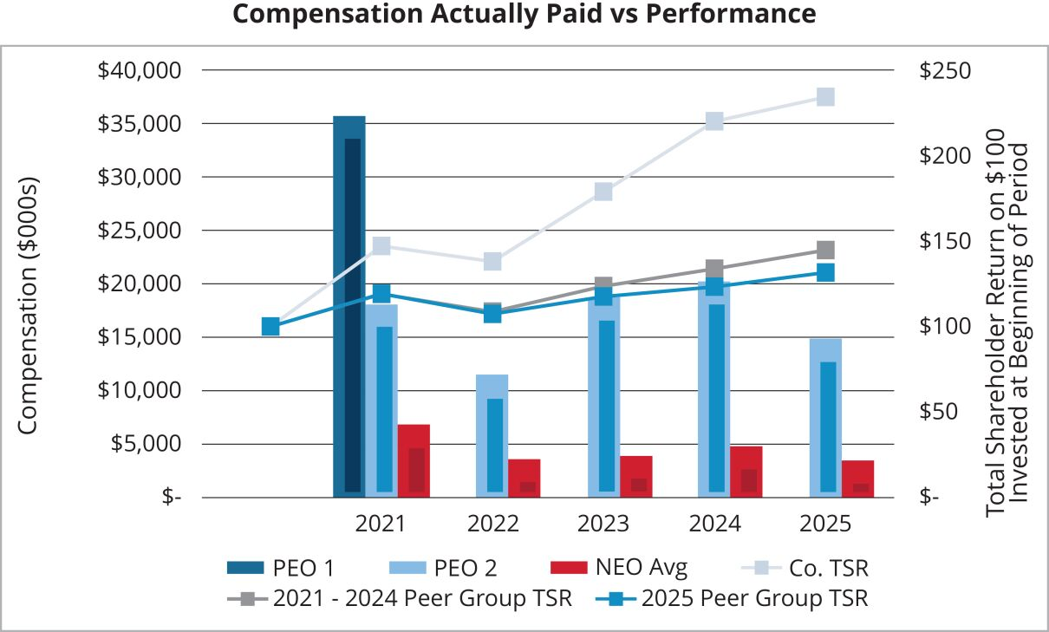

 |  |  |  | Republic Services, Inc. 2026 Proxy  Statement |  |  | | |  |  |  | 93

Table of Contents
PROXY SUMMARY |  |  |  | BOARD AND GOVERNANCE |  |  |  | EXECUTIVE COMPENSATION |  |  |  | PROPOSALS |  |  |  | MEETING INFORMATION |  |  |  | ANNEX

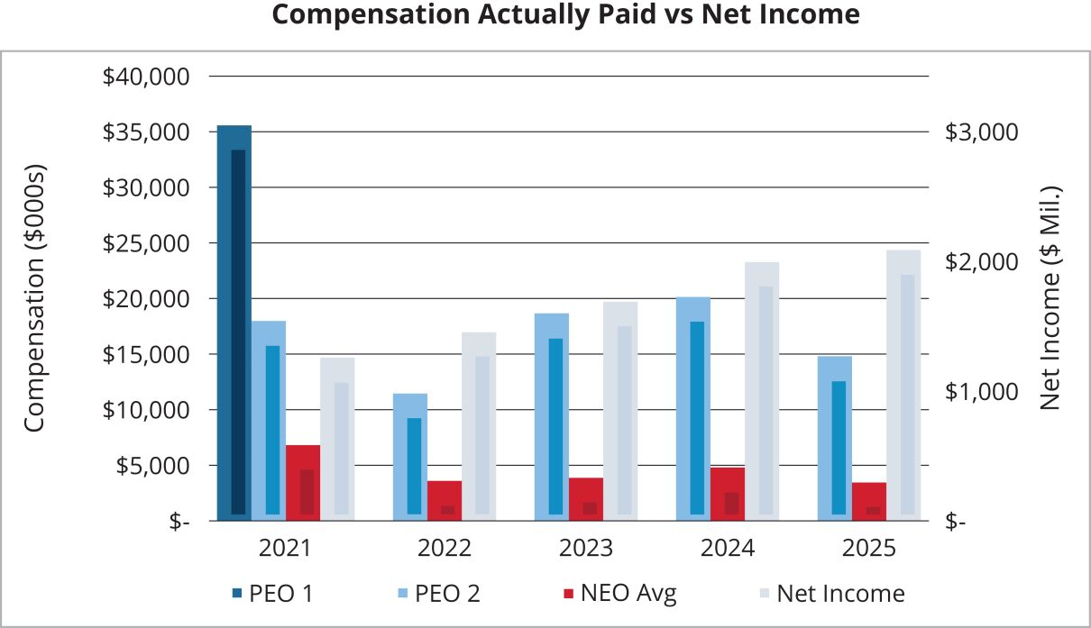

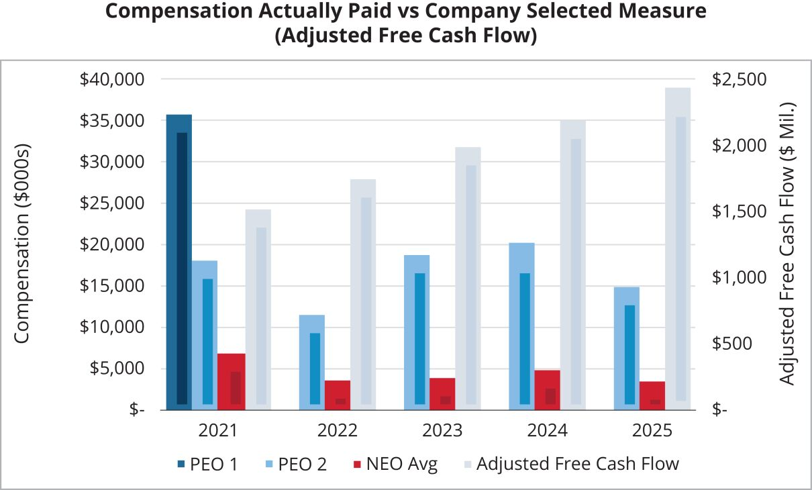
Tabular List of Company Performance Measures
The table below lists in
alphabetical
order the financial performance measures that we believe represent the most important performance measures used to link CAP to our named executive officers to our performance for the most recently completed fiscal year. See our CD&A at pages 56-79 for a further discussion of these performance measures.
Adjusted Earnings Per Share
Adjusted Free Cash Flow
Cash Flow Value Creation
Return on Invested Capital
Total Shareholder Return
For a more comprehensive discussion of how the Talent & Compensation Committee views the
relationship
between named executive officer pay and performance, please see our CD&A at
pages 56-79 of
this Proxy Statement.

94 |  |  | | |  |  | Republic Services, Inc. 2026 Proxy  Statement

Table of Contents


Table of Contents
PROXY SUMMARY |  |  |  | BOARD AND GOVERNANCE |  |  |  | EXECUTIVE COMPENSATION |  |  |  | PROPOSALS |  |  |  | MEETING INFORMATION |  |  |  | ANNEX

PROPOSALS TO BE VOTED ON AT THE MEETING

Proposal 1: Election of Directors
The Board has nominated 13 directors (the “Nominees”) based on the recommendation of the Board’s Governance Committee. If elected, each director will hold office until our next annual meeting or until his or her successor is elected and qualified to serve on the Board. Each Nominee has consented to be named in this Proxy Statement and has agreed to serve as a director if elected.

The Board recommends a vote “FOR” the election of the 13 Nominees listed below:

DIRECTOR NAME |  | AGE |  | DIRECTOR  SINCE |  | PRINCIPAL OCCUPATION
Manny Kadre (Chairman) |  | 60 |  | 2014 |  | CEO, Kollective Auto Group
Ian Craig |  | 53 |  | 2026 |  | CEO, Coca-Cola FEMSA
Michael A. Duffy |  | 56 |  | 2020 |  | CEO, Rentokil Initial plc
Thomas W. Handley |  | 71 |  | 2016 |  | Senior Advisor and former Chief Operating Officer of Cascade Asset Management Company, the investment office for William H. Gates III, and the Gates Foundation Trust
Jennifer M. Kirk |  | 51 |  | 2016 |  | CEO, Exubrion Therapeutics
Michael Larson |  | 66 |  | 2009 |  | Chief Investment Officer for William H. Gates III and the Gates Foundation Trust
Norman Thomas Linebarger |  | 63 |  | 2024 |  | Chief Executive Officer, Energy Transformation, General Catalyst
Meg Reynolds |  | 61 |  | 2023 |  | Co-Founder and Principal, Westwood Global Investments
James P. Snee |  | 59 |  | 2018 |  | Former Chairman, President and CEO, Hormel Foods Corporation
Brian S. Tyler |  | 59 |  | 2021 |  | CEO, McKesson Corporation
Jon Vander Ark |  | 50 |  | 2021 |  | President and CEO of Republic Services, Inc.
Sandra M. Volpe |  | 58 |  | 2016 |  | Former Senior Vice President, Strategic Planning, Communications and Business Development Solutions, FedEx Ground
Katharine B. Weymouth |  | 59 |  | 2018 |  | Venture Partner, Blu Venture Investors
The Nominees who receive a majority of the votes cast by the holders of our common stock represented at the Annual Meeting, without giving effect to abstentions, will be elected directors. According to our Bylaws, “majority of the votes cast” means that the number of votes cast “for” a director’s election exceeds the number of votes cast “against” that director’s election (with abstentions and broker non-votes not counted as a vote cast either “for” or “against” that director’s election).
Under our Bylaws, the number of directors is fixed from time to time by Board resolution and shall be not more than 13 (the majority of whom must be independent of Republic for purposes of the NYSE rules).

96 |  |  | | |  |  | Republic Services, Inc. 2026 Proxy Statement

Table of Contents
PROXY SUMMARY |  |  |  | BOARD AND GOVERNANCE |  |  |  | EXECUTIVE COMPENSATION |  |  |  | PROPOSALS |  |  |  | MEETING INFORMATION |  |  |  | ANNEX

Proposal 2: Advisory Vote on Named Executive Officer Compensation
In accordance with the requirements of Section 14A of the Exchange Act and the related SEC rules, we are asking our shareholders to cast a vote to approve the compensation of our NEOs. This proposal, commonly referred to as a “say-on-pay” proposal, gives you the opportunity to approve, not approve, or abstain from voting on our NEO compensation. This vote is not intended to address any specific item of compensation, but rather the overall compensation of our NEOs and the compensation principles, policies, and practices described in this Proxy Statement. Section 14A requires that we submit a proposal to shareholders similar to this one at least every three years. Based on the recommendation of our shareholders, we intend to submit a proposal similar to this one to our shareholders every year.
In considering your vote, you should review with care the information regarding our NEOs’ compensation appearing under the caption “Executive Compensation” on pages 55 through 94, including the CD&A beginning on page 56.
We have designed our executive compensation program to attract and retain our executives and to motivate them to increase shareholder value on both an annual and long-term basis primarily by improving our earnings and return on invested capital and generating increasing levels of free cash flow. The Talent & Compensation Committee believes our executive compensation program reflects a strong pay-for-performance philosophy and drives the alignment of shareholder and management interests.
Accordingly, we are submitting the following resolution for shareholder vote at the Annual Meeting:
“RESOLVED, that the shareholders of Republic approve, on an advisory basis, the compensation of Republic’s NEOs as disclosed in the proxy statement for the 2026 Annual Meeting under the heading “Executive Compensation,” including the Compensation Discussion & Analysis, the Summary Compensation Table, and the other tables and narrative disclosures set forth thereunder.”
The affirmative vote of a majority of the holders represented at the Annual Meeting and entitled to vote is required to approve this proposal. Abstentions will have the effect of a vote against Proposal 2 and broker non-votes have no effect on the proposal. This vote is an advisory vote only, and the result will not be binding on us. Although the vote is non-binding, the Talent & Compensation Committee values shareholders’ opinions. Accordingly, the Talent & Compensation Committee will review the results of voting on this proposal, seek to determine the cause or causes of any significant negative voting results and consider those matters when making future NEO compensation decisions.

The Board recommends a vote “FOR” approval of the compensation of our NEOs.

 |  |  |  | Republic Services, Inc. 2026 Proxy Statement |  |  | | |  |  |  | 97

Table of Contents
PROXY SUMMARY |  |  |  | BOARD AND GOVERNANCE |  |  |  | EXECUTIVE COMPENSATION |  |  |  | PROPOSALS |  |  |  | MEETING INFORMATION |  |  |  | ANNEX

Proposal 3: Ratification of Independent Registered Public Accounting Firm
Our Audit Committee has selected Ernst & Young LLP as our independent registered public accounting firm for the fiscal year ending December 31, 2026. This selection will be presented to the shareholders for ratification at the Annual Meeting. You may vote for, vote against, or abstain from voting with respect to this proposal. The affirmative vote of a majority of the holders represented at the Annual Meeting and entitled to vote is required to ratify the appointment. Abstentions will have the effect of a vote against Proposal 3. Broker non-votes have no effect on the proposal, however, we do not expect to receive broker non-votes on this proposal because the ratification of the appointment of our independent registered public accounting firm is a matter on which banks, brokers or other nominees are generally empowered to vote any shares for which a beneficial owner does not provide an instruction. If the shareholders do not ratify the appointment of Ernst & Young LLP, our Audit Committee may reconsider the selection of our independent registered public accounting firm.
The Audit Committee is directly responsible for the appointment, compensation, retention, and oversight of our independent registered public accounting firm retained to audit our financial statements. The Audit Committee has appointed Ernst & Young LLP as our independent registered public accounting firm for 2026. Ernst & Young LLP has been retained as our independent registered public accounting firm continuously since June 2002. The Audit Committee is responsible for the audit fee negotiations associated with our retention of Ernst & Young LLP. In order to assure continuing auditor independence, the Audit Committee periodically considers whether there should be a regular rotation of the independent registered public accounting firm. In conjunction with the mandated rotation of the audit firm’s lead engagement partner, the Audit Committee and the chair of the Audit Committee are directly involved in the selection of Ernst & Young LLP’s new lead engagement partner. The members of the Audit Committee and the Board believe that the continued retention of Ernst & Young LLP to serve as our independent registered public accounting firm is in the best interests of the Company and our shareholders. Representatives of Ernst & Young LLP are expected to be present at our Annual Meeting, will have the opportunity to make a statement if they desire to do so, and are expected to be available to respond to appropriate questions.

The Board recommends a vote “FOR” ratification of the appointment of Ernst &
Young LLP as our independent registered public accounting firm for 2026.

98 |  |  | | |  |  | Republic Services, Inc. 2026 Proxy Statement

Table of Contents


Table of Contents
PROXY SUMMARY |  |  |  | BOARD AND GOVERNANCE |  |  |  | EXECUTIVE COMPENSATION |  |  |  | PROPOSALS |  |  |  | MEETING INFORMATION |  |  |  | ANNEX

Questions and Answers and Information about the Annual Meeting
WHAT IS THE RECORD DATE AND WHO MAY VOTE AT THE ANNUAL MEETING?
Our only voting stock currently outstanding is our common stock. You may vote if you were a holder of record of Republic common stock as of the close of business on March 9, 2026 (the “Record Date”). A list of stockholders will be available for any purpose germane to the meeting for a period of 10 days ending on the day before the meeting date.
The trustee of our 401(k) Plan will vote shares held in each participant’s account in accordance with instructions provided by the participant on a completed proxy card. If a participant does not provide a completed proxy card, the trustee of the 401(k) Plan will vote the shares in a participant’s account in the same proportion that it votes shares for which it received valid and timely proxy cards from other participants or as otherwise required by applicable law.
HOW DO I PARTICIPATE IN THE ANNUAL MEETING?
This year’s Annual Meeting will be held in a virtual format through a live webcast. You are entitled to participate in the Annual Meeting if you were a shareholder as of the close of business on the Record Date or hold a valid proxy for the meeting. To be admitted to the Annual Meeting at www.virtualshareholdermeeting.com/RSG2026 you must enter the 16-digit control number found next to the label “Control Number” on your Notice of Internet Availability, proxy card, or voting instruction form, or in the email sending you the Proxy Statement. If you are a beneficial shareholder, you may contact the bank, broker or other institution where you hold your account if you have questions about obtaining your control number.
We encourage you to access the Annual Meeting before it begins. Online check-in will start approximately fifteen minutes before the meeting on May 7, 2026. If you encounter difficulties accessing the virtual meeting, please call the technical support number that will be posted on the Virtual Shareholder Meeting page.
HOW DO I ASK A QUESTION AT THE MEETING?
Shareholders may submit questions during the Annual Meeting using the “Ask a Question” field on the virtual meeting website. You will need to log in with your control number found on the Notice of Internet Availability of Proxy Materials, the proxy card or the voting instruction form to submit a question.
During the Q&A session of the Annual Meeting, we will answer questions pertinent to meeting matters as they come in and as time permits. Any questions pertinent to meeting matters that cannot be answered during the meeting due to time constraints will be posted online and answered on our investor relations page at investor.republicservices.com under “2026 Annual Meeting of Shareholders” as soon as practicable following the meeting and will remain available for one week after posting. Please refer to our Meeting Rules of Conduct for more information on how to ask questions which will be available during the Annual Meeting at www.virtualshareholdermeeting.com/RSG2026.
WHAT WILL I BE VOTING ON?
The following proposals will be considered at the Annual Meeting:

 | • |  | election of directors (Proposal 1);
 | • |  | advisory vote to approve our named executive officer compensation (Proposal 2); and
 | • |  | ratification of the appointment of our independent registered public accounting firm for 2026 (Proposal 3).
HOW MANY VOTES DO I HAVE?
You will have one vote for every share of our common stock you owned as of the close of business on March 9, 2026.
WHAT CONSTITUTES A QUORUM FOR THE ANNUAL MEETING?
As of the Record Date, 308,956,192 shares of our common stock were outstanding and entitled to vote. A quorum is at least a majority of the voting power represented by the shares of our common stock, or 154,478,097 shares. Abstentions and broker shares, which are shares held in street name, that are voted as to any matter presented at the meeting will be included in determining the number of shares present or represented at the Annual Meeting. Broker shares that are not voted on any matter at the Annual Meeting will not be included in determining the number of shares present or represented. A quorum must be present or represented at the Annual Meeting for any action to be taken. If a quorum is not present or represented, the holders of a majority of the shares entitled to vote who are present or represented at the Annual Meeting, or the chairman of the meeting, may adjourn the Annual Meeting until a quorum is present or represented. The time and place of the adjourned meeting will be announced when the adjournment is taken, and no other notice will be given.
HOW MANY VOTES ARE REQUIRED TO APPROVE THE PROPOSALS, ASSUMING A QUORUM?
The affirmative vote of the majority of votes cast with respect to that director’s election at the Annual Meeting is required for the election of each director (Proposal 1). The affirmative vote of the holders of a majority of the voting power of the shares of common stock present or represented by proxy and entitled to vote is required for approval of Proposals 2 and 3.

100 |  |  | | |  |  | Republic Services, Inc. 2026 Proxy Statement

Table of Contents
PROXY SUMMARY |  |  |  | BOARD AND GOVERNANCE |  |  |  | EXECUTIVE COMPENSATION |  |  |  | PROPOSALS |  |  |  | MEETING INFORMATION |  |  |  | ANNEX

HOW DO I VOTE?
The internet and telephone voting procedures have been designed to verify shareholders’ identities and allow shareholders to confirm their voting instructions have been properly recorded. Shareholders whose shares are held for them by brokers, banks or other nominees should follow the instructions provided by the nominees.
Submitting your proxy or voting instructions before the Annual Meeting will not affect your right to vote in person if you decide to attend the Annual Meeting. If, however, you hold your shares in street name, you must request a valid proxy from your broker, bank or other nominee to vote in person at the Annual Meeting.

Your vote is very important. Regardless of whether you plan to attend the Annual Meeting, please ensure that your vote is counted.

WHAT IF I DO NOT GIVE SPECIFIC VOTING INSTRUCTIONS?
Shareholders of Record. If you are a shareholder of record and you return a signed proxy card but do not indicate how you wish to vote on a particular matter, your shares will be voted in accordance with the Board’s recommendations on all matters presented in this Proxy Statement. Your shares will be voted as the proxy holders determine in their discretion regarding any matters not presented in this Proxy Statement that are properly presented for a vote at the Annual Meeting.
Beneficial Owners. If you are a beneficial owner and hold your shares in street name and do not provide your broker, bank or other nominee with voting instructions, the nominee will determine if it has the discretionary authority to vote on the particular matter. Under applicable rules, brokers have the discretion to vote on “routine” matters, but do not have discretion to vote on “non-routine” matters. The ratification of the appointment of our independent registered public accounting firm for 2026 (Proposal 3) is a matter considered “routine” under applicable rules. The election of directors (Proposal 1), and the advisory vote to approve named executive officer compensation (Proposal 2) are matters considered “non-routine” under applicable rules. Thus, there will likely be broker non-votes on Proposals 1 and 2.
401(k) Plan Participants. If you are a participant in our 401(k) Plan and do not provide the trustee with voting instructions, the trustee will vote the shares in your account in the same proportion that it votes shares for which it received valid and timely proxy cards from other participants or as otherwise required by applicable law.
WHAT ARE BROKER NON-VOTES?
The NYSE permits brokers to vote their customers’ shares on “routine” matters when the brokers have not received voting instructions from their customers. Brokers may not vote their customers’ shares on “non-routine” matters unless they have received voting instructions from their customers. Non-voted shares on non-routine matters are referred to as broker non-votes.
HOW ARE BROKER NON-VOTES AND ABSTENTIONS COUNTED?
Abstentions and broker non-votes will have no effect on Proposal 1, as the election is determined by counting the votes actually cast where abstentions and broker non-votes are not treated as votes cast. Abstentions will have the effect of a vote against Proposals 2 and 3, as the standard for the approval of these proposals is a majority of shares present and entitled to vote, and broker non-votes have no effect on these proposals.
CAN I CHANGE MY VOTE?
Yes. If you have submitted your proxy, you may revoke your proxy at any time until it is voted at the Annual Meeting. If you are a shareholder of record, you may do this in one of three ways: (1) you can send us a written notice stating that you would like to revoke your proxy; (2) you can complete and submit a new proxy card, or cast a new vote by telephone or internet; or (3) you can attend the Annual Meeting and vote in person. Your attendance alone, however, will not revoke your proxy. If you have instructed a broker to vote your shares, you must follow the procedure provided by your broker to change these instructions.
DO I NEED TO ATTEND THE ANNUAL MEETING?
No. Although you are welcome to attend virtually, it is not necessary for you to log on to the Annual Meeting to vote your shares.

 |  |  |  | Republic Services, Inc. 2026 Proxy Statement |  |  | | |  |  |  | 101

Table of Contents
PROXY SUMMARY |  |  |  | BOARD AND GOVERNANCE |  |  |  | EXECUTIVE COMPENSATION |  |  |  | PROPOSALS |  |  |  | MEETING INFORMATION |  |  |  | ANNEX

HOW DOES THE BOARD RECOMMEND I VOTE ON THE PROPOSALS?
The Board recommends you vote:

FOR  the election of the 13 nominees to  the Board  (Proposal 1) |  | FOR  approval of our named  executive officer compensation  (Proposal 2) |  | FOR  ratification of the appointment of  our independent registered  public accounting firm  (Proposal 3)
WHERE CAN I FIND MORE INFORMATION ABOUT REPUBLIC?
We file reports and other information with the SEC. This information is also available at our website at www.RepublicServices.com (click on “Investors”) and at the SEC’s website at www.sec.gov.
The information contained on, or that may be accessed through, our website is not a part of, or incorporated by reference in this Proxy Statement.
WHO CAN HELP ANSWER MY QUESTIONS?
If you have questions about the Annual Meeting or the proposals, or need help voting your shares, you can call Innisfree M&A Incorporated, which is the firm assisting us with our proxy solicitation, toll-free at (888) 750-5834.
EXPENSES OF SOLICITATIONS
Republic will bear the cost of soliciting proxies. In addition to solicitations by mail, our employees may solicit proxies in person or by telephone without additional compensation. We will pay all costs of solicitation, including certain expenses of brokers and nominees who mail proxy materials to their customers or principals. Also, we have engaged Innisfree M&A Incorporated to help in the solicitation of proxies for a fee of approximately $25,000 plus associated costs and expenses.
PROXY STATEMENT MAILING INFORMATION AND HOUSEHOLDING
The SEC allows us to deliver a single Notice of Internet Availability of Proxy Materials to one address shared by two or more shareholders. This delivery method is referred to as “householding” and can result in cost savings for us. We deliver a single package containing Notices of Internet Availability of Proxy Materials to multiple shareholders who share an address. If you prefer to receive separate packages containing the Notices of Internet Availability of Proxy Materials, or if you currently are a shareholder sharing an address with another shareholder and wish to receive only one package containing future Notices of Internet Availability of Proxy Materials for your household, please contact Broadridge, toll free at 1-866-540-7095. You may also write to: Broadridge, Householding Department, 51 Mercedes Way, Edgewood, New York 11717.
As permitted by SEC rules, we are making our Proxy Statement and our Annual Report on Form 10-K for the year ended December 31, 2025 available in digital form online. On or about March 24, 2026, we are mailing to our shareholders a Notice of Internet Availability of Proxy Materials containing instructions on how to access this Proxy Statement and our Annual Report on Form 10-K and how to vote online. Shareholders who receive the notice will not receive a printed copy of the proxy materials in the mail. If you would like to receive a printed copy, please follow the instructions included in the Notice of Internet Availability of Proxy Materials.
SUBMISSION OF SHAREHOLDER PROPOSALS FOR OUR 2027 ANNUAL MEETING
Any shareholder who wishes to present a proposal for action at our next annual meeting of shareholders, presently scheduled for May 2027, or who wishes to nominate a candidate for our Board, must submit such proposal or nomination in writing to: Attention: Office of the Corporate Secretary, Republic Services, Inc., 5353 E. City North Drive, Phoenix, Arizona 85054. The proposal or nomination should comply with the time period and information requirements as set forth in our Bylaws relating to shareholder business or shareholder nominations, as applicable. Shareholders interested in submitting a proposal for inclusion in the proxy statement for the 2027 annual meeting of shareholders may do so by following the procedures prescribed in our Bylaws and in accordance with the applicable rules under the Exchange Act. Shareholder proposals must be received by our Corporate Secretary:

 | • |  | no later than November 24, 2026, if the proposal is submitted for inclusion in our proxy materials pursuant to Rule 14a-8 under the Exchange Act;

 | • |  | between January 7, 2027 and February 6, 2027, if the proposal is submitted under our Bylaws, in which case we are not required to include the proposal in our proxy materials; or

 | • |  | between October 25, 2026 and November 24, 2026, if the proposal is submitted pursuant to our proxy access Bylaw provision.

102 |  |  | | |  |  | Republic Services, Inc. 2026 Proxy Statement

Table of Contents
PROXY SUMMARY |  |  |  | BOARD AND GOVERNANCE |  |  |  | EXECUTIVE COMPENSATION |  |  |  | PROPOSALS |  |  |  | MEETING INFORMATION |  |  |  | ANNEX

MISCELLANEOUS MATTERS
Our Annual Report on Form 10-K covering the fiscal year ended December 31, 2025 is available electronically with this Proxy Statement. It contains financial and other information about us, but is not incorporated into this Proxy Statement and is not to be considered a part of these proxy soliciting materials or subject to Regulations 14A or 14C or to the liabilities of Section 18 of the Exchange Act. The information contained in the “Talent & Compensation Committee Report,” the “Audit Committee Report” or any hyperlinks contained in this Proxy Statement shall not be deemed “filed” with the SEC or subject to Regulations 14A or 14C or to the liabilities of Section 18 of the Exchange Act.
We will mail upon written request, without charge, to each shareholder of record as of the Record Date, a copy of our Annual Report on Form 10-K for the fiscal year ended December 31, 2025, as filed with the SEC. Any exhibits listed in the Form 10-K report also will be furnished upon request at the actual expense we incur in furnishing such exhibits. Any such requests should be directed to Attention: Office of the Corporate Secretary, Republic Services, Inc., 5353 E. City North Drive, Phoenix, Arizona 85054. Our Annual Report on Form 10-K and exhibits thereto also are available on our website at www.RepublicServices.com or at the SEC’s website at www.sec.gov.
You are again invited to attend the Annual Meeting. We will hold the virtual Annual Meeting at 10:30 a.m., Pacific Time, on Thursday, May 7, 2026 online at www.virtualshareholdermeeting.com/RSG2026.
Other than the items described herein, management does not intend to present any other items of business and knows of no other matters that will be brought before the Annual Meeting. However, if any additional matters are properly brought before the Annual Meeting, the persons named in the proxy shall vote the proxies in their discretion in the manner they believe to be in our best interest. We have prepared the accompanying form of proxy at the Board’s direction and provide it to you at the Board’s request. Your Board has designated the proxies named therein.



 |  |  |  | Republic Services, Inc. 2026 Proxy Statement |  |  | | |  |  |  | 103

Table of Contents


Table of Contents
PROXY SUMMARY |  |  |  | BOARD AND GOVERNANCE |  |  |  | EXECUTIVE COMPENSATION |  |  |  | PROPOSALS |  |  |  | MEETING INFORMATION |  |  |  | ANNEX

Annex—CD&A APPENDIX
Reconciliation of GAAP to Non-GAAP Financial Measures

ADJUSTED DILUTED EARNINGS PER SHARE |  | FY 2023 |  |  |  | FY 2024 |  |  |  | FY 2025
Diluted earnings per share—as reported |  | $ | 5.47 |  |  | $ | 6.49 |  |  | $ | 6.85
Loss (gain) on extinguishment of debt and other related costs |  |  | — |  |  |  | (0.01 | ) |  |  | —
Restructuring charges |  |  | 0.08 |  |  |  | 0.07 |  |  |  | 0.05
Loss (gain) on business divestitures and asset impairments, net |  |  | (0.03 | ) |  |  | (0.07 | ) |  |  | —
Settlement and withdrawals on pension plans |  |  | 0.01 |  |  |  | (0.02 | ) |  |  | —
US Ecology acquisition integration and deal costs |  |  | 0.08 |  |  |  | — |  |  |  | —
Labor disruption |  |  | — |  |  |  | — |  |  |  | 0.12
Diluted earnings per share—as adjusted |  | $ | 5.61 |  |  | $ | 6.46 |  |  | $ | 7.02
ADJUSTED FREE CASH FLOW (IN MILLIONS) |  | FY 2023 |  |  |  | FY 2024 |  |  |  | FY 2025
Cash provided by operating activities |  | $ | 3,618 |  |  | $ | 3,936 |  |  | $ | 4,296
Property and equipment received |  |  | (1,717 | ) |  |  | (1,818 | ) |  |  | (1,923 | )
Proceeds from sales of property and equipment |  |  | 29 |  |  |  | 47 |  |  |  | 13
Divestiture related tax (payments) benefits |  |  | 1 |  |  |  | — |  |  |  | —
Cash tax benefit for debt extinguishment and other related costs |  |  | — |  |  |  | (1 | ) |  |  | —
Adjustment to withdrawal liability for a multiemployer pension fund, net of tax |  |  | — |  |  |  | — |  |  |  | —
Restructuring payments, net of tax |  |  | 29 |  |  |  | 19 |  |  |  | 9
US Ecology acquisition integration and deal costs, net of tax |  |  | 25 |  |  |  | — |  |  |  | —
Labor disruption |  |  | — |  |  |  | — |  |  |  | 38
Free cash flow—as adjusted |  | $ | 1,985 |  |  | $ | 2,183 |  |  | $ | 2,433
ADJUSTED EBITDA (IN MILLIONS) |  | FY 2023 |  |  |  | FY 2024 |  |  |  | FY 2025
Net Income attributable to Republic Services, Inc. |  | $ | 1,731 |  |  | $ | 2,043 |  |  | $ | 2,139
Net income attributable to non-controlling interests |  |  | — |  |  |  | 1 |  |  |  | —
Provision for income taxes |  |  | 460 |  |  |  | 388 |  |  |  | 455
Other (income) expense, net |  |  | (7 | ) |  |  | (23 | ) |  |  | (21 | )
Interest income |  |  | (6 | ) |  |  | (9 | ) |  |  | (8 | )
Interest expense |  |  | 508 |  |  |  | 539 |  |  |  | 574
Depreciation, amortization and depletion |  |  | 1,501 |  |  |  | 1,677 |  |  |  | 1,814
Accretion |  |  | 98 |  |  |  | 107 |  |  |  | 114
Loss from unconsolidated equity method investment |  |  | 94 |  |  |  | 255 |  |  |  | 163
Loss on extinguishment of debt and other related costs |  |  | — |  |  |  | 2 |  |  |  | —
Restructuring charges |  |  | 33 |  |  |  | 29 |  |  |  | 20
Loss (gain) on business divestitures and impairments, net |  |  | (4 | ) |  |  | (30 | ) |  |  | —
Adjustment to withdrawal liability for a multiemployer pension fund |  |  | 5 |  |  |  | — |  |  |  | 1
US Ecology acquisition integration and deal costs |  |  | 34 |  |  |  | — |  |  |  | —
Labor Disruption |  |  | — |  |  |  | — |  |  |  | 56
Adjusted EBITDA |  | $ | 4,447 |  |  | $ | 4,979 |  |  | $ | 5,307

 |  |  |  | Republic Services, Inc. 2026 Proxy Statement |  |  | | |  |  |  | 105

Table of Contents
PROXY SUMMARY |  |  |  | BOARD AND GOVERNANCE |  |  |  | EXECUTIVE COMPENSATION |  |  |  | PROPOSALS |  |  |  | MEETING INFORMATION |  |  |  | ANNEX

Calculation of Actual Results for Annual Incentive Performance Measures and GAAP Reconciliation

EARNINGS PER SHARE MEASURE |  | FY 2023 |  |  |  | FY 2024 |  |  |  | FY 2025
Diluted earnings per share—as reported |  | $ | 5.47 |  |  | $ | 6.49 |  |  | $ | 6.85
Loss (gain) on extinguishment of debt and other related costs |  |  | — |  |  |  | (0.01 | ) |  |  | —
Restructuring charges |  |  | 0.08 |  |  |  | 0.07 |  |  |  | 0.05
Settlement and withdrawals on pension plans |  |  | 0.01 |  |  |  | (0.02 | ) |  |  | —
Loss (gain) on business divestitures and asset impairments, net |  |  | (0.03 | ) |  |  | (0.07 | ) |  |  | —
US Ecology acquisition integration and deal costs |  |  | 0.08 |  |  |  | — |  |  |  | —
Benefit from RNG tax credit |  |  | — |  |  |  | (0.05 | ) |  |  | —
Labor disruption |  |  | — |  |  |  | — |  |  |  | 0.12
Earnings per share measure |  | $ | 5.61 |  |  | $ | 6.41 |  |  | $ | 7.02
FREE CASH FLOW MEASURE (IN MILLIONS) |  | FY 2023 |  |  |  | FY 2024 |  |  |  | FY 2025
Cash provided by operating activities |  | $ | 3,618 |  |  | $ | 3,936 |  |  | $ | 4,296
Property and equipment received |  |  | (1,717 | ) |  |  | (1,818 | ) |  |  | (1,923 | )
Proceeds from sales of property and equipment |  |  | 29 |  |  |  | 47 |  |  |  | 13
Divestiture related tax (payments) benefits |  |  | 1 |  |  |  | — |  |  |  | —
Cash tax benefit for debt extinguishment and other related costs |  |  | — |  |  |  | (1 | ) |  |  | —
Adjustment to withdrawal liability for a multiemployer pension fund, net of tax |  |  | — |  |  |  | — |  |  |  | —
Restructuring payments, net of tax |  |  | 29 |  |  |  | 19 |  |  |  | 9
US Ecology acquisition integration and deal costs, net of tax |  |  | 25 |  |  |  | — |  |  |  | —
Labor disruption, net of tax |  |  | — |  |  |  | — |  |  |  | 38
Free cash flow measure |  | $ | 1,985 |  |  | $ | 2,183 |  |  | $ | 2,433

106 |  |  | | |  |  | Republic Services, Inc. 2026 Proxy Statement

Table of Contents
PROXY SUMMARY |  |  |  | BOARD AND GOVERNANCE |  |  |  | EXECUTIVE COMPENSATION |  |  |  | PROPOSALS |  |  |  | MEETING INFORMATION |  |  |  | ANNEX

Calculation of Actual Results for 2023-2025 PSU Performance Measures*

THREE YEAR CASH FLOW VALUE CREATION MEASURE (IN MILLIONS) |  | FY 2023 |  |  |  | FY 2024 |  |  |  | FY 2025
Net Income per LTI definition |  | $ | 1,751 |  |  | $ | 1,997 |  |  | $ | 2,178
Add: after tax interest expense per LTI definition |  |  | 394 |  |  |  | 451 |  |  |  | 464
Add: DD&A and accretion |  |  | 1,599 |  |  |  | 1,784 |  |  |  | 1,928
Operating cash flow |  |  | 3,744 |  |  |  | 4,232 |  |  |  | 4,570
Less: capital charge |  |  | (1,772 | ) |  |  | (1,878 | ) |  |  | (1,963 | )
Cash flow value creation |  | $ | 1,972 |  |  | $ | 2,354 |  |  | $ | 2,607
Three year cash flow value creation measure |  |  |  |  |  |  |  |  |  | $ | 6,933
THREE YEAR RETURN ON INVESTED CAPITAL MEASURE  (IN MILLIONS EXCEPT WHERE NOTED AS A PERCENTAGE) |  | FY 2023 |  |  |  | FY 2024 |  |  |  | FY 2025
Net Income per LTI definition |  | $ | 1,751 |  |  | $ | 1,997 |  |  | $ | 2,178
Add: after tax interest expense per LTI definition |  |  | 394 |  |  |  | 451 |  |  |  | 464
Adjusted net income |  |  | 2,145 |  |  |  | 2,448 |  |  |  | 2,642
Average net assets per LTI definition |  | $ | 22,153 |  |  | $ | 23,473 |  |  | $ | 24,551
Return on Invested Capital |  |  | 9.7% |  |  |  | 10.4% |  |  |  | 10.8%
Sum of three year adjusted net income |  |  |  |  |  |  |  |  |  | $ | 7,235
Sum of three year average net assets |  |  |  |  |  |  |  |  |  | $ | 70,177
Three year return on invested capital |  |  |  |  |  |  |  |  |  |  | 10.3%

* | ROIC and CFVC are adjusted to exclude gains or losses (or related impairments) from divestitures, impairments of goodwill and other costs and impairments resulting from exiting a business, losses recorded on the extinguishment of debt instruments, gains or losses associated with withdrawal from or termination of one or more benefit plans, certain acquisition and integration costs, certain tax benefits, material changes caused by new accounting rules or new interpretations of previous accounting rules and other similar events or circumstances.

 |  |  |  | Republic Services, Inc. 2026 Proxy Statement |  |  | | |  |  |  | 107

Table of Contents


Table of Contents
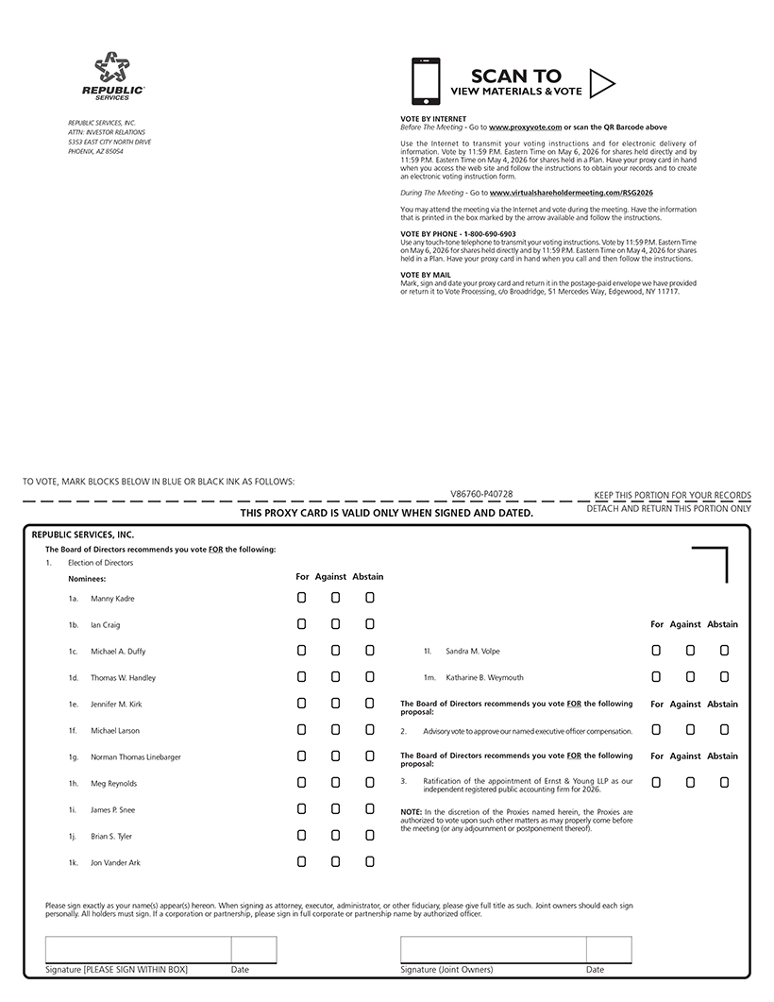
REPUBLIC SERVICES, INC. ATTN: INVESTOR RELATIONS 5353 EAST CITY NORTH DRIVE PHOENIX, AZ 85054 VOTE BY INTERNET Before The Meeting - Go to www.proxyvote.com or scan the QR Barcode above Use the Internet to transmit your voting instructions and for electronic delivery of information. Vote by 11:59 P.M. Eastern Time on May 6, 2026 for shares held directly and by 11:59 P.M. Eastern Time on May 4, 2026 for shares held in a Plan. Have your proxy card in hand when you access the web site and follow the instructions to obtain your records and to create an electronic voting instruction form. During The Meeting - Go to www.virtualshareholdermeeting.com/RSG2026 You may attend the meeting via the Internet and vote during the meeting. Have the information that is printed in the box marked by the arrow available and follow the instructions. VOTE BY PHONE - 1-800-690-6903 Use any touch-tone telephone to transmit your voting instructions. Vote by 11:59 P.M. Eastern Time on May 6, 2026 for shares held directly and by 11:59 P.M. Eastern Time on May 4, 2026 for shares held in a Plan. Have your proxy card in hand when you call and then follow the instructions. VOTE BY MAIL Mark, sign and date your proxy card and return it in the postage-paid envelope we have provided or return it to Vote Processing, c/o Broadridge, 51 Mercedes Way, Edgewood, NY 11717. TO VOTE, MARK BLOCKS BELOW IN BLUE OR BLACK INK AS FOLLOWS: V86760-P40728 KEEP THIS PORTION FOR YOUR RECORDS THIS PROXY CARD IS VALID ONLY WHEN SIGNED AND DATED. DETACH AND RETURN THIS PORTION ONLY REPUBLIC SERVICES, INC. The Board of Directors recommends you vote FOR the following: 1. Election of Directors Nominees: For Against Abstain 1a. Manny Kadre 1b. Ian Craig 1c. Michael A. Duffy 1d. Thomas W. Handley 1e. Jennifer M. Kirk 1f. Michael Larson 1g. Norman Thomas Linebarger 1h. Meg Reynolds 1i. James P. Snee 1j. Brian S. Tyler 1k. Jon Vander Ark For Against Abstain 1l. Sandra M. Volpe 1m. Katharine B. Weymouth For Against Abstain The Board of Directors recommends you vote FOR the following proposal: 2. Advisory vote to approve our named executive officer compensation. The Board of Directors recommends you vote FOR the following proposal: 3. Ratification of the appointment of Ernst & Young LLP as our independent registered public accounting firm for 2026. NOTE: In the discretion of the Proxies named herein, the Proxies are authorized to vote upon such other matters as may properly come before the meeting (or any adjournment or postponement thereof). For Against Abstain Please sign exactly as your name(s) appear(s) hereon. When signing as attorney, executor, administrator, or other fiduciary, please give full title as such. Joint owners should each sign personally. All holders must sign. If a corporation or partnership, please sign in full corporate or partnership name by authorized officer. Signature [PLEASE SIGN WITHIN BOX] Date Signature (Joint Owners) Date

Table of Contents
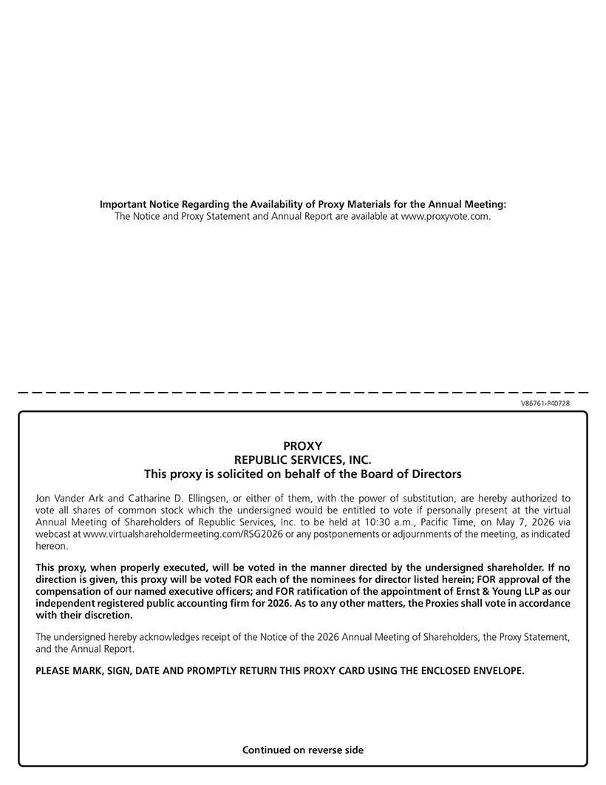
Important Notice Regarding the Availability of Proxy Materials for the Annual Meeting: The Notice and Proxy Statement and Annual Report are available at www.proxyvote.com. V86761-P40728 PROXY REPUBLIC SERVICES, INC. This proxy is solicited on behalf of the Board of Directors Jon Vander Ark and Catharine D. Ellingsen, or either of them, with the power of substitution, are hereby authorized to vote all shares of common stock which the undersigned would be entitled to vote if personally present at the virtual Annual Meeting of Shareholders of Republic Services, Inc. to be held at 10:30 a.m., Pacific Time, on May 7, 2026 via webcast at www.virtualshareholdermeeting.com/RSG2026 or any postponements or adjournments of the meeting, as indicated hereon. This proxy, when properly executed, will be voted in the manner directed by the undersigned shareholder. If no direction is given, this proxy will be voted FOR each of the nominees for director listed herein; FOR approval of the compensation of our named executive officers; and FOR ratification of the appointment of Ernst & Young LLP as our independent registered public accounting firm for 2026. As to any other matters, the Proxies shall vote in accordance with their discretion. The undersigned hereby acknowledges receipt of the Notice of the 2026 Annual Meeting of Shareholders, the Proxy Statement, and the Annual Report. PLEASE MARK, SIGN, DATE AND PROMPTLY RETURN THIS PROXY CARD USING THE ENCLOSED ENVELOPE. Continued on reverse side

